|  |  |  |  |  |
| --- | --- | --- | --- | --- |
| **`Document History** | | | | |
| **Version** | **Date** | **Author** | **Section** | **Changes** |
| 0.1 | 25-03-2016 | Indrajit Kumar | All | Initial draft |
| 0.2 | 28-04-2016 | Amit Kumar | All | Update interface apis |

InApp Purchase Integration

**DOCUMENT HISTORY**

|  |  |
| --- | --- |
| **Author** | Amit |
| **Approved by** |  |
| **Email Id** | amit.kumar_5@philips.com |

Table of Contents

1. Introduction 2

2. Prerequisites 2

3. Library Integration 2

3.1 Maven repository Integration 2

3.2 Library Integration 3

4. INITIALIZATION 5

5. InApp Purchase API Reference 5

6. Reference APP link 6

7. Notes 6

# Introduction

This document provides an overview of integration InApp Purchase feature in Android mobile application.

Source Path: <http://161.85.28.146:9000/scm/git/hor-inapppurchase-android>

# Prerequisites

I. Vertical project is configured for Android Studio

II. Setting->Developer Options->Don’t Keep Activities should be unchecked. [If Developer

Mode is on]

III. Android API version should on 10[Gingerbread]



# Library Integration

## Maven repository Integration

The easiest and preferred way to use these components is using maven. Only we need to add maven repositories in app build gradle:

allprojects {  
 repositories {  
 maven { url 'http://maartens-mini.ddns.htc.nl.philips.com:8081/artifactory/jcenter' }  
 maven {  
 url 'http://maartens-mini.ddns.htc.nl.philips.com:8081/artifactory/ext-release-local'  
 }  
 maven {  
 url 'http://maartens-mini.ddns.htc.nl.philips.com:8081/artifactory/libs-release-local-android'  
 }  
 maven {  
 url 'http://maartens-mini.ddns.htc.nl.philips.com:8081/artifactory/libs-stage-local-android'  
 }  
 flatDir {  
 dirs 'libs'  
 }  
 }  
}

## Library Integration

1. Check out the code from above path wherein you can find sample app which depends on InApp Purchase care library’s aar file : <http://161.85.28.146:9000/scm/git/hor-inapppurchase-android>
2. InApp Purchase needs other libraries to build which are as below
3. registerationApi

Please make sure all these are added to application with the latest versions along with InAppPurchase library aar file under libs folder.

1. Refer InApp Purchase dependencies along with .aar files in build.gradle as mentioned below :

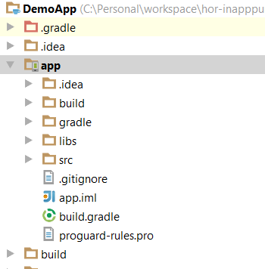

*Note: Since InApp Purchase Android was built with* ***'com.android.support:appcompat-v7:23+. version***

***so vertical app support libs should be greater or equal to mentioned versions***

dependencies {  
 compile 'com.philips.cdp:iap:1.0.0'  
 compile 'com.philips.cdp:uikitLib:3.0.0'  
 compile 'com.android.support:appcompat-v7:23+'  
 compile 'com.android.support:cardview-v7:+'  
 compile(group: 'com.philips.cdp', name: 'registrationApi', version: "5.0.0-rc.2", ext: 'aar') {  
 exclude group: 'com.android.support'  
 transitive = true  
 }  
}

1. Paste InApp Purchase related assets in assets folder from reference app:

**Note: Don’t change or rename folder structure**

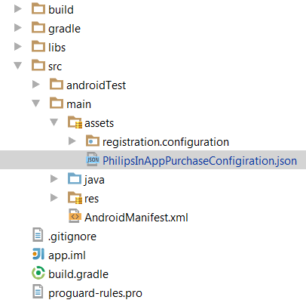

Inside the PhilipsInAppPurchaseConfiguration.json, app has to configure their host and site such as:

{  
 **"hostport"**: **"tst.pl.shop.philips.com"**,  
 **"propositionid"**: **"Tuscany2016"**}

1. Clean project



# INITIALIZATION

InApp store selection is based on the combination of language and country.

1. Create IAPSettings :

Parameters: language (ex: two chars long, “en”)

Country (ex: two chars long, “US”, “UK”)

themeIndex: int constant pointing to UIKIt theme resource

(ex:R.style.Theme_Philips_DarkPurple_WhiteBackground)

1. Create instance of IAPHandler.init class as below

Parameters: Context, IAPSettings

Example initialization for en-US

IAPHandler handler = new IAPHandler.*init*(**this**, **new** IAPSettings(**"US"**, **"en"**, R.style.Theme_Philips_DarkPurple_WhiteBackground);

Once IAPHandler instance initialized, refer below available apis.

# InApp Purchase API Reference

These are the InApp Purchase APIs.

**Class Overview**

This class having the inApp purchase methods to access the cart.

**Summary**

Inherited Constants

|  |  |  |  |
| --- | --- | --- | --- |
| int | IAPConstant.IAP_ERROR_NO_CONNECTION | 2 | No Connection |
| int | IAPConstant.ERROR_CONNECTION_TIME_OUT | 3 | Connection Timeout |
| int | IAPConstant.IAP.ERROR_AUTHENTICSTION_FAILURE | 4 | Authentication failure |
| int | IAPConstant.IAP_ERROR_INSUFFICIENT_STOCK_ERROR | 6 | Product out of stock |

Public Methods

|  |  |  |
| --- | --- | --- |
| IAPHandler | IAPHandler init(Context context, IAPSettings config) | First api call for initializing IAPHandler with language, country and themes. |
| void | **launchIAP(int** landingView, String ctnNumber, IAPHandlerListener listener) |  |
| void | getProductCartCount(IAPHandlerListner pIAPHandlerListner)) | It will give the count of products from cart |

Inherited Methods

|  |  |  |
| --- | --- | --- |
| void | onSuccess(int count) | getProductcount will give actual count on onSuccess call and for others, it will return count 0. |
| void | onFailure(int errorCode) | It will return int constants for error |

# Api details

1. **launchIAP(int** landingView, String ctnNumber, IAPHandlerListener listener)

landingView: Constant value of IAPConstatns.IAPLandginViews

IAP_PRODUCT_CATALOG_VIEW

IAP_SHOPPING_CART_VIEW

ctnNumber: Product ctnNumber

If ctnNumber is empty, product catalogue is launched, else the product is added in cart (if not already present) and shopping cart is launched.

# Reference APP link

<http://161.85.28.146:9000/scm/git/hor-inapppurchase-android>

# Notes

1. Registration is developed as separate library project. App is expected to invoke registration library on click of registration button inside consumer care support page.
2. Library should be initialized as per document or sample app otherwise library would throw runtime exception.
3. Please refer sample application for more details
4. All dependencies can be referred as it is.
5. Configuration can be followed [all sample configurations are provided in sample]