Main2Activity.kt:

package com.jew.lab10

import androidx.appcompat.app.AppCompatActivity

import android.os.Bundle

class Main2Activity : AppCompatActivity() {

override fun onCreate(savedInstanceState: Bundle?) {

super.onCreate(savedInstanceState)

setContentView(R.layout.activity_main2)

}

}

MainActivity.kt:

package com.jew.lab10

import android.content.Intent

import androidx.appcompat.app.AppCompatActivity

import android.os.Bundle

import android.widget.Toast

import kotlinx.android.synthetic.main.activity_main.*

class MainActivity : AppCompatActivity() {

override fun onCreate(savedInstanceState: Bundle?) {

super.onCreate(savedInstanceState)

setContentView(R.layout.activity_main)

//啟動按鈕監聽事件

btn_start.setOnClickListener {

//啟動Service並結束MainActivity

//使用startService，從目前Activity(this)啟動MyService

startService(Intent(this, MyService::class.java))

Toast.makeText(this, "啟動Service", Toast.LENGTH_SHORT).show()

//關閉Activity

finish()

}

}

}

MyService.kt:

package com.jew.lab10

import android.app.Service

import android.content.Intent

import android.os.Handler

import android.os.IBinder

class MyService : Service() {

override fun onCreate() {

super.onCreate()

//延遲5秒

Handler().postDelayed({

//宣告Intent，從MyService啟動Main2Activity

val intent = Intent(this@MyService, Main2Activity::class.java)

//Service要啟動Activity要加入Flag定義要去產生一個新的Activity

intent.flags = Intent.FLAG_ACTIVITY_NEW_TASK

this@MyService.startActivity(intent)

}, 5000)

}

override fun onStartCommand(intent: Intent, flags: Int, startid: Int): Int {

super.onStartCommand(intent, flags, startid)

//結束後不再重啟

return START_NOT_STICKY

}

activity_main.xml:

<?xml version="1.0" encoding="utf-8"?>

<androidx.constraintlayout.widget.ConstraintLayout xmlns:android="http://schemas.android.com/apk/res/android"

xmlns:app="http://schemas.android.com/apk/res-auto"

xmlns:tools="http://schemas.android.com/tools"

android:layout_width="match_parent"

android:layout_height="match_parent"

tools:context=".MainActivity">

<Button

android:id="@+id/btn_start"

android:layout_width="wrap_content"

android:layout_height="wrap_content"

android:text="啟動"

app:layout_constraintBottom_toBottomOf="parent"

app:layout_constraintLeft_toLeftOf="parent"

app:layout_constraintRight_toRightOf="parent"

app:layout_constraintTop_toTopOf="parent" />

</androidx.constraintlayout.widget.ConstraintLayout>

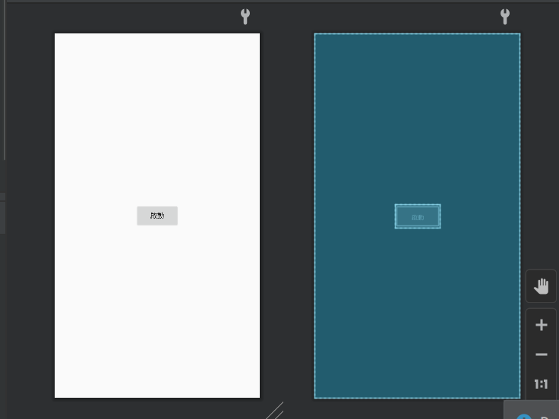

activity_main2.xml:

<?xml version="1.0" encoding="utf-8"?>

<androidx.constraintlayout.widget.ConstraintLayout xmlns:android="http://schemas.android.com/apk/res/android"

xmlns:app="http://schemas.android.com/apk/res-auto"

xmlns:tools="http://schemas.android.com/tools"

android:layout_width="match_parent"

android:layout_height="match_parent"

tools:context=".Main2Activity">

<TextView

android:id="@+id/textView"

android:layout_width="wrap_content"

android:layout_height="wrap_content"

android:text="成功"

app:layout_constraintBottom_toBottomOf="parent"

app:layout_constraintLeft_toLeftOf="parent"

app:layout_constraintRight_toRightOf="parent"

app:layout_constraintTop_toTopOf="parent" />

</androidx.constraintlayout.widget.ConstraintLayout>

