Binomial Addition Example

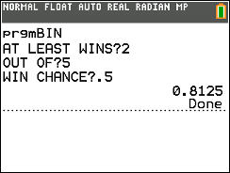

A coin is tossed 5 times. What is the chance you will have at least 2 heads? Answer: 81.25%

The program calculates the probability for each outcome and adds them to find the total probability.

Each win can be calculated by multiplying:

|  |  |  |  |
| --- | --- | --- | --- |
| Combinations | Win Chance | Loss Chance | Probability |
| 5 nCr 2 | .52 | (1-.5)(5-2) | 0.3125 |
| 5 nCr 3 | .53 | (1-.5)(5-3) | 0.3125 |
| 5 nCr 4 | .54 | (1-.5)(5-4) | 0.15625 |
| 5 nCr 5 | .55 | (1-.5)(5-5) | 0.03125 |
|  |  | Total | 0.8125 |

Variables

A – Individual total for each probability in the loop

B – Running total of all probabilities

W – Chance of desired outcome occurring

X – Minimum number of desired outcomes

Y – Maximum outcomes

Z – Used to step through outcomes

Step-by-step

1) Input the minimum number of desired outcomes

2) Input the maximum number of outcomes

3) Input the chance of the desired outcome

4) Resets the running total to 0

5) Loop that steps through desired outcomes

6) Combination for specific outcome is stored as A

7) A is multiplied by the chance of desired outcome

occurring and not occurring then stored as A

8) A is added to the running total B

9) End of loop from line 5

10) Display total B