ESBL-PE Predictor — Model Performance Report
Mbarara Regional Referral Hospital, Uganda

1. Introduction
This document presents the full model performance documentation for the ESBL-PE Predictor — a machine learning tool developed to identify cancer patients at risk of infection with Extended-Spectrum Beta-Lactamase-Producing Enterobacteriaceae (ESBL-PE) during empirical treatment at Mbarara Regional Referral Hospital (MRRH), Uganda.

2. Dataset & Split Summary
The full dataset contains 1,569 patients from MRRH. Only the 660 labelled rows (confirmed ESBL culture result) were used for model training and evaluation.
Split | Rows | ESBL+ (n) | ESBL- (n) | Notes
Full cohort | 1,569 | 281 (17.9%) | 379 (24.2%) | 909 unlabelled — no culture result
Labelled set | 660 | 281 (42.6%) | 379 (57.4%) | Used for modelling
Train (pre-aug) | 461 | 196 | 265 | 70% stratified split
Train (post-SMOTE) | 520 | 255 | 265 | After SMOTE on train only
Validation | 99 | 42 | 57 | 15% — model selection
Test | 100 | 43 | 57 | 15% — held out, used once

Note: SMOTE (Synthetic Minority Over-sampling Technique) was applied only to the training split. Validation and test sets reflect the true clinical class distribution.

3. Metric Definitions
The following metrics are reported across training, validation, and test splits:
Metric | Definition & Clinical Meaning
AUROC | Area under the ROC curve. Probability the model ranks a random ESBL+ patient higher than a random ESBL- patient. Values ≥0.80 indicate strong discrimination.
Accuracy | Overall proportion of correct predictions. Can be misleading with class imbalance.
Precision | Of patients flagged as ESBL+, what fraction truly are. High precision → fewer unnecessary broad-spectrum treatments.
Recall (Sensitivity) | Of all true ESBL+ patients, what fraction are correctly identified. High recall → fewer missed cases. Critical for patient safety.
F1-Score | Harmonic mean of Precision and Recall. Balances both concerns.
MCC | Matthews Correlation Coefficient. Ranges -1 to +1. The most informative single metric for binary classification on imbalanced data.

4. Classification Metrics — All Models
Metrics are reported for each model on training, validation, and test splits. ★ = best model (Logistic Regression). Green-highlighted rows = test set of best model.
Model | Split | AUROC | Accuracy | Precision | Recall | F1 | MCC
Logistic Regression | Train | 0.9688 | 91.1% | 91.1% | 91.1% | 91.1% | 0.8176
Logistic Regression | Val | 0.9248 | 82.8% | 83.1% | 82.8% | 82.5% | 0.6477
Logistic Regression ★ | Test | 0.9062 | 82.0% | 82.0% | 82.0% | 82.0% | 0.6328
Random Forest | Train | 1.0000 | 100.0% | 100.0% | 100.0% | 100.0% | 1.0000
Random Forest | Val | 0.9089 | 79.8% | 81.0% | 79.8% | 79.1% | 0.5903
Random Forest | Test | 0.8605 | 80.0% | 80.0% | 80.0% | 79.9% | 0.5893
XGBoost | Train | 0.9996 | 98.9% | 98.9% | 98.9% | 98.9% | 0.9780
XGBoost | Val | 0.9198 | 85.9% | 87.0% | 85.9% | 85.5% | 0.7177
XGBoost | Test | 0.8862 | 78.0% | 77.9% | 78.0% | 77.8% | 0.5479

5. Cross-Validation Results (5-Fold)
5-fold stratified cross-validation on the augmented training data. A low standard deviation indicates a robust, consistent model.
Model | Mean AUROC | Std Dev | Approx. 95% CI
Logistic Regression | 0.9253 | ± 0.0097 | 0.9157 – 0.9350
Random Forest | 0.9377 | ± 0.0105 | 0.9272 – 0.9482
XGBoost | 0.9296 | ± 0.0187 | 0.9109 – 0.9483

6. ROC Curves — All Models (Test Set)
The curve closest to the top-left corner indicates the best discrimination.
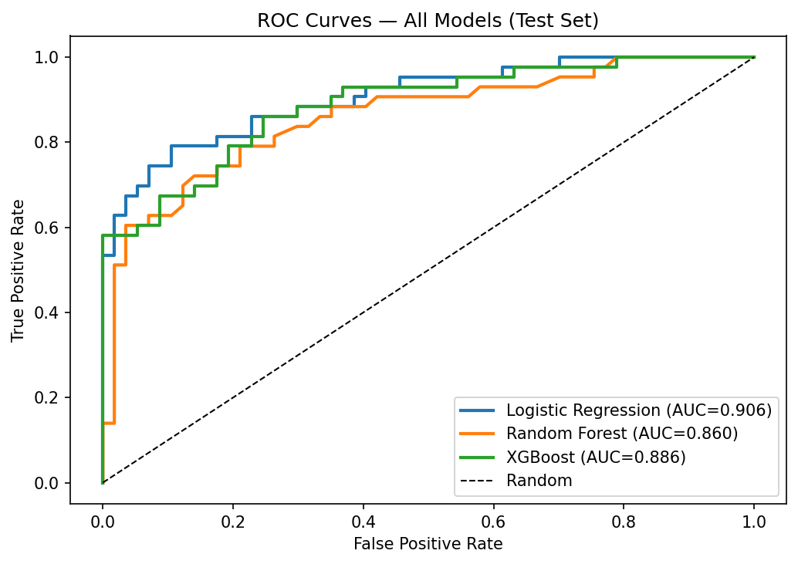

7. Per-Model Evaluation Charts (Test Set)
Confusion matrix, ROC curve, and Precision-Recall curve for each model. All charts use the held-out test set.

7.1. Logistic Regression
Confusion Matrix:
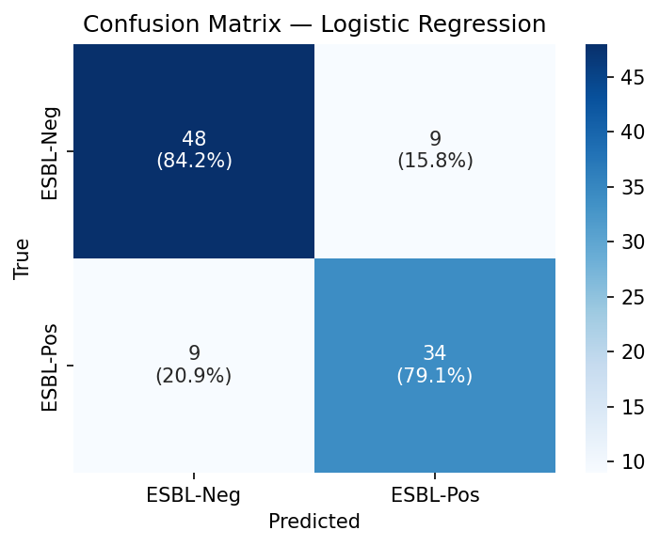
ROC Curve:
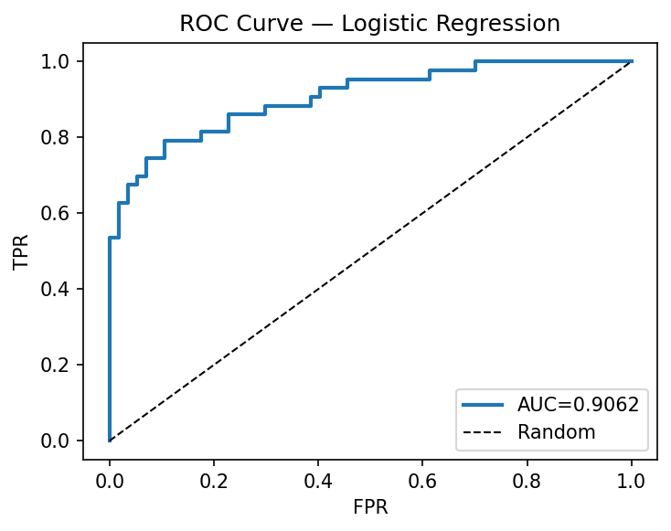
Precision-Recall Curve:
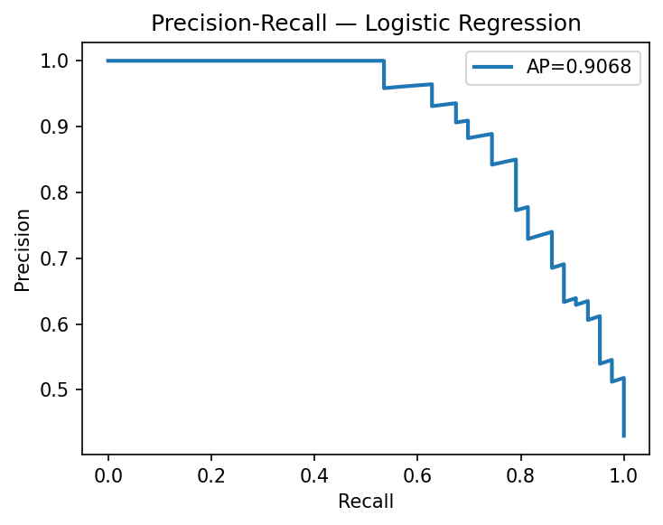

7.2. Random Forest
Confusion Matrix:
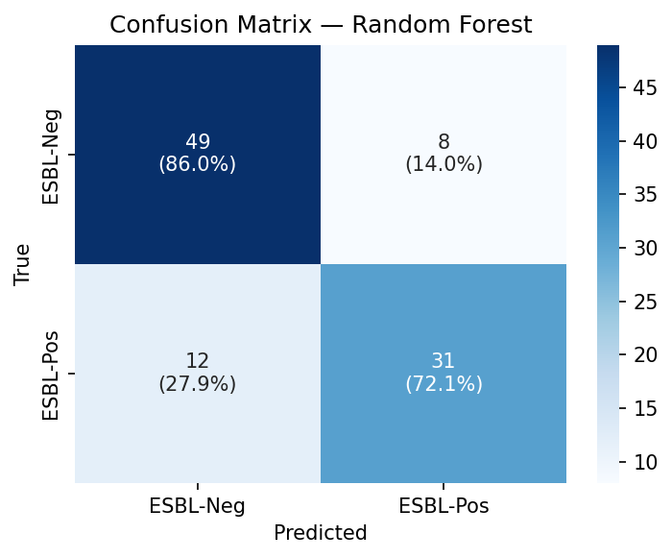
ROC Curve:
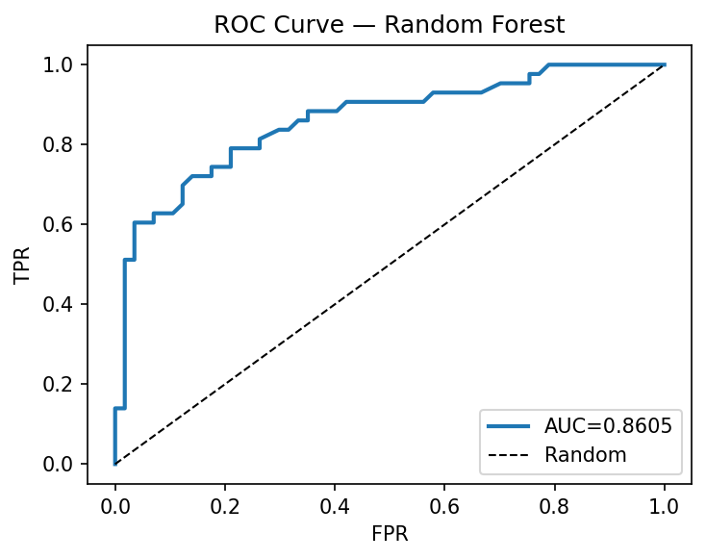
Precision-Recall Curve:
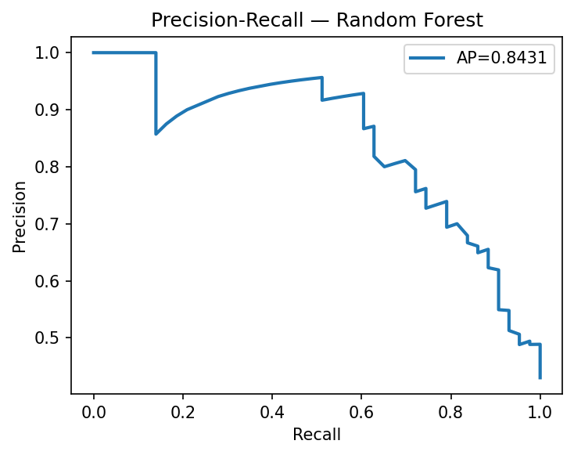

7.3. XGBoost
Confusion Matrix:
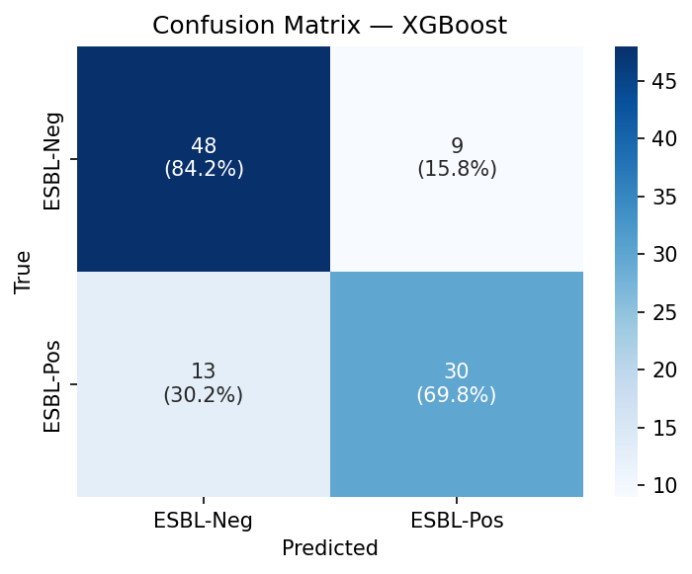
ROC Curve:
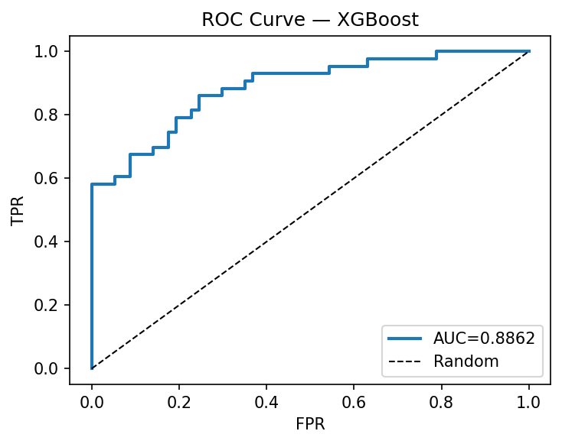
Precision-Recall Curve:
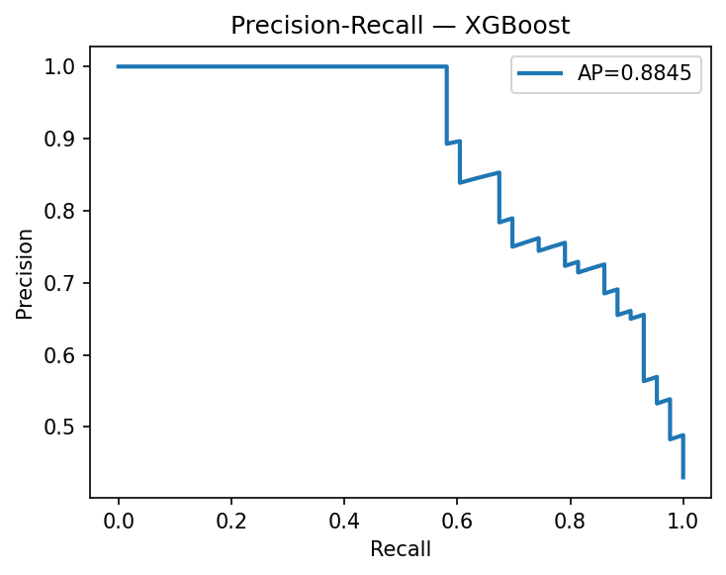

8. Feature Importance — Logistic Regression (Best Model)
Importance is derived from absolute coefficient magnitudes (Logistic Regression). Direction indicates whether the feature increases (+) or decreases (-) the predicted ESBL risk.
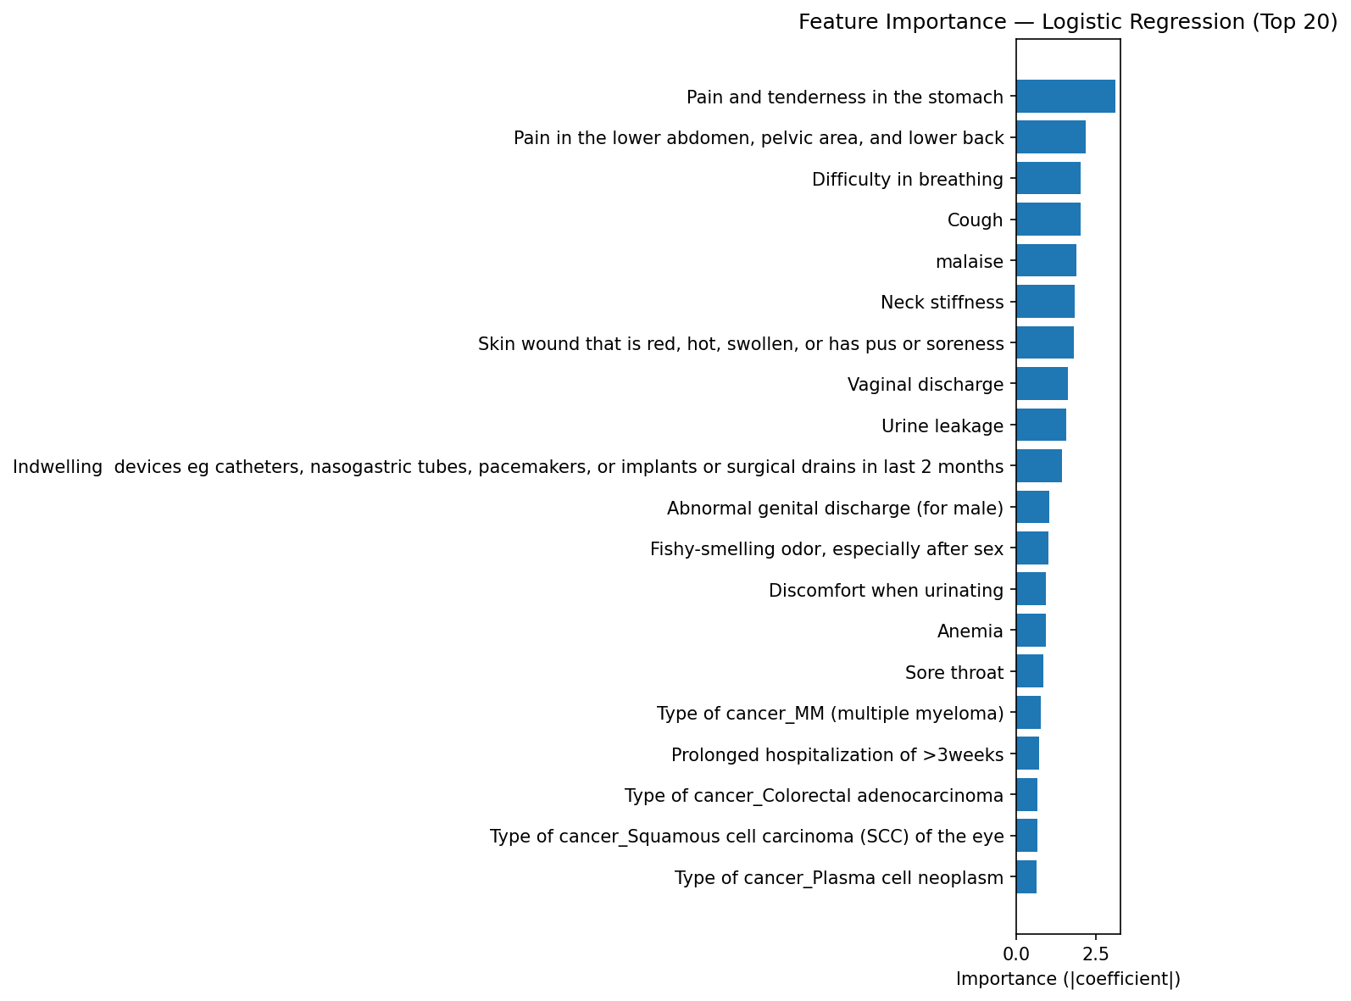
Top 10 Most Important Features:
Rank | Feature | Importance | Direction | Magnitude
1 | Pain and tenderness in the stomach | 3.107307 | positive | high
2 | Pain in the lower abdomen, pelvic area, and lower back | 2.170432 | positive | high
3 | Difficulty in breathing | 2.014378 | positive | high
4 | Cough | 2.002662 | positive | medium
5 | malaise | 1.873356 | positive | medium
6 | Neck stiffness | 1.837106 | positive | medium
7 | Skin wound that is red, hot, swollen, or has pus or soreness | 1.790381 | positive | medium
8 | Vaginal discharge | 1.600416 | positive | low
9 | Urine leakage | 1.546333 | positive | low
10 | Indwelling devices eg catheters, nasogastric tubes, pacemakers, or implants or surgical drains in last 2 months | 1.425350 | positive | low

9. Clinical Interpretation
Best model: Logistic Regression
Test AUROC: 0.9062 | Test Accuracy: 82.0% | Test F1: 82.0%

What the AUROC means clinically
An AUROC of 0.9062 means that if a clinician randomly selected one ESBL-positive and one ESBL-negative patient from this cohort, the model would rank the ESBL-positive patient higher approximately 90.6% of the time.

Classification threshold
The model outputs a probability score (0–100%). The default threshold is 50% — patients with a predicted probability ≥50% are classified as High Risk. This threshold can be adjusted depending on whether higher sensitivity (fewer missed cases) or higher specificity (fewer false alarms) is preferred.

Limitations
- The model was trained on a single-institution dataset (MRRH). Performance may differ at other sites.
- Only 660 of 1,569 patients had confirmed culture results and were used for training.
- Post-culture features (antibiogram, isolate species, specimen type) were excluded to ensure the model is applicable at the point of empirical treatment decision.
- This tool is a decision-support aid and does not replace clinical judgement. All predictions must be interpreted by qualified healthcare professionals.

ESBL-PE Predictor | Mbarara Regional Referral Hospital, Uganda

