Phillip Kimbrel

CA’s are very important as they are the way to insure and verify individuals and websites. Without this the protection of data like card numbers, passwords and personal information would not be protected via encryption and stay private. Not only will the encryption protect for personal identity from being released it will also protect from cyber attacks via the same encryption.

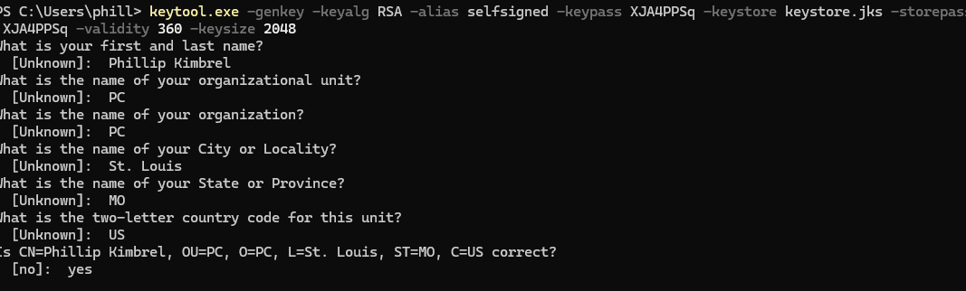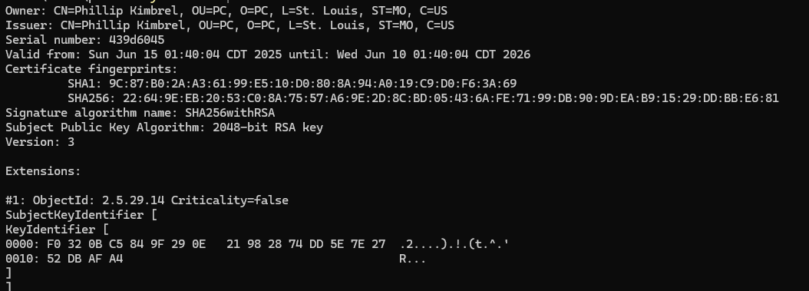

**References**

Administrator, S. D. (2023, January 13). *What Is a Certificate Authority (CA)?* SSL Dragon. https://www.ssldragon.com/blog/certificate-authority/

Coclin, D. (2021, June 26). *What Is a Certificate Authority? | CA’s Explained | DigiCert*. Www.digicert.com. https://www.digicert.com/blog/what-is-a-certificate-authority