INTRODUCTION TO REPORTS
(SO 1, AC 1) IDENTIFIED FOR SELECTION
(SO 1,AC 2) INFO OF THE ORG ARE LINKED TO THE PURPOSE OF EACH IDENTIFIED REPORT
(SO 1, AC 3) TEMPLATE IS DRAWN UP FOR EARCH REPORT IN A CO SPECIFIC FORMAT INCL MANDATORY CONTENT HEADINGS
(SO 1, AC 4) TABLE IS CREATED LISTING EACH REPORT, PURPOSE THE REGULAR RECIPIENTS AND FREQUENCY OF DISTRIBTION
(SO3, AC2) TEMPLATES ARE USED TO WRITE THE REPORT AND ANY NECESSARY MODIFICATIONS MADE AND NOTES TO E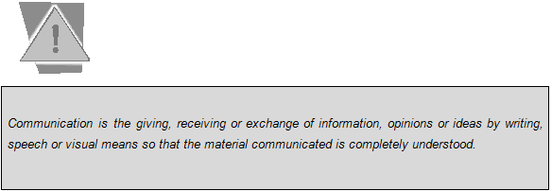NSURE COMPLIANCE WITH BUSINESS REQUIREMENTS
A REPORT CAN BE WRITTEN ON:
The results of a marketing campaign
The progress in any department
Quality control on a new product
Even on a assessment of staff members
Reasons for report writing
- To enable us a keep records
- To inform all interested SA
- To tell about failures and successes
- To communicate to others eg. Managers , funders shareholders
- To ourselves , to keep on knowing what we are doing
- So other people can be encourage to do their own projects/job/task
- So other people can learn what we did
Reports deliver:
*facts
Assessment of situation
Recommendations.2 REGULAR BUSINESS REPORTS (SO 1, AC 1)
The following are the common reports in the business environment (this list is not exhaustive).
- Progress reports;
- Recommendation justification report
- Trip reports; and
- Meeting reports.
- Incident report
- Performance report

1.2.1 PROGRESS REPORTS
A progress report refers to any routine progress report: monthly, bimonthly, quarterly, biannual or annual. This type of a report is different from a situation report (sitrep) in that a sitrep merely states what has happened and what was done about it during the reporting period. A progress report, in contrast, relates activities to objectives or results.
A good progress report is not merely a descriptive activity report, but must analyse the results of those reported activities. The analysis should answer the question, "How far have the object Format of a progress report
A progress report must include the following headings
1. Background
2. Activities completed
- Final against plan (data)
- Learning to be shared
3. Activities in process
- Status against plan (data)
- Issues/concerns
- Recommendations/implications/conclusions
4. General progress of activities (apprais
ves been reached.

