Client: Altrascape cc

Your chosen package is the Unlimited VoIP Line Premium, which includes number porting.

Pricing Details:
- Monthly service fee: R345
- One-time number porting fee: R150

Switch Telecom Unlimited VoIP Packages
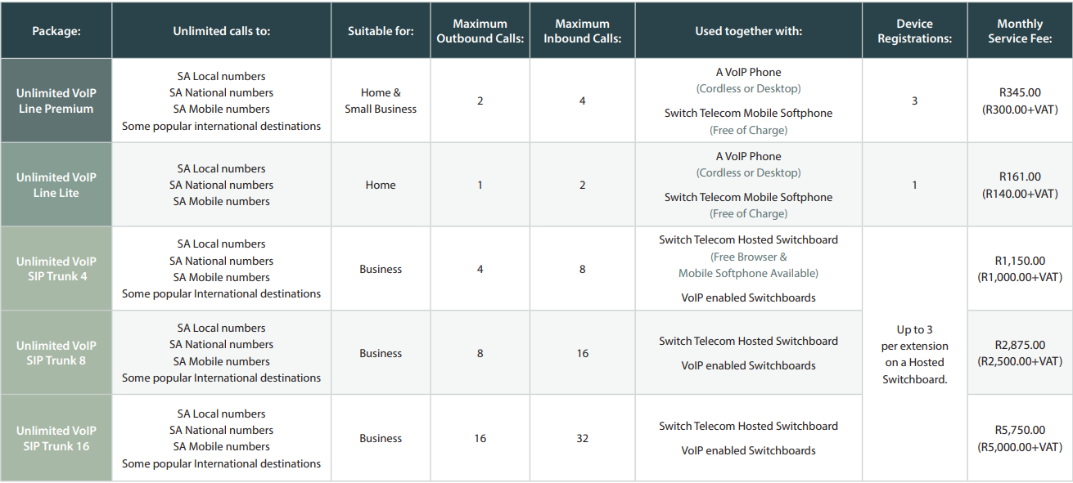

VoIP Phones

Own Phones
If you already own VoIP-compatible phones, simply send an image of the MAC address and serial number for each device to get them set up.

New Phones
Below are phone recommendations based on your business needs and preferences, with a catalogue of all phones and accessories. Should you wish to buy new phones, send us the name of the phone(s) you would like to order.

Device Recommendations
Entry-Level Phone | 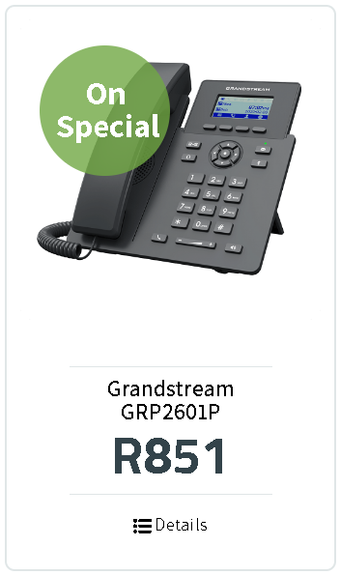 | - 4 XML programmable context-sensitive soft keys, 5 (navigation, menu) keys.  - 5-way voice conferencing to maximize productivity.  - Dual 10/100Mbit/s ethernet with PoE.  - Power supply included.  - 132 x 48 (2.21’’) LCD display.
Colour Phone with More Features | 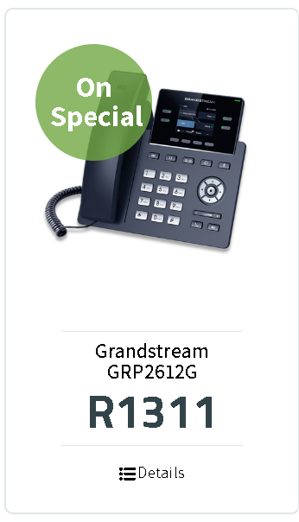 | - 4 line keys with up to 2 SIP accounts.  - 4 XML programmable context-sensitive softkeys.  - 5 navigation/menu keys, 9 dedicated function  - Pickup, Bridged-line-appearance (BLA), Downloadable Phonebook (XML, LDAP, up to 2000 items)  - 2.4″ colour LCD screen.  - Dual switched Gigabit ethernet ports with integrated PoE  - Digital BLF and Speed Dial keys, 4 programmable soft keys.  - Support of up to 16 VPKs (4 pages).  - 1000 contact phonebook.  - Power supply included.
Wireless Phone for Mobility | 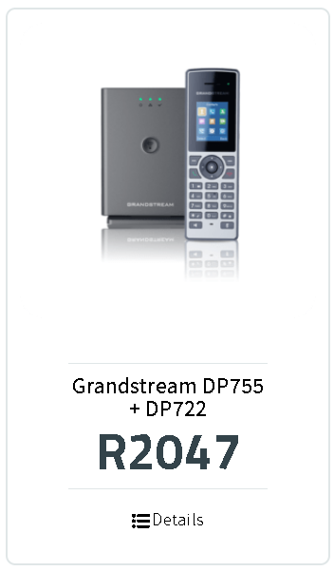 | - Up to ten DP722 handsets supported on each DP755 base station.  - 1.8 inch (128×160) colour LCD with 2 programmable soft keys.  - 20 hours talk time and 250 hours standby time.  - Supports up to 20 SIP accounts and 20 lines per handset as well as 3-way conferencing.  - HD audio on the speakerphone, handset, and headset jack.  - The range is dependent on construction.

Phones & Accessories
