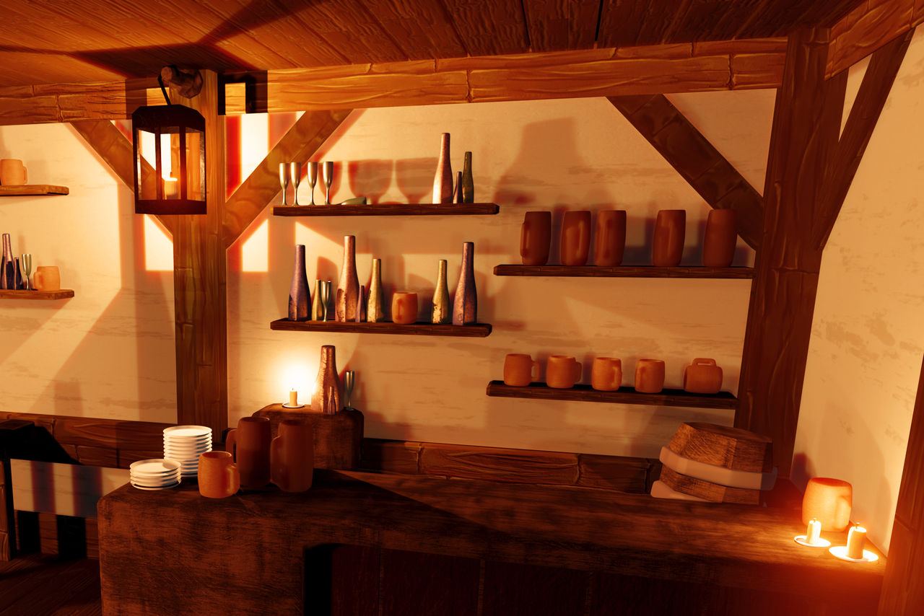
Image Source: Low poly fantasy tavern by Bernevega on DeviantArt
There are multiple shapes in this scene. The table can be constructed using a box, and so can the beams. The beams will require multiple boxes to recreate the supports. The candles can be recreated with cylinders, the wick can be a box, and the plates can be created using planes. The bottles can be created with cylinders for the body and spheres for the neck. The shelves will require boxes to create, and the cups can be created with cylinders. The wine glasses can be created with planes as the base, cylinders for the handle, and spheres or maybe a cone for the cup.

