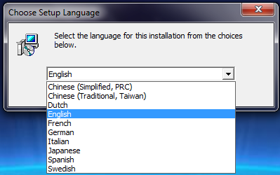

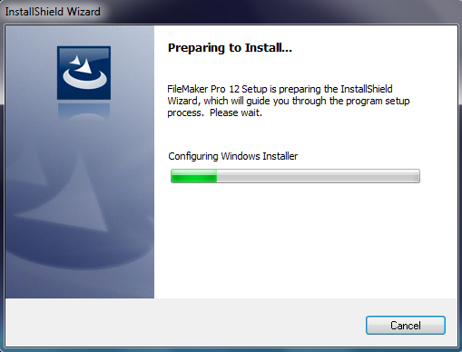

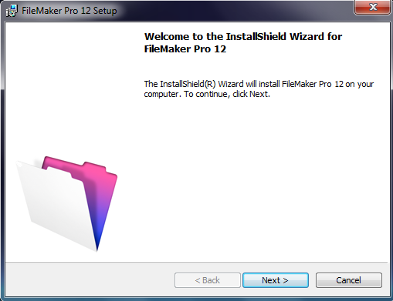

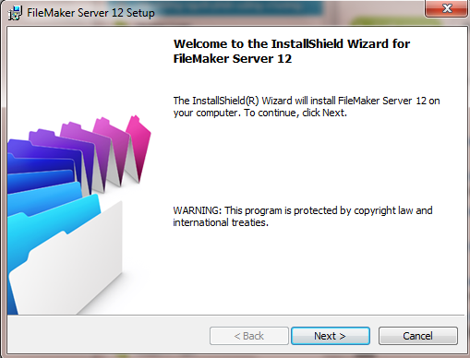

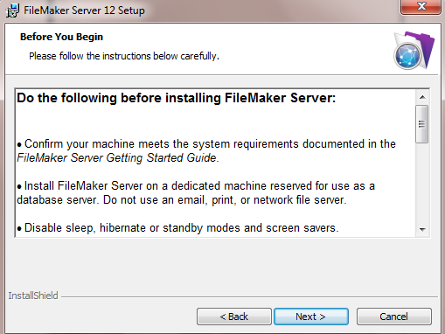

[**Do the following before installing FileMaker Server:**

• Confirm your machine meets the system requirements documented in the *FileMaker Server Getting Started Guide*.

• Install FileMaker Server on a dedicated machine reserved for use as a database server. Do not use an email, print, or network file server.

• Disable sleep, hibernate or standby modes and screen savers.

• Open the ports required by FileMaker Server if your server machine has a firewall.

• Locate your license key.

• Quit FileMaker Pro if it is running on the same machine.

• Make sure the web server is enabled if you want to use web publishing.

•  If FileMaker Server is already installed on this machine, note or save your existing settings, stop FileMaker Server, back up any database files, shell script files, and plug-ins, and then uninstall. You cannot run two different versions of FileMaker Server on the same machine at the same time.

• For a multiple-machine deployment, install FileMaker Server on worker machines first, then the master machine.

For more information, see the *FileMaker Server Getting Started Guide*.

