FIRST THOUGHT  
ABOUT LICENSE ACTIVALTION MODEL



Nov 09, 2012

PREFACE

License module of software is a little bit complicated part. So, I think we should have something to come to an agreement about this module. The following contents just are my thought about how to implement license module basically in our product. It will be updated in the near future, absolutely. So, I hope to receive your feedback to comprehensive it as much as possible.

INSTALLATION WIZARD

The internet is required to perform installation wizard.

Setup – Product XXX

-

X

**License Agreement**  
 Please read the following important information before continuing [Icon]

Please read the following License Agreement. You must accept the items of this agreement before   
 continuing with the installation

I accept the agreement  
 I do not accept the agreement

Content here

Back

Next

Cancel

Figure 1 – End User License Agreement.

Setup – Product XXX

-

X

**License Activation**  
 Choose License Type [Icon]

Provide a serial number.

Your serial number is sent at the time of purchase.

Install this product as a trial.  
 You will be able to enter a serial number after installation

License expires on: 22.12.2012 11:00:00

Additional licenses may be purchased at: http://abc.com

Back

Next

Cancel

Figure 2 – License type selections.

**If user selects the secondary option (Install this product as trial)**

The installation process will be proceeding normally.  
Get the MAC address of computer (unique). Then send this address information to server. At server-side, it will mark this MAC address has been started the Trial version which includes date-time together.

Notify user to know that they can’t proceed because of expired trial.

Continue the installation

Get the remaining day(s) for trial.

Prevent re-install when expired

Trial expired

Connect to Server

DB

Trial version selected

Get MAC address

Unique computer

**Server side processing**

False

True

First Installation

Cancel installation wizard

F T

True

Add a new record

T F

False

Installed

Machine

Marked this computer installed trial

03.07.2012

01:2f:00…

00:1f:00…

22.12.2012

Full 30 days trial

Figure 3 – Trial model

**If user selects License key activation**

Continue installing

Enter license   
key

True

Notify invalid license

Is empty

True

False

False

Verify result

Notify to user know this license can applied only in 1 computer.

Notify to user know this license wasn’t purchased.

Get MAC address

Verify result from  
 server (encrypt)

License key +   
MAC address

Verify right license.

False

True

False

Get information about this license  
. User information.  
. License type  
…..

Send email to Administrator

Check license  
 purchased.

True

Check license  
expired

DB

True

False

Get license type   
(Use hash function)

True

License key +   
MAC address

Is this license   
 activated?

Is Single User,  
Single Computer

True

False

False

Need to think more

Figure 4 – License key activation

Note:

We are going to apply Hash table, encrypt/decrypt algorithm (SHA-256, AES, SALT…) with the intent of security (data transfer between application and server). So, all data send/receive will be encrypted as well. The license key contains itself information about end-user who purchased, identifiable code (MAC address), license type…To get these information, put license-key as key in a hash table.

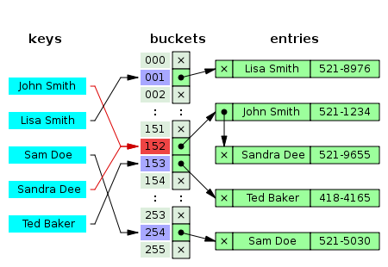

Figure 5 – Hash table example

APPENDIX

This trial version of product XXX will expire in 20 days   
Click “Buy” to upgrade to a full version of product XXX

[Icon]

Learn

Try

Buy