USA WEIGHTLIFTING’S

SPORTS PERFORMANCE AND CLUB
COACH CERTIFICATION COURSES

FEBRUARY 7 & 8, 2009
9AM TO 6PM SATURDAY THE 7TH & 9AM TO 3PM THE 8TH

AT EMERSON PERSONAL TRAINING

3401 PIEDMONT AVENUE, OAKLAND, CA, 94611
INSTRUCTOR: JIM SCHMITZ
US OLYMPIC TEAM WEIGHTLIFTING COACH 1980, 88, & 92
USA WEIGHTLIFTING PRESIDENT 1988-96
ASSISTANT COACH: BUTCH CURRY, 1980 OLYMPIAN & PWA PRESIDENT
You enroll by going to USA Weightlifting’s website: www.weightlifting.usoc.org and
click on Coaching Course Calendar and Registration
FOR DETAILED INFORMATION CONTACT JIM SCHMITZ AT:
415 595 8067 or jimschmitz@mac.com
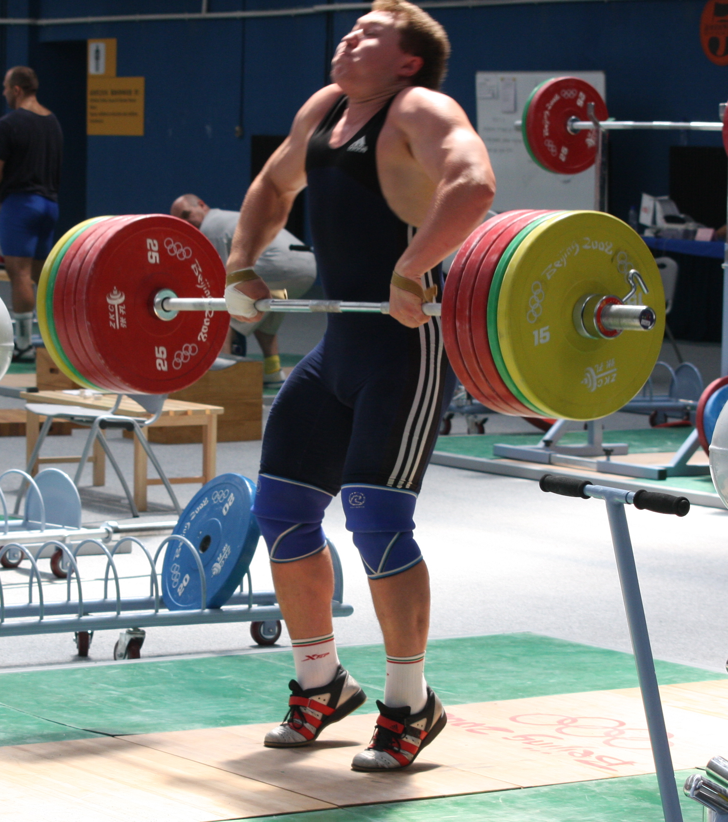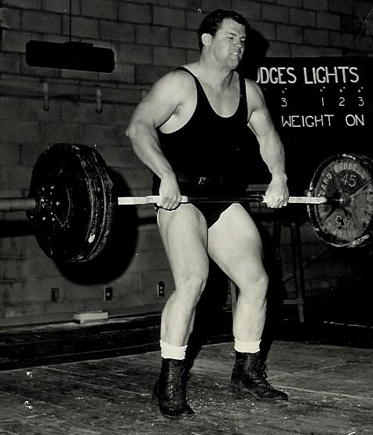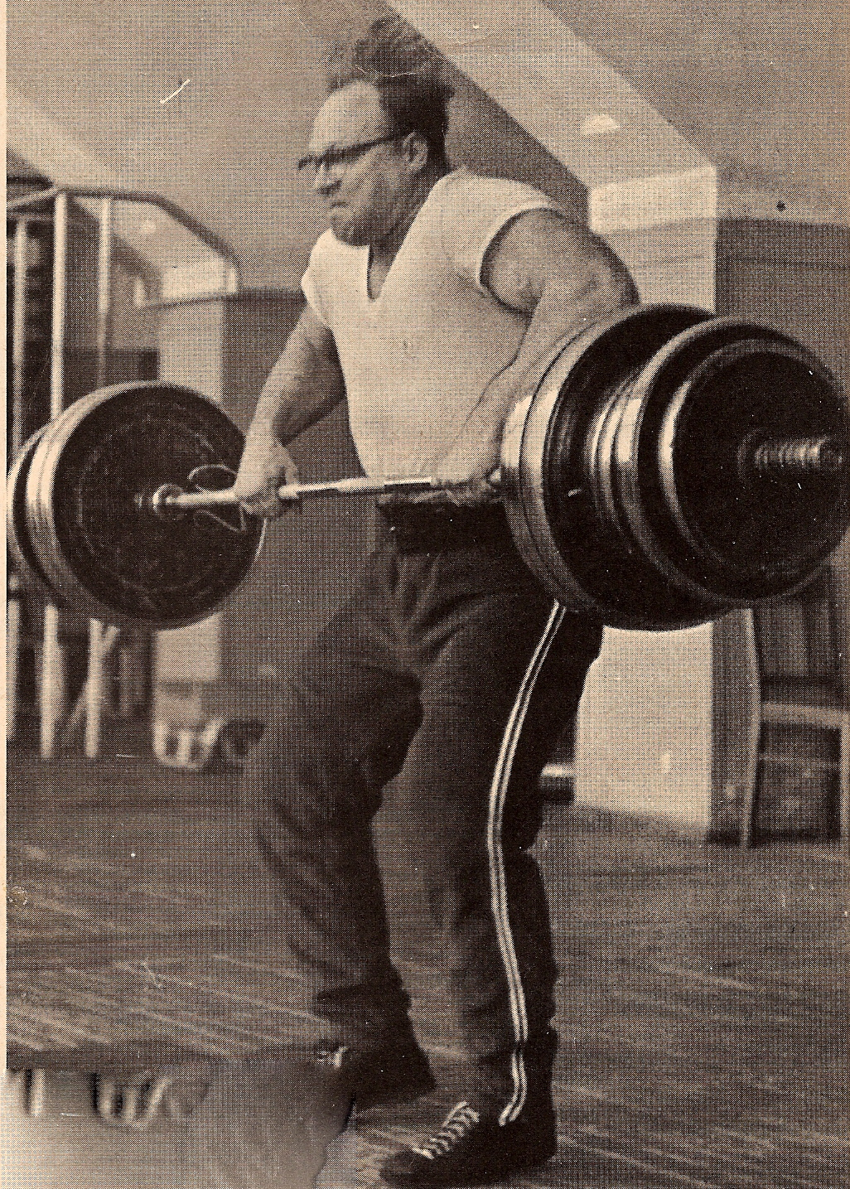
Andrei Aramnau Jim Schmitz Norbert Schemanski
2008 Olympic Champ 1988 Olympic Coach 1948 Olympic Champ

THE SPORTS PERFORMANCE CERTIFICATION COURSE focuses on the utilization and application of the Olympic Lifts, the SNATCH and the CLEAN & JERK and their assistance exercises to the area of sport specific training, power development, and injury prevention.
THE CLUB COACH CERTIFICATION COURSE also focuses on the SNATCH and the CLEAN & JERK and their assistance exercises for sport and developing weightlifters for competition and how to form a club.

THE SPORTS PERFORMANCE AND CLUB COACH COURSES ARE VERY SIMILAR AND WILL BE TAUGHT TOGETHER EXCEPT WHERE THE COURSES DIFFER. REMEMBER WHEN ENROLLING BE SURE TO ENROLL IN THE COURSE YOU WANT, SPORT PERFORMANCE OR CLUB COACH!

