Week 10 Assignment - Comprehensive Project Plan

Phillip Gross
Professor: Mark Cohen
Course: CIS599
March 14, 2026

Executive Summary
TrailForge Gear, Inc. is a venture funded directly by a consumer ecommerce startup that currently generates approximately $5 million in annual revenue and is targeting $30 million within two years. The company’s technology challenge is that no production ready network, enterprise identity, secure commerce platform, or implementation roadmap exists for the new facility. This comprehensive project plan recommends a hybrid, SaaS first technology strategy that delivers secure digital commerce, scalable operations, and disciplined project governance without overinvesting in on premises infrastructure.
The recommended solution combines hosted e-commerce and business applications with a right sized in office network and security footprint. Core value comes from five outcomes: faster time to launch, lower operating complexity, stronger security and compliance, better customer experience, and a platform that can support headcount growth from 10 to 30 employees. The first-year implementation cost is estimated at $93,000 including hardware, software, labor, and contingency. That investment is reasonable when compared with the business objective of supporting a six-fold increase in revenue and the broader growth in U.S. ecommerce activity. The U.S. Census Bureau reported that ecommerce sales in 2025 were estimated at $1.2337 trillion and accounted for 16.4 percent of total retail sales, reinforcing the scale of the market opportunity.
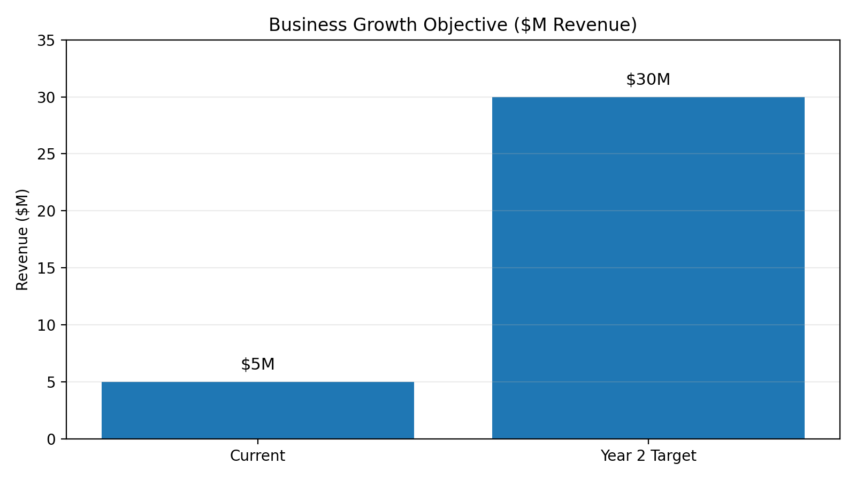
Figure 1. TrailForge revenue objective from current state to year two target.

1. Business Context and Strategic Need
TrailForge sells premium outdoor gear and accessories through a branded ecommerce experience. Its growth strategy depends on a reliable storefront, trusted payment experience, responsive customer support, and enough operational visibility to scale without losing control of cost or service quality. The move to a new two-story facility creates a forcing function: the company must establish not only office connectivity, but also a secure platform for order support, returns, analytics, and cross-functional collaboration.
In practical terms, the business problem is not merely buying hardware. The problem is that the company currently lacks a technology operating model that is mature enough to support scale. Without defined architecture, implementation plan, and governance model, growth would create fragility: more downtime risk, slower onboarding, fragmented data, and weak security controls. Investors therefore need to evaluate the project as business infrastructure, not just an IT purchase.

2. Project Goals, Objectives, Scope, and Control Measures
The project’s primary goal is to implement a secure, scalable, and supportable information systems environment that enables TrailForge to operate from its new facility while accelerating growth. The solution must support digital sales, order processing, customer support, collaboration, analytics, and basic warehouse and returns activities.
Project scope includes network equipment, endpoint devices, core software subscriptions, support tooling, logical and physical designs, a bill of materials, and an implementation roadmap. Scope excludes custom software development, a full warehouse management system, and any direct storage of payment card data. These boundaries keep the project aligned to investor priorities: fast execution, controlled spending, and a low complexity operating model.
Control measures include requirements and design sign offs, documented change control, stage gate approvals between design, procurement, installation, and go live, and success criteria tied to connectivity, security, and operational readiness. This governance model is especially important for a startup because resources are limited and scope creep is expensive.

2.1 Objectives and Control Highlights
- Deploy a production ready facility network with secure Internet access, wireless coverage, segmented LANs, and protected administrative access.
- Implement hosted business platforms for ecommerce, payment processing, customer support, collaboration, identity, and analytics.
- Enable baseline security controls including multi factor authentication, endpoint protection, centralized logging, backups, and documented incident response.
- Create a repeatable implementation plan that covers engineering, furnishing, installation, validation, and hypercare.
- Use stage gate approvals and formal change control to keep the project aligned to schedule and budget.

3. Recommended Technology Solution
The recommended solution is a hybrid, SaaS first operating model. Customer facing commerce, payment processing, customer support, collaboration, and analytics are delivered through hosted platforms. On site technology is limited to what the business truly needs in the facility: a secured network closet, firewall and switching, wireless access points, printers, cameras, workstations, and a small amount of edge security and monitoring.
This choice balances speed and control. Hosted services reduce implementation time, minimize patching effort, and provide elastic capacity during promotions. A right sized office network gives TrailForge the secure connectivity, segmentation, and physical control needed for staff operations. The design also preserves future flexibility because the company can add access points, devices, and support seats as headcount grows without redesigning the entire environment.
Security is built into the solution rather than added after the fact. The plan aligns governance and lifecycle controls to the NIST Cybersecurity Framework 2.0, which emphasizes Govern, Identify, Protect, Detect, Respond, and Recover as a full risk management cycle. Payment handling is intentionally outsourced to a hosted processor, so TrailForge avoids storing cardholder data directly. This does not eliminate responsibility, but it meaningfully reduces scope and supports alignment to PCI DSS requirements for protecting payment account data.
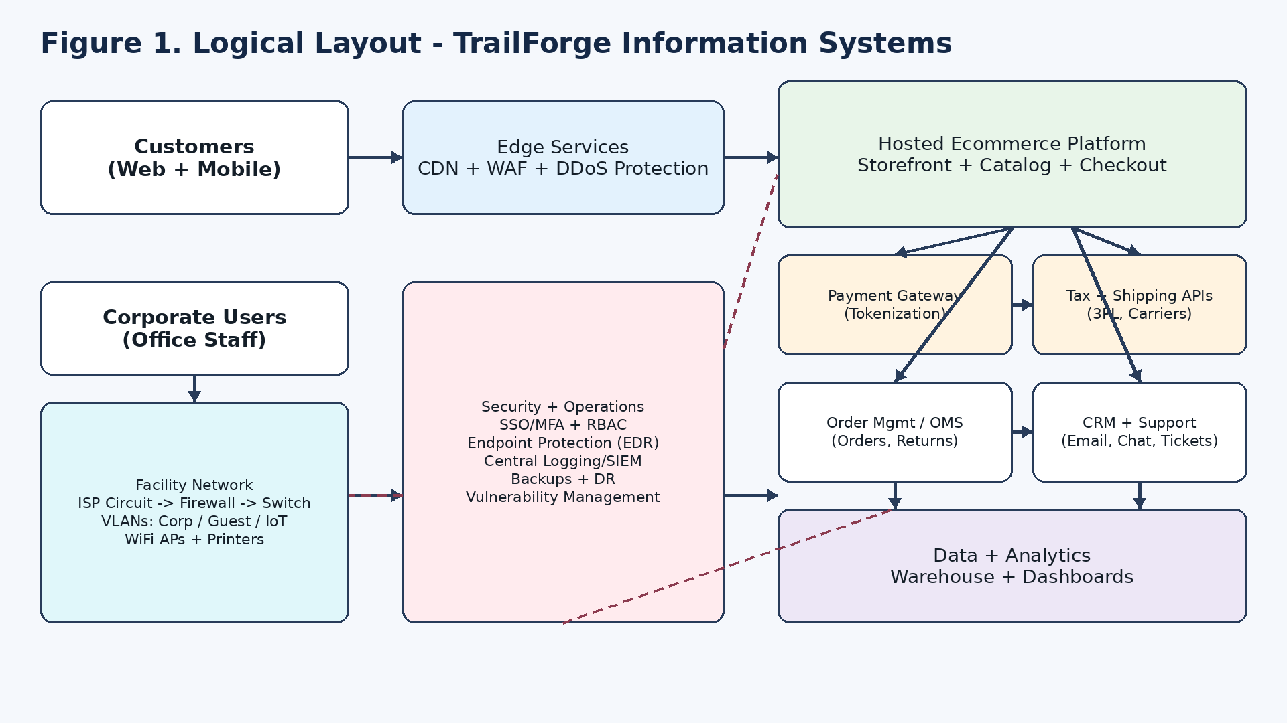
Figure 2. Logical view of the proposed TrailForge operating environment.

4. Why the Solution Creates Competitive Advantage
The value of the proposed solution is that information technology becomes a revenue enabler and a risk reducer at the same time. TrailForge’s competitive advantage depends on delivering consistent customer experience, handling demand spikes without outages, supporting returns and service efficiently, and making decisions faster than competitors with less visibility.
The solution improves competitive position in four specific ways. First, a hosted ecommerce stack with payment and shipping integrations shortens time to market and supports marketing surges without large capital investment. Second, standardized identity, endpoint, and logging controls reduce operational noise so a small team can manage the environment efficiently. Third, analytics and dashboards support better decisions on conversion, returns, product performance, and support demand, giving leadership better control over margin and customer experience. Fourth, the in-office network and endpoint standards create a stable operational backbone for support, finance, and administration, which is critical when a company scales faster than its process maturity.
In investor terms, the project protects upside while controlling downside. It supports revenue growth through speed, customer trust, and scalability, while containing risk through governance, standardization, and low first year spend.

5. Implementation Roadmap and Project Controls
The plan follows the phased structure developed through the course deliverables: initiation and governance, procurement and vendor setup, requirements analysis, solution design, build and configuration, security and compliance, testing and training, go live and hypercare, and closeout. This sequence creates discipline and provides natural control points for executive review.
The most important project controls are requirements and design sign off before procurement and configuration work begins, a documented bill of materials and system implementation plan before installation, security validation, and operational readiness checks before going live, formal change control for scope, budget, and timeline changes, and hypercare monitoring immediately after launch.
The Week 8 implementation plan provides the engineering, furnishing, and installation details behind these controls. Work is intentionally sequenced so critical path items such as ISP readiness, rack and network installation, and security configuration are validated before users fully cut over. That staged approach lowers execution risk and avoids the common startup mistake of trying to turn everything on at once.

5.1 Final Delivery Sequence
- Finalize and approve scope, requirements, and solution design.
- Complete bill of materials and implementation planning.
- Procure and receive hardware, software, and services.
- Install rack, network, wireless, and endpoint environment.
- Complete validation, security checks, training, go live, and hypercare.

6. Rough Cost Estimate for the Entire Project
The cost estimate below is derived from the bill of materials created in Week 8 deliverable and a reasonable labor assumption for a small office implementation. Hardware includes networking, rack and cabling, user devices, and printing and shipping equipment. Software reflects first year subscription costs for productivity, identity, security, and support tooling. Labor reflects planning, engineering, procurement coordination, installation oversight, endpoint deployment, validation, and hypercare.
The rough first year project total is approximately $93,333. This estimate is intentionally conservative. It assumes commercial grade equipment, standard subscriptions, and a modest labor model without custom software development. For an organization pursuing rapid revenue growth from $5 million to $30 million, the cost is proportionate to the business objective and low relative to the downside risk of operating without a mature platform.
The estimate also supports financial flexibility. Most of the cost is one time labor and hardware necessary to establish the environment. Recurring software spend is comparatively small and scales with headcount. That means TrailForge can grow users and support capacity over time without a step function increase in capital cost.
Cost Category | Estimate | Notes
Hardware and physical equipment | $28,188 | Network and security gear, rack and cabling, endpoints, printers, shipping equipment
Software and subscriptions (Year 1) | $4,859 | Productivity, identity and security, password management, ticketing
Labor | $51,800 | Project leadership, engineering, installation oversight, training, hypercare
Contingency reserve | $8,486 | Approximately 10 percent of subtotal
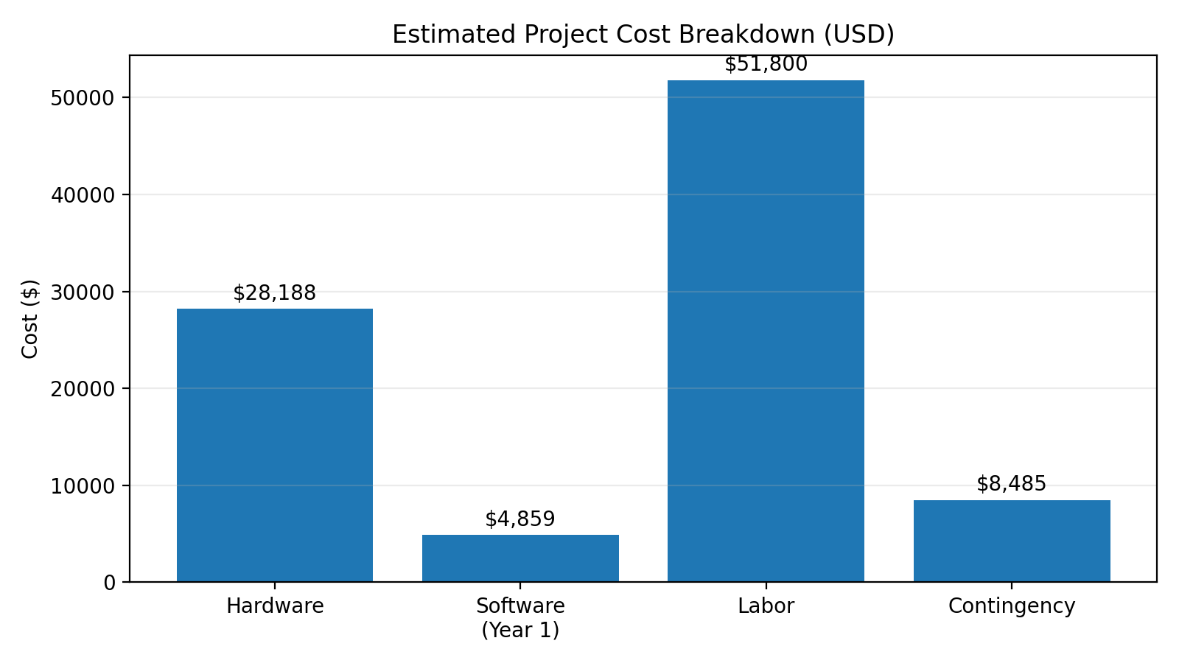
Figure 3. Estimated first year project cost breakdown.

7. Major Risks and Mitigation Strategy
No project of this type is risk free, but the major risks are identifiable and manageable. The largest risks are vendor lead times, ISP activation delays, misconfigurations during rollout, and user adoption issues. These risks are mitigated through early procurement, staged configuration and testing, change control, and phased end user enablement.
Vendor and delivery risk is mitigated through early ordering, approved alternates, and staged receiving. Connectivity risk is mitigated through ISP scheduling, validation before move day, and temporary failover options. Security risk is mitigated through MFA, least privilege access, logging, endpoint protection, and no storage of cardholder data. Adoption risk is mitigated through quick start training, support documentation, and hypercare support after launch.
These mitigations matter because early-stage companies rarely fail from one large design flaw; they usually fail from a series of small execution errors. The control model in this plan is designed specifically to prevent avoidable mistakes.
- Vendor and delivery risk: early ordering, approved alternates, staged receiving.
- Connectivity risk: ISP scheduling, pre move validation, temporary failover option.
- Security risk: MFA, least privilege, logging, endpoint protection, no cardholder data storage.
- Adoption risk: role-based onboarding, quick start guides, hypercare support.

8. Success Measures and Investor Decision Criteria
Investors should evaluate approval against measurable outcomes rather than only technical completion. The project should be considered successful if it achieves secure Internet and LAN connectivity across the facility, complete staff onboarding to the new environment, reliable hosted commerce and support tool access, documented backups and security controls, and stable operations through the initial hypercare period.
At the business level, the more important measure is whether TrailForge gains a stronger growth platform. That means the technological environment should improve the company’s ability to process orders, support customers, manage returns, and make decisions from shared data. Those outcomes directly support revenue growth, brand trust, and investor confidence.

9. Investor Recommendation
The recommended project should be approved and funded because it delivers a practical technology foundation that is aligned with TrailForge’s growth objective and risk tolerance. The solution is intentionally not overengineered. It emphasizes standard platforms, contained first year cost, and execution discipline while still giving the company the capabilities it needs to scale.
Approval should authorize three things: the proposed architecture, the rough first year technology budget, and execution of the final implementation schedule. With those decisions in place, TrailForge can move from planning to controlled execution and be positioned to support stronger revenue growth, better customer experience, and more resilient operations.

Source List
- National Institute of Standards and Technology. (2024). The NIST Cybersecurity Framework (CSF) 2.0. U.S. Department of Commerce.
- PCI Security Standards Council. (2024). PCI Data Security Standard (PCI DSS) v4.0.1. PCI Security Standards Council.
- U.S. Census Bureau. (2026). Quarterly retail e-commerce sales report, fourth quarter 2025 and full year 2025. U.S. Department of Commerce.

