New Perspectives Microsoft Office 365 & Access 2019 Comprehensive
Appendix A
Answers to Review Assignments
1. Relation, tuple, and attribute, respectively; record and field
2. A domain is a set of values from which one or more columns (fields) draw their actual values.
3. An entity is a person, place, object, event, or idea for which you want to store and process data.
4. If one or more fields, or collections of fields, can serve as the primary key for a table, each is called a candidate key. Only one candidate key is chosen to be the primary key for the table.
5. A composite key is a primary key that consists of two or more fields.
6. A foreign key is a field, or a collection of fields, in one table in which each column value must match the value of the primary key of some table or must be null.
7. Various solutions are possible. An example of a one-to-one relationship is an employee that can have only one email address. An example of a one-to-many relationship is one employee that can have more than one office (offices at two or more locations of the company). A n example of a many-to-many relationship is many employees can work many shifts (more than one employee working the same shift, and more than one shift available).
8. You use an entity subtype when a table has fields that could have null values.
9. The entity integrity constraint requires that the primary key cannot be null. For a composite key, none of the individual fields can be null.
10. Referential integrity is the constraint specifying that each nonnull foreign key must match a primary key value in the primary table.
11. For the cascades option, changing a primary key value also changes the matching foreign key values to the new primary key value and deleting a primary key value also deletes the matching foreign-key rows.
12. A partial dependency is a functional dependency on part of the primary key, instead of the entire primary key. A transitive dependency is a functional dependency between two nonkey fields, which are both dependent on a third field.
13. An insertion anomaly occurs when you cannot add a row to a table because you do not know the entire primary key value. A deletion anomaly occurs when you delete data from a table and unintentionally lose other critical data. An update anomaly occurs when you change one field value and either the DBMS must make more than one change to the database or else the database ends up containing inconsistent data.
14. Insertion anomaly: You cannot add a new record to the table without knowing both values of the EmployeeID and PositionID fields. If only the EmployeeID value is known, along with the name of the employee, you cannot leave the PositionID blank (null). Doing so violates entity integrity.
Deletion anomaly: Deleting record 2817 from the table, because the employee is no longer employed with the company, would remove the only instance of HealthPlan 2. You would then have no knowledge that HealthPlan 2 is the 90/10 plan.
Update anomaly: If you were to change the LastName, HealthPlan, or PlanDesc fields for either EmployeeID 3480 or 5128, you would have to modify multiple records in the table. Failure to successfully update all appropriate tables would result in inconsistent data.
15. In the Personnel table, the second row’s null TitleID field value violates entity integrity, because none of the fields of a composite key can be null. In the Personnel table, the next to the last row's FacultyNum value 5815 violates referential integrity, because this field is a foreign key but does not match a primary key value for the FacultyNum field in the Faculty table.
16. The table does not contain repeating groups, so it is in 1NF. Because the primary key, the StudentID field, is not a composite key, the table is in 2NF. However, it has transitive dependencies, so the table is not in 3NF. The 3NF version of the table is:
Tutor (TutorID, TutorName)
Session (SessionID, SessionDay, SessionTime, TutorID)
Foreign key: TutorID to Tutor table
Student (StudentID, StudentName, StudentPhone, StudentEmail, SessionID)
Foreign key: SessionID to Session table
17. Leave the StudentID column value blank (null) to violate entity integrity, and enter a value other than ACC, BUS, CSC, EGR, or null, for the MajorID column value to violate referential integrity.
18. a. The Auction table in first normal form is:
Auction (AuctionID, AuctionDate, AuctionMinPrice, DonationID, DonationDate,
DonationDesc, DonationValue, PatronID, PatronName, PatronPhone, PatronEmail)
b. The third normal form tables are:
Auction (AuctionID, AuctionDate, AuctionMinPrice)
Donation (DonationID, DonationDate, DonationDesc, DonationValue)
Patron (PatronID, PatronName, PatronPhone, PatronEmail)
19. a. The Customer table in first normal form is:
Customer (CustID, CustName, CustBal, CustCredit, RepID, RepName, RepDateHired)
b. The third normal form tables are:
Customer (CustID, CustName, CustBal, CustCredit)
Rep (RepID, RepName, RepDateHired)
20. a. The tables for the veterinary database are:
Owner (OwnerID, OwnerName, OwnerPhone, OwnerEmail)
Animal (AnimalID, OwnerID, AnimalName, AnimalType, AnimalBreed)
Foreign Key: OwnerID to Owner table
Visit (VisitID, AnimalID, VisitDate, Reason)
Foreign Key: AnimalID to Animal table
Invoice (InvoiceID, VisitID, InvoiceDate, InvoiceAmount)
Foreign Key: VisitID to Visit table
b. The ERD for the expedition database is as follows:
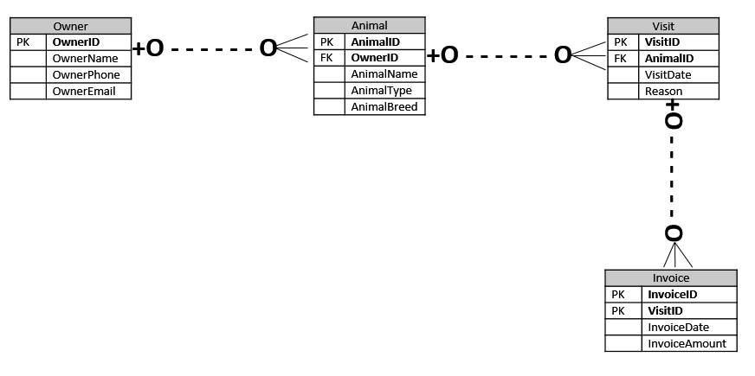
21. Natural, artificial, and surrogate keys are all primary keys. Both natural and artificial keys are visible to users, and surrogate keys are hidden from users. A natural key consists of a field, or a collection of fields, that is an inherent characteristic of the entity described by the table, but neither artificial nor surrogate keys are inherent characteristics.
22. A database contains thousands of objects, fields, controls, and other items, and keeping track of their names and what they represent is a difficult task. Consequently, you should use naming conventions that identify the type and purpose of each item in a database.

