Agnitio Research
To: Kurt Collins
From: Raphina Dagher
Date: 3/1/2025

Market Research
Kurt,
Here are the top 10 states in terms of the number of pizza restaurants per 10,000 persons.
State | Stores | Population | Stores per 10,000 People
New Hampshire | 473 | 1,320,720 | 3.58
Iowa | 1,080 | 3,074,190 | 3.51
Pennsylvania | 4,483 | 12,763,540 | 3.51
Massachusetts | 2,324 | 6,646,140 | 3.50
Connecticut | 1,240 | 3,590,350 | 3.45
Rhode Island | 358 | 1,050,290 | 3.41
New Jersey | 2,983 | 8,864,500 | 3.37
Delaware | 303 | 917,090 | 3.30
Ohio | 3,771 | 11,544,230 | 3.27
West Virginia | 557 | 1,855,410 | 3.00

Here is the map you requested showing a state-by-state comparison of the number of pizza restaurants per 10,000 persons in each of the 50 states and District of Columbia. In general, pizzerias are most densely populated in the Northeast and Midwest. There are relatively few pizzerias found in the Southeast and Southwest. I have other charts and maps that might interest you. Let me know if you want them.
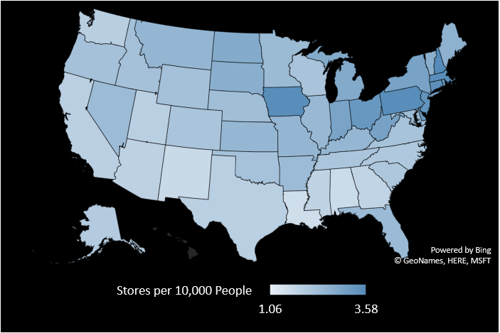
Regards,

