Newland Health Care
Flu shot clinic. Free to all HMO members.
Every Wednesday in November
10 a.m. to 2 p.m.
Stop the flu before it gets you!
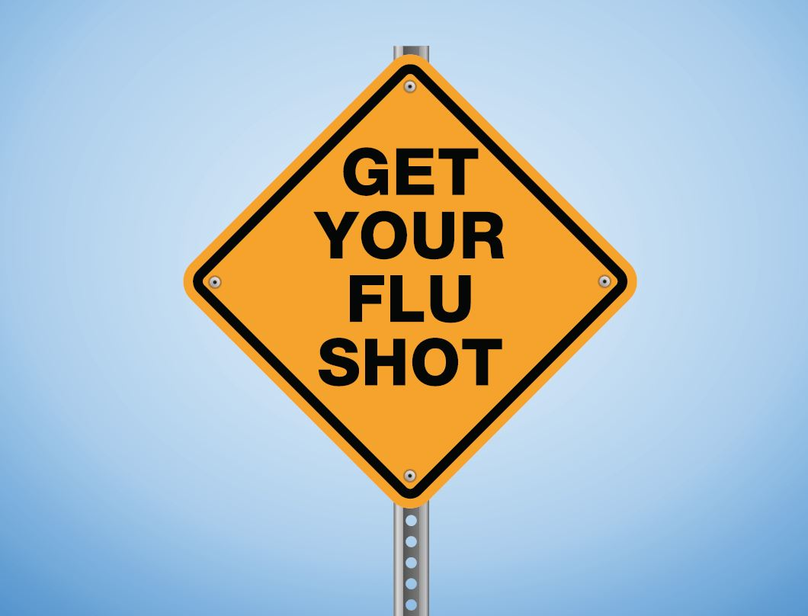
Influenza is a serious, sometimes life-threatening disease. The Centers for Disease Control and Prevention recommend vaccinations for everyone over 6 months old. For more information, call Student Name at 608-555-0100 today.

