We need your help to protect our city’s drinking water.
Join a Citizen Advisory Panel and let your voice be heard.
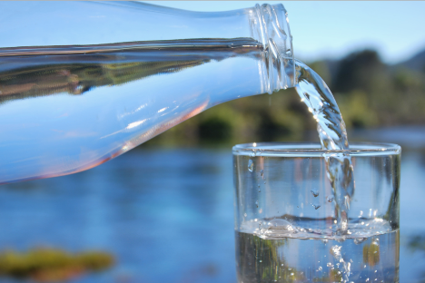
Provide input on upcoming water resource projects.
All community members are welcome.
Contact Student Name at water@portland.cengage.com today.

