Solana Homes: Creating a Sustainable Community
Recycling Bins
Each household is entitled to one recycling bin for curbside pickup. You can recycle an unlimited amount of materials.
Recycle, Reuse, Renew

Solana Builds Recycling Pavilion
W
e’re happy to announce that the Solana Homes community will include a recycling pavilion offering state-of-the art collection facilities, with bi-weekly pickups. The pavilion is designed to make recycling easy in all kinds of weather. The Solana architects were motivated by numerous studies demonstrating that community support and accessible facilities greatly increase the number of families committed to recycling.
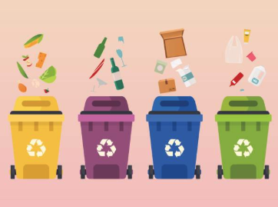
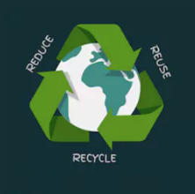
Recycling bins will also be installed throughout the grounds, and residents can schedule curbside pickups at no extra cost. Solana Homes has contracted with Mason Waste Disposal and Recycling to handle trash and recycling pickups. Company owner Ella Fortman has been recognized numerous times as an innovator in co-mingling reuse and recycling.

Hazardous Waste Collection
M
any household hazardous wastes can be recycled cleanly and effectively by recycling professionals. Aren’t sure what’s considered hazardous waste? The labels of most products will provide helpful clues. Look for the following words: caution, danger, toxic, pesticide, keep away from children, flammable, and warning. Acceptable materials include antifreeze, brake fluid, kerosene, oil-based paint, furniture polish, pesticides, herbicides, household batteries, pool chemicals, and fertilizers.
Many hazardous wastes can be recycled
Hazardous waste collection will be handled by the city Sanitation Department, which has a robust hazardous waste treatment program. Sanitation workers will retrieve the items from the curb next to your trash bins on your usual trash pickup day.

Winners of the Solana Green Award

Casey Ann Ramirez-Bosco
Michael Paul Berners
Becky Cade
Elina Compere
Jose Carmela
Layla Carrington
Bruce Butler
Roger Kent Erickson
Henry Douglas
Tomas Carrico
Clarita Carrico
Kelly Dowell
Seamus Dante Dolan
Clarissa Fey-Esperanza
Haiyan Jiang
Tory Jeschke
Jacques Lambeau
Tia Morello-Jimenez
Mario Ruffolo
Eileen Jasper-Schwartz
Helena Pentakota Smith
Sigrid Del Rio
Harriet Schaefer
Jonas Jones
Sandra Jane Carmel
Christina Chamberlain
Student Name

