Solana Homes: Creating a Sustainable Community
Recycling Bins
Each household is entitled to one recycling bin for curbside pickup. You can recycle an unlimited amount of materials.

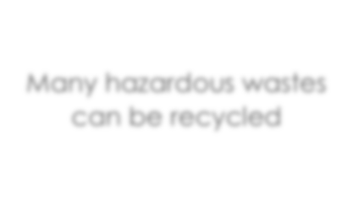


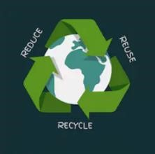

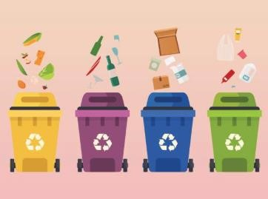
Solana Builds Recycling Pavilion
Many hazardous wastes
can be recycled

W
e ’re happy to announce that the Solana Homes community will include a recycling pavilion offering state-of-the art
collection facilities, with bi-weekly pickups. The pavilion is designed to make recycling easy in all kinds of weather. The Solana architects were motivated by numerous studies demonstrating that community support and accessible facilities greatly increase the number of families committed to recycling.
Recycling bins will also be installed throughout the grounds, and residents can schedule curbside pickups at no extra cost. Solana Homes has contracted with Mason Waste Disposal and Recycling to handle trash and recycling pickups. Company owner Ella Fortman has been recognized numerous times as an innovator in co-mingling reuse and recycling.
Hazardous Waste Collection
M
any household hazardous wastes can be recycled cleanly and effectively by recycling professionals. Aren’t sure what’s
considered hazardous waste? The labels of most products will provide helpful clues. Look for the following words: caution, danger, toxic, pesticide, keep away from children, flammable, and warning. Acceptable materials include antifreeze, brake fluid, kerosene, oil-based paint, furniture polish, pesticides, herbicides, household batteries, pool chemicals, and fertilizers.
Hazardous waste collection will be handled by the city Sanitation Department, which has a robust hazardous waste treatment program. Sanitation workers will retrieve the items from the curb next to your trash bins on your usual trash pickup day.

Winners of the Solana Green Award
Casey Ann Ramirez-  Bosco  Michael Paul  Berners  Becky Cade  Elina Compere  Jose Carmela  Layla Carrington  Bruce Butler | Roger Kent Erickson  Henry Douglas  Tomas Carrico  Clarita Carrico Kelly Dowell  Seamus Dante  Dolan  Clarissa Fey-  Esperanza | Haiyan Jiang  Tory Jeschke  Jacques Lambeau  Tia Morello-Jimenez  Mario Ruffolo  Eileen JasperSchwartz  Helena Pentakota  Smith | Sigrid Del Rio  Harriet Schaefer  Jonas Jones  Sandra Jane  Carmel  Christina  Chamberlain  Student Name

