Non-stiff 9th order chain system

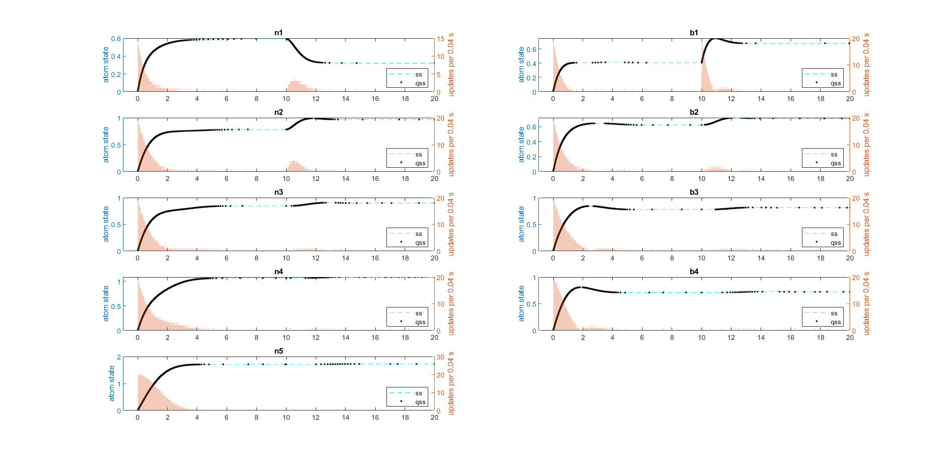

Stiff 9th order chain system (1e-6 to 10k)

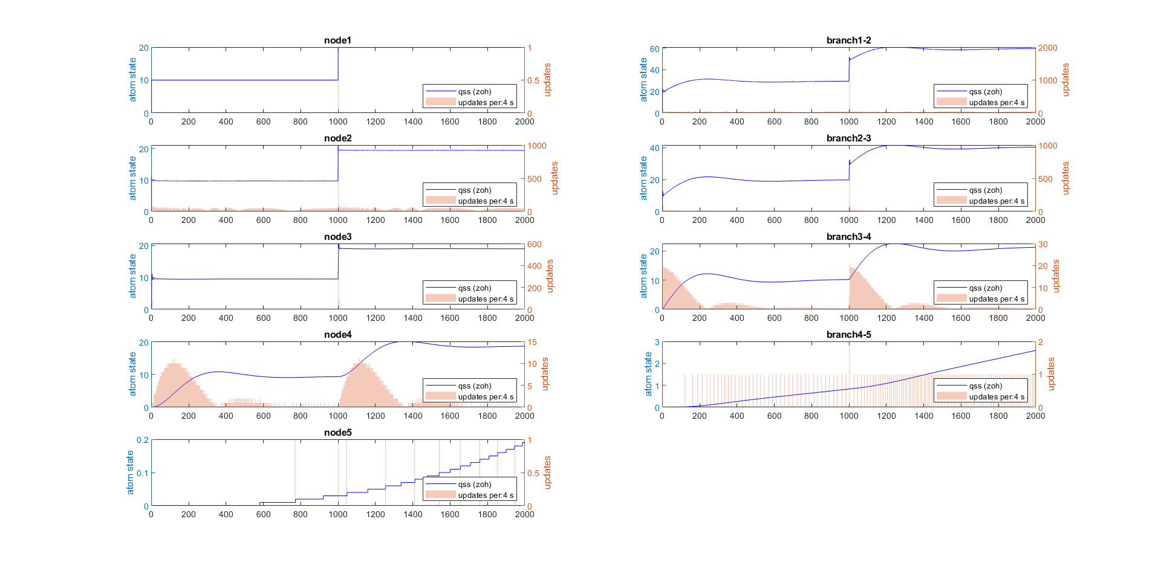

40th order stiff grid with 4 quadrants. Plots of corner nodes (with zoom on corners 1 and 2)

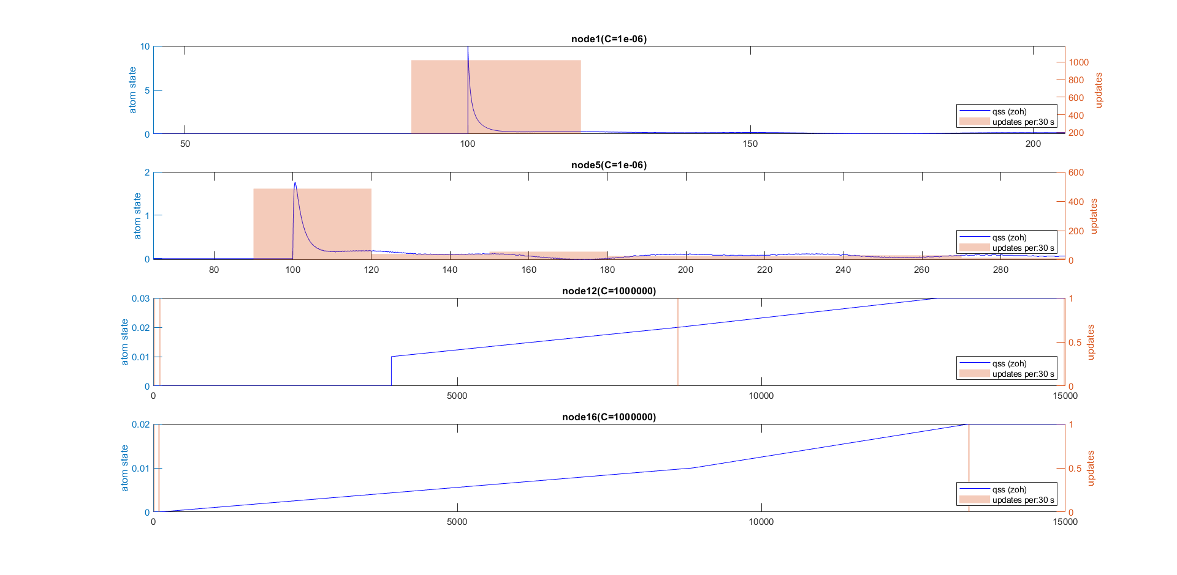

DC motor model with PWM source and controlled source coupling (low dq with ripple)

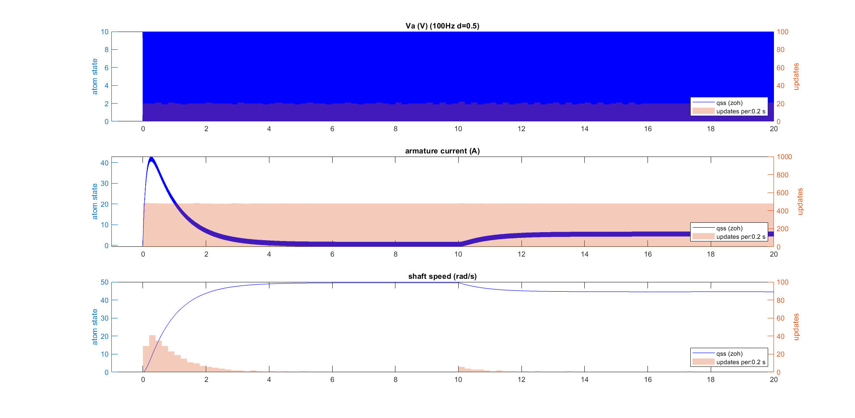

DC motor model with PWM source and controlled source coupling (high dq with no ripple)

