User Requirement Specification

2015

Mikaeil Shaghelani Lor - Mervin Vrolijk - Bolarinwa Iruemiobe - Nibras Shawy - Tarwiya Al Ismaili | ei7S

Group 3

vERSION 16/Sep/2015

**1.Table of Content**

1. Table of Contents -----------------------------------------------1
2. Introduction ----------------------------------------------------2-3
3. Functional Requirements (USE-cases) ---------------------4-7
4. User Interface ----------------------------------------------------8
5. Non-functional Requirements ---------------------------------9

**2.Introduction**

Assignment: Building a traffic simulation application.

In order to secure the transportation system in the city and decreasing the number of accident, our group of developer assigned to this project. Our main goal is to create a simulation system for the user to analysis the traffic flow and statistics. In this document you will find the use cases, design, non-functional requirements.

**3.Functional Requirements**

**-UseCases**

## Place crossing

Actor: The person who is using the software

Pre: The software is running

MSS:

1. Actor chooses crossing type from the toolbox
2. Actor clicks crossing and drags it to the desired place on the grid
3. System shows the item on the grid-cell where the user places it.

Ex:

1. System checks if actor overlaps crossing

Then system places it in the nearest empty grid-cell

## Remove crossing

Actor: The person who is using the software

Pre: The software is running

MSS:

1. Actor clicks delete button from the toolbox
2. Actor clicks on the crossing
3. System deletes item

Ex:

1. Actor doesn’t click on crossing

System informs actor about the error in status section.

## Enter specifications

Actor: The person who is using the software

Pre: The software is running

MSS:

1. Actor chooses crossing layer from Crossing Panel
2. Actor specifies required crossing information for every enabled feeder
3. Actor clicks on apply button

Ex:

1. Actor didn’t specify all required information

System informs actor

## Run simulation

Actor: The person who is using the software

Pre: The software is running

MSS:

1. Actor clicks on Start from the simulation box
2. System checks if all input is complete
3. System starts the simulation
4. System shows results at the end in a pop up form

Ex:

1. Actor didn’t input all required information

System informs actor of error in the status section

## Save as

Actor: Person who is using the software

Pre: System is running

MSS:

1. Actor clicks on save as
2. System shows save as dialog
3. Actor choose the directory and inputs the file name
4. Actor clicks on save button
5. System saves the file

Ex:

1. File name already exists

System informs actor

## Save

Actor: The person who is using the program

Pre: Software is running

MSS:

1. The actor clicks on save from the file tab
2. System saves the file

Ex:

1. The file hasn’t been saved before

System shows save as dialog

## Open

Actor: The person who is using the software

Pre: The software is running

MSS:

1. The actor clicks on open from the file tab
2. System opens file

Ex:

* 1. If a file is open, system goes to save use case
  2. System closes previous file.

## Reset

Actor: The person who is using the software

Pre: The software is running

MSS:

1. The actor clicks on reset from edit tab
2. System reset the simulation project

Ex:

## Stop simulation

Actor: The person who is using the software

Pre: The simulation is running

MSS:

1. Actor clicks on Stop from the simulation section
2. System Stop the simulation
3. System shows a message that simulation stopped in status section.

Ex:

1. Actor didn’t input all required information

System informs actor of error in the status section

## Exit Application

Actor: The person who is using the software

Pre: The Software should be running

MSS:

1. Actor clicks on Exit from File tab
2. System checks if changes has been made
3. System closes the application.

Ex:

1. If any changes has been made, system goes to save use case

## About

Actor: The person who is using the software

Pre: The Software should be running

MSS:

1. Actor clicks on About in Help tab
2. System opens a pop-up page.

## User Manual

Actor: The person who is using the software

Pre: The Software should be running

MSS:

1. Actor clicks on the User’s Manual in Help tab
2. System opens the Digital User’s Manual.

## New

Actor: Person who is using the software

Pre: System is running

MSS:

1. Actor clicks on New from File tab
2. System Opens a new project

Ex:

* 1. If a file is open and not saved, system goes to save use case
  2. System closes previous file.

**4.User Interface**

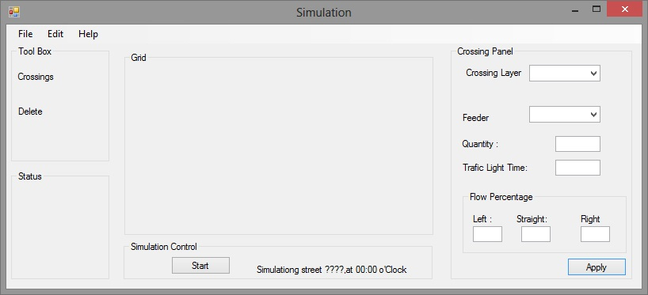

Figure 4.a

**5.Non-functional Requirements**

**(rules, restrictions?)**

* This application will run on windows machines.
* Crossing’s positions: users can create Crossing by clicking on anywhere on the gird work space and inside a grid cell
* Completed Crossing simulation can be saved.