**Rapid Reporter** 



A non-intrusive exploration note-taking tool.

<http://testing.gershon.info/reporter>

Built for SBTM software testing, but can be used for more than that.

Readme File. Document version 2.3. Date 16/Dec/2012

Table of Contents

Introduction 2

System Requirements 2

Benefits 2

Basic Usage 3

Testing Notes 3

Session Debriefs 3

Visual Guide 4

Detailed Usage: How to 5

Enter a note 5

Attach screenshots or extended notes 5

Edit a note 5

Change the working directory or folder 6

Use Rapid Reporter with different terminology or note types 6

View the session report 6

View the session report in HTML 7

Change the visuals of the HTML report 8

Aggregate many sessions into one single file 8

Different Usages 9

FAQ 9

I need persistent data in order to track test results. How to do it? 9

I started a session in a folder where there already was one. Will the session files mix up? 10

What language is this programmed on? 10

Some Known Issues 10

Future Improvements 11

How to help Rapid Reporter 11

Troubleshooting Rapid Reporter 11

Summarized Changelog 12

# Introduction

Hello! This is Rapid Reporter:  


Rapid Reporter is a tool built carefully in order to enhance the experience of Managing Tests Based on Sessions (*Session Based Test Management[1]*). It aims **boosting good note taking during test sessions** and **building reports that invite analysis and discussion**. Notes are easy to record and easy to debrief.

As a tester, you will find that Rapid Reporter lets you master the session, doesn’t interrupt your lines of thought and helps you keep track of notes during tests. It may help you test better.  
If you are a test lead or manager or a peer tester, you will find that Rapid Reporter provides easy-to-study reports, which can be viewed and manipulated in a spreadsheet at will or viewed from a web-browser. My personal experience is that the review of files in this format is more fruitful than other formats of notes or reports I have tried[2]: This application was useful where the other options failed, due to being minimalist. As it doesn’t do much, it doesn’t divert the tester’s attention from the testing session.

Rapid Reporter is a work in progress, based on practical and ongoing experience, and has been evolving like that for a year. It is not perfect now (*see the* *Some Known Issues* *section*), and it will not be perfect in the future - but you can help make it better (*see the* *How to Help* *section*).

# System Requirements

Rapid Reporter **requires .NET framework 3.0** (*3.5 and 4.0 are fine too*). That means it will also **require a Microsoft Windows Operating System**, at least until .NET 3.0 is ported to other platforms.  
Both **32 and 64 bits are supported** by the executable, as well as **any screen resolution**. **Multiple monitors** are supported for screenshots, but no tests are known on more than two screens.

# Benefits

Some of the benefits of Rapid Reporter, in no particular order:

* One single standalone file - Requires **no** installation, keep it in your disk-on-key and use it in any computer (*that complies with the* *System Requirements*).
* Yellow always-on-top interface - No more switching windows or looking for the note taking application.
* Every note has a type, a timestamp, and (*optionally*) two types of attachments: a screenshot, or an extended note (*rich text*).
* There is no editing or tinkering with the notes on-session, this can be done easily in or before the session debrief.
  + This allows the tester to tell the story of his session in the order and with the details the session happened.
* The whole session, with reference to attachments, is recorded in a CSV file which provides easy manipulation (*can be opened/filtered in a Spreadsheet*) and search indexing (*find text in files*).
  + These CSV files can be consolidated or transformed into HTML documents with command line operations.
* A progress bar shows the tester how close the end of the session is. There are no noisy alarms, testers own their session time.

# Basic Usage

## Testing Notes

The first thing a tester does when firing Rapid Reporter is enter two special notes: His name (*“Reporter:”*) and his exploration charter or mission (*“Charter:”*).

After these two are entered, Rapid Reporter starts advancing the session timer (*default is 90 minutes*). The session does not really ends when the timer is over. The timer is only an indication, and testers can decide to stop before or after time is up.

To keep notes, a testers can **enter notes in the notes line**, and **change the type by pressing the up or down arrow** (*even if he’s on the middle of the note*).  
Each note entered is saved by pressing the enter key.

There are two types of attachments: Screenshots and Extended notes. **Screenshots are taken, saved and attached immediately when the screenshot button  is pressed**, without any intervention from the tester (*but a tester can edit the shot if desired, by pressing the ‘SHIFT’ key while clicking the screenshot button*). **Extended notes are also saved+attached at the press of a button ** , and have triple use: Adding more information to a one-line note, pasting test results or data to augment a one-line note, and keep track of information over time (*notes entered in the extended text area are persistent until a tester clears them*).

## Session Debriefs

After the application is closed the session notes are ready to be reviewed. You will find all the files generated during the sessions at the session folder: *.CSV, *.JPG, *.RTF, *.HTM.  
The session folder will be the folder from which Rapid Reporter was executed, unless you pick a different folder (*See the* *Change the working directory or folders* *section for details on how it’s done*).

One way to look at and review the session is by opening the appropriate *.CSV file (*you can find it according to the creation date or file name*) in a **spreadsheet**. By viewing it through a spreadsheet you can easily filter and look at one single type of note (*bugs, questions, ideas for next charter…*) or change the order the data is being shown (*you can always return back to chronologic order*). A spreadsheet also allows getting numbers like amount of sessions and bugs found etc.  
Users that don’t have MS Office installed can use free spreadsheet software from <http://www.openoffice.org/> or <http://projects.gnome.org/gnumeric/> .

Another way to look at the session is generating an **HTML report**. These are very useful because they include screenshots embedded and can carry logo or company colors - but at this moment do not present filtering or ordering options. In order to generate an HTML report, you have to run Rapid Reporter from command line:   
**C:\> RapidReporter.exe -tohtml NAMEOFSESSIONFILE.CSV**

Both views are useful. You may find yourself using HTML reports for expositions or quick debriefs, and the spreadsheet view for in-depth debriefs, statistics and data manipulation.

# Visual Guide

Some people prefer learning with visual clues. Here’s a summary of the different areas in Rapid Reporter’s graphic user interface:

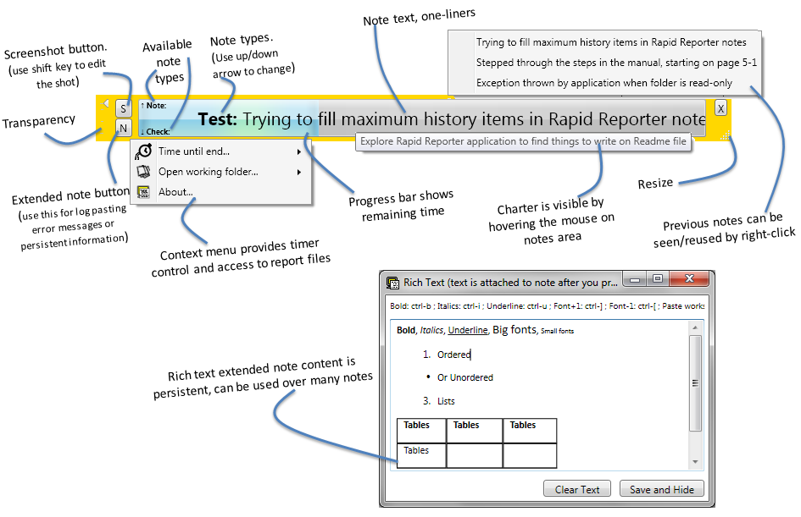

# Detailed Usage: How to

## Enter a note

1. Write your note in the note area (*the big blank space in the middle of the app*)
2. The note is saved into the session when the enter key is pressed.
3. Press the up or down arrow to iterate between the note types. This can be done before the actual note is written or while it is being written. A note type cannot be changed from within Rapid Reporter after the enter key is pressed.

## Attach screenshots or extended notes

1. Attachments can be added to a note before the note they relate to is written or while it is being written. A note attachment cannot be changed from within Rapid Reporter after the enter key is pressed.
2. Press any of the two attachment buttons to take a screenshot or to add an extended note.

Screenshots:

* 1. By pressing the button, the whole screen is saved and marked as attachment for the next note.
  2. Pressing the button while holding the SHIFT key will open the screenshot for editing in MS Paint. This is useful when you are interested in adding a note or cropping part of the screenshot.
  3. Pressing the keys CTRL + ALT + F9 at the same time will capture a whole screen screenshot and attach it to the current note. This is useful when you are interested in capturing ‘hover’ or ‘mouse-over’ effects (*like pop-up menus*). Keeping the keys above pressed will create a quick sequence of images.

Extended notes:

* 1. These notes can be used to add logs info, error messages, pictures and etc. Use it also for taking notes that persist for a while in the session (*the content is not deleted when the note attachment is saved*).
  2. Use the keyboard shortcuts for formatting: Ctrl-B, ctrl-I, ctrl-U… Advanced formats (*like tables*) are supported but need to be copied from a different text editor at this moment.

## Edit a note

Notes cannot be edited from within Rapid Reporter’s interface.

My personal experience shows that after a note is entered, there is no much reason to edit it or fix it. In fact, if there is a reason to fix the note, this would be important material for the session debrief, so mistakes and confusions in notes are worth being kept.

Nevertheless, notes can be edited by following these steps:

1. Pressing the “Open working folder” in the context menu will show all the session files
2. Locate the appropriate *.CSV file and edit it on notepad or a spreadsheet (*note that spreadsheet apps may lock the file from Rapid Reporter’s use*).

## Change the working directory or folder

By default, Rapid Reporter will use the directory from which it was executed for all his file manipulations (*saving the session and the attachment, or making consolidated reports or HTML docs*).

This directory can be modified in one of two ways, allowing you to have one copy of Rapid Reporter yet work on different session paths:

1. Graphic interface
   1. Before the session starts (*i.e. before the charter is entered*) Rapid Reporter context menu allows you to modify the working directory
   2. After the session starts, all that can be done from the context menu is opening the directory. No path changes are allowed during the session (*after the charter is entered*).
2. Command line interface
   1. Rapid Reporter has a command line argument called -directory that let’s you change the directory used for a session:

**C:\> RapidReporter.exe -directory PATH**

* 1. This will work for testing session, for HTML docs, for consolidation reports…

**C:\> RapidReporter.exe -directory PATH -report**

**C:\> RapidReporter.exe -directory PATH -tohtml FILE.CSV**

## Use Rapid Reporter with different terminology or note types

Rapid Reporter starts with the following note types by default:

Setup / Note / Test / Check / Bug / Question / Next Time

Some people would like less, or more, types.

Other people would like to use the terminology used at their workplace (*Defect instead of Bug, or Segment instead of Setup*).

Other people use other languages and would like to translate the types (*Pergunta instead of Question, Notitie instead of Note*)

1. To change the note types, start Rapid Reporter from command line. Any word added after the executable name will be used as a note type. For example:
   1. **C:\> RapidReporter.exe Nota Prueba Pregunta Proxima**

or

* 1. **C:\> RapidReporter.exe Information Question Lookup**

## View the session report

1. Find the appropriate *.CSV, by looking at the creation date or the file name.
   1. A session started on 21/11/2010 08:35 will be called 20101121_083548.csv, for example.
2. Open it in your favorite spreadsheet (*usually double clicking the file is enough*)
3. Now, according to the capabilities of your spreadsheet, you can re-order the notes per type, per tester, per time… You can count sessions and times and bugs… Apply filters…
4. The file name of the note attachments is displayed in the same line, in a different column.

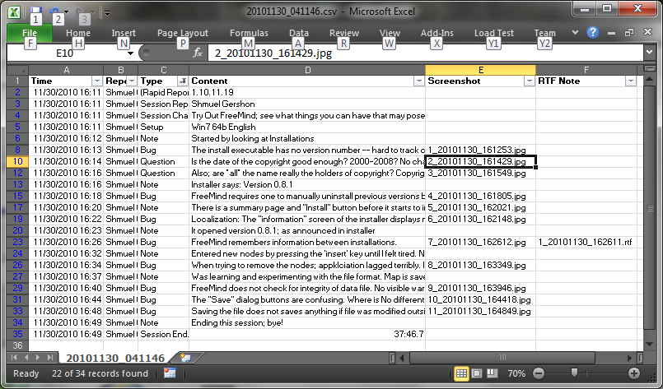

## View the session report in HTML

The HTML report will allow you to see the screenshot attachments and the extended notes links embedded with the session notes. Additionally, it will allow you to change the visuals of the report to include the logo of your company or project, for example. These two benefits make it great for discussing the session with managers.

To create a report of a session *.CSV file (*either of single session or cumulative sessions*), use the following command in command line:

**C:\> RapidReporter.exe -tohtml NAMEOFSESSIONFILE.CSV**

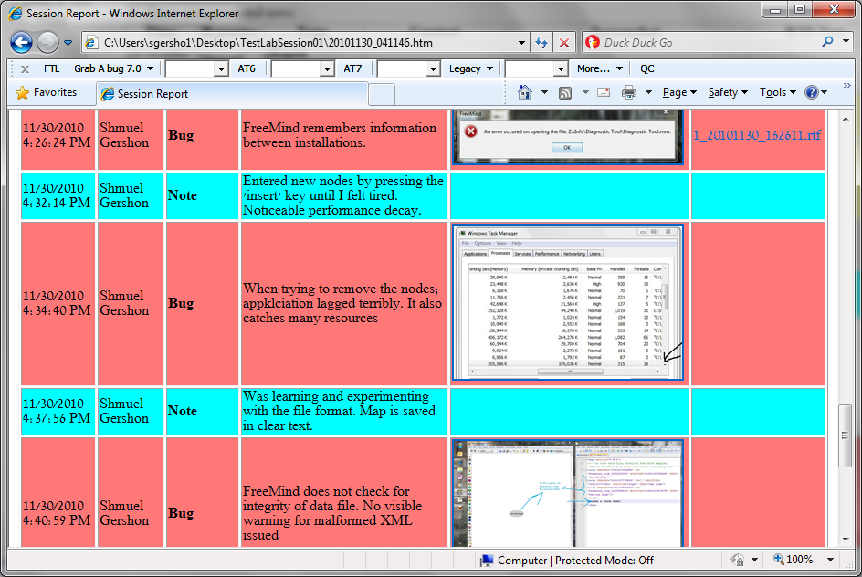

## Change the visuals of the HTML report

Changing the visuals of the HTML report is useful when you want to add your company’s logo to the report, when you want the colors of the report to match the ones in other reports you provide, when you prefer to hide or emphasize one type of note… Almost all visuals of a report can be manipulated.

1. Use a file named style.css in the same folder as the HTML report.
2. You will need acquaintance with CSS to customize the report. Looking at the HTML source should elucidate what to edit according to your preferences.

An example of stylesheet would be:

body

{

background: #FFFFDD;

}

#allbody

{

background-image:url('http://upload.wikimedia.org/wikipe 🡯

🡮 dia/commons/d/d9/Free_Mind.png');

background-repeat:no-repeat;

background-position:right top;

}

table tr.Bug {font-weight: bold;}

H1 {color:#000000;}

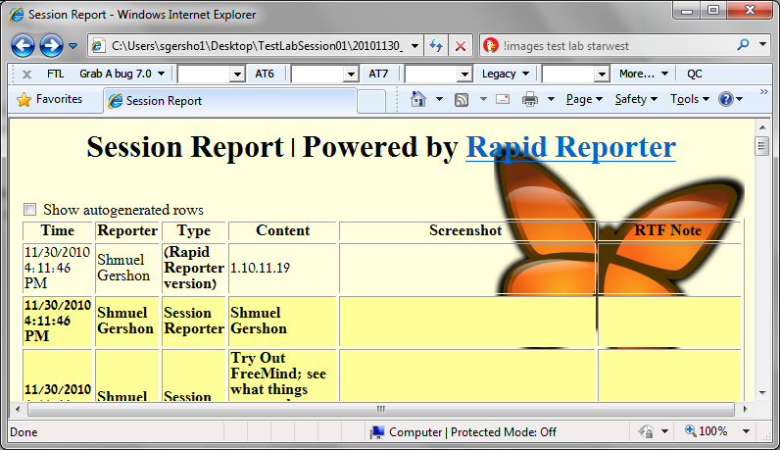

## Aggregate many sessions into one single file

After you’ve done a few sessions, you may want to consolidate all the *.CSV files into a single one, to allow analysis of the whole project to date together.

To do that, run the following command in the command line, which will concatenate *.CSV files into a single one. The command will take any file with a file name ending in the ########_######.csv format (*where ‘#’ represents a digit*), without validating the content. Consolidated reports files (*which start with “report_”*) or files with a different name format will be ignored.

**C:\> RapidReporter.exe -report**

# Different Usages

You can use Rapid Reporter for other activities.

1. One good usage of Rapid Reporter is to listen to webinars.
   1. Start Rapid Reporter with a smaller set of note types, like “**RapidReporter.exe Information Question Lookup**”. Then, jot your notes of what the speaker is saying on the application, and your questions. Whenever there’s an interesting thing on the slides on screen, take an automatic screenshot to accompany your notes. You can later print all the notes and screens in HTML.

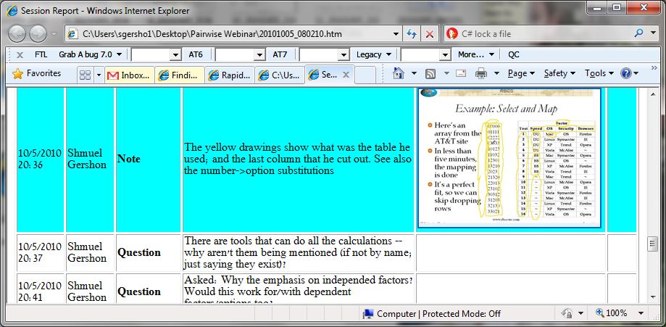

1. A similarly useful way to use Rapid Reporter is to take minutes, or meeting notes.
   1. Start Rapid Reporter with a set of note types that represent participants, as in “**RapidReporter.exe Moe Larry Curly**”. Then you can write each person’s contribution, which will be timestamped and organized for you. If the meeting has online slides, you can add the slides to each contribution by taking a screenshot.

# FAQ

## The CTRL+ALT+F9 hot key conflicts with a hot key set in my computer. How do I disable the hot key?

In the context menu (*right-click any yellow area*), you’ll see a menu for controlling the hot key:

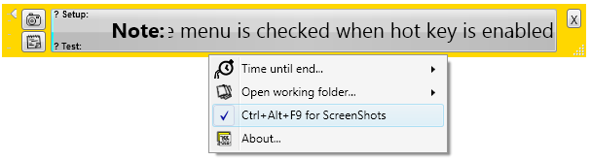

If the menu is checked, the system-wide hot key is enabled, if the camera icon appears, it is disabled. Pressing this line on the menu toggles its status.

## I need persistent data in order to track test results. How to do it?

There are three ways to use persistent notes. In order of preference:

1. Use the extended notes screen. These notes will stay on until you delete them or press the clear button. This area is good for keeping track of information over many notes (*even creating incremental attachments*).
2. Use the right-click context-menu in the notes area. This will show you all your past notes.
3. “Open working folder” from context menu and look at the notes directly from the *.CSV file. This is not recommended because some apps will lock the file access, which would cause an error message to appear.

## I started a session in a folder where there already was one. Will the session files mix up?

No.

All files have the names generated from the current time, so two files will not be confused.

Rapid Reporter was built to have all the sessions executed from one single folder that would collect all the screenshots, notes etc.

## What language is this programmed on?

Rapid Reporter was written in C# with WPF (*Windows Presentation Foundation*) using Microsoft Visual Studio 2008 and Microsoft Visual Studio 2010. Code versions are kept in a revision control system called Fossil.

The application is released in a Creative Commons license BY-NC-SA.  
I will gladly listen to any feedback or idea you may have and either discuss its value or implement it into Rapid Reporter, so I discourage forks and clones.

# Some Known Issues

1. The session file is not protected for editing or deletion while Rapid Reporter runs.
   1. That means that the user can open it in notepad for quick fixes.
   2. But that also means the user can open it with Excel - which will lock the file. Rapid Reporter will show an error message every time it tries to write to the file when it is open in Excel.
   3. This relates to ticket [3b74cc89ca](http://testing.gershon.info/rapidreporter/versions.cgi/tktview/3b74cc89ca4f8ef46163803ae5171a11edec65b0)
2. In some computers, maximizing the app makes it jump around the screen. Try it in yours, it’s actually funny.
3. Rapid Reporter will not load if you execute it from certain network folders. Try copying it to a local computer folder or run it from a network folder mapped to a drive letter (*a network folder that appears as “F:”, for example*).
4. When taking an ‘edited Screenshot’ (*pressing the button with the SHIFT key*), Rapid Reporter will momentarily disappear to be invisible to the screenshot. However, as this happens quickly, sometimes the tooltip showing the charter is still seen on the screenshot bitmap.
5. When progress bar is running, CPU consumption goes high. .NET framework issue ☹.
6. When you chose a folder to work from, Rapid Reporter does not check if the directory is writable. This may cause an error when recording notes.
7. You can see a list of currently open bugs on the [Tickets not closed](http://testing.gershon.info/rapidreporter/versions.cgi/rptview?rn=2) report.

# Future Improvements

Some future enhancements to Rapid Reporter, apart from fixing bugs, include:

1. Attach any existing file to the report. Logs, test results, debug files, pictures…
2. Adding a “test idea hint”, probably inspired by the Software Quality Characteristics list by the Test Eye.
3. Cross-Platform Rapid Reporter with support to Linux/Mac/Windows. Probably using Qt.

# How to help Rapid Reporter

You can help Rapid Reporter by

* Using it
* Using it with your peers
* Posting your feedback on the website
* Sending feedback by mail
* Promoting it at your workplace
* Promoting it on Social Media
* Filling bugs on the ticketing system or through a message to me
* Looking at the code and submitting improvements
* Believing in it

## Troubleshooting Rapid Reporter

The following information is very helpful when troubleshooting Rapid Reporter. If you want to report a bug, providing these (*in addition to the problem description*) will make the support faster and easier.

* The version of Rapid Reporter (*you can see it on the about box, or in the help dialog by running “****RapidReporter.exe /?****”*).
* The session CSV file created, or the one you were trying to manipulate
* Rapid Reporter log.
  + Rapid Reporter has a secret logging mechanism that is triggered whenever there is a file called “_rrlog_.log” in the Rapid Reporter folder. Log entries will be appended to it.
* Screenshots of exceptions or other problems you see.
* The output to these two command line operations (*will enumerate.NET frameworks*):  
   **dir /b /ad /o-n %systemroot%\Microsoft.NET\Framework\v?.\*** **dir /b /ad /o-n %systemroot%\Microsoft.NET\Framework64\v?.\***

🙢🙡 🙣🙠

You can see the list of people who have helped at the “credits” area inside the about dialog. As things happen very quickly, I may have forgotten someone. If your name is missing from the credits, I am sorry and embarrassed - don’t be shy of dropping me a note.

Thanks for the interest in Rapid Reporter. I hope you find it useful.

Shmuel

# Summarized Changelog

|  |  |
| --- | --- |
| 1.12.12.16 | New: Hot Key for Screenshots  Fixed: Abs and Rel pats when creating HTML reports  Fixed: Workaround for Windows’ bug on new folder creation.  Better: Command line arguments |
| 1.12.01.06 | Fixed: Report bugs |
| 1.11.09.06 | Fixed: A few crashes in the app  Better: Timer configuration |
| 1.11.03.20 | Better: Added logging point /past/ the end of my classes, to catch .NET exception  Better: Log now gets system info for Net version comparison |
| 1.11.03.18 | New: Directory selection (*see* *guide*)  Better: Milliseconds precision on session time removed  Better: Session timer now in different thread demands less resources  Better: Troubleshoot logging mechanism improved (*more logging points added*)  Better: Attachment icons now look disabled before the session starts  Fixed: When using edit-screenshots (*see* *guide*), Rapid Reporter window now hides  Fixed: When using “-report”, app skips all files that don’t look like session files  Fixed: Code refactored to allow easier changes and improvements |
| 1.10.12.10 | Fixed: Bug with timer recalculation when changing the session duration |
| 1.10.12.09 | New: Attachment buttons now have graphical icons  New: Readme document (*this one*)  New: HTML report can now be stylized with a styles.css file (*see* *guide*) |
| 1.10.11.19 | New: Progress timer now changes proportionally instead of incrementally  Better: Timers now have indicator checkmarks |
| Previous: | 1.10.11.16, 1.10.11.15, 1.10.10.27, 1.10.09.15, 1.10.09.14, 1.10.09.12 |

1. Information about Session Based Test Management, or SBTM, can be found at <http://satisfice.com/sbtm>
2. This tool is fruit of first-hand experience with real sessions and session debriefs; and learning how both activities can get better.