ETL Processing Final
In this final project, you will create a complex ETL process. This activity will take you about 20 to 30 hours, so plan accordingly!

The Final consists of four Milestones:

Milestone 1: File Imports
Automate ETL from clinic CSV files to Patients database

Milestone 2: Data Warehouse ETL
Automate ETL from Patients and DoctorSchedules databases to the DWClinicReportsData database

Milestone 3: Non-SQL ETL
Upload ETL report data from DWClinicReportData to a MongoDB Atlas database

Milestone 4: Automation, Reports, and Documentation
Automate, Report, and Document your ETL process, then write a "Lessons Learned" paper.

Important: You must upload your current milestone version of the final each week to the same assignment in Canvas.

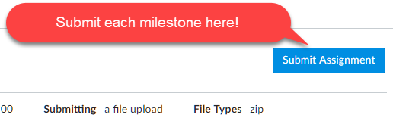
Figure 1. Summitting the assignment.

Note: Name your zip file as ETLFinal_YourNameHere.zip each time you upload the file in Canvas. The instruction team will see all the previous versions, so there is no need to be more specific.

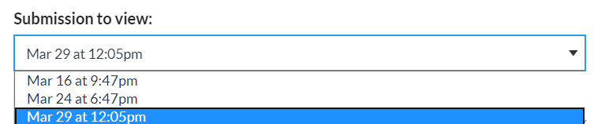
Figure 2. What the instructor sees when multiple files are submitted for assignments.

Be aware that, although you must upload your current milestone file each week, the assignment will only be graded once, at the end of the course!

Important: The structure of your files and folder will affect your grade, just as it would on a real-life project.

Overview
In this final you play the role of a consultant hired to an ETL solution for a small medical clinic. It is similar to a contract I worked on many years ago and acts as a practical measure of your knowledge.

Currently, the business has individual clinics send data to a corporate office by uploading CSV files each day. Those files are then added to one of the two databases. The current ETL process is entirely manual.

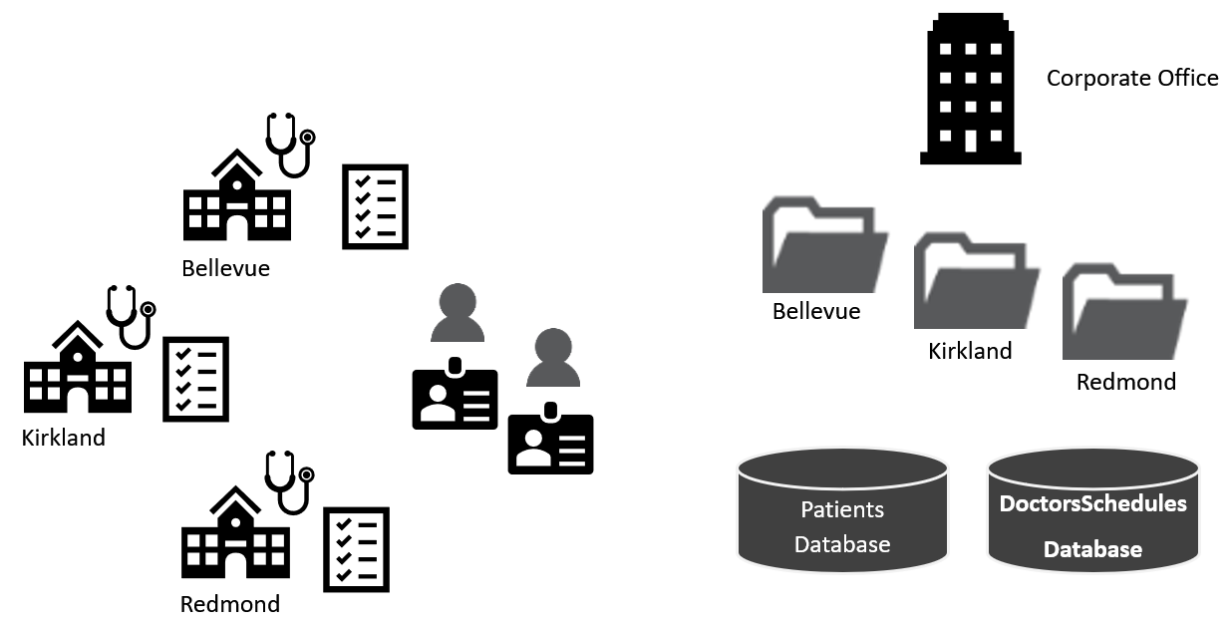
Figure 3. Topology of the current design.

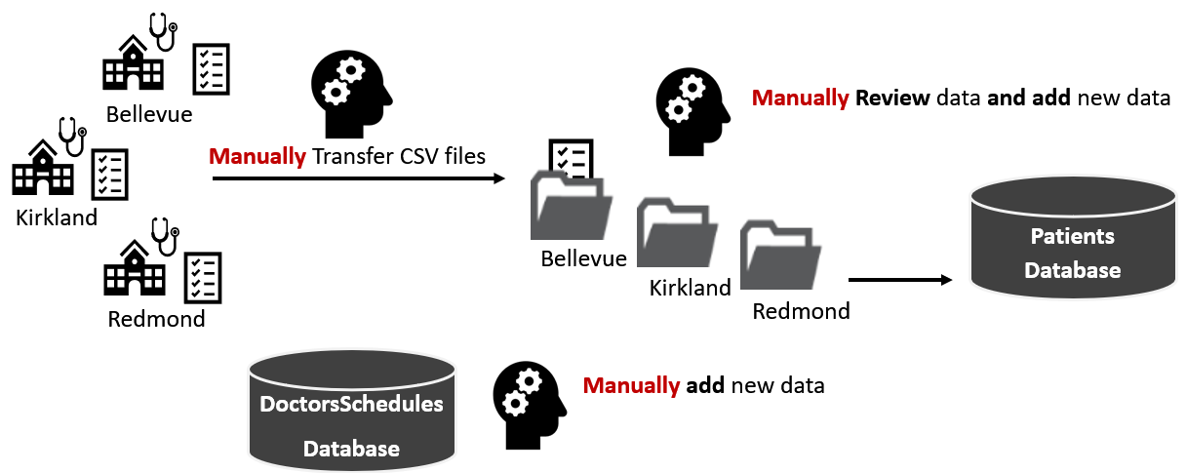
Figure 4. Visualization of the manual ETL file process

The new ETL process will include some automation. If all goes well, they may fully automate in the future.
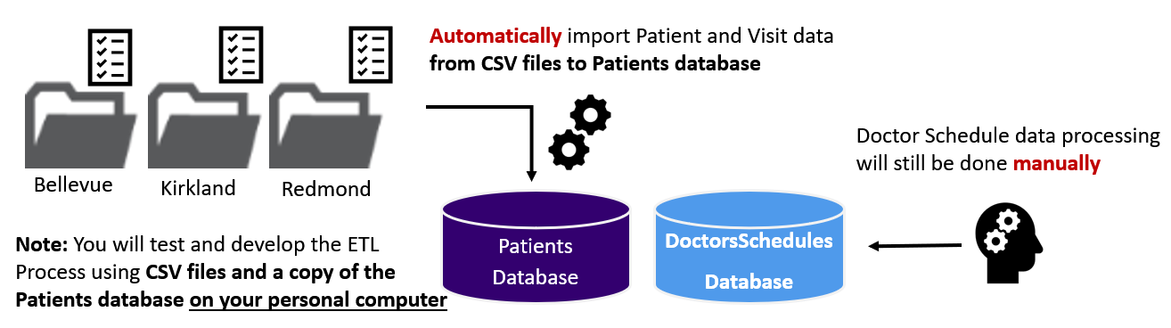
Figure 5. Visualization of the manual ETL file process

Milestone 1: File-Based ETL
The goal of milestone 1 is to automate the import of data from the CSV files into the "Patients" database. There are two sets of files in each folder, with new patient data and new visits data. Perform the listed steps to complete Milestone 1.

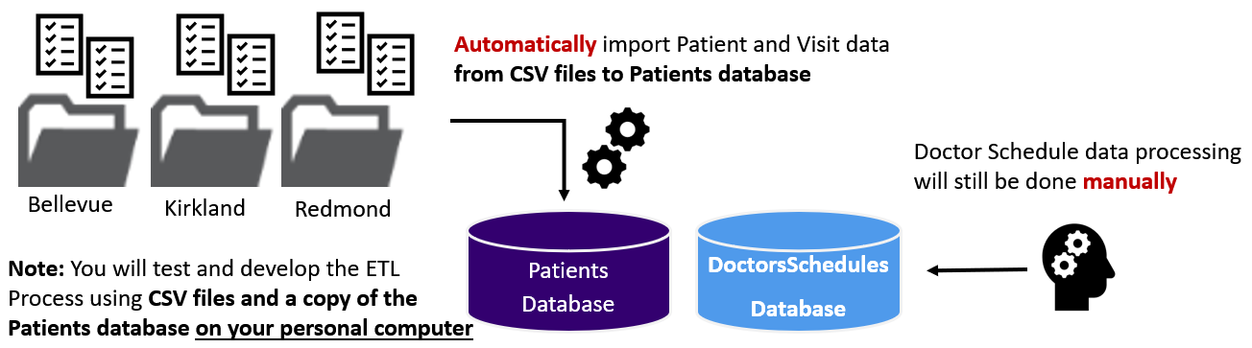
Figure 6. Visualization of the file import process

Important: You need to review and look for common issues (bad data, nulls, data types, column order, etc.) to make your ETL process work.

Step 1 - Review the Data
There are two sets of CSV files to process. These files represent data added daily to the source databases.

Copy the ClinicDailyData folder (with its subfolders and files) to your "C:\_BISolutions\" folder. Then review each file, watching for any issues in their design and data! Next, review the data in each of the databases, noticing the table, columns, data types, and any issues in the data.

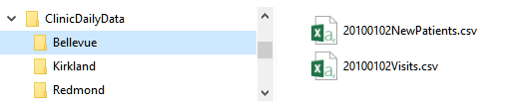
Figure 7. Examples of the daily data CSV files

Note: There are several typical issues to address:
- Column Names
- Column Order
- Bad Data
- Concatenations
- Dates and times

Step 2 - Create a Blank Visual Studio Solution
You must organize these files into a single VS solution as we have throughout the course. Your physical folders and files must be organized as shown in figure 8.
- Make sure make matching virtual folders in Visual Studio
- Make sure to place your files in the correct physical folders and add them in Visual Studio.
- Make sure you start organized and stay organized as you work, or you will lose points!

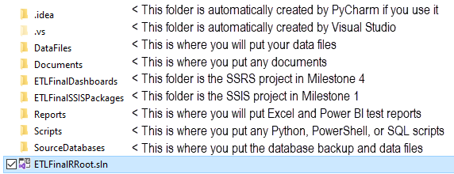
Figure 8. File and folder organization of the solution

Step 3 - Create a Dev copy of the OLTP Databases
You need to attach the two source databases called DoctorsSchedules and Patients on your personal computer. These will be your developer copies of the databases. The .BAK files for each database are included with Finals Zip file and should be placed in the _BISolutions\Databases folder. The following code restores those databases (Note the Path!)

ALTER DATABASE [Patients] SET SINGLE_USER WITH ROLLBACK IMMEDIATE;
RESTORE DATABASE [Patients]
FROM DISK = N'C:/_BISolutions/Databases/Patients.bak'
WITH RECOVERY, REPLACE;
ALTER DATABASE [Patients] SET MULTI_USER;
go
ALTER DATABASE [DoctorsSchedules] SET SINGLE_USER WITH ROLLBACK IMMEDIATE;
RESTORE DATABASE [DoctorsSchedules]
FROM DISK = N'C:/_BISolutions/Databases/DoctorsSchedules.bak'
WITH RECOVERY, REPLACE;
ALTER DATABASE [Patients] SET MULTI_USER;

Note: In real life you would not work on the Production server when you are testing your file import automation. Instead, you would use a "Dev" server to create and test your process. Consider that you are working on your own "developer" server to simulate this.

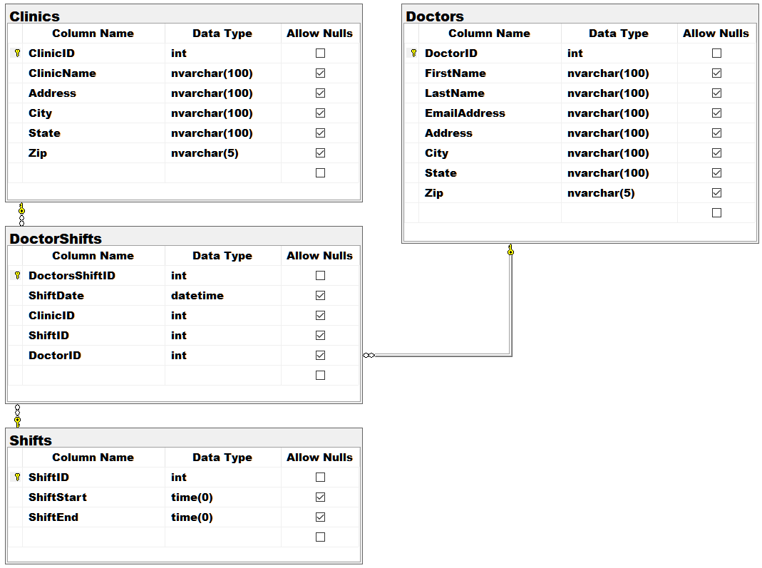
Figure 9. The DoctorsSchedules Database

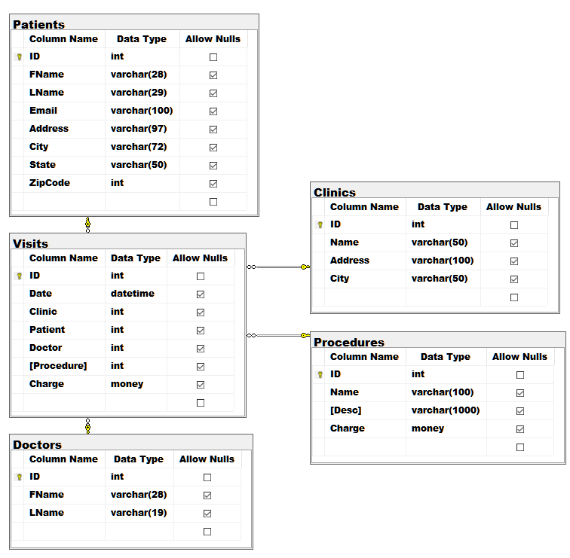
Figure 9. The Patients Database

Step 4 - Document the tables and transformations
Now review the local dev copies of the source databases and note any issues you find in their designs. Look for things like inconsistent or ambiguous names and data types. Document your source, destination, and transformations in the ETL Transformation metadata worksheet (.\Document\BISolutionWorksheets.xlsx). Make sure to update both tabs as needed.

Hint: Pay attention to column orders, emails, dates, and times issues.

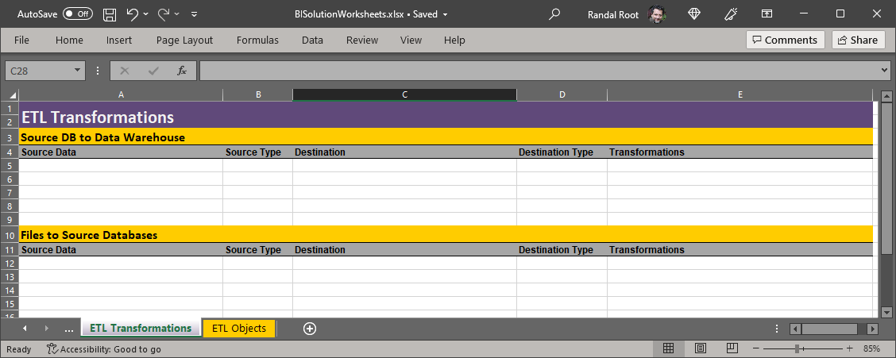
Figure 10. The Metadata Worksheet

Step 5 - Create an SSIS Package
Add an SSIS project ETLFinalSSISPackages to your Visual Studio. Create a package called ETLFilesToDatabases that imports data from the files into your local dev version of the "Patients" database.

Notes:
- You may use Python, SQL, or SSIS tasks to perform this ETL process.
- Any Python or SQL code must be added to a script file and included in the solution, even if it is already in a SISS Script task.
- Incrementally load the source databases with CSV data (This is supposed to happen daily).
- Convert schedule time data to a 24-hour format.
- Use Views and Stored Procedures when working with SQL code.
- Update your Excel worksheet with any objects or changes you made while developing your ETL process (.\Document\BISolutionWorksheets.xlsx.)

Important:
- Please create and save your Visual Studio solution as C:\_BISolutions\UWETLFinalYourName
- Please set the Python interpreter path to C:\Python\Python310 (so we can grade it without having to change paths!). If you have Python installed somewhere else use a symlink. https://www.howtogeek.com/howto/16226/complete-guide-to-symbolic-links-symlinks-on-windows-or-linux/

Submit a BI Solution to the Canvas Site
Note: You must upload the new versions of the final each week to the same assignment in Canvas. Although you must upload your current milestone file each week, the assignment will only be graded once, at the end of the course! (See Figures 1 and 2 for clarification!)

Milestone 02: Data Warehouse ETL
The goal of Milestone 02 is to create an ETL process from the "DoctorsSchedules" and "Patients" OLTP databases and to "DWClinicReportData" OLAP database. The two OLTP databases are on different servers, one hosted on Azure and the other on the UW network. These are the production versions of the two databases you restored in Milestone 1 - Step 3, and you only have read access to these.

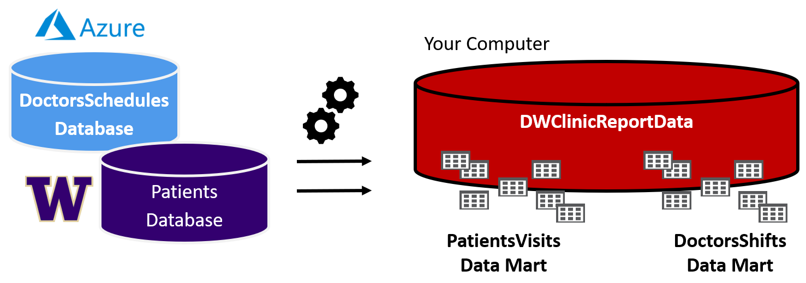
Figure 11. The databases used in the Milestone 2

Setup:
- The DoctorsSchedule database is on our class's Azure cloud server
  - Server: sqlteaching.westus.cloudapp.azure.com
  - Login: BICert
  - Password: BICert
- The Patients database is on our class's UW Server
  - Server: is-root01.ischool.uw.edu\BI
  - Login: BICert
  - Password: BICert
- DWClinicReportData is created on your computer!

Important:
- To access my UW SQL Server you must to connect to the UW network using "OnNet" Virtual Private Network software: Husky-OnNet (also know as BI-IP Edge Client)
- https://itconnect.uw.edu/tools-services-support/networks-connectivity/husky-onnet/installing-configuring-and-using-husky-onnet/
Note: If you have problems connecting to the remote databases, you can temporarily use the local copies on your computer, created in milestone 01, allowing you to continue working until you can get the connections fixed.

Step 1. Create a Data Warehouse
Use the data warehouse database script (\Scripts\CreateDWClinicReportData.sql) to create your data warehouse destination database.

Step 2. Review this database design
There are two data marts (A and B) in this data warehouse. Note that DimPatients is a Type-2 SCD design, but all other tables are a Type-1 SCD design.

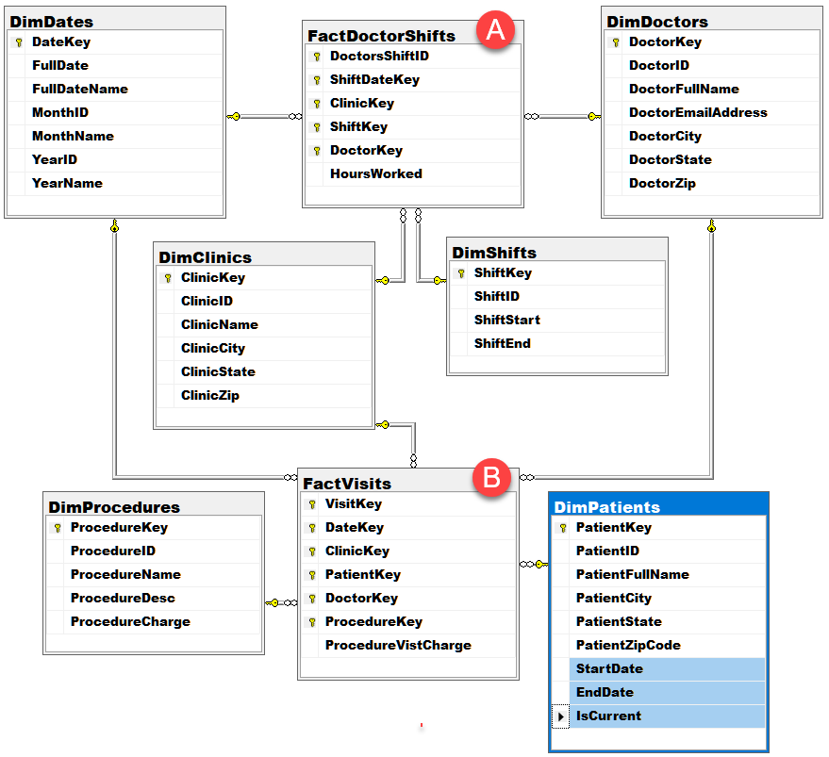
Figure 12. The CreateDWClinicReportData database tables

Step 3. Update your ETL process design in Excel
Update the metadata spreadsheet with the source, destination, and transformation metadata as needed to describe your ETL process (See figure 11). Make sure to update both tabs as needed.

Step 4. Create a SQL ETL process and SSIS Package
Create an ETL processing scripts using SQL views and stored procedures. Then create an SSIS ETL package called "DWClinicReportDataETL.dtsx" to run the stored procedures.

Notes:
- Transformations can be done using SQL or Python (but I recommend using SQL and staging tables).
- Incrementally load all tables (except DimDates and DimShifts.)
- All script code must be placed in script files and included in the solution. Make sure to organize your files and folders, as shown in figure 8.
- Update your Excel worksheet with any objects or changes you made while developing your ETL process (.\Document\BISolutionWorksheets.xlsx.)
- Since you only have read access to the production databases, temporally use your local copies of the databases if you want to test adding, updating, or deleting data in your source databases.

Important:
- Please create and save your Visual Studio solution as C:\_BISolutions\UWETLFinalYourName
- Please set the Python interpreter path to C:\Python\Python310 (so we can grade it without having to change paths!). If you have Python installed somewhere else use a symlink. https://www.howtogeek.com/howto/16226/complete-guide-to-symbolic-links-symlinks-on-windows-or-linux/

Submit a BI Solution to the Canvas Site
Note: You must upload the new versions of the final each week to the same assignment in Canvas. Although you must upload your current milestone file each week, the assignment will only be graded once, at the end of the course! (See Figures 1 and 2 for clarification!)

Milestone 03: Non-SQL ETL
The goal of Milestone 03 is to create an ETL process between the "DWClinicReportData" database and your own MongoDB database hosted on Atlas.

Step 1. Create a MongoDB Database
Create a MongoDB database on Atlas to host the new report documents called ClinicReportsData (figure 13).
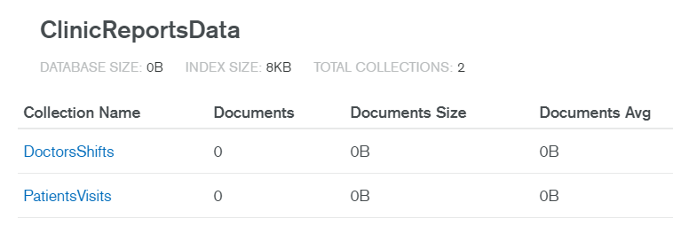
Figure 13. The MongoDB database and collections need for the solution

Step 2. Create Views
Create two views in the data warehouse to shape export data to be used in the ETL process like the one in figure 14. Have one view pull data about doctor shifts and the other data about patient visits.

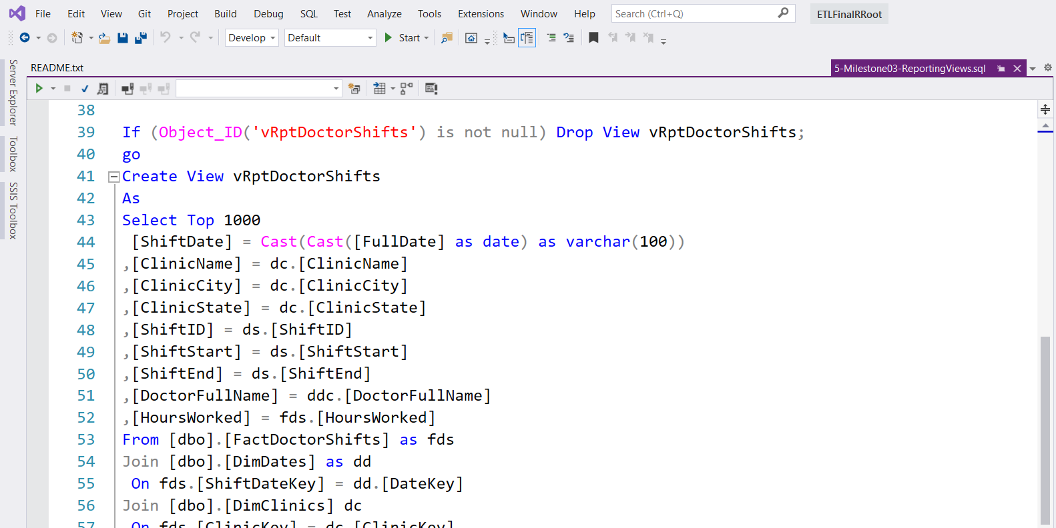
Figure 14. An example view for shaping export data

Step 3. Extract, Transform, and Load data
Create one or more Python scripts to Extract, Transform, and Load data from a SQL Server relational data warehouse to your MongoDB Atlas document database. Use different collections for each datamart Visits and Dr. Shifts (Figure 15).

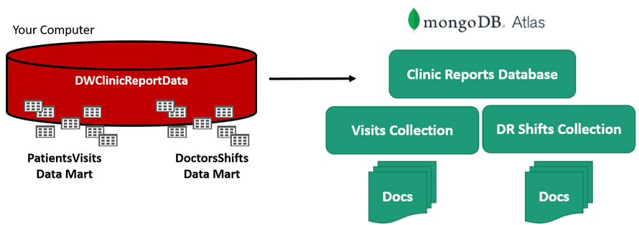
Figure 15. Exporting data to the MongoDB Atlas database.

TIP: It is often simpler to export data from the relational database to simple .CSV files before importing it into the document database, but any system that works is acceptable.

Step 4. Create an SSIS Package
Create an SSIS package called, ETLClincReportsDocumentData.dtsx, that executes your Python scripts.

Step 5. Update your ETL process design in Excel
Update the metadata spreadsheet with the source, destination, and transformation metadata as needed to describe your ETL process (See figure 11). Make sure to update both tabs as needed.

This ETL process must:
- Upload two sets of data to your MongoDB database.
- All script code must be placed in script files and included in the solution. Make sure to organize your files and folders, as shown in figure 8.

Important: You must have your Visual Studio project under C:\_BISolutions and the Python path set to C:\Python\Python310 for us to grade it. If you have Python installed somewhere else use a symlink. https://www.howtogeek.com/howto/16226/complete-guide-to-symbolic-links-symlinks-on-windows-or-linux/

Submit a BI Solution to the Canvas Site
Note: You must upload the new versions of the final each week to the same assignment in Canvas. Although you must upload your current milestone file each week, the assignment will only be graded once, at the end of the course! (See Figures 1 and 2 for clarification!)

Milestone 04: Automation, Reporting, and Documentation
The goal of Milestone 04 is to complete the BI solution by adding automation, reporting, and documenting your solution. Perform the following steps to complete Milestone 04.

Step 1. Create a new SQL Agent Job to automate your ETL process.
- Create a SQL Agent Job called ETLDWClinicReportData to run your SSIS package.
- Set the Job Owner as SA and configure it to run each night at 1 AM.
- Generate a SQL Script for the Job and add structured error handling to the script.
- Add the script file to your Visual Studio Solution.
Step 2. Create SQL Reporting Views
- Create ETL report views that pull data ETL log and the MSDB jobs tables.
Step 3. Create ETL Dashboard Reports with SSRS.
- Add an SSRS project called ETLDashboardReports to your Visual Studio solution.
- Create ETL report that shows the contents of the ETL log and MSDB jobs table.
Note:
- Be sure to name your SSRS DataSources and DataSets to identify what database or objects they are using.
- Make sure to update your Excel development document to record the objects in your BI solution accurately. The reason for this is that things tend to change as you go through the creation of any BI Solution, and you need to make sure your final documentation reflects what was built.

2. Create a Technical Manual
Next, you need to create a technical manual that describes the ETL processes you've created. Any reader should read your documents and understand the solution's components, why they are used, and how they are used. Please save your document as a PDF.

Submit a BI Solution to the Canvas Site
Each week you configure and test your solution, ZIP the entire BI solution folder, and upload it to the Canvas website. Remember that you will have placed all the ETL scripts, SSIS, Excel ETL, and Word docs into one solution folder. Zip everything up into one Zip file and submit it to Canvas.

Note: You must upload the new versions of the final each week to the same assignment in Canvas. Although you must upload your current milestone file each week, the assignment will only be graded once, at the end of the course! (See Figures 1 and 2 for clarification!)

Bonus Points: Write a Lessons Learned Paper
Write a paper that outlines what you have learned in this class. The review helps both you and me to understand your progress in this class. You may be surprised to see that this process solidifies what you have learned (or at least other students have told me it does!) There is no need to make this an exhaustive coverage of what you did but write least a few well-written text paragraphs.

Final Grading
- Milestone 1: File Imports (100 pts)
- Milestone 2: Data Warehouse ETL (100 pts)
- Milestone 3: Non-SQL ETL to MongoDB (100 pts)
- Milestone 4: Automation, Reports, and Documentation (100 pts)
- "Lessons Learned" paper (50 Bonus points)

