

Contents

Contents 2
Requirements 5
Hardware and Software 5
Internet access 5
Launching Colloquia 6
Installation 6
Starting Colloquia 6
Adding a profile 7
Editing or deleting a profile 8
Setting Preferences 9
My Details 9
Email setup 9
Using a POP email account 10
Other settings 11
Browser settings 12
The Colloquia Screen 14
The Toolbar 15
The People Folder 16
What it is for 16
Adding a person manually 17
Sorting People 18
Putting People into sub-folders 18
Other ways People get added to your People Folder 18
When receiving Activities sent to you 18
Importing People 19
Adding People directly to an Activity Folder 19
Using the Notes Tab 19
The Activities Tab 20
Deleting a Person 20
The Resources Folder 21
What it is for 21
Displaying the Resource in an external browser 22
Saving a Web Resource 23
Saving a non-web Resource 24
Adding a new Resource 24
If you know its URL 24
Directly From the Browser 25
Updating a URL 26
Describing Resources 26
Adding Personal Notes 26
Finding out where the Resource is used 26
Deleting a Resource 26
Putting Resources into Resource Groups 27
Other ways Resources get added to your Resources Folder 27
When receiving Activities sent to you 27
Importing Netscape Bookmarks 27
Importing Internet Explorer Favourites 28
Receiving a contributed Resource 28
Creating a complete Resource 28
Contributing a Resource 30
Messaging in Colloquia 31
Receiving Messages in Colloquia 33
Activities 35
Receiving Activities in Colloquia 35
Accepting or rejecting an invitation 35
Resources 37
Saving a Web Resource as a local copy 37
Saving a non-web Resource 37
Adding Personal Notes 38
Finding out where else the Resource is used 38
People 38
Messages 39
Reading a Message sent to the whole group 39
Replying to a Group Conversation Message 40
Sending a New Message to the Group Conversation 40
Reading a Message sent just to you by an individual 41
Replying to a Message from an individual 41
Sending a new personal Message 42
Attachments 42
Sending all Messages in your Outbox 42
Re-Sending Messages 42
Marking Messages as “not read” 42
Reading and submitting an Assignment 43
Creating your own Activities 44
The New Activity Wizard 44
Adding Multiple People and Resources to an Activity 46
Setting an Assignment 46
Activity Details, Description and Objectives 47
Adding a Sub-Activity 47
Sending Activities to Participants 47
Updating Activities 48
Shared Resource Activities 49
Activity Properties 49
Managing Assignments 50
Leaving an Activity 51
Rejoining an Activity 51
Ending an Activity 52
Restarting an Activity 53
What happens to completed Activities 53
Sending My Details to other people 54
The Templates Folder 54
The Colloquia Tree 55
Hiding and Showing People, Resources and Assignments 55
Moving Things Around 55
Appendix 1: Colloquia on a dial-up connection to the Internet 57
Appendix 2: Using Colloquia with your existing POP3 mail account 58
Using Colloquia with your existing POP3/IMAP mail account (for Bangor University users) 58
Appendix 3: E-mail Servers and Settings 59
Outgoing Mail 59
Incoming Mail 59
Email accounts and Email addresses 60
Email addresses and aliases 60
Appendix 4: Colloquia data and where it is saved 61
Appendix 5: The Notes Editor 63
Appendix 6: Key to Icons and Buttons 65
Appendix 7: Setting up zipped Resources 66
Appendix 8: Changing the language and wording of Colloquia 67
Appendix 9: Installing Quicktime for Java 69

Requirements

Hardware and Software

Colloquia will run on any Java 2 enabled platform. At the time of writing this includes Windows 98, 98SE, NT, ME, XP, and 2000, but NOT Windows 3.1 nor Windows 95. It also includes MacOS X but not any earlier versions of the Macintosh operating system, although earlier versions of Colloquia do run on MacOS 8 and 9. Linux and Solaris also support Java 2.

Colloquia and Java together require a minimum of 64Mb RAM (preferably 128Mb) plus 50Mb of free space on the hard disk and a fairly fast processor speed on your computer.

Colloquia includes Java in its installer, so there is no need to install it separately. However, if you already have an installed version that is more recent than that supplied with Colloquia, you will be able to choose that version when installing Colloquia.

Internet access

Colloquia is a software system for communication across the Internet. Consequently you will need an account with an Internet Service Provider, or be located within an organisation that provides Internet access.

Colloquia uses normal email as its means of exchanging messages, so you will need to know some details of the email system you will be using, which you can get from your Internet Service Provider or system administrator. The information you need is as follows:

- Your email address
- Your email account ID
- Your email password
- Your incoming mail server
- Your outgoing mail server

These can also be found in your email client, under your account details (this may be Outlook Express or Netscape Communicator, for example.) Their precise location depends on your email client and the version you are using.

Information on how email transport works is provided in Appendix 3.

Colloquia can use your normal email account to send and receive its messages, and can identify and extract Colloquia messages from your email Inbox. However, it is possible to delete Colloquia messages using your normal email client, so care is needed to make sure that this does not happen. This is fully described in Appendix 2.

To avoid these possible problems, we recommend that you get a separate email account for use only with Colloquia. Most ISPs provide several email accounts and Inboxes as part of their service, so this should not cause any difficulty. Consult their documentation on how to set up an additional email account.

Launching Colloquia

Installation

The fact that you are reading this guide means that you have already successfully downloaded Colloquia from the website http://www.colloquia.net. Installation simply involves double clicking on the downloaded installation file and following the instructions. If you accept all the defaults, the Colloquia software (and the Java Runtime Environment) will be installed in a directory or folder at the top level of your hard disk, and the Colloquia icon  will be added to your desktop or Start Menu depending on your choice. This manual will assume that you have the Colloquia icon on the desktop, and the software in the default folder.

Starting Colloquia
Launch the software by double clicking on the Colloquia Icon . This will take you to the Log-on Window:

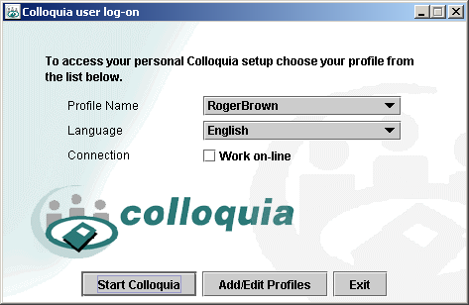

There are a number of language options available and you may select the language of your choice from the Language Drop-down Menu.

If you tick the Work on-line checkbox, your computer will automatically go online and get your messages every time you start Colloquia.

If you have already set up a user profile, select your profile name and click on Start Colloquia.

If you have launched Colloquia by mistake, click on Exit to return to your desktop.

Adding a profile

If this is the first time Colloquia has been launched, there will be no user profiles and the Start Colloquia Button will be greyed out. To add yourself as a new user, click on the Add/Edit Profiles to access the Profiles Wizard:

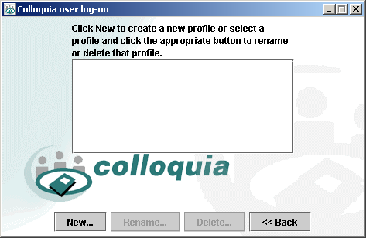

Click on New… to go to the next window and type in a profile name in the Profile Name Field, e.g. your own name but do not use characters that your computer’s filing system will not like, such as “*” or “?”.

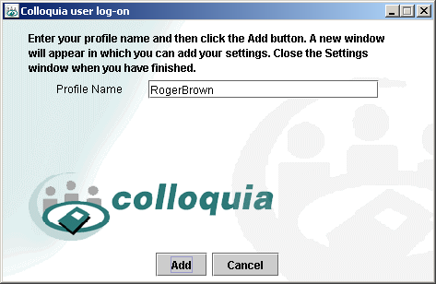

Click Add to

launch Colloquia and to access the Preferences Window. You must now provide the necessary e-mail details in order for the program’s messaging system to work (see the Setting Preferences section).

If you select Cancel, you will be returned to the Add/Edit Profiles Window.

When you launch Colloquia subsequently, all you need to do is display your profile, click in the Work on-line Box to work online or unchecked to work offline, and click on Start Colloquia.

[NB: if you tick the Work online Box, Colloquia will assume you have made a connection to the Internet, and will try to get your messages immediately. If this box is unchecked, then you will have to get your Messages after loading Colloquia.]

Editing or deleting a profile

You can change a profile name displayed by clicking on Add/Edit Profiles to access the Add/Edit Profiles Window. Highlight the appropriate Profile Name and click Rename…. You will then be prompted to change the highlighted name. Make your changes and click OK. If you have made a mistake, click on Cancel to return to the Add/Edit Profiles Window.

If you wish to delete a Profile Name, highlight the appropriate Profile Name and click Delete… to access the Delete Options:

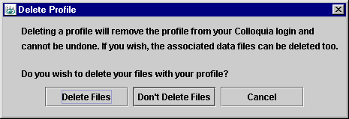

If you select Delete Files, your profile and all the associated data, such as Activities and Resources, will also be deleted. NB: You will not be able to retrieve this data once it has been deleted.

If you select Don’t Delete Files, only your profile will be deleted. The Activities and Resources will still be accessible for reinstallation if necessary. You may want to choose this option if you have two profiles as a result of having two separate email addresses pointing to the same data. If you were to select Delete Files at this point, you would delete the data to which your other profile was pointing and you would no longer be able to retrieve it.

Setting Preferences

When you first set up a new profile, you will be able to access the Preferences Window.

My Details

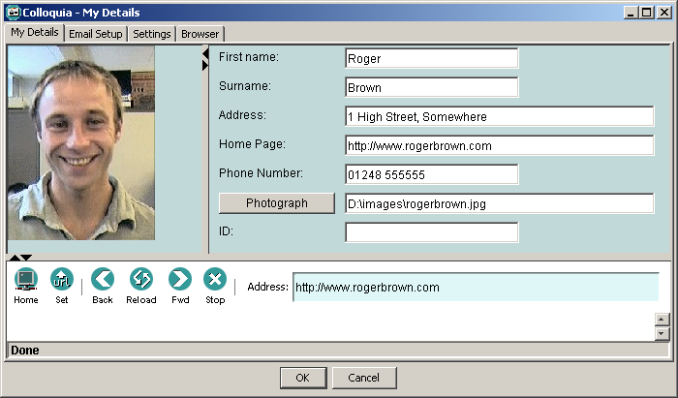

You MUST enter your First Name and Surname in the first two fields. The other information is optional. You can browse for a photograph by clicking on Photograph from where you can browse for a photograph, which will be shown in the left-hand frame.

If you decide to enter an address for your home page, you can check that you have done this successfully by using the browser window (the lower frame) by clicking on Home .

(You can come back to this screen at any time to change the information by clicking on Prefs on the Colloquia Toolbar or by selecting My Details from the Edit Menu.)

Email setup

Clicking on the Email Setup Tab at the top of the screen in will give you the Email Setup Window. It is of crucial importance that the details required be entered correctly as the example shows:

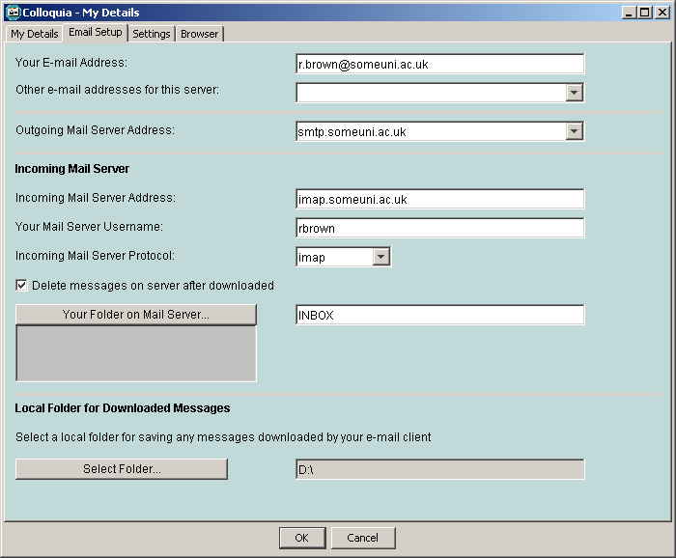

Appendix 3 explains the meaning of these settings. You can get these from your Internet Service Provider, or by checking your normal email client for this information. In Outlook Express 5, this can be found under Tools, Accounts, Mail. In Netscape Messenger 4, the same information is under Edit, Preferences, Mail & Newsgroups.

Using a POP email account

If you have to use a POP email server for your incoming messages, there is a danger that Colloquia messages could be diverted or lost by your normal email client. A POP email account involves downloading all your email from the email server to your local storage space, like your hard disk. If you check your email BEFORE checking for Colloquia messages, then your Colloquia messages will be downloaded by your email client and saved onto your disk BEFORE they can be accessed by Colloquia. Within your email client you will see them listed, and if you try to open one, you will see a similar message to “This is a Colloquia message”. You will also note that there is an attachment to this message. Save this attachment in a folder on your hard disk, and make sure that the name of this folder is the same as entered in your Colloquia email settings under Local Folder for Downloaded Messages.

So, to recap, create a folder in your Colloquia email settings under Local Folder for Downloaded Messages, and make sure that any Colloquia message attachments that end up in your normal email inbox are always saved in this folder.

To avoid this cumbersome approach we have three recommendations, as follows:

- Use a separate email account just for Colloquia OR
- Use IMAP instead of POP, and ignore Colloquia messages that appear in your email client (do NOT delete or save them) OR
- Always check for Colloquia messages BEFORE checking your normal email.

Other settings

Click on the Settings Tab to access the Settings Window. This window contains a number of settings that allow you to control how Colloquia looks and operates.

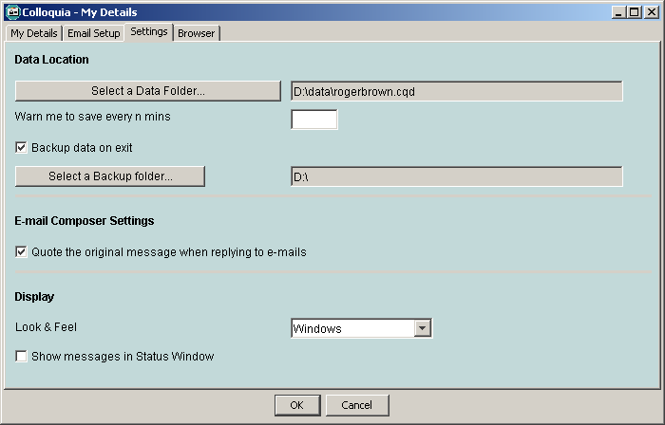

The Data Location is where all your Colloquia information is stored, including Messages, Resources, information on People, and so on. It always ends in .cqd (for ColloQuia Data). We advise, for simplicity’s sake, that you use the default folder – but you can change it if you wish by clicking on Select a Data Folder….

You will be prompted to make a backup to your hard drive every time you leave Colloquia if you put a tick in the Backup data on exit Box. We recommend that you use this option if you wish to secure archived safety copies of your data although you may not wish to do this every time you exit Colloquia. The backup file location can be changed if needed by selecting Select a Backup Folder…. This could be set to backup to a zip drive, for example, and then restored on a different machine.

If you put “5” in the Warn me to save every n mins Box then you will be reminded every 5 minutes that you should save your work by a flashing Save icon on the main Colloquia toolbar (you can choose to ignore these warnings!).

If you want to quote messages to which you are replying, put a tick in the Quote the original message when replying to e-mails Box.

There are various options for the Look & Feel of Colloquia. Windows users can have the traditional look and feel, Mac users can have the look and feel they are used to, and there are also some Unix look and feels. Choose the one you like from the menu provided.

If the Show messages in Status Window Box is ticked, this will allow you to see any error/warning messages that may occur.

Browser settings

Click on the Browser Tab to access the Browser Settings Window. This window contains a number of settings that allow you to control how the Colloquia internal web browser operates.

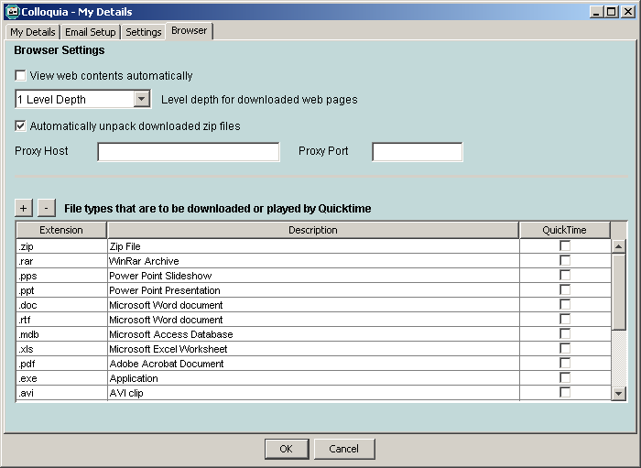

View web contents automatically - Ticking this box will allow web pages to display as soon as you click on the Resource’s name. You should only tick this if you always work online. If you work offline, then having this box ticked will result in Colloquia trying to access the Internet, and your machine launching its dial-up connection.

Level depth for downloaded pages - Colloquia allows you to save web pages including all graphics and links. If you only want to save a single page and its graphics, then select 1 Level Depth. If you want to save the page and all the pages linked from it, then select 2 Level Depth, etc. We strongly advise that you keep this set at 1 Level Depth unless you have a specific requirement. For example, if every page has an average of five links on it, then two levels will result in six pages being downloaded, three levels will result in 31 pages being downloaded, and so on. If you are not careful, you could easily end up saving whole websites!

Proxy Host and Proxy Port – If you need to connect to the internet via a Proxy server, you may enter the Host and Port settings. If you are not sure about this, leave these fields blank.

Automatically unpack downloaded zip files – This allows any zip files that have been downloaded from an FTP URL in a Colloquia Resource to be automatically unpacked and referenced in the Local File field of the Resource (see Saving a non-web Resource for further details.) If this option is set, downloaded zip files are automatically unzipped into a user specified folder and the first file contained in the zip file is automatically referenced in the Resource's Local File field.

Note – if there is a simple text file called startfile placed in the zip file, the file name that is in this will be the file that is referenced in the Local File field. For example, a tutor may wish to create a Resource that consists of many dependent files with one main file as the file to launch. These files could then be packed into a zip file together with the text file named startfile. The startfile would contain one line of text – the name of the starting file to be launched. See Appendix 7 – Setting up zipped Resources.

File types that are to be downloaded or played by QuickTime – Normally, a URL is displayed in the Colloquia web browser as a web page. Usually this will be an HTML file. However, some types of web page or file are not meant to be displayed as HTML text and graphics and will require a special plug-in or player in order to display them. By specifying a file extension here, the browser will know that the file type is to be downloaded or played by QuickTime instead of displayed in the browser. For example, zip files have the .zip extension and will be downloaded and saved as local files on your computer. If the file is a media file, such as an mp3 file, simply checking the QuickTime tick field will ensure that it is played by the QuickTime Player.

In order to play QuickTime media files you will have to install QuickTime on your computer. See Appendix 9 – Installing QuickTime

To add a new file type, click the plus (+) button and fill in the appropriate fields in the new blank row that will be inserted at the end of the list. Don’t forget to add a dot (.) at the start of the extension type. Entries may be removed with the minus button (-).

Click on OK once you are happy with all of your settings and they will be automatically saved. You can now start using Colloquia.

The Colloquia Screen
Navigation Frame (Tree)
Main Frame
Toolbar

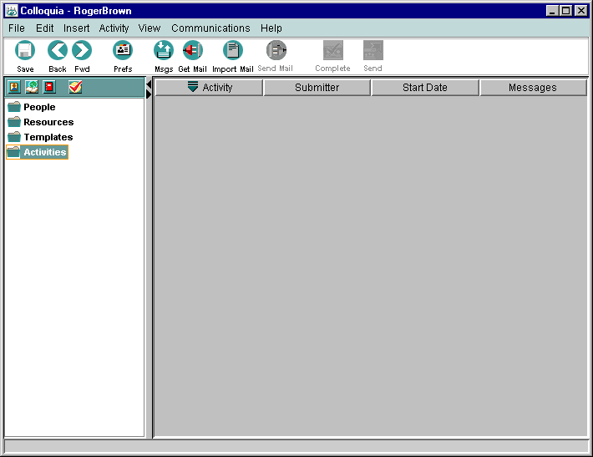

The Colloquia main window is made up of several frames:

- The Toolbar allows frequently used features to be easily invoked with a single click. Leaving your pointer over an icon also brings up more information on precisely what the button is for (these are called “tool tips”).

- The Navigation Frame (or Tree for short) is where all Colloquia information is navigated. Initially it contains four folders - People, Resources, Templates and Activities (or Groups).

- The Main Frame is where Colloquia information is displayed. It is often divided into two sub-frames, and at different times displays Messages, Resources and information on People.

The Toolbar

The buttons on the toolbar have the following functions:

Save | Saves all your work. This can be set to flash as a reminder to save your work every few minutes, as set in your Preferences.
Back Fwd | Allow you to move back and forth across the various nodes that you have traversed within the Colloquia tree.
Prefs | Brings up the Preferences/My Details Window, described earlier in this document.
Msgs | Brings up the Message Centre, containing links to all the Messages you have received and sent.
Get Mail | Connects to your email and downloads Colloquia Messages into Colloquia.
Import Mail | Imports any Colloquia Messages that have been saved locally with your normal email client.
Send Mail | Sends all Messages listed in your Message Centre Outbox.
Complete | Completes an Activity you are involved in, informing other members of that Activity group.
Send | Sends any Activity or group you have created to its participants and/or invitees.

These functions are described in detail in later sections of this document.

The People Folder

What it is for

The People Folder is where all the people who are members of any group you are involved in are listed. Double clicking on the People Folder opens it, and displays the list of people underneath, whilst the Main Frame displays their names and email addresses. These can be used for sorting the list of people. Here is an example of the People Folder:

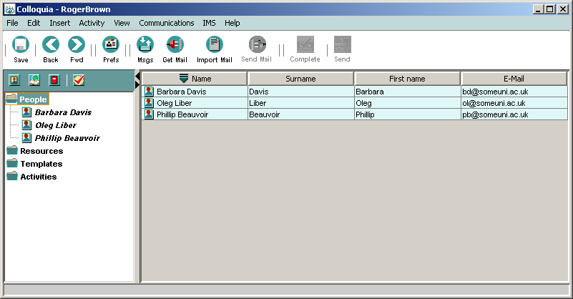

Clicking on a Person in the tree highlights their name and displays their information:

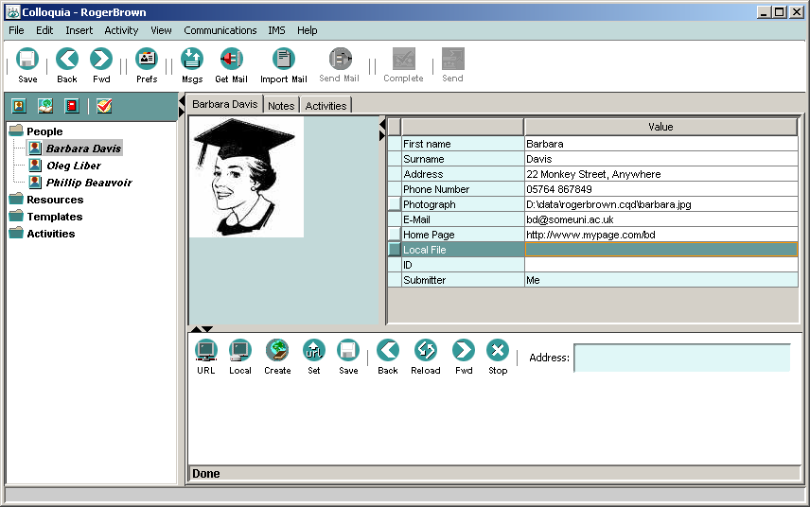

Adding a person manually

To add a person, click on the People Folder once to highlight it. Then select New Person from the Insert Menu, to give you the dialogue box:

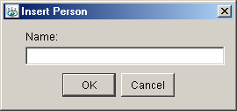

Enter a name and click OK (this need only be a short name if you so wish). This name will appear inside your People Folder, and you will be able to add further details in the Main Frame. Here is an example of a new person called Tom Smith.

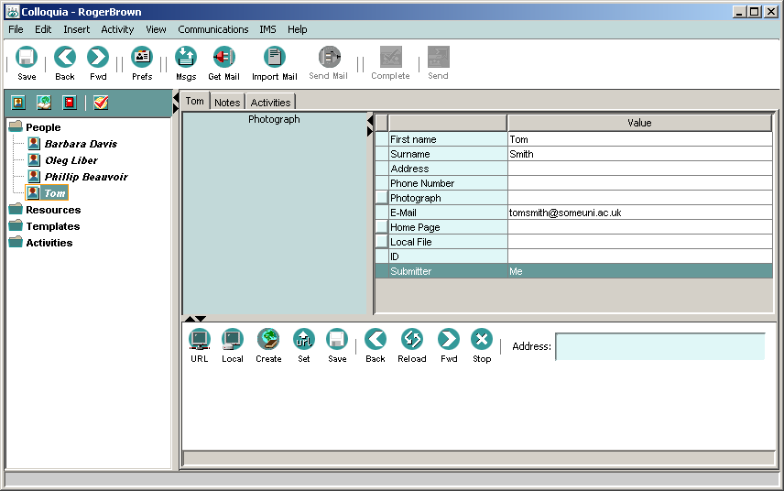

Notice that in the tree, he has been added simply as “Tom”, but in the Main Frame, his first name and surname have been added, as well as his email address. Double click inside each field, enter the information and then press Return to add further details.

You can enter all the other information, including browsing for and finding a photo or picture for Tom (a .GIF or .JPEG file), just as you did when setting up your details earlier. You can also resize the photo frame, and the image will adjust itself to fit. However, this will be overwritten when Tom updates you with his details, so it might not be worth doing.

If you have input a URL for the person’s home page, then you can view this using the built in browser in the bottom half of the Main Frame. Click on the URL Button , and the web page will be displayed, but make sure you are connected to the Internet when you do this.

[NB: you can also save the person’s home page locally, and view it offline – this is explained in the section on Saving A Web Resource.]

Sorting People

You can sort people in the People Folder according to their short name (in the tree), their first name, their surname or their email address. Click on the People Folder to highlight it and to display the list of people in the Main Frame. Clicking on each heading causes the list to be sorted alphabetically by that heading. Clicking on the same heading again reverses the direction of the sort (i.e. from ascending to descending). Any sort you do is reflected in the list of people in the People Folder on the tree.

Putting People into sub-folders

You can put groups of People into folders to help manage the long list that you will eventually get in your People Folder. This is done by first inserting a new folder, and then dragging people into it, as follows:

Highlight the People Folder with a single click. From the Insert Menu select New Person Group. In the dialogue box, enter a name for it and click OK. A sub-folder with that name will appear inside your People Folder.

To copy a Person into the sub-folder, simply click on the Person, hold down the left mouse button, and drag that Person until the pointer is over the sub-folder. Then release the mouse button (this is called “drag and drop”). You will see the Person’s name appear inside the sub-folder AS WELL as remaining in the parent folder – they have been copied into the sub-folder.

To copy a person into the sub-folder and remove them from the parent folder, do exactly the same as above, but hold down the Ctrl Key after clicking on the Person to be copied.

Once you have sub-folders in place, you can add new people directly into them by highlighting the sub-folder first, and then following the process in Adding A Person Manually.

Other ways People get added to your People Folder

When receiving Activities sent to you

When you begin to use Colloquia, you will receive and join in Colloquia Activities others have set up and asked you to join. These will usually include several other people, who as well as appearing in the Activity Folders, will also get added automatically to your People Folder. However, you will not be able to change any of their details.

Comment: The list of people with whom you interact will grow depending on how wide the range of Activities is in which you are involved. You can also create new Activities to which you can invite and introduce people that you met in different Activities. In this way, Colloquia can be seen as a tool that helps with networking.

Importing People

If you already have a list of people you need to enter into Colloquia in a spreadsheet or database, you can import them into Colloquia. First, you need to reorganize the fields in the spreadsheet or database like this:

Surname, first name, address, phone, email address, and ID (even though some of these may be blank)

and then save the spreadsheet or database file in tab delimited format.

Finally, highlight the People Folder with a single click, and select Import People from the File Menu. Browse and find the tab-delimited file, select it, and the list of people will be imported and appear in your tree.

Take care with this – it is very easy to get text in the wrong fields!

Adding People directly to an Activity Folder

You can add people directly to an Activity Folder that you are setting up. This is done in exactly the same way as adding them to the People Folder, except that you first highlight the Activity Folder with a single click instead of the People Folder (see Adding A Person Manually).

Using the Notes Tab

You will have noticed that when you are viewing information about a person that there are three tabs at the top of the Main Frame: one has the person’s name, the next is entitled Notes, and the third is called Activities. If you click on the first tab, you will be given the person‘s details. If you click on the Notes Tab, you will be given a blank frame where you can write some private notes about the person – these will only be viewed by you, and will not be sent out to anyone under any circumstances whatsoever.

Simply click on Edit , and you will be given a few simple formatting tools. Click in the white space, and type your notes, using the formatting tools on the toolbar to enhance your text. The formatting tools are fully described in Appendix 5.

When you have finished editing, click on View to get rid of the formatting tools.

The Activities Tab

Clicking on a person’s Activities Tab while in the People Folder displays a list of the Activities you and they have in common, the date it ended (or is due to end), and any grade they may have been given (but only if you are their tutor in that Activity).

You can navigate directly to that Activity by double clicking anywhere on the row that contains its name.

Comment: this allows a tutor to track all the courses and sub-activities on which they teach the student.

Deleting a Person

You can only delete a person from your People Folder if that Person is not involved in any of your Activities. If this is the case, their name will be in italics. Otherwise, you will have to find all the Activities they appear in (using the Activities Tab), delete them from those, and then delete them from the People Folder. If a person belongs to an Activity initiated by someone else, then you will not be able to delete that Person until that Activity is completed.

To delete a Person, highlight their name and select Cut Tree Node from the Edit Menu.

The Resources Folder

What it is for

The Resources Folder is where all your references to materials are listed. These are typically web-based Resources, which can be displayed or downloaded from a web or ftp server. However, other Resources can be listed here, such as those that have a local file reference, or even a physical location.

Resources can be organized into folders for easy management, and you can track which Activities they are used in.

Web Resources can be saved locally and displayed when offline. Locally stored Resources that cannot be displayed with the web browser will launch the appropriate application (e.g. Adobe pdf files will launch Acrobat Reader). Online Resources that cannot be displayed with the web browser will be saved locally, and can then be displayed.

Double clicking on the Resource Folder opens it, displaying the list of Resources underneath, and the Main Frame displays information about the Resources. These can be used for sorting the list of Resources:

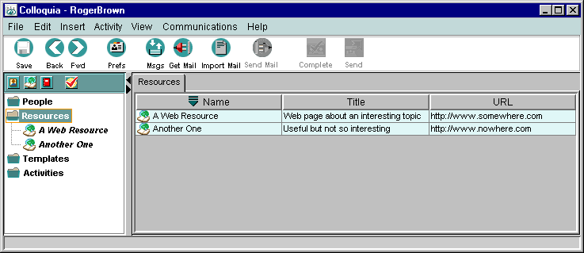

Highlight the Resource name by clicking on it to display its information:

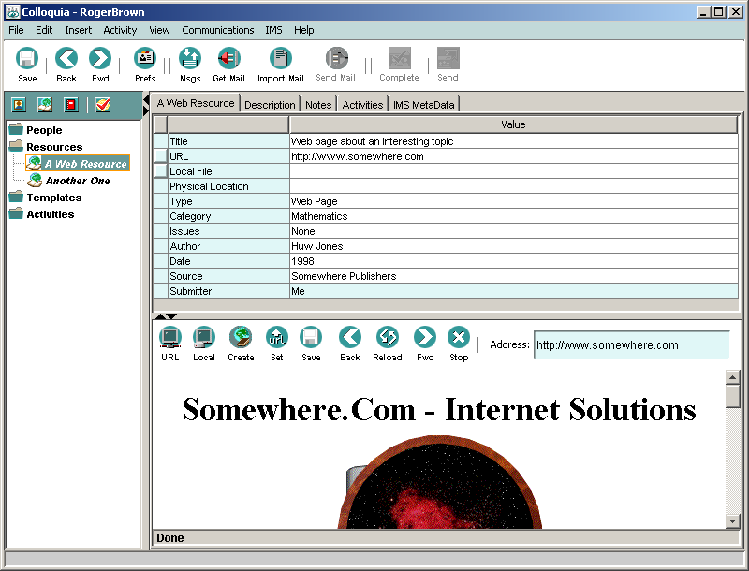

You can view a description of the Resource (if there is one) by clicking on the Description tab. You can view the Resource itself by clicking on the URL Button in the Browser Frame (make sure you are connected to the internet first).

Displaying the Resource in an external browser

You may prefer to view the Resource in an external browser, such as Netscape or Internet Explorer. This allows you to access all web content using your preferred web browser instead of Colloquia’s built in browser. You should do this if the web content you need to use does not display properly (e.g. if it requires a special plug-in). You can specify this for each Resource by clicking on the button next to the URL field:

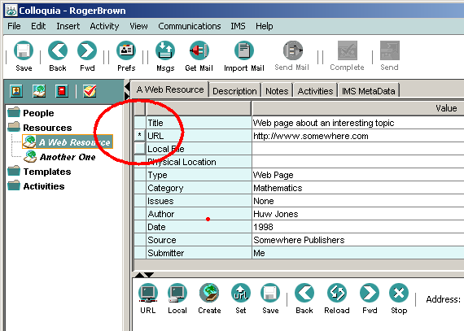

An asterisk will mark that the Resource is to be displayed in the external browser when the URL/Display Resource button in the Browser Frame is pressed. This can be toggled off in the same way.

Saving a Web Resource
You can save a web Resource locally by clicking on Save in the Browser Frame. You will see a progress meter like the one below while the Resource is being saved.

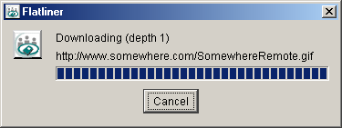

As soon as the Save has completed, a reference will be automatically added to the Local File Field, and from now on, you will be able to display the locally saved version by clicking on the Local Button in the browser. The web page, all its graphics and links will be saved. If you have set the depth to greater than one (see the Other Settings Section), then linked pages will also be saved locally.

Saving a non-web Resource

If the Resource is not a web page, for example a pdf file, then the internal Colloquia browser cannot display it. Clicking on the URL Button in the browser will cause the file to be saved locally (e.g. on your hard disk) at a location of your choice.
As soon as the Save has completed, a reference will be automatically added to the Local File Field, and from now on, you will be able to display the locally saved version by clicking on the Local Button in the browser.

If the file does not display correctly in the browser and you know that it should be a file that is to be downloaded, then you may set the file type as downloadable in the Browser Settings of the Preferences page (see Browser Settings.)

Some zip file types can be automatically unpacked and referenced if you wish – see Automatically unpack downloaded zip files for more details.

Adding a new Resource

If you know its URL

To add a Resource to your Resources Folder, click on it once to highlight the folder. Select New Resource from the Insert Menu, to give you the dialogue box below.
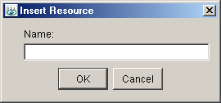

Enter a name and click OK (this need only be a short name if you so wish). This name will appear inside your Resources Folder, and you will be able to add further details in the Main Frame. Here is an example of a new Resource called “eLearning”:

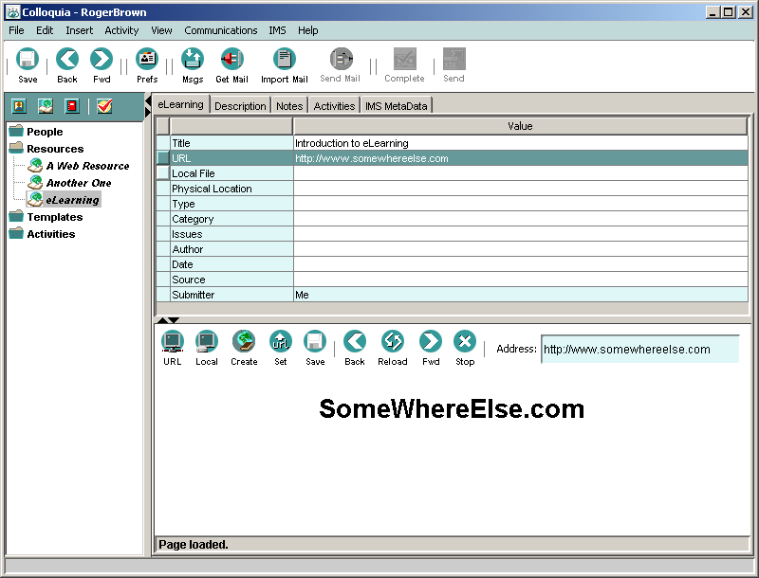

Notice that in the tree, the Resource has been added simply as “eLearning”, but in the Main Frame, the full title has been added, as well as various other details. Double click inside each field, enter the information and then press Return to add further details.

If you have put in a URL for the Resource, then you can view this using the built in browser in the bottom half of the Main Frame. Simply click on the URL Button , and the web page will be displayed – but make sure you are connected to the Internet when you do this. You can also save and then view a local version, as described in the Saving A Web Resource Section.

You can add any Resource that can be downloaded from a web or ftp server, even if the browser cannot display it – these will simply be saved instead of displayed (see the Saving A Non-Web Resource Section).

Directly From the Browser

A typical way of adding Resources is to browse or search the web using the browser, and reference it when you have found one you want to add to your Resource Folder. Simply click on the Create Button in the browser to do this. This will give you the New Resource dialogue box and from here the process is identical to that previously described in the If You Know Its URL Section.

Updating a URL

If you find that a URL has changed for one of your Resources, you can use the browser to find the new location, and then click on Update URL in the browser. This will update the URL in the Resource’s URL field (assuming this information is currently displayed – if you do not take care you could easily update the wrong Resource!)

Describing Resources

When displaying a Resource, there are four tabs at the top of the Main Frame. One has the name of the Resource, and clicking on this displays the Resource’s basic information. The next tab is entitled Description. Clicking on this will either display a textual description (if someone else has sent this Resource to you) or a space where you can type your own description of the Resource. Simply click Edit , and you will be given a few simple formatting tools. Click in the white space, and type your notes, using the formatting tools on the toolbar to enhance your text. The formatting tools are fully described in Appendix 5.

When you have finished editing, click on View to get rid of the formatting tools. This description will be sent with the Resource when you use it within an Activity.

Adding Personal Notes

You can also add personal notes about the Resource. Click on the Notes Tab, and then add notes in exactly the same way as adding a description. The only difference is that notes are private – they DO NOT get sent out with the Resource.

Finding out where the Resource is used

Clicking on a Resource’s Activities Tab while in the Resources Folder displays a list of the Activities the Resource is being (or has been) used in, its URL and who contributed the Resource. You can navigate directly to any of these Activities by double clicking anywhere on the row that contains its name.

Comment: this allows a tutor to track all the courses and sub-activities that use the Resource.

Deleting a Resource

You can only delete a Resource from your Resources Folder if it is not used in any of your Activities. If this is the case, its name will be in italics. Otherwise, you will have to find all the Activities it appears in (using the Activities Tab), delete it from those, and then delete it from the Resources Folder. If a Resource is used in an Activity initiated by someone else, then you will not be able to delete it until that Activity is completed.

To delete a Resource, highlight its name and select Cut Tree Node from the Edit Menu.

Putting Resources into Resource Groups

You can put groups of Resources into folders to help manage the long list that you will eventually get in your Resources Folder. First insert a new Resource Group Folder, and then drag Resources into it, as follows:

- Highlight the Resources Folder with a single click. From the Insert Menu select New Resource Group. In the dialogue box, enter a name for it and click OK. A sub-folder with that name will appear inside your Resources Folder.

- To copy a Resource into the sub-folder, simply click on the Resource, hold the left mouse button down, drag the Resource until the pointer is over the sub-folder. Then release the mouse button (this is called “drag and drop”). You will see the Resource’s name appear inside the sub-folder AS WELL as remaining in the parent folder – it has been copied into the sub-folder.

- To copy a Resource into the sub-folder and remove it from the parent folder, do exactly the same as above, but hold the Ctrl Key down throughout the whole process.

Once you have Resource Groups in place, you can add new Resources directly into them by highlighting the sub-folder first, and then following the process in the Adding A New Resource Section.

Other ways Resources get added to your Resources Folder

When receiving Activities sent to you

When you begin to use Colloquia, you will receive and join in Colloquia Activities others have set up and asked you to join. These will usually include a range of Resources, which as well as appearing in the Activity folders, will also get added automatically to your Resources Folder. However, you will not be able to change any of their details.

Importing Netscape Bookmarks

You can import Netscape Bookmarks into your Resources Folder as follows:

- Highlight the Resources Folder with a single click
- Select Import Netscape Bookmarks from the File Menu
- Browse and locate a Netscape Bookmarks file and click Open.

The whole file will be imported, including any folder structures into a sub-folder of your Resources. You can now amend any of the information about each bookmark.

Importing Internet Explorer Favourites

You can import Internet Explorer Favourites into your Resources Folder as follows:

- Highlight the Resources Folder with a single click
- Select Import Internet Explorer Favourites from the File Menu
- Browse and locate your Internet Explorer Favourites folder and click Open.

The whole folder will be imported, including any folder structures into a sub-folder of your Resources. You can now amend any of the information about each favourite.

Receiving a contributed Resource

If you have set up the Activity to receive contributed resources, you may receive Resources from Activity members, with requests to include the Resource on your activity. The new Resource will appear in your ‘unread’ folder, and the Activity will be marked as ‘Hot’. If you decide to share the Resource with other Activity members, you need to update the Activity. Alternatively, you may delete the Resource.

Creating a complete Resource

Quite often people want to create a new Resource from scratch. This might be a Word document, a web page, or anything else that can be made on a computer. Once it has been created, it needs to be put on a server to be accessible to others. Colloquia provides support for the uploading of such a Resource to an ftp site.

Before you start, you need access to an ftp site, and permission to upload files to it. Usually this involves you having an address for it (e.g. ftp://ftp.some.site.com/myspace/), an ID (e.g. jon999) and a password (e.g. drowssap).

This example assumes you have already made a Resource that is a .pdf file and is saved on your disk with the title “MyResource.pdf”. You need to be connected to the Internet to do this.

- Create a new Resource in your Resource Folder, e.g. called “My Resource” as described in the Adding A New Resource Section.

- Now we need to set the location of the file. Click on the Local File button in the Resource’s data sheet:

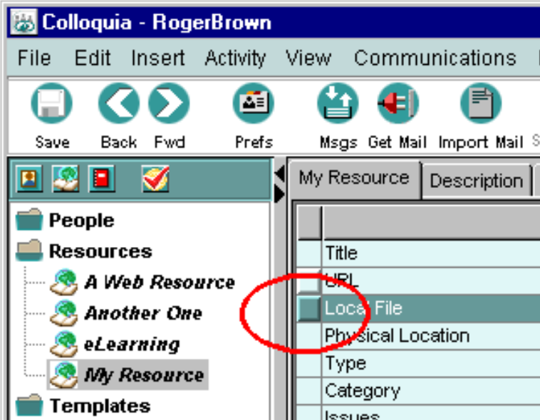

- Browse your disk until you have located the file, and click Open. The Local File path is set to your selected file.

- You may add other details and a description if you wish.

- From the Communications Menu, select Upload Resource. The following figure shows an example of the completed Upload Resource screen but make sure you have your own details. The Wizard will guide you through the rest of the process.

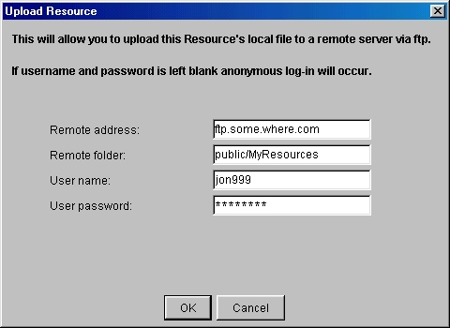

When you click OK, the file will be uploaded, and the appropriate URL will be inserted in the URL Field.

If the ftp site requires password access for those intended to access the Resource, they will be prompted for an ID and password before they will be allowed to save or display the Resource. Once you have completed this, the information will be stored for next time.

Contributing a Resource

You may offer a Resource to the owner of the Activity, provided that they have allowed this when they set up the Activity. To find out if this is the case, right-click on the Activity on the tree, and select Activity Properties. To add the Resource, place it in the Activity using copy and paste, or drag and drop. Then select Send Resource from the Communications menu.

Note – the Send Resource option will be greyed out if the parent Activity is not set to accept Resources. Also there are a number of conditions that apply as to whether you can send the Resource depending on whether the Resource is yours and where you have selected it in the tree:
- If you select a Resource that you have created in a Resource Group (i.e. you have selected the Resource “globally”), you can send it to everyone who is a member of an Activity that you created where this Resource occurs.

- If you select a Resource that you have created in an Activity that you have created, you can send it to every active member of that Activity (you can also use this option to update Activity members with a new or changed Resource without sending the parent Activity again).

- If you select a Resource that you have created in an Activity that you have not created, you can send it to the creator of that Activity and they can then choose whether to send it on to the other members of the Activity.

Messaging in Colloquia

Colloquia has a number of unique messaging features, and offers a number of ways of navigating your Messages. Before we explain how to engage in Colloquia Activities, here is an overview of the key concepts and facilities provided to help with messaging.

You can receive six types of Message:

An invitation to join an Activity
An update of an Activity
A Group (shared) Message relating to an Activity
A personal Message from someone in one of the Activities of which you are a member
An Assignment or Assessment
Details about a Person (their full name, photograph)
A new or updated Resource.

All Messages received are immediately put in their proper locations, as follows:

- Activity invitations appear within the Activities Folder in your Colloquia tree.
- Updates to existing Activities appear within the Activities Folder in your Colloquia tree.
- Group Messages about an Activity can only be viewed from within that Activity. New Messages are indicated by the number of unread Messages, e.g. “(3 unread)”, next to the Activity’s name.
- Personal Messages about an Activity can only be read from within the Activity. New Messages are indicated by the number of unread Messages, e.g. “(2 unread)”, next to the Person’s name within the Activity.
- Assignments appear within the Activity Folder to which they belong.
- Personal details replace that Person’s details everywhere they appear in your Colloquia tree (the People Folder and all the Activities in which they are involved.
- Resources appear within the Activity to which they belong (and in your Resources Folder).

Information about the number of messages and whether they have been read or not can be obtained by:

- Group Messages – The number of unread messages is displayed in brackets against the Activity name on the tree, e.g. “(3 Unread)”. Hovering the mouse cursor over the Activity name on the tree allows a tool tip to display the number of total Group messages for that Activity, e.g. “Messages: 2”

- Personal Messages – The number of unread messages is displayed in brackets against the person’s name in the Activity on the tree, e.g. “(3 Unread)”. Hovering the mouse cursor over the Activity name on the tree allows a tool tip to display the number of total Group messages for that Activity, e.g. “Messages: 2”

It is very important to note that unlike most email clients, Messages are NOT read from within an Inbox. They are always read IN CONTEXT – i.e. from within an Activity. By casting your eye down your (opened) Colloquia Activities Folder, you can quickly see where you have unread Messages.

As a further aid, Colloquia provides a Message Centre , accessible from the Colloquia Toolbar, which provides a catalogue of all Messages you have received and sent:

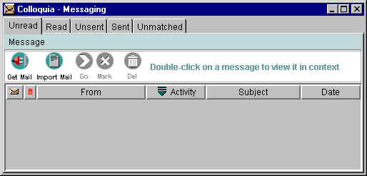

At the top of the Message Centre are five tabs entitled: Unread, Read, Unsent, Sent and Unmatched.

Clicking on each in turn gives you a list of Messages.

- The Unread list displays all Messages (of any sort) received and not yet read. As soon as they have been read, they are automatically removed from this list.
- The Read list contains all the Messages you have received and read (transferred from the Unread list).
- The Unsent list contains all the Messages you have written but not yet sent.
- The Sent list contains all the Messages you have written and sent.
- The Unmatched list contains any Messages that to not appear to have a location. This would normally be empty, but there are some unusual circumstances when you might get a Message that has no home (e.g. if your email delivers a Message BEFORE you have received its Activity).

You can delete any item in a list by highlighting it and clicking Delete . You can select multiple items by holding down Shift or CTRL and clicking on them.

Similarly, you can mark messages as being read by clicking the Mark button. Effectively, this marks the message as being read and places a copy of it in the Read list.

You can use the Message Centre to navigate to any of the Messages. Double-click on a Message, and you will be taken to the correct place in Colloquia where the Message is located, and it will be displayed. You can use the Message Centre to:

- Make sure you have read all new Messages
- Find old Messages whose location you cannot remember.

The Message Centre toolbar also allows you to check for new Messages on your Mail server by clicking on Get Mail (the same as on the main Colloquia toolbar, see the Receiving Messages in Colloquia Section).

It also allows you to import any Messages you might have saved on you disk using your normal email client, as described in Email Setup Section.

Clicking on Send Mail , which also appears on the main Colloquia Toolbar, can send any Unsent Messages. They can also be re-edited by double clicking on them, which will put you back in context (i.e. back in the Activity to which they belong).

Remember – entries in the Message Centre are pointers to the actual message. To view a referenced message you need to double-click on the row in the message table to be taken to the message in its Activity context. Thus, deleting a message reference in the Message Centre table does not actually delete the original message.

Receiving Messages in Colloquia

In most circumstances, you would set Colloquia up to automatically get Messages on loading the software (by ticking the Work on-line box in the Login Window), or you would get your Messages as follows:

Click on Get Mail on the Colloquia Toolbar or choose Get Mail from the Communications Menu.

You will be asked to enter your email password and your Colloquia Messages will be downloaded. Finally, you will be told how many Messages you have received.

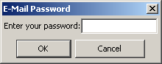

Wait a few minutes while your mail is downloaded.

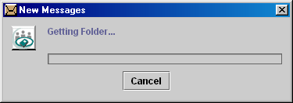

Once all the Messages have been downloaded, you will see a Message informing you of how many Messages have been received:

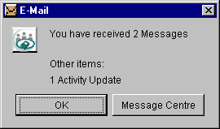

If you click on Message Centre, you will be put in the Message Centre, from where you can get to any Message by double clicking on it (see the Messaging in Colloquia Section). If you click on OK, you can look at the Activities tree to see where any unread Messages are located.

Activities

Colloquia Activities are the heart of the system. The word “Activity” can represent a wide range of entities. An Activity might be used to represent a whole course, or a module, or a unit of learning Activity, or a project team, and many more things we have not even thought of.

An Activity has a description, objectives and is “initiated” by a single person who controls what happens to it. Typically it “contains” a group of people, a set of (optional) Resources, and (optionally) an assignment or task. It can also contain sub-Activities that have People, Resources and Assignments and… sub-Activities ad infinitum.

Sub-activities can be set up by any of the participants in the parent Activity and do not have to include all the People in the parent Activity (not even the person who set up the parent Activity). Sub-activities can also include People who are NOT in the parent Activity.

While this might seem surprising at first, the reasoning behind this is straightforward. For example, an Activity might be a module set up by a university tutor, including all the students studying the module. One student might decide to set up a private study group to discuss the course content. S/he does not need to include the tutor in this, and might want to invite an old school friend studying the same subject at a different university to join.

Only those who are participants in a sub-activity will know that it exists.

The following section will take you through all that you can do with Colloquia Activities.

Receiving Activities in Colloquia

Activities arrive as Messages in Colloquia, first as invitations to participate that you can examine to decide if you want to accept them. If you accept an invitation, then you will receive an Activity update, which will allow you to see information on other People involved (i.e. those who have also accepted the invitation). You will also be able to look at Resources included in the Activity and to see any Assignment or task it might involve (if the Activity is a type of course). Most importantly, you will be able to participate in group and personal discussions in a unique, context based way. All discussions have a conversation thread – the Messages that you both send and receive are listed together to represent their proper sequence. You will also be able to undertake the Assignment and discuss it with the Activity initiator, and in some cases, contribute Resources of your own to the group.

The following sections describe how to do all of these.

Accepting or rejecting an invitation

Invitations to participate in Activities are automatically inserted in the tree with the icon and its name alongside. This icon indicates that you have not yet accepted (or rejected) the Activity.
If you click on an Activity you have been invited to, an Accept/Reject Wizard will be launched. If you accept the Activity, your correct personal details, which you entered when setting up your Colloquia, are automatically sent to the initiator, so that the e-mail address used is your preferred one. When you are editing your details, you should bear in mind that these will be sent to all participants whenever you accept an Activity.

Before you decide to accept or decline the invitation, you can look at the description and objectives of the Activity, as well as the titles of Resources to be used and the names of other People invited to participate (but not their details). At this stage, these are only displayed in the Main Frame and NOT in the tree.

Every time you click on the Activity, a dialogue box will appear, asking you to accept or decline the Activity. You can keep closing the box by clicking the Cancel Button, to allow you time to look at the Activity’s details. You can do this by clicking on the various tabs at the top of the Main Frame. Eventually, though, you will have to reply by clicking on either the Accept or Decline Button and on either Send Now (to send it immediately) or Outbox (to store it for sending later).

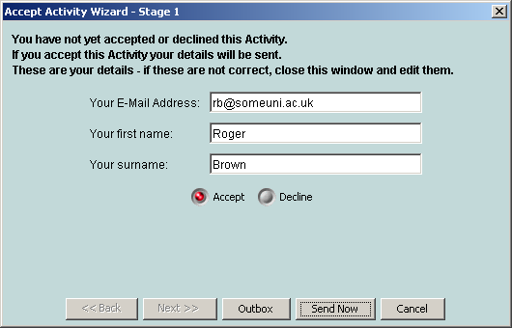

If you decline the Activity, the icon will change to . You may then delete the Activity by selecting Cut Tree Node from the Edit Menu.

If you accept the Activity, the icon changes to . This indicates that your acceptance has been sent. When the initiator of the Activity receives your acceptance, they will send an Activity update. When you receive this, the Activity will become live as indicated by the icon.

Examine the Activity by selecting its various contents (you can open and close an Activity by double clicking on it like any other folder). These are described below.

Resources

Items with the icon are Resources that the sender has provided for this Activity (e.g. a tutor may have provided learning Resources). These will also appear in your Resources Folder.

If you click on a Resource , you will see four tabs in Colloquia’s top right hand frame, and a web browser will appear in the frame below (with its own toolbar). Three of these were described in detail in The Resources Folder Section, and contain information about the Resource, as follows:

- The tab with the Resource’s name gives you information about it, including its URL
- The Description Tab tells you about the Resource
- The Notes Tab gives you a space to write your own notes about it
- The Activities Tab shows you all the Activities you are involved in that use this Resource.

Click on URL Button in the browser’s toolbar to display the Resource, if it is not already displayed (you will need a live internet connection).

Saving a Web Resource as a local copy
You can save a web Resource locally by clicking on Save in the browser frame. A progress meter will be displayed while the Resource is being saved.

As soon as the Save has completed, a reference will be automatically added to the Local File Field, and from now on, you will be able to display the locally saved version by clicking on the Local Button in the browser. The web page and all its graphics and links will be saved. If you have set the depth to greater than one (see Other Settings Section), then linked pages will also be saved locally.

Saving a non-web Resource

If the Resource is not a web page, for example a pdf file, then the internal Colloquia browser cannot display it. Clicking on the URL Button in the browser will cause the file to be saved locally (e.g. on your hard disk) at a location of your choice.
As soon as the Save has completed, a reference will be automatically added to the Local File Field, and from now on, you will be able to display the locally saved version by clicking on the Local Button in the browser.

If the file does not display correctly in the browser and you know that it should be a file that is to be downloaded, then you may set the file type as downloadable in the Browser Settings of the Preferences page (see Browser Settings.)

Adding Personal Notes

You can also add personal notes about the Resource. Click on the Notes Tab, and then add notes as described in the Adding Personal Notes Section, above. Remember that notes are private – no one else will have access to your notes.

Finding out where else the Resource is used

Clicking on a Resource’s Activities Tab while in the Resources Folder displays a list of the Activities YOU ARE INVOLVED IN and that the Resource is being (or has been) used in, its URL and who contributed the Resource. You can navigate directly to any of these Activities by double clicking anywhere on the row that contains its name.

People

Each Person node on the tree contains information about the other People on the course. All People sent with an Activity are also put into your global People Folder.

Click on a Person’s icon under the Activity node in the tree and you will see four tabs. Three of these were described in the earlier section on People:
- The tab with the Person’s name contains information on the student including their email address, and their photo if they have sent it to you
- Notes - where you can enter your own private notes about this Person
- Activities - which shows all the Activities this person has in common with you, and which you can use to navigate to these other Activities as before.

The fourth tab is entitled:

- Conversations - where private email exchanges with this Person about this Activity are stored, displayed and engaged with. This is described in the subsequent sections.

Messages

Reading a Message sent to the whole group

If you highlight the Activity itself (with a single click on its name), you are given a space for group conversations with ALL the people in that Activity.

[NB: all Colloquia Messages are ASYNCHRONOUS Messages, like e-mail, not instant or chat Messages.]
Highlight the Activity, with a single click on its icon . As before, several tabs (six in this case) will appear in the top right hand frame.

The first tab on the right hand side is the Conversations Tab, which has its own toolbar containing six buttons:

New Message
Edit/View Message
Reply to Message
Resend Message
Attachment
Delete a Message

Messages are listed below the toolbar and a selected Message is displayed in a viewing window lower down:

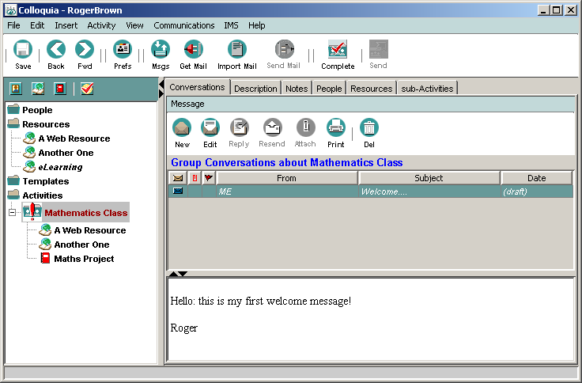

When you click on the Message title, the Message will be displayed in the bottom window.

Replying to a Group Conversation Message
With the Message selected, click on Reply on the Conversations Toolbar. A new window will open which will allow you to edit the title if you wish, and then to type your Message:

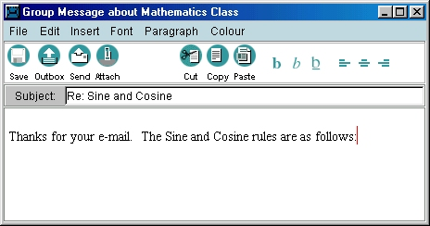

Click on Send Now to send it immediately or click on to put it in your Outbox for sending later.

Your reply will be sent (or stored in the Message Centre Outbox), and added to the list of Messages in the Conversation Index. If you wish to just save the Message as draft, click on Save As Draft . You can continue to edit the Message now or later by double clicking on it. It will remain in italics until it is sent.

Sending a New Message to the Group Conversation
If you click on New Message on the Conversations Toolbar, a new window will open, where all you have to do is:

- Enter a new subject
- Type your Message
Click on Send Now to send it immediately or click on to put it in your Outbox for sending later.

Your Message will be sent (or stored in your Outbox), and added to the list of Messages in the Conversation Index. If you wish to just save the Message as draft, click on Save As Draft . You can continue to edit the Message now or later by double-clicking on it.

Reading a Message sent just to you by an individual

Highlight the Person on the tree within the Activity, with a single click on their icon and then click on their Conversations Tab. You will see the Message title on the top right window (there may be several, including Messages you have sent to them):

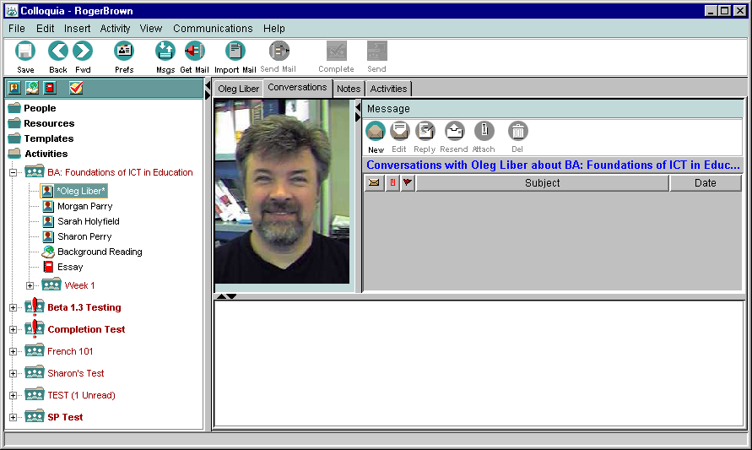

Note that the Person’s photo is displayed while you read and write Messages to them, and that the heading for the Message list reminds you what this “conversation” is about.

If you click on the Message title, it will be displayed in the bottom viewer window.

Replying to a Message from an individual
With the Message selected, click on Reply on the Conversations Toolbar. A new window will open, where all you have to do is:
- Give your Message a title
- Type your Message

Click on Send Now to send it immediately or click on to put it in your Outbox for sending later.

Your reply will be sent (or stored in your Outbox), and added to the list of Messages in the Conversation Index. If you wish to just save the Message as draft, click on Save . You can continue to edit the Message now or later by double-clicking on it.

Sending a new personal Message

Highlight the Person on the tree within the Activity, with a single click on their icon . Click on New Message in the Conversation Toolbar. A new window will open, where all you have to do is:

- Give a new subject
- Type your Message

Click on Send Now to send it immediately or click on to put it in your Outbox for sending later.

Your Message will be sent (or stored in your Outbox), and added to the list of Messages in the Conversation Index. If you wish to just save the Message as draft, click on Save . You can continue to edit the Message now or later by double clicking on it.

Attachments
Attachments can be added to Messages by clicking on Attach in the Message Box. In the next window, click Add and browse to the appropriate file(s). Click Add and then OK.
Likewise, Attachments to Messages sent to you can be read by clicking on Attach in the Message Box. In the next window highlight the Attachment and click View. Any Attachment will be displayed in its own application.

Sending all Messages in your Outbox

If you have been working offline and storing all your outgoing Messages in your Outbox, you can send them all at once by clicking on Send Pending Mail on the Colloquia Toolbar.

Re-Sending Messages

If a message has not reached the intended recipients, you can correct the error by clicking the Resend Button . This will re-send the message to all the original recipients, therefore some users may find a second copy of the message in their Inbox.

Marking Messages as “not read”

You may mark a message as not being read by clicking on the flag marker in the message table:

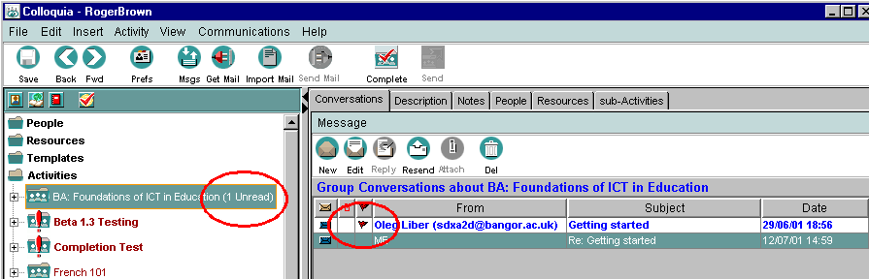

The message index entry will become emboldened and the Colloquia tree will show it as unread against the Activity.

Reading and submitting an Assignment

The Assignment is set by the Activity’s submitter and appears in the Activity tree with the icon. To see information about the Assignment, including when it has to be completed, and any associated web page, click on the Assignment you have been sent and then click on the Assignment Tab (top right hand frame).

Click on the URL Button on the Browser Toolbar to load the web page if there is one.

When you are ready to start the Assignment, click on the Workspace Tab and:

EITHER
Click on New Message in the Assignment Messages Toolbar. A new window will open, where all you have to do is:

- Enter a new subject
- Type your Assignment

Click on Send Now to send it immediately or click on to put it in your Outbox for sending later.

Your Assignment will be sent (or stored in your Outbox), and added to the list of Messages in the Conversation Index. If you wish to just save the Message as draft, click on Save . You can continue to edit the Message now or later by double clicking on it.

OR

If you decide to use some other application (like a word processor) to do it you can send it as an attached file by creating your Assignment using any application of your choice. In Colloquia, click on the Assignment you have been sent and then click on its Workspace Tab. Click on New Message on the Assignment Messages Toolbar. A new window will open, where all you have to do is:

- Enter a new subject
- Type a Message about your Assignment

Click on Attachments to find and attach the file(s) to your Message. Click on Send Now on the Assignment Messages Toolbar to send it immediately or click on to put it in your Outbox for sending later.

Your Assignment will be sent (or stored in your Outbox), and added to the list of Messages in the Assignment Conversation Index. If you wish to just save the Message as draft, click on Save . You can continue to edit the Message now or later.

You can add your own private notes on the Assignment by clicking on the Notes Tab, and entering your notes in the frame below.

Once your tutor has received your Assignment, they can send back comments to you, and if they wish, a grade. These appear as Messages from the tutor in the Messages panel in the lower right portion of the screen.

Creating your own Activities

Every user of Colloquia can also create and initiate their own Activities. In education, this means that everyone can set up a study group, which they are responsible for managing. In business or elsewhere, it means that any user can create an Activity centred on their concerns or interests, and invite others to join them.

As described earlier, an Activity contains:

People participating in the Activity
Learning Resources for that Activity
Sub-Activities, which contain:
Subsets of the People doing the Activity
Additional Resources (or subsets)
Sub-Activities, which contain:
…and so on.

The New Activity Wizard

When creating a new Activity, it is assumed that it has not yet started, and so it becomes a future Activity with the icon (reminding you it will need to be sent at some time).

To launch the Activity Wizard, which guides you through the process, highlight the Activities Folder in the left-hand frame with a single click and select New Activity from the Insert Menu:

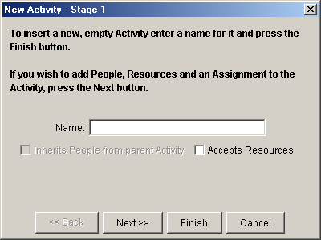

Enter a name for the new Activity and decide whether or not you wish to allow participants to submit Resources to your Activity – if so you should tick the box provided. Click the Next Button (or the Finish Button if you do not want to add People or Resources at this stage). You will be presented with the list of people in your People Folder:

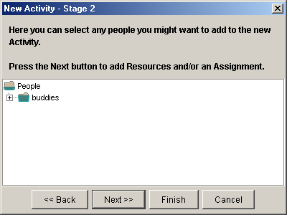

Select those people you wish to participate in your new Activity by using the Shift or Ctrl keys clicking on each Person (Macintosh users should use the Command Key instead of Ctrl). Shift click selects a block of People, whilst Ctrl click selects People one by one.

Click the Next Button and you will be presented with the list of Resources in your Resources Folder. Select those Resources you wish to add to your new Activity by Shift or Ctrl clicking on each Resource (Macintosh users should use the Command Key instead of Ctrl). Shift click selects a block of People, whilst Ctrl click selects Resources one by one.

Click the Next Button and enter a title for an (optional) Assignment. Click the Next Button and then click on Finish.

You will be given the option to click on Finish at every stage – you do not need to add People, Resources or an Assignment at this stage.

An Activity will appear in the tree with the icon. If you open it you will see the items you have added to it. Resources will have their usual icon, but People will have the icon, indicating that they have not yet accepted the Activity.

You can further populate the new Activity by ‘dragging and dropping’ or ‘copying and pasting’ People and Resources from the top level folders to the specific learning Activity by opening the People or the Resources Folder. Click on a Person (or Resource) AND KEEP THE LEFT MOUSE BUTTON HELD DOWN. Drag the mouse pointer until it is over your Activity and it has become highlighted. Release the mouse button.

The Person or Resource will have been copied into the Activity.

Adding Multiple People and Resources to an Activity

If you want to add several new People and Resources at the same time, highlight the Activity involved with a single click and select Add People and Resources from the Activity Menu.

This will launch a “wizard” that will guide you through the process. You will be presented with the list of People in your People Folder and the contents of your Resource Folder.

Select those People and Resources you wish to add to your new Activity by Shift or Ctrl clicking on each Person (Macintosh users should use the Command Key instead of Ctrl). Shift click selects a block of People, whilst Ctrl click selects People one by one. Click on OK.

You can add People and Resources to an Activity at any time during its life.

Setting an Assignment

You can add a single Assignment or task to an Activity at any time.

Highlight the Activity with a single click and select New Assignment from the Insert Menu. Enter a name for the Assignment.

It will be added to the Activity. Three tabs will appear at the top right-hand frame of the Colloquia screen with the Assignment name, Description and Notes.

If the Assignment involves looking at a web page enter its URL in the Location Field, otherwise you can leave this blank. Complete any of the other fields you wish. Click on the Assessable Button to change its assessable status.

Click on the Description Tab. Enter a description for this Assignment (this could be where you define the Assignment).

Click on the Notes Tab. Enter any personal notes on the Assignment (these will not be sent to students).

Activity Details, Description and Objectives

Every Activity has six tabs on the Main Frame. Clicking on them displays the following information:

Conversations | The Activity’s group Messaging area
Description | Information about the Activity
Notes | The place where you can keep private notes about the Activity
People | A list of all the Activity members: you can sort the list here as described in the Sorting People Section
Resources | A list of all the Resources: you can sort the list here as described in the What It Is For Section
Sub-Activities | A list of all the sub-activities

It is good practice to describe the Activity in some detail, so that those being invited know what it is about and its objectives.

There are three parts to the Activity description:

- Its details including the name of the tutor (if it is an educational Activity), the start and end dates, and a physical location, if members plan to meet

- A description, which can be entered and formatted using the editor provided (see Appendix 5)

- Objectives, which can be entered and formatted using the editor provided (see Appendix 5).

These are sent with the Activity to invitees.

Adding a Sub-Activity

Sub-Activities allow you to structure your Activity by breaking it into sections. These may be time based (Week 1, Week 2, etc), or may be used to put People into groups. The process is exactly the same as adding an Activity.

Select the Activity with a single click and select New Activity from the Insert Menu. Now follow the guidelines offered by the “wizard”, as you did before when adding the parent Activity. You will be given the option to have the Sub-Activity “inherit” the People from the parent Activity – if you wish this to happen, tick the box provided.

A new Sub-Activity will appear within the selected Activity in your tree.

You can further populate the new sub-Activity at any time as described in the Activities Section.

Sending Activities to Participants

Once you have populated your new Activity, and are ready to start, click Send Activity .

This will start the Send Activity Wizard. This will take you through the process of sending it, checking whether you and the learners have valid email addresses, and allowing you to choose whether to send the Activity immediately or put it in your Message Centre’s Outbox for sending later. It will send the whole tree, including People and Resources to all recipients, where it will arrive in their Inbox, and become part of their Colloquia tree, providing that they decide to accept it.

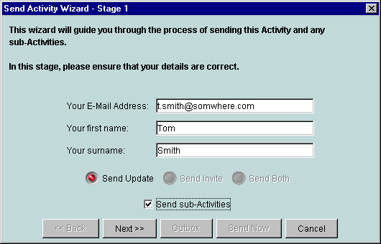

If this is the first time the Activity is sent, only Activity Invitations will be sent to recipients. These allow them to see the description and objectives of the Activity, and the names of People and Resources involved but not their details. People icons will remain until they have sent back an acceptance, at which point the icon will change to . This indicates that the person has accepted the Activity and is now ready to receive the actual Activity Update. Once the actual Activity has been sent to a Person the icon will change to . If they decline the invitation, their icon will become .

The wizard provides you with an opportunity to send out a mixture of Activity updates and Activity invitations depending on the acceptance status of individual members.

When Activities are re-sent, then updates and/or invitations will be sent depending on whether people have received an earlier version.

NB: People only get each other’s names and email addresses with an Activity - no other details are sent by the initiator. Additional details have to be sent by the person themselves, described later. People will also not get the details of any sub-activities of which they are not members.

Updating Activities

Whenever you make changes to an Activity, such as adding or removing members, adding or removing Resources, or adding sub-activities, you need to send updates to all the members. You will be reminded of this by a change in the icon from Live Activity to Hot Activity . Sending the Activity is done in exactly the same way as before by highlighting the Activity to be sent with a single click and sending it to all the students by clicking Send Activity on the Colloquia Toolbar.

This will start the "Send Activity Wizard", again taking you through the process of sending the update, checking whether you and the learners have valid email addresses, and allowing you to choose whether you send the Activity immediately or put it in your Outbox for sending later. It will re-send the whole tree, with information on People and Resources to all students, and on arrival in their Inbox, it will replace the previous version in their Colloquia tree. All existing conversations will however be preserved.

Only the Activity initiator can make changes to an Activity and send it to People. Recipients can only participate in it. However, recipients can create sub-activities, which they have complete control over. They can invite anyone they want to be part of the Activity, whether or not they are members of the parent Activity. They can exclude the owner of the parent Activity if they so wish in which case they would not even know that the sub-activity existed.

Shared Resource Activities

If the initiator so wishes, an Activity can be configured to allow all members to contribute Resources, by ticking the box when setting up a new Activity.

When a member contributes a Resource, only the Activity initiator receives it, so that they can check that this is a Resource they are willing to accept. If they do, they then need to update the Activity (i.e. re-send it) to all participants.

Activity Properties

You can get all the information about an Activity by selecting Activity Properties from the Activity Menu:

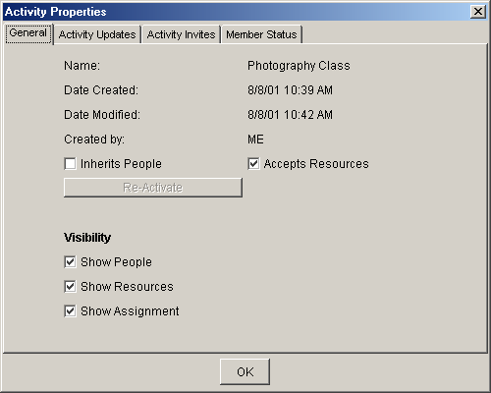

This display has four tabs, and tells you when the Activity was created and most recently modified, who created it, whether it accepts Resources from members, and if it is a sub-activity, and whether it inherits people from its parent Activity. These last two can be changed at any time by clicking in the appropriate box (if you created the Activity).

The Reactivate Button allows an Activity that was completed to be reactivated, and be re-sent to all participants.

You can also decide what is displayed on the tree for the Activity in question. For example, if an Activity contains a very long list of People, you might decide to deselect the Show People Checkbox, only turning it on when you need to.

The Activity Updates Tab shows the dates when different People last received an update.

The Activity Invites Tab shows the list of invited People.

The Member Status Tab shows who has been invited, and who has accepted the Activity. The possible states are:

Accepted – the person has accepted the Activity and is an active member of it

Pending – awaiting the person’s acceptance of the Activity

Declined – the person has declined the Activity

Awaiting Activity – the person has accepted the Activity and now needs to be sent the Activity update

The Active checkbox allows you to de-activate a person from an Activity or activate them again without actually removing them from the Activity structure.

Managing Assignments

Once a participant has completed and sent an Assignment, it will arrive with all other Messages.

Click on Get Mail on the Colloquia Toolbar to get all new Messages in the usual way.

Within the Activity concerned, click on the name of the Person returning an Assignment. Click on the Assignment Tab in the Main Frame.

If the Assignment was completed using the in-built text editor, it will be displayed in the bottom frame. If it was sent as an attachment then this may be viewed by clicking on Attachments .

To make a comment about the Assignment, click on New Message on the Assignment Messages Toolbar. The Message window will open, where all you have to do is:

- Enter a new subject
- Type your reply/assessment

Click on Send Now to send it immediately or click on to put it in your Outbox for sending later.

Your comment will be sent (or stored in your Outbox), and added to the list of Messages in the Conversation Index. If you wish to just save the Message as draft, click on Save As Draft . You can continue to edit the Message now or later.

If you decide to annotate the Assignment itself using some other application (like a word processor), you can send it as an attached file as follows by clicking on New Message on the Assignment Messages Toolbar.
A new window will open, where all you have to do is:

- Enter a new subject
- Type a comment

Click on Attachments to find and attach the file(s) to your Message. Click on Send Message on the Assignment Messages Toolbar to send it immediately or click on to put it in your Outbox for sending later.

Your assessment will be sent (or stored in your Outbox), and added to the list of Messages in the Assignment’s Conversation Index. If you wish to just save the Message as draft, click on Save . You can continue to edit the Message now or later.

If you want to add a grade or mark to an Assignment, simply enter this into the box provided before sending your final comment.

NB: You can always get to a student's Assignment by selecting their name in the appropriate learning Activity, and clicking on their Assignment Tab.

Leaving an Activity

A participant can resign from an Activity at any time. All they need to do is highlight the Activity in their Activities Folder and click on Complete on the Colloquia Toolbar.

The Activity icon in your tree will also change to the icon. A resignation message will automatically be sent to the Activity owner, and your name will become greyed out on their version of the Activity. They can then send an Activity update to all participants, and cause your name on their trees to also become greyed out. They can now delete you, if they wish. You will no longer receive any Messages within this Activity.

Rejoining an Activity

If you later change your mind, you can rejoin the Activity by highlighting it and clicking on Activity on the Main Toolbar. Select Activity Properties and click on the Re-Activate Button.

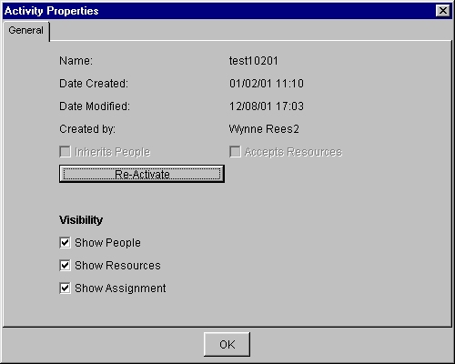

A window will appear asking if you would like to continue:

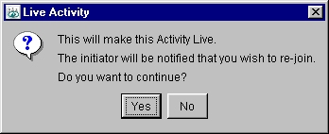

Click on Yes and the re-activated Activity acceptance will be sent out again to the submitter of the Activity.

Ending an Activity

The Activity owner or initiator can end an Activity at any time. Highlight the Activity in your Activities Folder. Click on Complete on the Colloquia Toolbar. A confirmation dialogue box will inform you of your action:

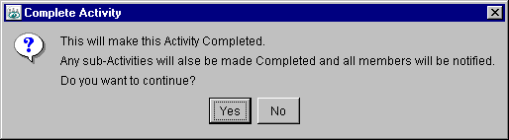

Clicking Yes will cause the Activity icon in your tree to change to the icon. A completion message will be sent to all participants, and cause the Activity icon on their trees to also change to the completed icon . They will no longer be able to send any Messages within this Activity.

Restarting an Activity

An Activity owner can restart an Activity by highlighting it and clicking on Activity on the Main Toolbar. Select Activity Properties and click on the Re-Activate Button.

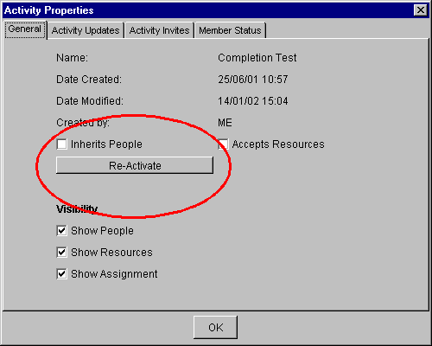

A window will appear asking if you would like to continue. Click on Yes and the re-activated Activity will be sent out again showing the live status and re-inviting the members to accept the restarted Activity. Click on OK and the icon in your tree will change to .

An Activity cannot be re-activated (made live) if its parent Activity is Completed (i.e. an Activity that is completed also has its sub-Activities completed.) In this case the Re-Activate button will be greyed out.

NB: When the owner completes a parent Activity, all sub-activities belonging to the owner of the parent will also be completed. However, sub-activities set up by other participants will continue to be active until they decide to end them. So, for example, students can keep a study group going beyond the end of a formal course.

What happens to completed Activities

Completed Activities stay on the Colloquia tree, and act as an archive of your previous actions. In an educational context, this means that you have a record of the course you took, the People you worked with, the Resources used, the Assignments you undertook and all the discussions you were involved in. This can be seen as a portfolio of your work, and if you use the Notes areas to add your reflections on your learning, then it becomes a valuable record of your student experience.

As a tutor you have excellent information on the course you have run and the students’ experience, allowing you to adapt your materials for future courses.

In non-educational contexts, Colloquia provides a record of projects and achievements, who participated in them and what they did. Colloquia provides for a high level of self-organization, but maintains excellent information on how projects unfold, and people’s contributions, permitting adaptive planning for future actions.

Sending My Details to other people

If at any time you wish to send or update other Colloquia users with your personal details (name, photograph etc.) select the Send My Details option from the Communications menu. A wizard will guide you through the process. Note that the people to whom you can send your details shown in the wizard will depend on what is selected in the Tree :-

If an Activity (or a node in an Activity) is selected on the Tree only those people in that Activity will appear in the wizard. Otherwise, all people that share Activities with you are selected.

The Templates Folder

If you decide that you want to re-use an Activity later with a different set of People, you can store it in your Templates Folder. Simply drag and drop the Activity into the folder, and a copy will be made there, preserving all of its description, Resources and Assignments, but removing all the People. When you next want to use it, drag and drop it back into the Activity Folder, and another copy will be made to which you can add new People (you will also be encouraged to give it a new name).

The Colloquia Tree

Hiding and Showing People, Resources and Assignments

As you add Resources and People, and engage in more Activities, the information in the Colloquia tree will grow rapidly, making navigation difficult and requiring lots of scrolling. Most of the time it is advisable to keep the People and Resources Folders closed, and earlier it was described how you could control what is displayed within each Activity (see the Activity Properties Section), using the Activity’s Properties window.

You can also globally hide People, Resources, Assignments, and completed Activities by clicking on the icons on the small toolbar above the tree:

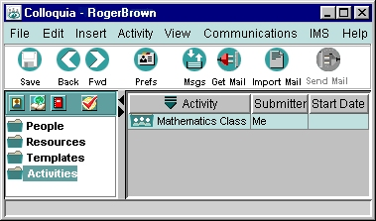

Clicking on hides all the People in all Activities.
Clicking on hides all the Resources in all Activities
Clicking on hides all the Assignments in all Activities
Clicking on hides all completed Activities.

Clicking on each a second time redisplays the item in question as in Colloquia’s previous state.

Moving Things Around

People can be dragged into People Folders to help manage the long list that you will eventually get in your People Folder. This is done by first inserting a new folder, and then dragging People into it, as follows:

Highlight the People Folder with a single click. From the Insert Menu select New Person Group. In the dialogue box that appears, enter a name for it and click OK. A folder with that name will appear inside your People Folder.

To copy a Person into the sub-folder, simply click on them, hold the mouse button down, and drag them until the pointer is over the sub-folder, and release the mouse button (this is called “drag and drop”). You will see their name appear inside the folder AS WELL as remaining in the parent folder – they have been copied into the new sub-folder.

To copy a Person into that folder and remove them from the parent folder, do exactly the same as above, but hold the Ctrl Key down throughout the whole process.

Once you have sub-folders in place, you can add new People directly into them by highlighting the sub-folder first, and then following the process above.

You can put groups of Resources into folders to help manage the long list that you will eventually get in your Resources Folder. This is done by first inserting a new Resource Group folder, and then dragging Resources into it, as follows:

From the Insert Menu select New Resource Group. In the dialogue box that appears, enter a name for it and click OK. A sub-folder with that name will appear inside your Resources Folder.

To copy a Resource into that sub-folder, simply click on it, hold the mouse button down, drag it until the pointer is over the sub-folder, and release the mouse button (this is called “drag and drop”). You will see its name appear inside the sub-folder AS WELL as remaining in the parent folder – it has been copied into the new sub-folder.

To copy a Resource into that folder and remove it from the parent folder, do exactly the same as above, but hold the Ctrl Key down throughout the whole process.

Once you have Resource Groups in place, you can add new Resources directly into them by highlighting the sub-folder first, and then following the process above.

You can further populate the new Activity by ‘dragging and dropping’ or ‘copying and pasting’ People and Resources from the top level folders to the specific learning Activity by opening the People or the Resources Folder. Click on a person (or Resource) AND KEEP THE LEFT MOUSE BUTTON HELD DOWN. Drag the mouse pointer until it is over your Activity and it has become highlighted. Release the mouse button. People Groups and Resource Groups can also be dragged onto Activities and their members will be copied into the Activity (assuming that the Activity is yours.)

Appendix 1: Colloquia on a dial-up connection to the Internet

Colloquia requires that your computer be set up to access the Internet, so you must have an Internet account. If you are using a dial-up connection through a modem, you must either log on to the Internet before you can send and receive Colloquia Messages (and log off when you have got them), or set up you computer so that it automatically connects to the Internet when you click on Get Messages or Send Messages . The latter option provides a smoother working method, but make sure that your computer disconnects when you want it to.

We have provided a number of features to reduce your phone bills or demand on bandwidth. You can read and prepare all messages while offline, and you can save all Resources for viewing offline. However if bandwidth or phone bills are not a problem, Colloquia is happy to work in a permanently online mode.

Consult your computer’s manual or help system on how to do establish a dial up connection, and how to get it to dial automatically when you request a web page or email download.

Appendix 2: Using Colloquia with your existing POP3 mail account

If you have to use a POP email server for your incoming messages, there is a danger that Colloquia messages can be diverted or lost by your normal email client. A POP email account involves you downloading all your email from the email server to your local storage space, like your hard disk. If you check your email BEFORE checking for Colloquia Messages, then your Colloquia Messages will also be downloaded by your email client and saved on your disk. Within your email client you will see them listed, and when you open one, you will see the text “This is a Colloquia message” or similar. You will also note that there is an Attachment to this Message. Save this Attachment in a folder on your hard disk, and make sure that the name of this folder is the same as in your Colloquia email settings (see Local Folder for Downloaded Messages.)

Colloquia will always look in this folder every time you click on Get Mail as well as access your email server. However, if by chance you have saved the Colloquia Message elsewhere, you can click on Import Mail on the Colloquia Toolbar, navigate to where you saved the Message(s), and import them.

So, to recap, create a folder in your Colloquia email settings, and make sure that any Colloquia Message Attachments that end up in your normal email inbox are always saved in this folder.

To avoid this cumbersome approach we have three recommendations, as follows:

- Use a separate email account just for Colloquia OR
- Use IMAP instead of POP, and ignore Colloquia Messages that appear in your email client (do NOT delete or save them) OR
- Always check for Colloquia Messages BEFORE checking your normal email.

Using Colloquia with your existing POP3/IMAP mail account (for Bangor University users)

We have found a way of simplifying the above procedures for those users at the University of Wales, Bangor. On installation, Colloquia will set up its own Inbox. It will then separate, or ‘filter’, the Colloquia messages from the rest of your mail, and place it in the new inbox. This means that Colloquia messages cannot be diverted or lost by your normal email client, irrespective of whether you are using IMAP or POP.

However, this also means that Colloquia messages are not seen in the ‘Inbox’ folder of your usual e-mail client. If you would prefer them to remain visible in this inbox, you can disable the filtering mechanism by deleting the file .procmailrc from your M: drive.

Appendix 3: E-mail Servers and Settings

Email settings can be rather confusing to people new to the Internet, so we provide here a simple explanation of how email works, which we hope will help with understanding these settings.

Email works in a very similar way to the letter post. Physical mail has post-boxes, where you post your letter, and postal sorting offices, where your letters arrive before being delivered by the postman. If you receive a registered letter, and are not at home, the postman leaves a card asking you to go to the sorting office to pick it up yourself. To use the postal service successfully, you need to know the location or address of at least one (but preferably several) post-box(es), and of your local sorting office.

Email is almost exactly the same, except all messages are registered mail, so you need to go and pick them up yourself. But you can post your mail in any post-box you want – almost.

Outgoing Mail

Internet Service Providers (ISPs) all have a post-box that you should use to post (send) your messages. Some of them allow anyone to use their post-box, even people who are not their customers. But many are now only allowing their customers to use them. It is as if all post-boxes were moved inside local banks, and only their customers are allowed to use them.

So it is advisable to use your ISP’s post-box, since others might reject you. In Internet terms, this is known as the “Outgoing Mail Server”, or the SMTP server (Simple Mail Transport Protocol).

These often have an address that start with SMTP. For example, if you use Freeserve as your ISP, their outgoing mail server has the address SMTP.FREESERVE.CO.UK

Outgoing mail servers do not usually require a password – they simply check if you are one of their customers, and reject you if you are not.

If you are a nomadic user, working in different places on your laptop, then you might need to use different outgoing servers in different locations, depending on which ISP you are using (work, home, or college). To help with this, Colloquia allows you to add a number of SMTP servers to a menu in the Email setup, so that you can select the one you want to use at any time.

Incoming Mail

To collect your mail, you need to go to the “sorting office”, which often (but not always) has a different address. In Internet terms this is known as the Incoming Mail Server, and can be one of two types.

The most common is known as a POP server (standing for Post Office Protocol). Another is known as an IMAP Server (standing for Internet Mail Access Protocol). These differ in several ways, but the most important is this:

- POP servers require you to take your messages home before you read them (i.e. save them on your computer’s disk) although you can leave a copy at the Post Office.

- IMAP servers allow you to read them AND store them at the Post Office (i.e. you do not have to save them on your disk) – but you can save them if you wish. It also allows you to set up a range of folders for storing your messages in as well as the place where they arrive – the INBOX.

Many ISPs do not yet support IMAP, but most universities prefer staff and students to use them. They also have addresses similar to the Outgoing Mail Server. Again, Freeserve’s has the address POP.FREESERVE.CO.UK

Colloquia treats IMAP and POP servers in the same way. It always saves Messages on your hard disk, and deletes them from the server unless you indicate otherwise on the Email setup window. Deleting Colloquia Messages from the server makes sure that they never appear in your normal email client.

Email accounts and Email addresses

Incoming Mail servers always require that you have a user ID, which is NOT the same as your email address, and a password. If you have an account on an incoming server, then you do not have to be a customer. For example, if you are a student, you will have an email account with your university, and you will have another given to you by your ISP – just as if you had two addresses, your home address and your university’s address. You will need to pick up messages from two different servers. Messages sent to your university address will arrive at their incoming mail server. Messages sent to your private address will arrive at your ISP’s incoming mail server. So when you set up Colloquia, you need to know which email account and which incoming mail server you plan to use – although you can set up different profiles with different email accounts.

Email addresses and aliases

Whenever you are given an email account, it has an associated email address, which always looks like this:

xxx.yyyyy@somewhere.co.uk

There are times when you would prefer to use a different name to the one that you have been given, and you can ask your ISP for an ALIAS. All messages to this alias arrive in the same mailbox, so the only real advantage is that you might prefer the name.

Quite often universities give students numbers instead of names, like exp759@some.college.edu as their “real” email addresses, but then give them an alias like j.smith@some.college.edu.

Colloquia uses the email address to construct a unique identity for each user, so aliases can cause some problems. If you use aliases, you MUST tell Colloquia in the Email Setup window.

If you have followed the above explanation, you should have no difficulty in setting up your email for Colloquia.

Appendix 4: Colloquia data and where it is saved

When you first set up a profile in Colloquia, it creates a new user profile on your machine. On a Windows 98 PC this can be found in the C:\WINDOWS\COLLOQUIA\ folder.

Here you will find a file called XXXX.CQP and a folder called XXXX.CQD, where XXXX is the profile name. The CQP file contains all your preferences that you entered when you set up the profile – your name, address, email address, servers and so on. DO NOT DELETE THIS FILE!

The CQD folder contains all the data that your Colloquia profile generates – Activities, People, Resources, Messages and so on. Once again, do not delete or change anything in this folder.

If you use Colloquia on several machines, then you will need to copy the CQP file and the CQD folder to the same directory on the other machine. If you do this properly, then Colloquia will immediately add you to the profile list on the new machine, and give you access to the data.

TAKE CARE to keep the two machines’ data properly synchronized. If you make changes on one machine then copy this file and folder to the other before using it.

You can use Windows Briefcase to keep these files synchronized. Or you can use Colloquia’s backup facility:

In Colloquia’s Preferences, set the Backup Data Folder to an appropriate external storage device such as a Zip Drive (see Other Settings). This data can then be restored to another machine.

All Colloquia data files are very small, and so copying them should be quick and easy. The only large files are downloaded Resources.

Below is the structure of a Colloquia CQD folder:
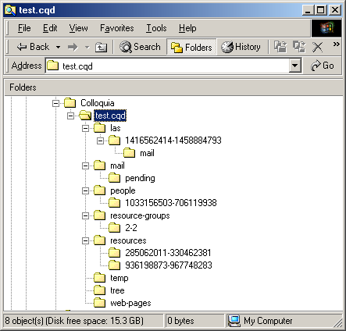

The las folder contains all the Activities, each with a unique ID. Each Activity Folder contains a description of its “tree” plus a folder for any saved messages.

The mail folder contains Messages waiting to be sent, plus information about your Message Centre.

The people folder contains information on every Person in Colloquia’s People Folder, each with a unique ID.

The resources folder contains information on every Resource in Colloquia’s Resources Folder, each with a unique ID.

The tree folder contains a description of the overall tree structure.

The web pages folder is where locally saved web Resources are saved.

All the files contained within these can be viewed with a text editor like Notepad, but take great care not to change them, as this will affect your Colloquia display and how it works.

Appendix 5: The Notes Editor

Colloquia allows you create text files in various places including:

Descriptions of Activities, Assignments and Resources
Objectives for Activities
Notes about People, Activities, Assignments and Resources.

The editor used for each is identical. Below is an example:

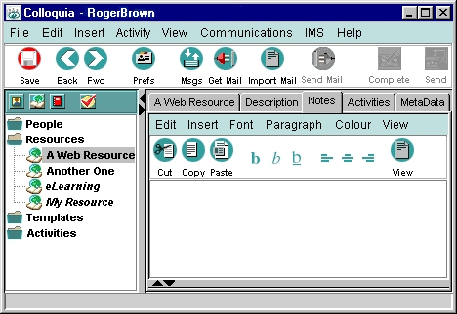

You can type text in the white space, and then format it using the simple tools provided.

- Cut, Copy and Paste work in the usual way
- b, b, b change highlighted text to bold, italic or underlined
- The next three icons align the text left, centre or to the right
- The View Button switches off the editor, and displays the text.

A single line break is inserted by pressing Shift and Return (the Enter key) together.

The following keyboard shortcuts are also implemented:

Ctrl B – Bold

Ctrl I – Italic

Ctrl U - Underline

All these features can also be accessed from the Edit, Font, Paragraph and View menus.

The Font Menu also allows you to vary the size of the text, and type of text used.

The Colour Menu allows you to change the colour of any highlighted text.

The Insert Menu allows you to insert a list, bullets and hyperlinks when creating Descriptions or Objectives and Notes. Hyperlinks are inserted as follows:

Highlight the text you want to be a link and select Insert Hyperlink from the Insert Menu:

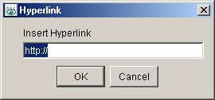

Click OK and the text is linked. To test it, first click on the View Button to switch off the editor, and then click on the link.

Appendix 6: Key to Icons and Buttons

Icon | Meaning
 | Person
 | Person pending
 | Person declined
 | Person needs updated Activity
 | Resource
 | Resource allowed to be cut (example – somebody else’s Resource placed in another Activity)
 | Activity Future
 | Activity- declined
 | Activity - accepted
 | Activity - live
 | Activity - HOT!
 | Activity Completed
 | Activity Template
 | Assignment
 | Assignment allowed to be cut
 | Single Message
 | Group Message
Text Editor Buttons
 | Text Bold
 | Text Underline
 | Text Italic
 | Text justify
 | Text left-justify
 | Text right-justify

Appendix 7: Setting up zipped Resources

You may wish to create a Resource that consists of a number of files that need to be placed together in a Zip file. The recipient of the Resource can then download the zipped file and access the contents automatically.

For this to work the option Automatically unpack downloaded zip files needs to be set in Preferences (see Browser Settings.)

This allows any zip files that have been downloaded from an FTP URL in a Colloquia Resource to be automatically unpacked and referenced in the Local File field of the Resource (see Saving a non-web Resource for further details.) If this option is set, downloaded zip files are automatically unzipped into a user specified folder and the first file contained in the zip file is automatically referenced in the Resource's Local File field.

If there is a simple text file called startfile placed in the zip file, the file name that is in this will be the file that is referenced in the Local File field.

For example:

Suppose you have the following set of files that work together with the file MyPresentation.ppt being the main file to launch:

MyPresentation.ppt
supportfile.wav
welcome.wav
opening.gif

Using a simple text editor create a new text file called startfile. Add the name of the main file as a single line into this text file:

MyPresentation.ppt

Now save this text file and add it to the zip file together with the other files.

When the recipient of the Resource downloads the zip file it will be unpacked, the files extracted, the referenced file in the startfile will be referenced in the Local File URL field and the zip file deleted (only the local copy, not the original!)

Appendix 8: Changing the language and wording of Colloquia

Colloquia has multi-language support and you may wish to define your own language set or edit some words or phrases to suit your environment. Here’s the background:

Included in the Colloquia install folder is a file named strings.txt. Open it in a text editor.

The first few lines of this file look something like this:

# English / Default

# General re-usable Strings
# ------------------------------------------------------------------------------
CANCEL=Cancel
OK=OK
ME=Me
YES=Yes
NO=No

The hash sign (#) indicates a comment line and any text to the right of this is ignored.

The word in capitals to the left of the equals sign (=) is the key and should not be changed.

The text to the right of the equals sign is the text that is displayed in Colloquia in menus, dialog boxes, information screens and so on.

You may create an edited version of this file renamed to mylanguage.strings (where mylanguage is your chosen language name) in the Colloquia install folder.

For example:
- Make a copy of the strings.txt file. Rename this file to mylanguage.strings.

- Open the mylanguage.strings file in a text editor and edit the words to the right of the equals sign.

- Save the file.

When Colloquia next launches and finds this new file it will appear as a language option on the logon screen:

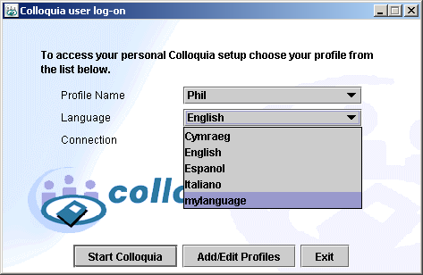

Further language sets may be created in the same way.

Appendix 9: Installing Quicktime for Java

In order to play media files that are referenced as Resources in Colloquia you need to have Quicktime for Java installed. You can download it from this link:

http://www.apple.com/quicktime/download/

You will need to do a Custom installation so that you can select Quicktime for Java and to install support for playing Sound files. In order to play movie files and sound files you must configure Quciktime to do this. See the Quicktime installation guide for help.

Once you have installed Quicktime for Java when you click on the URL or Local button in the Browser for the Resource, the media file will play.

