Community Site for a College English course

-WordPress site developed locally with Local by Flywheel, Text Editor, Terminal

-Languages: HTML, CSS, PHP, JavaScript

Home Page (top half desktop)

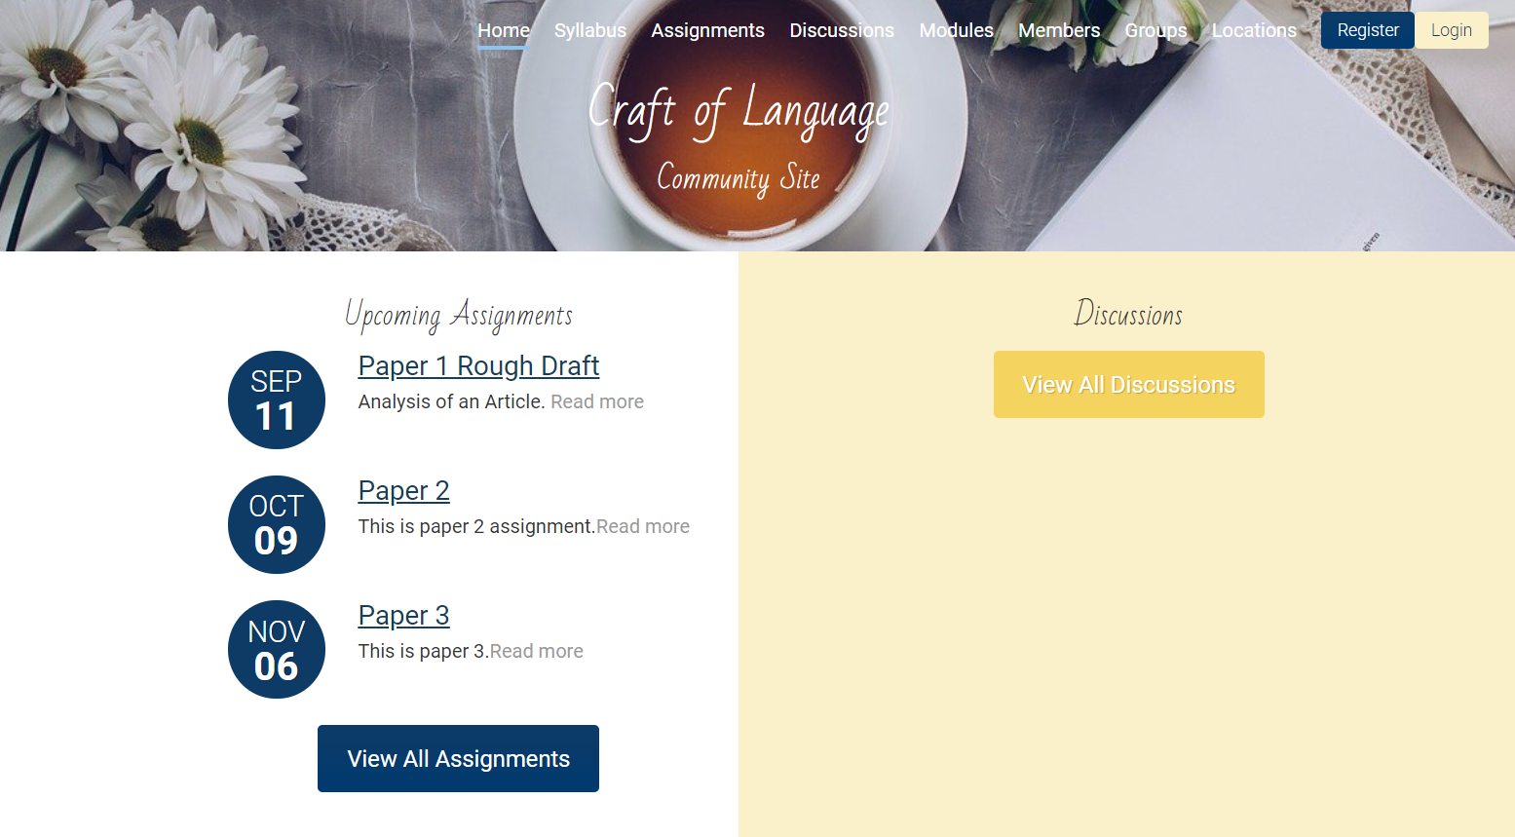

Home Page (bottom half desktop)



Home Page (mobile/responsive)

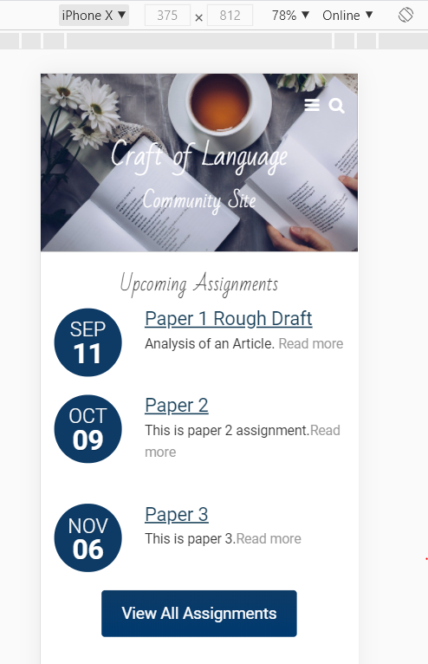

Custom Login Screen

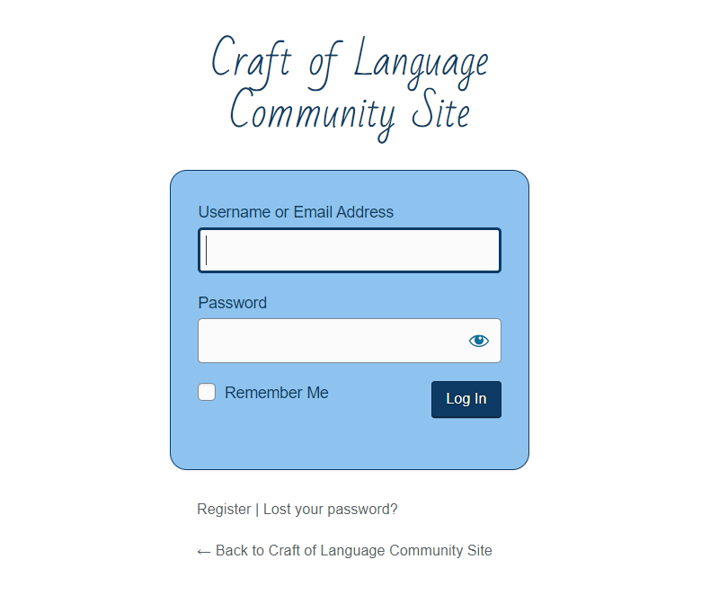

Class Poetry Collection Page with FlipBook Plugin

