Recruitment Management System

Introduction

The significance of a placement system is growing by the day. Thousands of candidates are depending on the placement cell. However, the applicants also have plenty of issues. This initiative is an attempt to reduce an applicant's difficulties in finding the right job. It will be more faster and more convenient for the candidates if we can make it an online automated and mobile alert process. New technologies, far from troubling issues, have primarily made life better and significantly easier for the majority of people, and thus they must be supported.

Manpower can be reduced dramatically while efficiency and accuracy are improved significantly. Furthermore, by using the proposed solution, time consumption can be decreased to a much greater extent. It helps the organization also to search for a profile with specific skills only, so they do not have to go through every job seeker asking him/her about the skill they needed. The system has a different segment to process a specific task which is the modules.

The problem in traditional online recruitment systems

Many applicants attest that searching jobs online, doesn’t have a personal touch. Job seekers need the ability to communicate with someone to clear out the questions regarding the company and the job they are interested in. Job seekers commonly complain that employers are so unreachable and have very little or no human interaction. Expired job postings are the next significant disadvantage of online hiring that job applicants experience. Many applicants say that they have applied for job posting which currently appears in vacancies but find out weeks later that the position had already been filled a long time ago. Company websites that break down when trying to submit their recruitment materials is one of the major complaints that applicants do. Others are saying that some website interfaces are so complex and find it difficult to route through the site. Employers trust the applicant tracking system to store resumes that include relevant indexes. Some candidates purposely include their resume with keywords, so their resume is getting selected by the system. So, recruiters tend to call applicants for interviews that do not meet the job requirements.

The advantages of Online Recruitment Systems Online recruitment

Services provide a large variety of tools such as per-employment screening, assessing personalities and testing to screen candidates to allow you to select suitable candidates who fit your organization's values with automating human interaction. Many recruiting software offer multiple services similar to this, where you can personalize your organization's specific requirement for every job. This reaches a vast community of potential employees than other tools. By allowing you to reach job seekers anywhere, you can find candidates with unique skills and compatibility. Many online recruiters are targeted for specific industries. Also, many organizations help employers to post job vacancies on their websites. This ensures employers can find people with very specific skills and it can also attract candidates who are not looking for new job opportunities. In most companies, hiring costs are one of the highest expenses. Recruiting involves both actual costs of hiring an employee, as well as the costs of retaining and training. Each employee needs to receive training and orientation and a time period to learn the pattern of his job. This can be considered as an investment for many organizations. If an employee leaves before the organization pays off those costs, the recruitment process has to begin again, which is considered as a financial loss. Properly planning online recruitment and selection procedures can significantly reduce costs and minimize employee turnover, which is very favorably effects on the revenue.

Scope of Change
Recruiting is competitive, especially for candidates with high-demand technical skills, and it is driving interest in sophisticated recruiting systems. These systems are being designed to improve the efficiency of recruiters as well as job seekers. This will help the system to developed easily and makes it more user-friendly.

Scope and Limitation The scope of this project is to build a working solution of recruitment management and career guidance system in respective iterations. System will be web based along with APIs for integration with other systems. The system consists of mainly 3 types of users which are recruiters, candidates and admin users. Also, candidates can act like freelancers. The system facilitates to register users as a candidate or a recruiter. If a user registers as a recruiter, there will be a special access code which the user has to obtain to register under a company. Recruiters can post job openings, view candidate profiles, schedule interviews, etc. This system will automate the hiring process and therefore recruiters must do only minimal work for that. The system will generate time wise reports to recruiters regarding candidate information, job postings and so on. Also, the system will generate special access codes for recruiters when they want to register under a company. The system will automate the candidate selection process and therefore select the suitable candidates with minimal effort. When a user is registered as a candidate, the system will allow you to add skills, education qualifications, professional qualifications and employment history to your profile. The system will allow candidates to apply for jobs. Also, the system will notify candidates when a relevant job vacancy is posted. The system will group candidates with similar sets of skills and network them via the system. System will provide study materials to candidates for preparing interviews. The other important benefit of this system for candidates is the system will generate CV and 4 portfolio according to the candidate’s skills. Also, if a candidate is registered as a freelancer, there are freelance jobs available in the system. The system provides a messaging service to communicate between recruiters and candidates. Therefore, every recruiter and candidate has his own message box. The system will conduct online interviews and practice tests for candidates. Also, the system will rank candidates and recruiters according to their performance. There are also admin users in the system. The system will allow admin users to configure the system. Also, admin users have the privilege to add companies to the system and generate access tokens for recruiters under a particular company and admin users can manage other user roles. One of the most important features of the system is that the system will generate various reports for admin users, recruiters and candidates. It will help to track candidate and recruiters’ performance, number of job postings and so on. The high level objectives of the system are stated below. 1. Provides the environment for recruiters to offer their job postings. 2. Candidates will be able to find jobs via the system. 3. Freelancers will be able to find freelance jobs through the system. 4. Rank and evaluate candidates, recruiters and freelancers according to their performance. 5. Automate hiring process and conduct online interviews. 6. Automate candidate selection process through their rank and overall score. 7. Communicate between recruiters and candidates via messaging service provided by the system. 8. Provide reports and statistics to recruiters time-wise.

Use Case Diagram

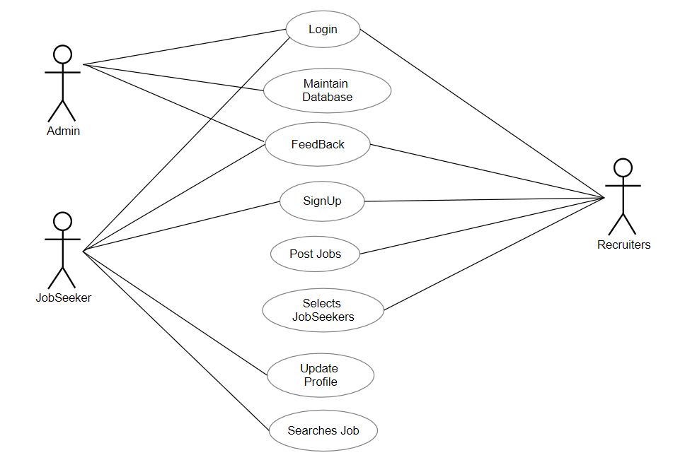

Class Diagram

