Task 3

Movie Data Web Scraping and Analysis

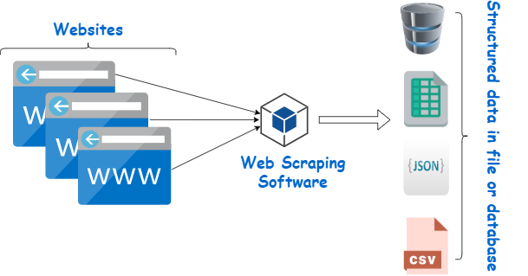

Submitted by: Yousef Elshabrawy  
 Philopateer Emad

Used Libraries:

requests, scrapy.Selector, pandas, csv, scrapy.crawler, scrapy. Matplotlib.pyplot

Findings From Data Analysis:

Visualization for distribution of movie ratings

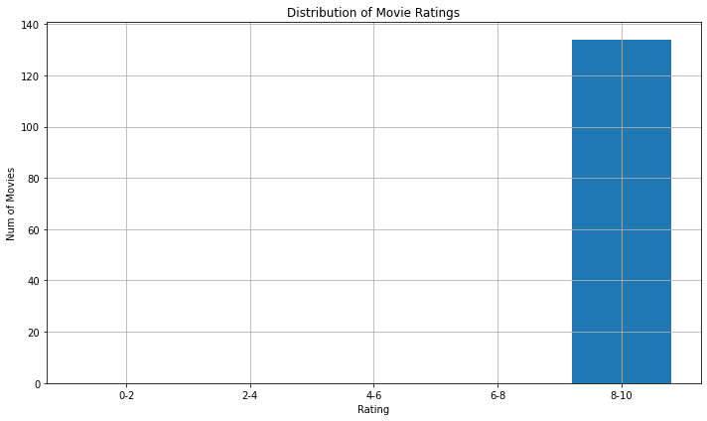

Visualization for distribution of movie genre

