PCleaner
  - Final Report
Ahmed Amr
Philopatear Salib
Nourhan Ayman

MCT 382: Design of MCT (2) | 22/5/2019

Table of Contents
Table of Figures 4
Introduction 6
Problem Statement 6
Motivation 6
Project Objectives 6
Design Thinking and Market Research 6
Customer Segment 6
Primary Features 6
Secondary Features 6
Value Proposition Canvas 7
Lean CAnavs 8
MarkeT Rsearch Survey 9
Product concept 9
Analyzed Data 10
Product Design and Human–Machine Interface 11
Ergonomics and usability 11
Ready to Market 12
Form Follows Function 12
Realistic Render 13
Design Development 14
Conceptual Design 14
Design Alternatives 14
Propsed Design 15
CAD Modelling 15
Mechanical DEsign 15
Actuator Sizing 17
MATLab Simulation 17
Simulink (Simscape Model – Velocity Control) 17
Results 19
Simplified Model 19
Results 20
Hand Calculaiotns 21
Horizontal Forces 21
Selected Pump/Actuator 1
VerTical Forces 1
Path Generation 1
Simulink Model 2
System Interconnection Diagram 4
Electrical Schematics 5
Circuit Schematics 5
Circuit Layouts 6
Power Sizing 8
Software Architecture 9
Project Plan 10
Project Timeline 11
Manufacturing Timeline 11
Integration Plan 12
Componenets Integration 12
Modular Integration 12
Saptial Integration 12
Test Plan 13
System Verification 13
System Validation 13
Bill of Materials and Cost 13
Conclusion 14
Time Line……………………………………………………………………………………………………………………………………………………..………20
Conclusion………………………………….……………………………………………………………………………………………………………….20

Table of Figures
Figure 1: Value Proposition Canvas 6
Figure 2: Lean Canvas 7
Figure 3: Market Research Survey 8
Figure 4: Analyzed Data if customers would buy the product or not 9
Figure 5: Analyzed Data if customers have bought such a product before 9
Figure 6: Analyzed Data of how often would customers use this product. 9
Figure 7: Analyzed Data of how much would customers pay for such a product. 9
Figure 8: Analyzed Data of how many males or females would use this product. 9
Figure 9: Analyzed data of the ranges of ages whom would use this product. 10
Figure 10: Handle facilitates moving of robot 10
Figure 11: Proposed Design 14
Figure 12: Overall Model – Velocity Control 17
Figure 13: System 18
Figure 14: DC Motor & Driver 18
Figure 15: Load & sensing 18
Figure 16: Pump flow rate Figure 17: Vehicle Velocity 19
Figure 18: Simplified Model 19
Figure 19: Vehicle Velocity (Simplified Model) ……………………………….…………………... ……………………………………….20
Figure 20: Thrust acting on vehicle (Simplified Model) 20
Figure 21: Path Generation 2
Figure 22: Thruster_{x} 2
Figure 23: Drag Force_{x} 3
Figure 24: Angle Scope 3
Figure 25: Displacement Scope 3
Figure 26: Turning a bilge pump into a thruster 5
Figure 27: SID 6
Figure 28: 24 AWG 7
Figure 29: ATmega328 Stand Alone Schematic Circuit 7
Figure 30: (a) ATmega328PU Stand Alone Layout Circuit 8
Figure 31: Integrated Circuit Schematic 8
Figure 32: Path of Vehicle along a pool 10
Figure 33: Flowchart 10
Figure 34: VDI 2206 11
Figure 35: Sample of how tasks has been handled 13

Introduction

Problem Statement
This project is being designed to meet all the requirements stated in the project description of MCT 382 Course. The vehicle designed is capable to fulfill and satisfy the requirements of a specified slice of the market. It should be capable of cleaning small sized rectangular pools in efficient way and average velocity.

Motivation
The motivation to design this mobile mechatronic system comes from the fact that a small section of highly income level of customers are willing to pay money in an efficient product that can actually offers a daily care for their pools without the need of someone to break in their privacy, or having to do it their selves.

Project Objectives
This project is being designed to follow the guidelines given by the course and meet all the requirements specified. Its general task is to provide daily care for small sized rectangular pools by removing leaves, insects or whatever that can float on the surface water of the pool.

Design Thinking and Market Research
This project is the output of the design thinking process which included empathize; which is done though surveys and interviews of clients, define; which is done by analyzing qualitative information gathered and specifying the actual and real problem of a customer, ideate; which is done by creating many different ideas to the find a solution for the same problem, prototype; which is approached by gathering all ideas in one product and trading off between, and lastly test; which is done by going back to the clients and asks if it actually satisfies their need, if he would buy such a product, and may be how much money he would pay for that.

Customer Segment
Primary Features  - Easy to Install  - Compact  - Average velocity  - Low time consumption  - Low maintenance | Secondary Features  - Water temperature displaying  - Chlorine Dispensing  - Insecticides Dispensing
Mobile robot that provides daily care for medium sized pools in villas owned by females or males who are aged between 30 -50 years old and having a relatively high income level. All of the previous data is gathered and re-arranged in a Value Proposition Canvas and Lean Canvas.

Value Proposition Canvas
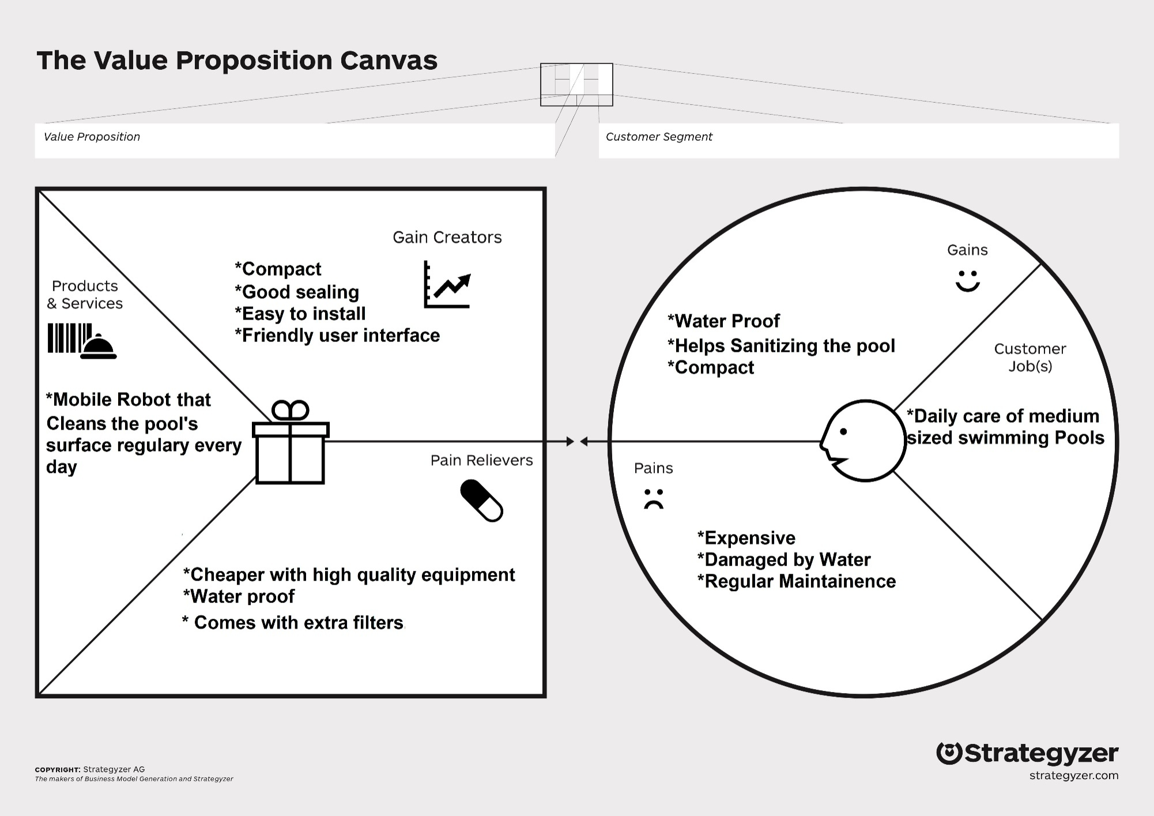
Figure 1: Value Proposition Canvas

Lean CAnavs
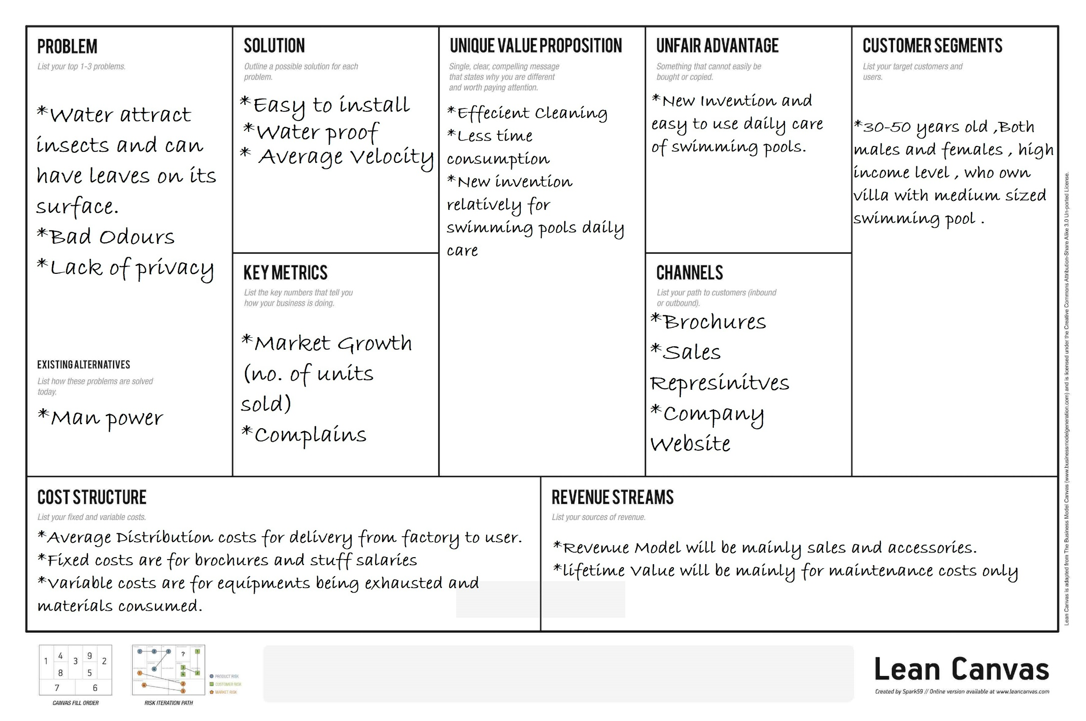
Figure 2: Lean Canvas

MarkeT Rsearch Survey

Product concept
Product concept is to provide daily care for average sized swimming pools by cleaning the water surface from environmental contaminations as leaves and insects using a mobile robot.
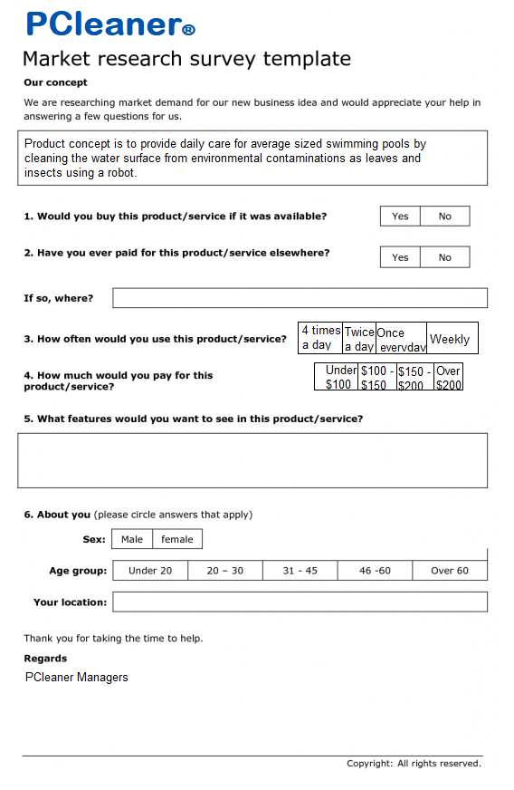
Figure 3: Market Research Survey

Analyzed Data – Survey Results
Figure 4: Analyzed Data if customers would buy the product or not | Figure 5: Analyzed Data if customers have bought such a product before
Figure 6: Analyzed Data of how often would customers use this product. | Figure 7: Analyzed Data of how much would customers pay for such a product.
Figure 8: Analyzed Data of how many males or females would use this product. | Figure 9: Analyzed data of the ranges of ages whom would use this product.

Product Design and Human–Machine Interface

Ergonomics and usability
During the phase of the product design we considered mainly the ergonomicsin the design of our product. Thus a handle is made that fits average hands’ size, placed in the exact center of the product weight, and at a suitable height for average people to avoid bending their back as much as possible, but at with a limit that it won’t cause the robot to be unbalanced.
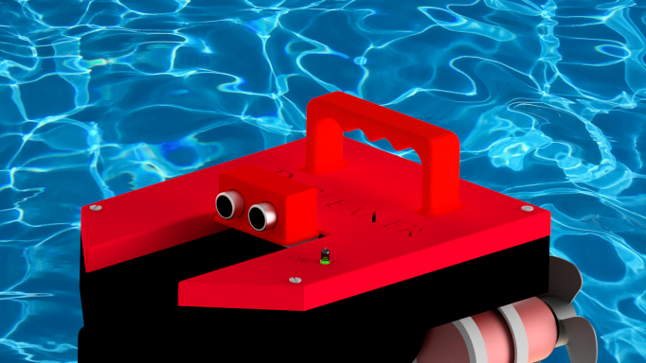
Figure 10: Handle facilitates moving of robot
A very easy human–machine interfaceis represented for the user, an On/Off Buttonand a LED is used to indicate if the robot is in operation.
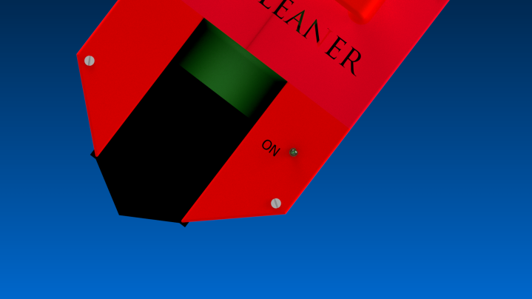

Figure 4: On/Off Button
A water detector is present between the propellers to assure that the robot is operating in a suitable water level to avoid the damage of the propellers and as a safety in case of human errors.
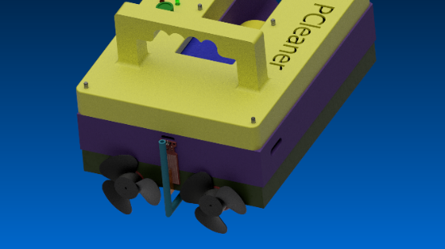
Figure 5: Water Sensor fixed on the robot

Ready to Market
Aesthetics is one of our main concerns in product design, this is achieved by choosing a combination of colors that are cheerful and suitable to the environment/surrounding. Materials used are mainly polymers either PLA or acrylic, which are available in market and suitable in our application, since they have a low density and can be manufactures in a way that is suitable to come out with the robot’s parts perfectly. We consider our design a little bit innovative, since it re-used very common products in a completely different way. An average sized aquarium pump is used to perform the suction of water through a filter and bilge pumps were used as thrusters after modifying some feature and adding another.

Form Follows Function
We assume/think that this product structure is primarily related to its intended function obviously, since a very quick look upon it from an average person can inform him/her what the product is actually doing. Propellers at the end and the boat shape at the front are the main structures that helps people to identify its function, its forward direction, and their operating environment.

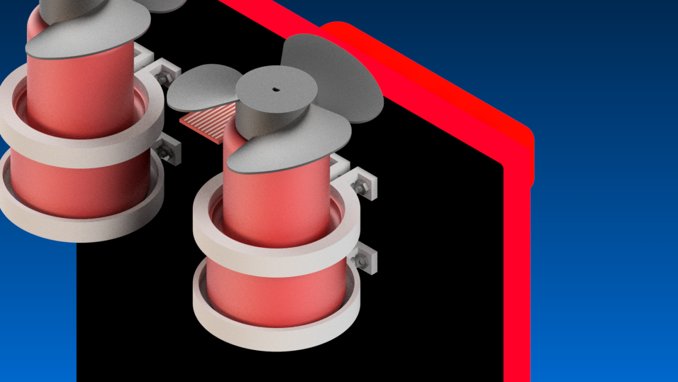
Figure 6: Propellers

Realistic Render
Here we present a realistic rendered image of the product and how it shall look at the very end of the process.
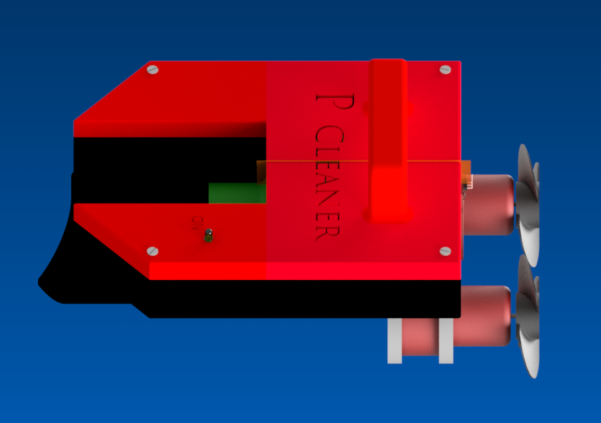
Figure 7: Realistic Rendered Image

Design Development

Conceptual Design
Primarily the design process was guided by minimizing the effect of drag force on the robot without creating any manufacturing complexity. Drag can be reduced by minimizing the surface area normal to the direction of travel, thus a cone/triangular shape is created at the forward direction of the vehicle, and since it’s not designed to travel backward, the normal area on the other end is rectangular.
A relatively positive buoyancydesign is determined to reduce the amount of risk of electric components to be exposed to water, although they’re well sealed, but also assure that a sufficient enough water can reach the aquarium pump, which is used as water sucker through a filter, and to maintain a suitable depth for the propellers to act upon.
Other considerations as water proof electronics and control system are bore in mind through the design process.

Design Alternatives
There are 2 primary orientations for the thrusters which are a direct drive, where thrust is directed normal to a surface, and vector oriented thrusters, where the thrusters are aimed at various angles from the ROV to propel the ROV in various directions operating by the sum of the forces creating a resultant force in the desired direction of travel. Because of the added cost of multiple thrusters and the attempt to minimize cost this project was designed using direct thrusting techniques.
This design has 2 thrusters, for the horizontal direction moving. The initial design had a water temperature sensor and a chlorine dispenser, in addition to the already existing components, but upon pricing components, it was discovered that these would add an additional expenses to the design.

Propsed Design
The primary design accounts horizontal travel path and rotating about the vertical axis giving a significant amount of control to the operator. This was done by implementing 2 thrusters at the rear end of the vehicle. Once the thrusters’ configuration was established, the electrical components were arranged and a frame was developed.

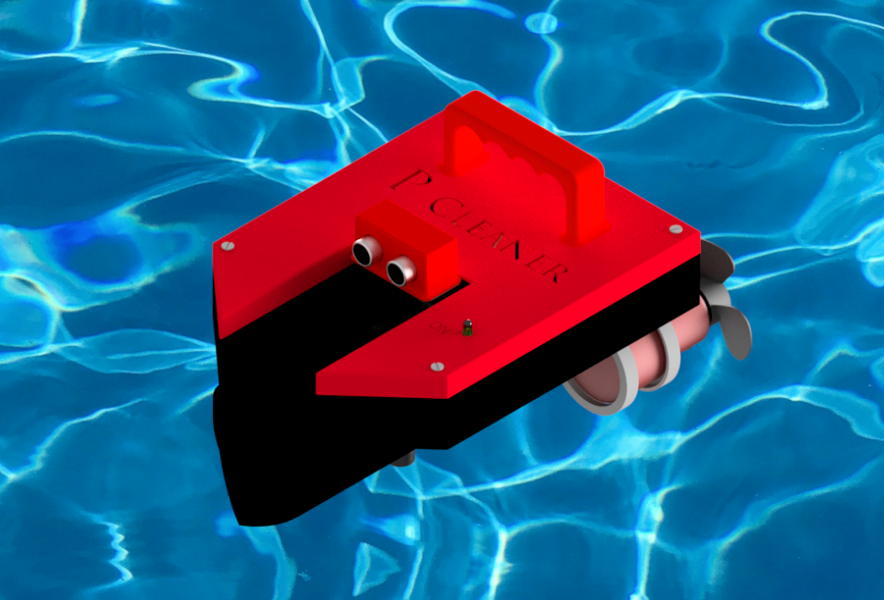
Figure 11: Proposed Design

Mechanical Design

CAD Model
Our main interest concerning the mechanical design where the fixation of motors of the thrusters. Motors are embedded in a housing taking their cylindrical shape and bolted with studs to assure tight fixation and allow easy disassemblyin case of maintenance.
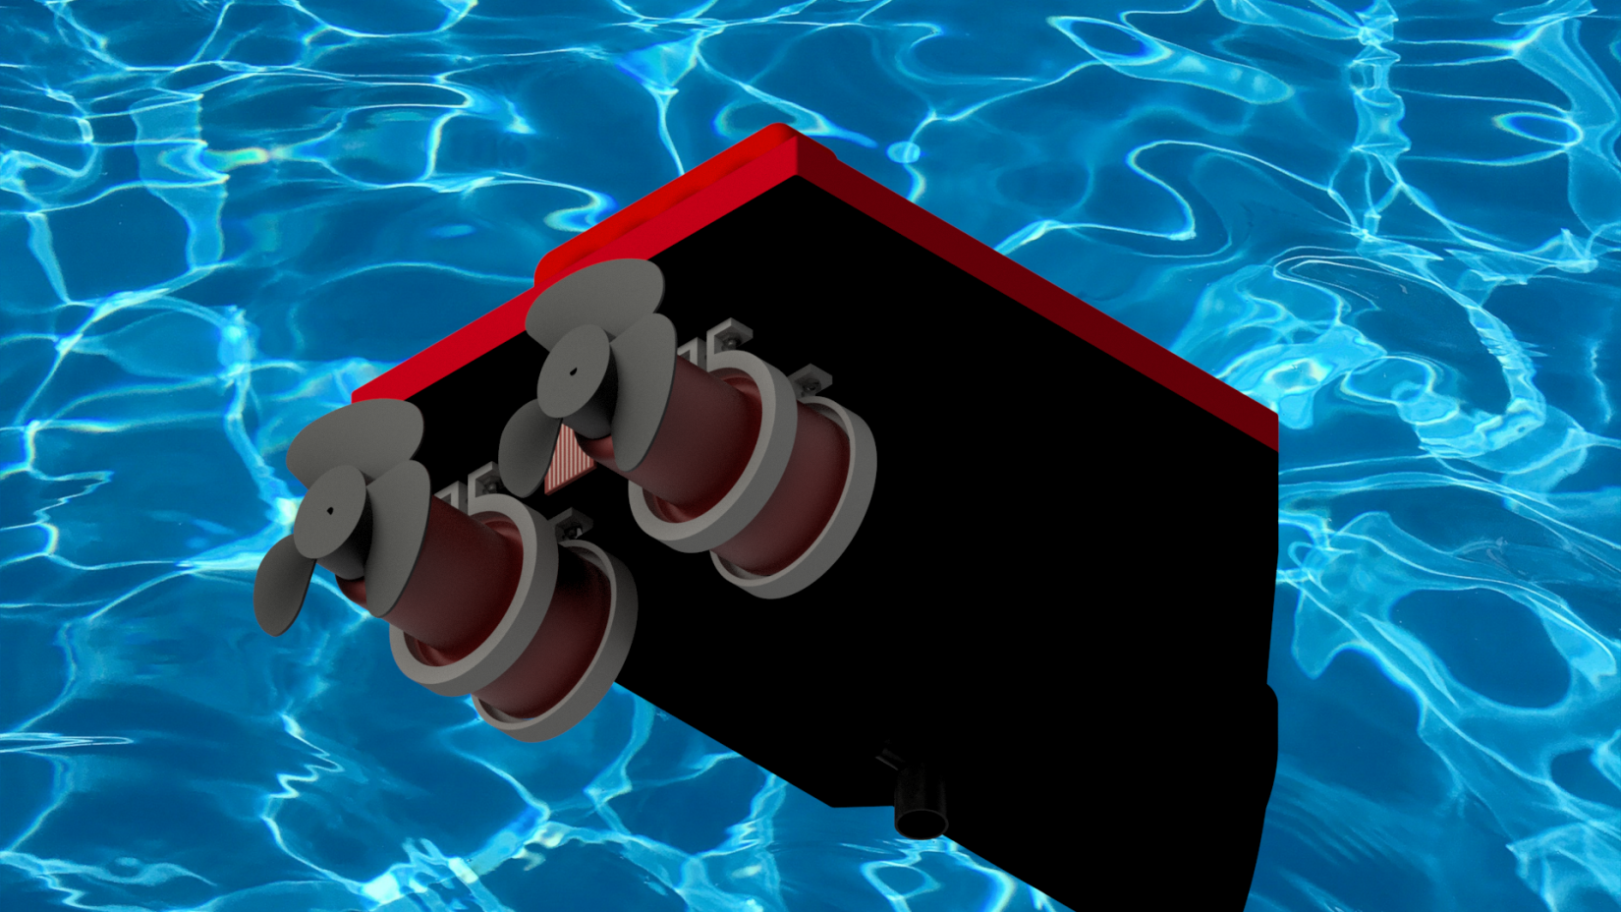
Figure 5: Fixation of Motors Stress Analysis

Stress ANAlysis
Since floating on the surface of water, makes almost no stress at any of the robot parts. The only part suspected to failure is the handle of the robot whenever the robot is lifted by the user. The following analysis shows that the handle can tolerate the robot’s weight.

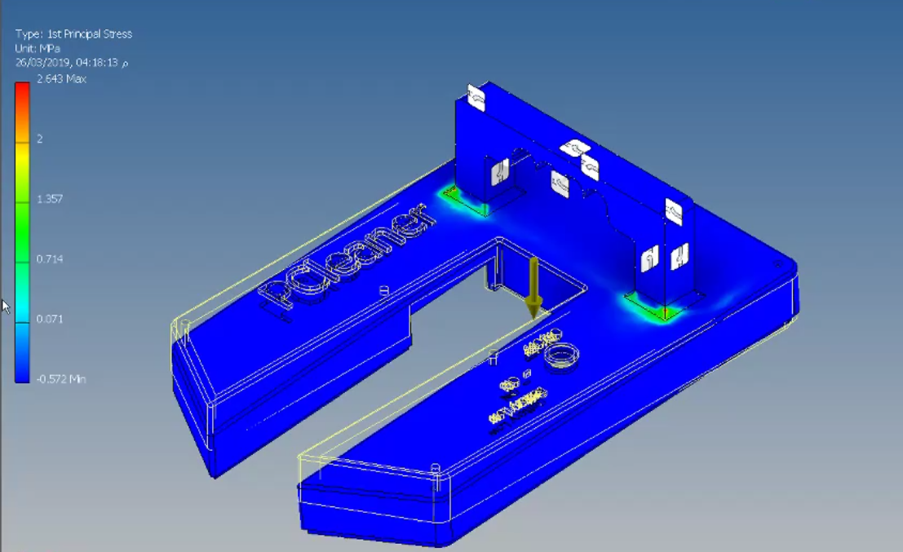
Figure 5: Stress Analysis on the handle applying the whole weight of the robot
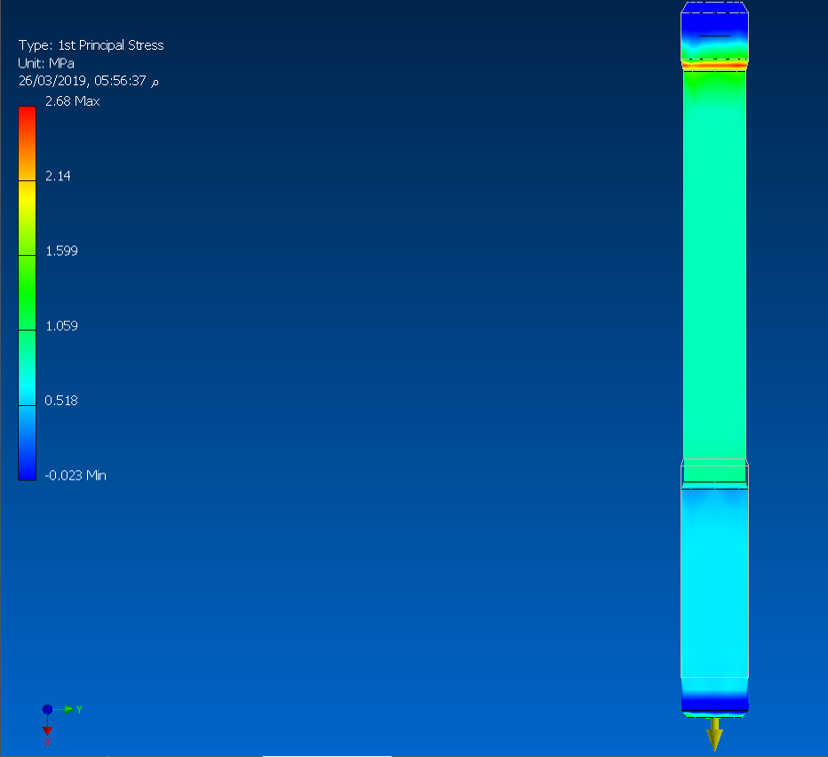
Figure 6: Stress analysis on a stud applying the weight of the robot

Actuator Sizing

MATLab Simulation
This model is primarily made as a simulation for the robot in case of controlling its velocity. But actually the available encoders were insufficient due to their shortness in operating under water. Thus an alternative idea is made as an approach to the closed loop requirement of the course.
Although this model wasn’t applicable due to the previous mentioned technical issues, it helped in actuator sizing to choose the suitable pumps.

Simulink (Simscape Model – Velocity Control)
Set point is compared to the signal coming from the system, and the error is fed to the PID controller which we tune its parameters until we reached the nearest point around the set point, as shown in figure (6).
Figure (8) shows the output of the PID fed to the motor driver which controls the motor using the PWM technique, while the motor shaft rotates, figure (9) shows the centrifugal pump being drove by the motor and from its flow rate, velocity outlet is obtained using the following equation:since q = Av, where q is the pump flow rate, A is the cross sectional area of the propeller enclosure, and v is the velocity of the outlet. Then, thrust of thrusters is obtained using:T = ρq (v2 – v1) where ρ is the density of water, v₁ is the velocity of the vehicle, and v₂ is the outlet velocity of pump while drag force is calculated using:D = T = 1/2 x CD x ρ x A_{normal} x v₁₂D is the Drag acting against the vehicle, CD is the coefficient of Drag. A_{normal} is the area normal to the moving direction of vehicle. Thus, calculating the resultant thrust acting on vehicle.
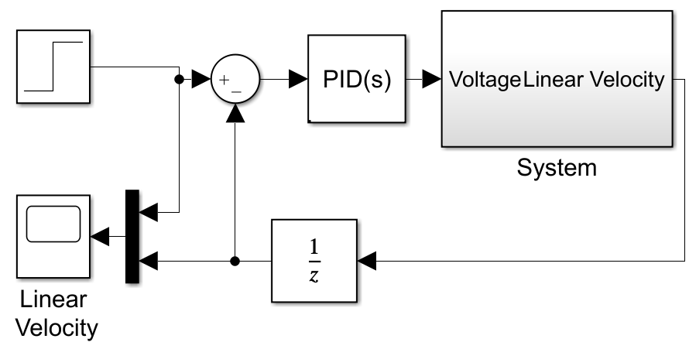
Figure 12: Overall Model – Velocity Control

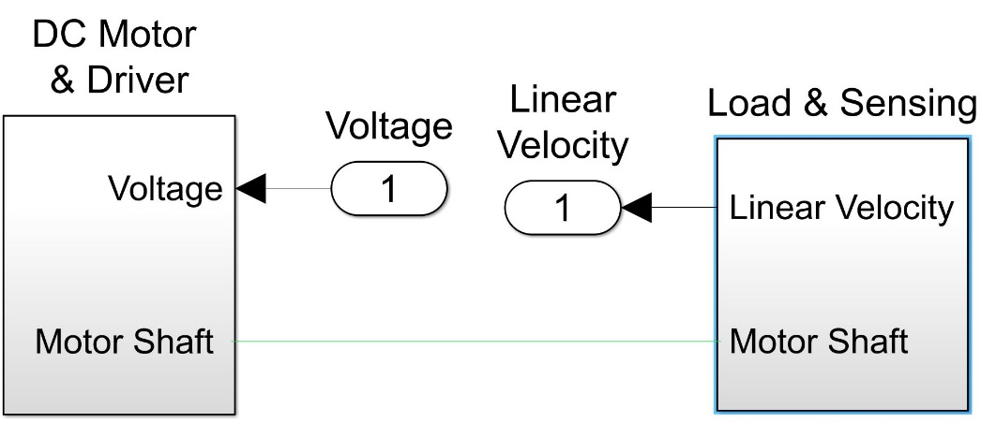
Figure 13: System

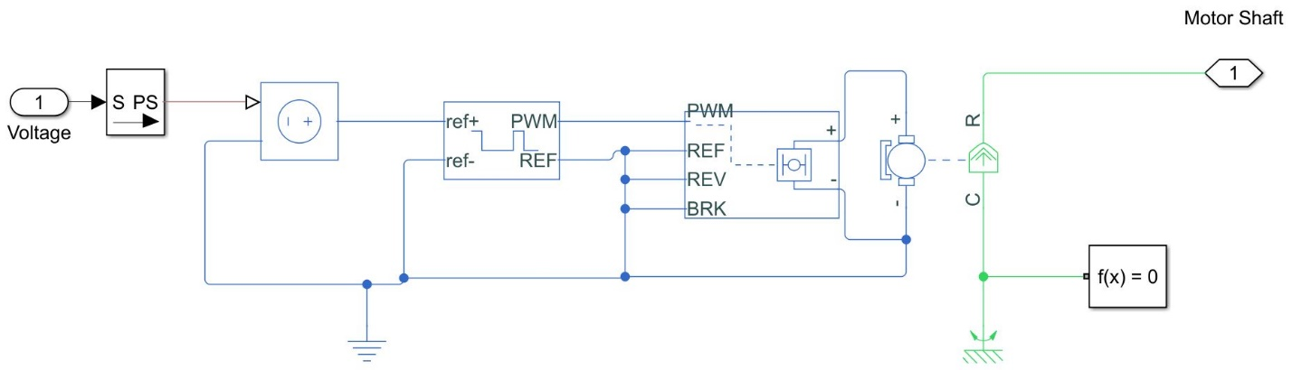
Figure 14: DC Motor & Driver
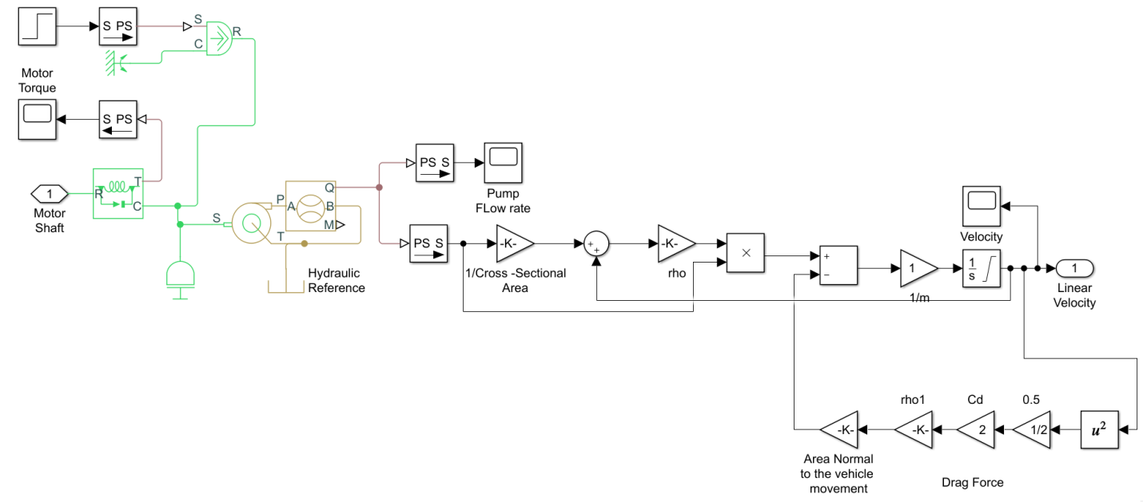
Figure 15: Load & sensing

Results

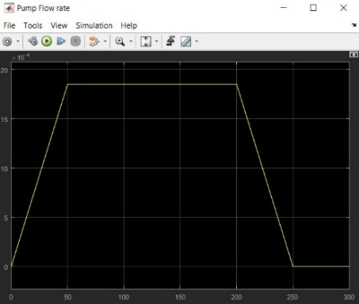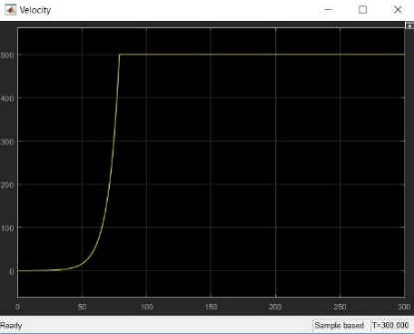
Figure 16: Pump flow rate Figure 17: Vehicle Velocity

Simplified Model
Here is another model presenting the vehicle velocity using the previously used equations.
Drag Force against vehicle: D = T = $\frac{1}{2}$ x CD x ρ x A_{normal} x v₁₂
Propulsive or Thrust Force: T = ρq (v₂ – v₁)

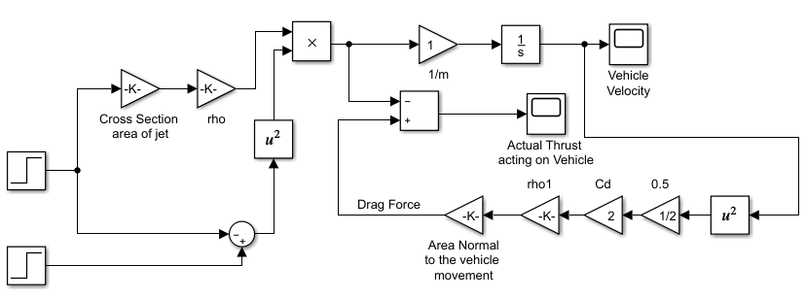
Figure 18: Simplified Model

Results
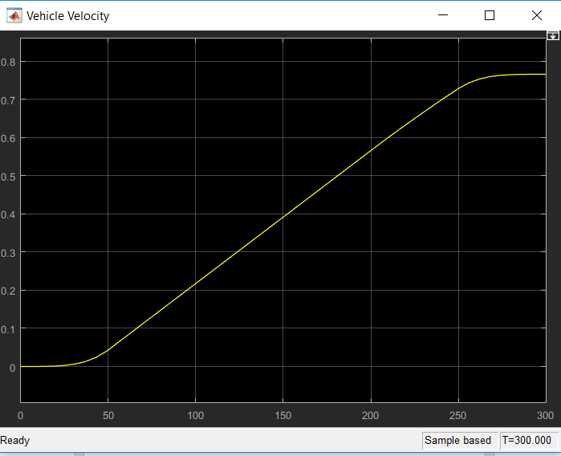 c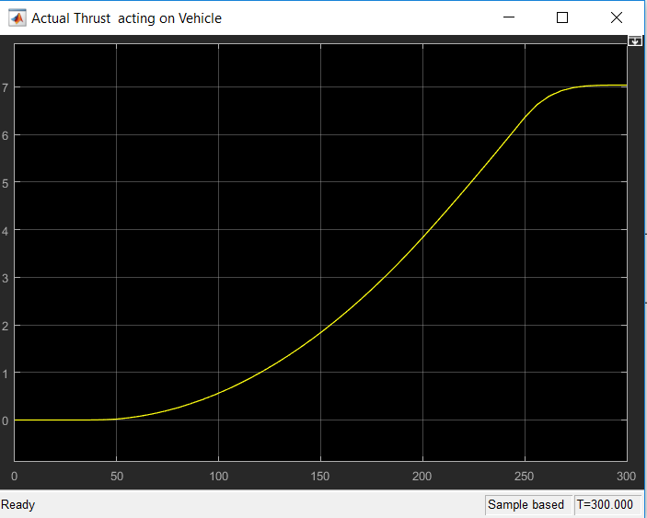
Figure 19: Vehicle Velocity (Simplified Model) Figure 20: Thrust acting on vehicle (Simplified Model)

Hand Calculations
Forces acting on vehicle horizontally are the thrust forces exerted by the thrusters to move the vehicle forward against drag force exerted by water in the opposite direction of movement, and forces acting on vehicle vertically are buoyancy forcesagainst the vehicle weight.

Parameters
Maximum velocity of vehicle = 0.2m/s, (v₁)
Mass = 1 kg, (m)
Volume of fluid displaced = 3.54 l,(v_{f})
Flow rate = 3634 l/h, (q)
Density = 1000 kg/m³,(ρ)or (ρ_{f})
Enclosure Diameter of propeller = 79.812 mm, (D_{en})
A_{normal triangle =} 5.24 x 10⁻³ m²
A_{normal rectangle =} 4.08 x 10⁻³ m²
A_{normal cylinder =} 5.514 x 10⁻³ m²
g = 9.8 m/s²

Horizontal Forces
Drag Force against vehicle: D = T = $\frac{1}{2}$ x CD x ρ x Anormal x v1² Eq. (1)
Where;
D is the Drag acting against the vehicle
ρ is the density
C_{D} is the coefficient of Drag
A_{normal} is the area normal to the moving direction of vehicle
v₁ is the velocity of the vehicle
Known that:
C_{Drect}= 1.05, C_{Dtri}= 0.5, C_{Dcyl}= 1.15
Substituting in Eq. (1): T = 0.32 N, resistive force needed to overcome by the thrusters.
Propulsive or Thrust Force: T = ρq (v₂ – v₁) Eq. (2)
Where,
v₂is the outlet velocity of pump
Solving Eq. (2) for v₂: v_{2 = 0.37 m/s}
Since, q = Av = π$\frac{(Den)2}{4}$ Eq. (3)
Where,
Cross Sectional Area of Jet = A, note that the enclosure diameter is assumed to be the diameter of a jet to simplify calculations
Velocity outlet = v
Substituting in Eq. (3): q = 1.85 m³/s = 111 l/min, flow rate required to move the vehicle with a maximum velocity of 0.2 m/s

Since primarily design has 2 thrusters/pumps, each thruster requires a pump of 55.5 l/min.

Selected Pump/Actuator
A bilge pumps of 63 l/min flow rate is selected. Which means q_{new} = 3780 l/h = 0.00105 m³/ for the whole vehicle to achieve the maximum speed, meaning that each pump/thruster requires 2x10⁻³m³/s
Thus solving Eq. (3) for v using q_{new}: v = v_{new2}= 0.42 m/s
Substituting in Eq. (2): T_{new} = 0.462 N

Path Generation
Using MATLab, this model shown in figure (15) simulated successfully the control of the vehicle yaw angle using an IMU. Using the famous equation that relates the torque to the angular acceleration: T = Jθ’’, and by integrating the angular acceleration about the z-axis twice, we obtain the yaw angle, which is compared to the set point and the error is fed to the PID controller of tuned parameters K_{p} = 10.15, K_{i} = 20.19, K_{d} = 0.446. These parameters were obtained by Zeigler – Nicholas Method. MATLab auto tuning didn’t work, since system couldn’t be linearized. PID output is fed directly to one of the thrusters and its sign is inversed and fed to the other. Thus we obtain one of the thrusters rotating in a speed higher than the other, until vehicle reaches the nearest point around the set point.
Figure (16) shows how the thrust of each thruster is calculated using the continuity equation, thus by creating a look up table between the pump flow rate and current from the pump data sheet, pump flow rate is obtained and since q = Av, where q is the pump flow rate, A is the cross sectional area of the propeller enclosure, and v is the velocity of the outlet, velocity is obtained. And since the propulsive/Thrust force: T = ρq (v2 – v1) where ρ is the density of water, v₁ is the velocity of the vehicle, and v₂ is the outlet velocity of pump, thus Thrust of each propeller is calculated.
In Figure (17), we calculated the Drag force resisting the thrust resulted from the thrusters using the following equation: D = T = 1/2 x CD x ρ x A_{normal} x v₁₂D is the Drag acting against the vehicle, CD is the coefficient of Drag. A_{normal} is the area normal to the moving direction of vehicle.

Simulink Model
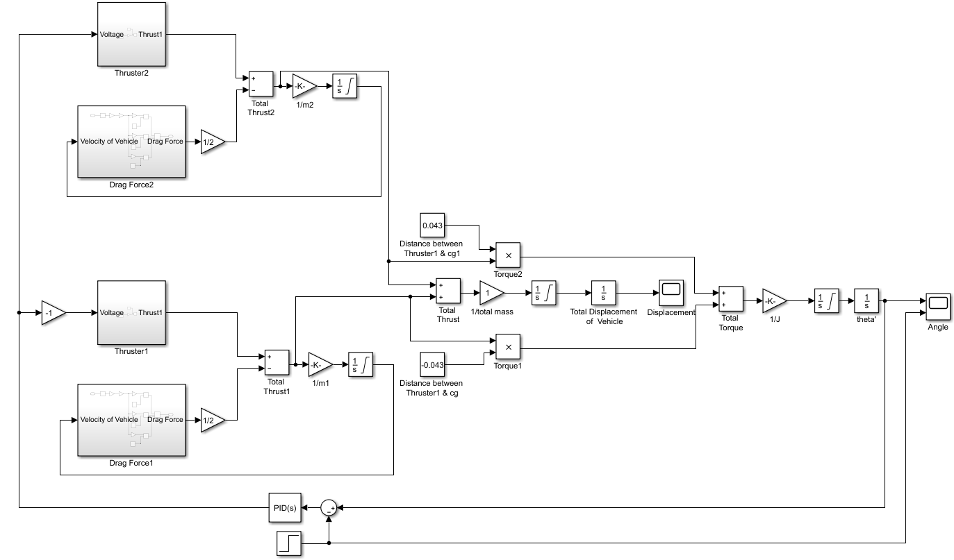
Figure 21: Path Generation
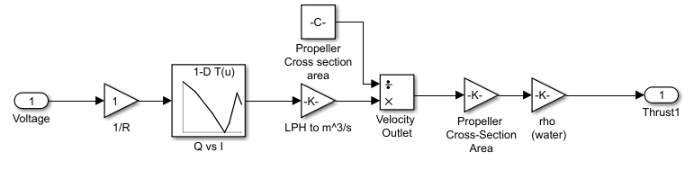
Figure 22: Thruster_{x}
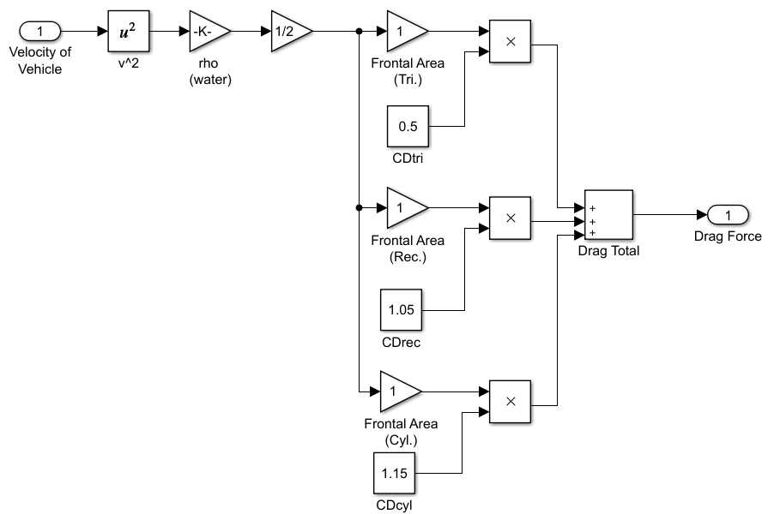
Figure 23: Drag Force_{x}

Results
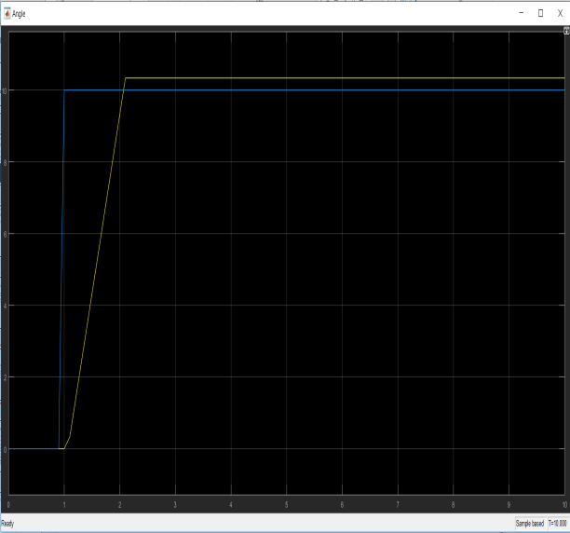  Figure 24: Angle Scope | 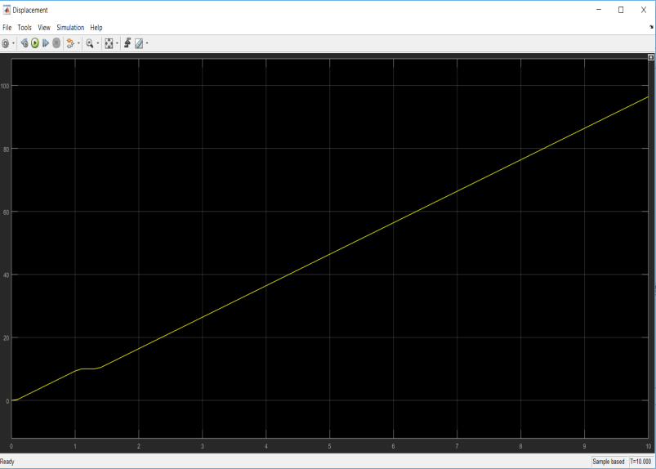  Figure 25: Displacement Scope

Stability
Stability is achieved by calculating the amount of volume required to be immersed versus the weight of the vehicle.

Vertical Forces
Buoyancy Force: F_{B} = ρ_{f} x v_{f x} g Eq. (4)
Substituting in Eq. (4): F_{B} = 34.692 N
To achieve equilibrium:
Since ΣF = 0,
Then F_{B =} Weight of the vehicle
34.692 = m_{max} x 9.8
Then, m_{max} = 3.54 kg
Robot toppling due to misalignment of center of gravity and center of buoyancy, a wide volume is left at the front of the vehicle to allow the addition of variable weight.

ImPLemenataTion Efforts And Resutls

CAD Model
Chassis frontal area is made in an optimum shape to decrease the drag force as much as possible, while the lateral area is ignored since our the vehicle function won’t require to go in a reverse direction.
*figure of frontal area from cad*
We faced the difficulty of immersing the filter pump underneath water while keeping most of the electric cables away as much as possible from being immersed in water.
*figure showing the immersed volume and the non—immersed volume*
Also, the fixation of thruster onto the base through the foam made a difficulty that was solved by trying our best to cut the foam in regular curved shapes by hand, since laser cut wasn’t able to do so because of heat that will melts the foam polymer based.
*figure of real foam being cut and fixed into the base and the thruster*

Actuator Sizing
We faced a difficulty in actuator sizing, since the usage of thrusters under this scale is not commonly used. The smallest thrusters size available in market are too big for our application, according to that an alternative is made to create a suitable thruster for this product. A bilge pump is used as a thruster by removing its impeller and impeller housing and replacing it by a small suitable available boat propeller which is designed mainly for under water applications.
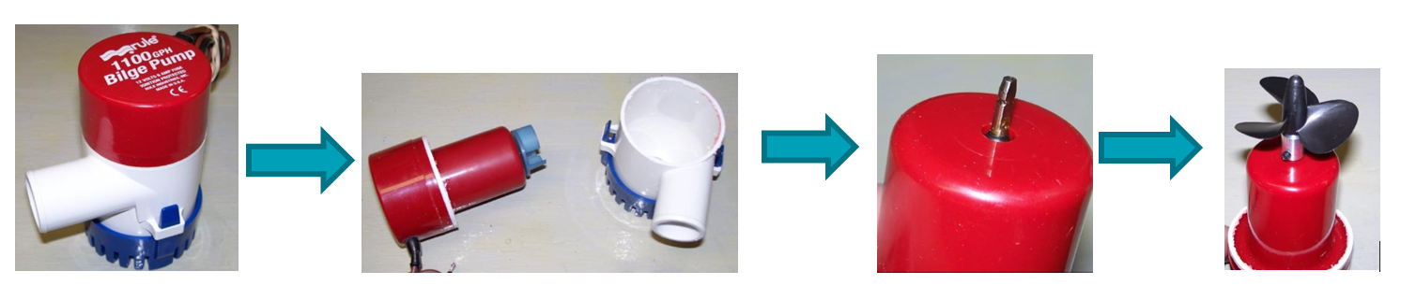
Figure 26: Turning a bilge pump into a thruster
Thus, instead of sizing a motor for a thruster, a pump sizing was made instead. In addition to that, the available pump data sheet didn’t provide enough information about the motor and system identification wasn’t sufficient for some technical issues.
Accordingly, MATLab didn’t provide us any logical results although our attempts were many and continuously with the help of our teacher assistants.

Manufacturing
We’ve used 3D-Printing in most of our manufacturing processes. Although we tried our best to avoid the common random workshops available inside and around the campus, since they’re expensive, when speaking about the workshops around the campus, or deliver very low quality of products, when speaking about the workshops of the campus, we faced the difficulty of splitting each part into too many subparts since all the available beds of the 3D-printers were too small.
Thus, more time was consumed to integrate each part, while creating a male-female assembly technique to facilitate the integration process.

Stability
Here we had the issue of trying to achieve the exact positive buoyancy of the vehicle that allows the filter pump to be immersed while keeping the electric cables away from being immersed as much as possible.

Electrical Design

System Interconnection Diagram

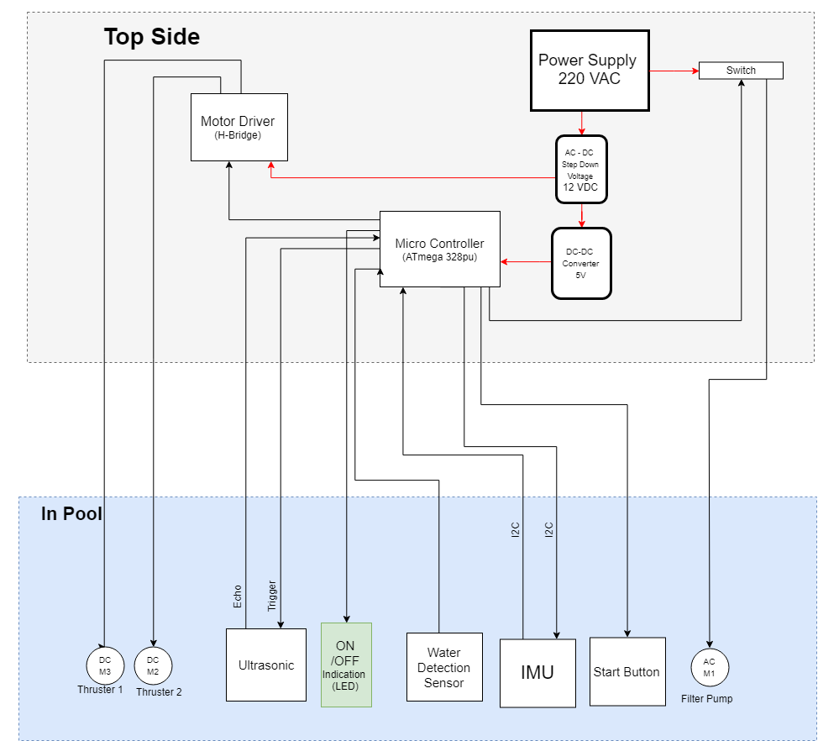
Figure 27: SID

Electrical Schematics
AC source is used to provide the sufficient amount of power for the robot, and conversions to 5V and 12V DC is made to meet the specs of other components.
AC source is mainly used to provide the required amount of power without any restrictions, and to avoid the heavy weight of the robot due to batteries. Also, although our application is mobile it only works in a fixed known area (swimming pool) thus AC source is the most suitable for our case.
ATmega328 (8-bit AVR Microcontroller with 4/8/16/32K Bytes In-System Programmable Flash) is used to be the only controller of the robot. It has been chosen mainly since it has enough number of digital, analogue, and PWM pins for the robot usage. In addition to, its high performance, low power consumption and simplicity.

Wire Sizing
Our application required a compact cable of about 18 wires going out of the vehicle and into the control unit. The available compact cables have identical wires; all wires are capable of carrying equal amounts of current. Since the thrusters are the most current consuming of about 3.2 A per Thruster. Thus 24 AWG wires are used to meet the requirements of thrusters’ current.
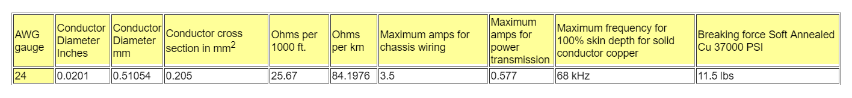
Figure 28: 24 AWG

Circuit Schematics
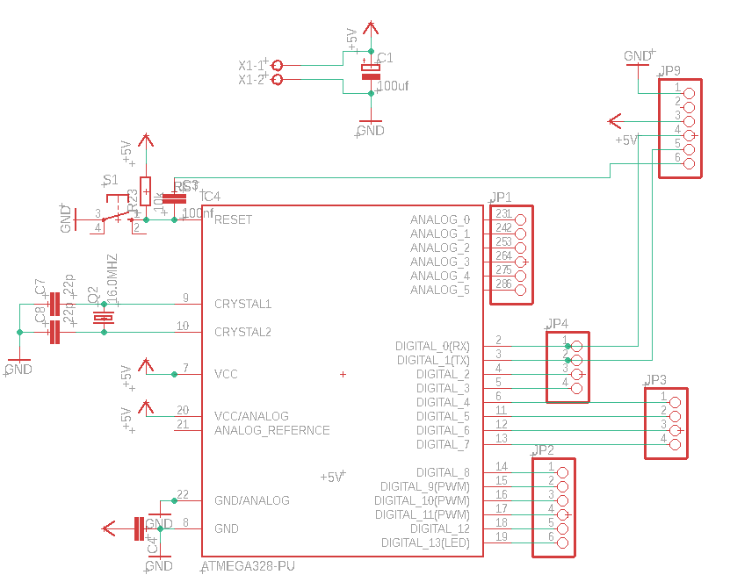
Figure 29: ATmega328 Stand Alone Schematic Circuit

Circuit Layouts
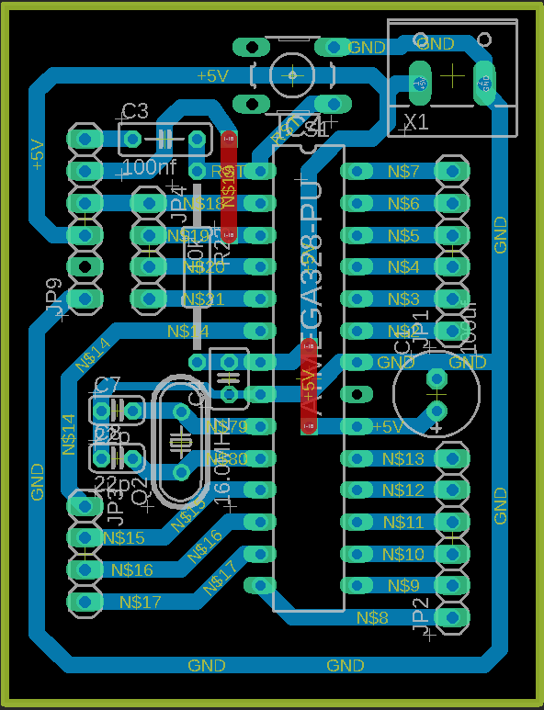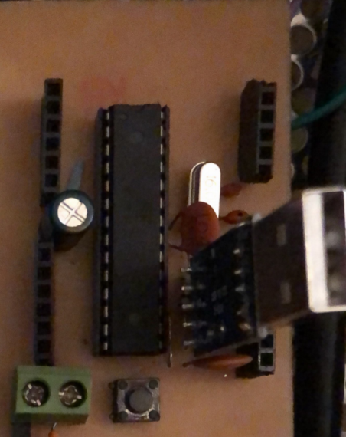
Figure 30: (a) ATmega328PU Stand Alone Layout Circuit
(b) ATmega328PU Stand Alone PCB

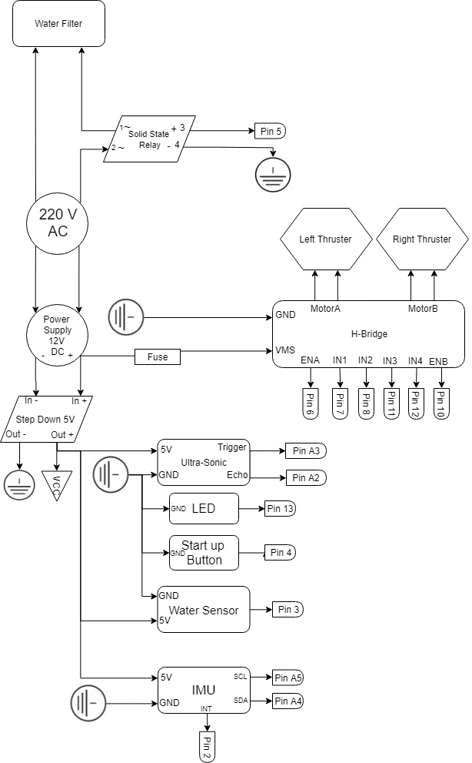
Figure 31: Integrated Circuit Schematic

Power Sizing
Calculations of each component consumption at its maximum draw of current. | Calculations of current losses through the whole circuit.
  Components | Current (Ampere) | Voltage | Power (Watt)
  Motors | 4.000 | 12 | 48.00
  Ultrasonic | 0.015 | 5 | 0.08
  Water Sensor | 0.020 | 5 | 0.10
  IMU | 0.004 | 5 | 0.02
  Filter Pump | 0.136 | 220 | 30.00
  Total Current Dissipated | 4.2 | Total Power | 78.19
  Components | Efficiency |  | Power Loss(Watt)
  AC - DC Converter | 80% |  | 15.64
  DC Chopper | 96% |  | 3.13
  Wires |  |  | 6.00
  Total Power Loss |  | 24.8
  Total Power Consumed | 103

Safety
Since AC is used to power this robot, high level of safety is considered.Ready sealed products are only present in water to avoid any unexperienced mistakes made that would result in any huge accidents. High quality isolated wires were used. All Electronic components are separated in a water proof box out of water (Control Unit) that also allowed easy heat dissipation due to great stepping down of voltage.Also. A Solid State Relay with an optocoupler is used to prevent high voltages from affecting the system receiving the signal.
Components safety were achieved by using a fuse on the motor drivers and on the AC to DC converter. A circuit breaker would be better but much expensive.
Also awater sensor is used to assure that even if the start button is pressed but the robot isn’t placed in a suitable level of water, it won’t operate.

Implementation Efforts and Results
The thrusters together consumed about 6.5A, the available inexpensive motor drivers can tolerate about 4A. Thus, two inexpensive motor drivers were cheaper than the only available motor driver that tolerate 30A, which we used.

Software Design
Main concept of the software design is that the dimensions of the rectangular average sized swimming pool will be previously known and the robot will be pre-programmed before it’s handled to customer. Thus just by changing the width and the length and re-burning the code to the microcontroller, the robot autonomously will be able to calculate the number of turns required to clean the pool and return back to the start point, thus being ready for another trip through the swimming pool.
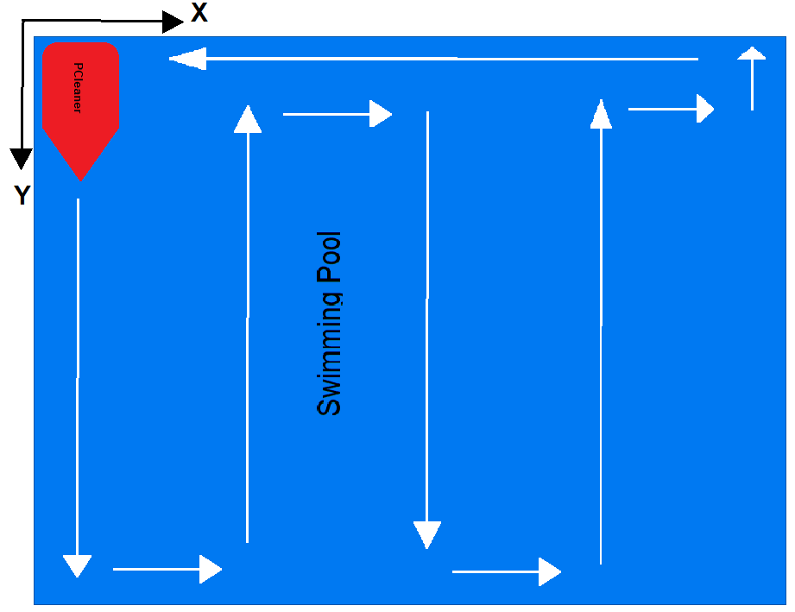
Figure 32: Path of Vehicle along a pool
The PID controls the PWM of the thrusters according to the IMU readings compared to the set point fed to the microcontroller. The PID parameters are tuned using Zeigler-Nicholas method, and aK_{p} = 10.15, K_{i} = 20.19, and K_{d} =-0.446 are obtained.
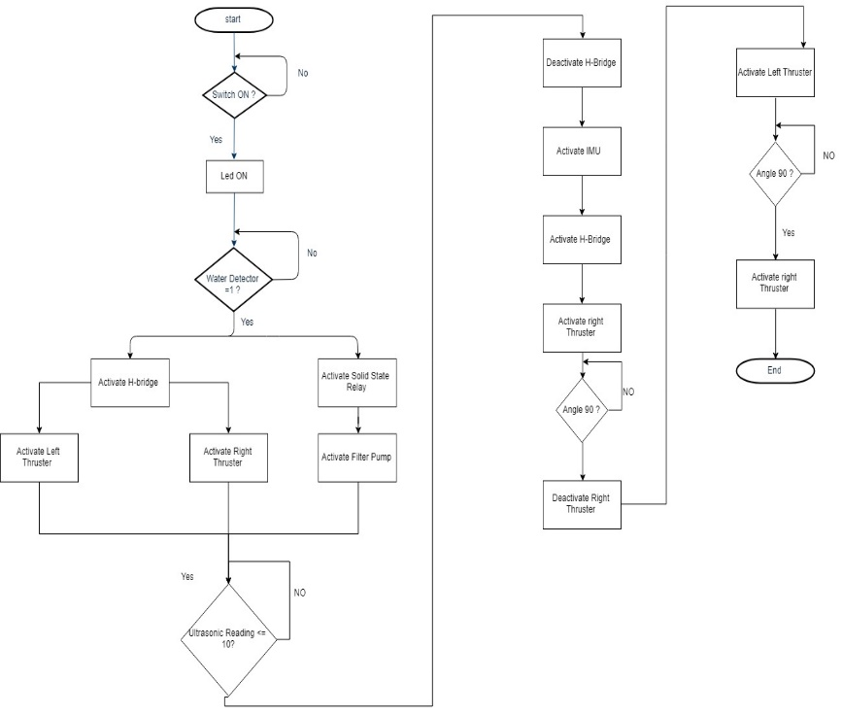
Figure 33: Flowchart

IMplementation of efforts anD REsults
We had an issue concerning the IMU calibration and noisy signals, but that was overcame using a Kalman filter.

Project Plan
We’ve followed the VDI 2206 standard which describes the logical sequence of important sub steps in the development of a mechatronic system.

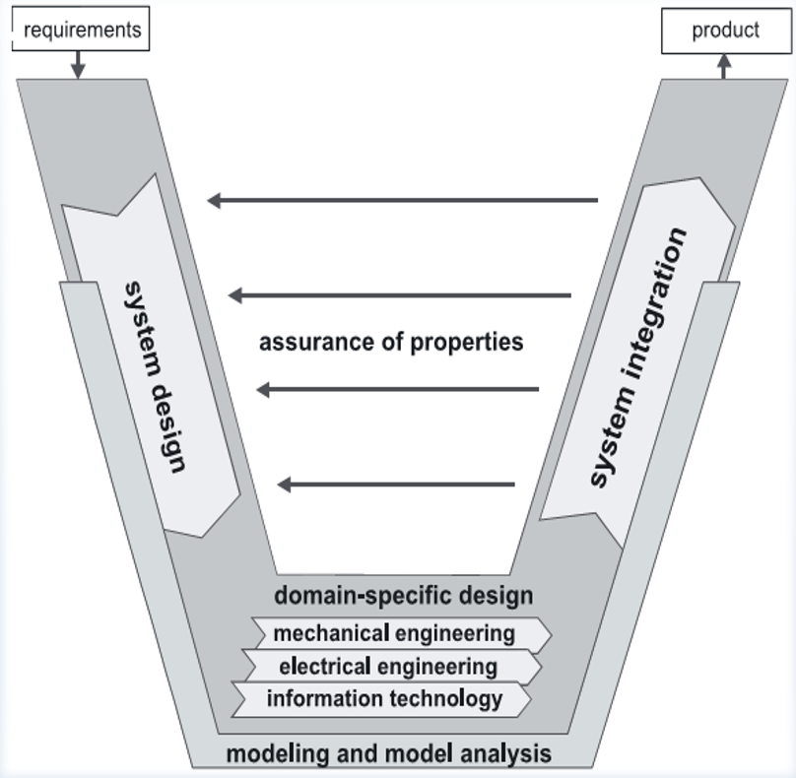
Figure 34: VDI 2206

Project Timeline
Project Timeline
Tasks / Weeks | Week #1 | Week #2 | Week #3 | Week #4 | Week #5 | Week #6 | Week #7 | Week #8 | Week #9 | Week #10 | Week #11 | Week #12 | Week #13 | Week #14
Design Thinking
Product Design
Mechanical Design
Stress Analysis
Manufacturing Plan
Manufacturing
Hardware System
Full System Integration
Paper Work

Manufacturing Timeline
Manufacturing Timeline
Parts | Thurs. 11/4 | Fri.  12/4 | Sat.  13/4 | Sun.  14/4 | Mon.  5/4 | Tues.  16/4 | Wed.  17/4 | Thurs.  18/4 | Fri.  19/4 | Sat.  20/4 | Sun.  21/4 | Mon.  22/4 | Tues.  23/4 | Wed.  24/4
Bilge Pumps
Propellers
Chassis
Base
Lower Thruster holder
Upper Thruster holder
Floating Bed
Filter Pump
Testing
Assembly

Here’s a sample of how our project tasks are scheduled.

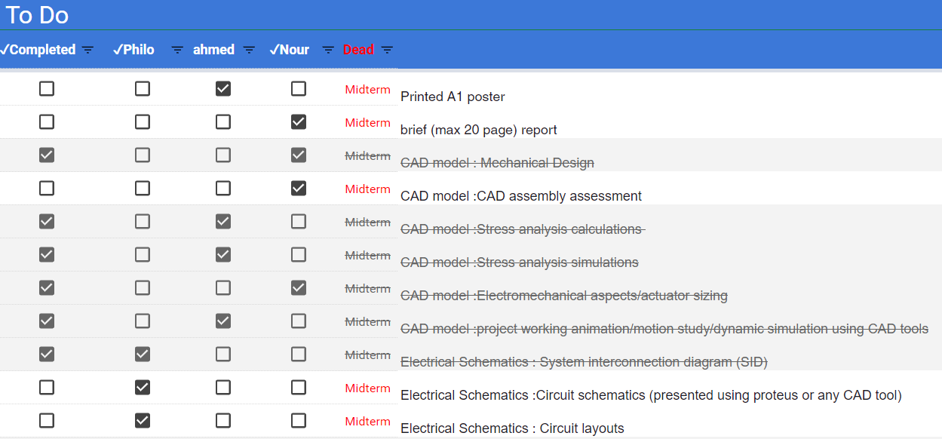
Figure 35: Sample of how tasks has been handled

Integration Plan

Componenets Integration
Most components were bought ready for modular integration except the microcontroller. A standalone circuit for the ATmega328 is made and manufactured from scratch. Mainly by integrating a 16MHz oscillator with the ATmega328, a burner, and a push button for the chip reset.

Modular Integration
Motor driver module, buck converter modules, AC to DC converter, alongside with the water sensor, ultrasonic, and IMU modules are integrated together with the microcontroller performing the whole circuit fully functioning while creating the suitable algorithm for the system control.Software design is made considering the PID controller and the PID parameters, integrated with the electrical system

Saptial Integration
Mechanical and electrical systems are integrated together forming a fully functioning system. Thrusters are brought within their housings and fixed into the base, while ultrasonic is brought to its housing and fixed into the chassis. IMU and water sensor were fixed in a suitable to achieve their function accordingly. Other modules as the AC to DC converters, buck converter, motor driver, solid state relay and the standalone PCB of the microcontroller is fixed to the control unit box. Cables inside the control unit and the inside the vehicle is managed properly.

Full System Integration
Tasks/Days | 11/5 | 12/5 | 13/5 | 14/5 | 15/5 | 16/5 | 17/5 | 18/5
Components Integration | ATmega3282P standalone circuit Schematic | ATmega3282P standalone circuit Layout | ATmega3282P standalone PCB Manufacturing
Modular Integration | AC to DC Converter - Buck Converter | Motor Driver Modules | Ultrasonic and water sensor | IMU
Spatial Integration |  |  |  | Fixing components to base | Fixing components to control unit | Cable Management | Algorithm creation

Integration efforts and results
Some difficulties were faced during integration, one of the most important issues is the holes made for the bolts to fasten different parts together. Holes made in base resulted in water entering the base when vehicle is placed in water, thus the vehicle sank. As a solution for that, silicon is used to assure no holes will allow water into the vehicle. The same issue was faced for the cable being inserted into the base, leaving clearance that was also avoided using silicon.
*figures of real image of silicon sealing the base*

Test Plan

System Verification
Thrusters, ultrasonic, water sensor, and filter pump responded correctly to the microcontroller signals and robot operated as expected. IMU had some issues concerning its calibration and noisy signals, but that is overcame using a Kalman filter.

System Validation
Robot functioned as good as a prototype would function to prove the concept of a whole newly idea. Robot cleaned an area of about 2m² in less than 30 seconds.
Testing Plan
Tasks/Days | 20/4 | 21/4 | 22/4
System Verification | Vehicle Velocity and vehicle yaw in respond of the PID Controller
System Validation |  | Sufficient cleaning in average time | Obstacle avoidance and low maintenance

Testing efforts and results
During verification, some issues have appeared like the bolts and the nuts which experienced corrosion that was solved using a transparent nail paint which was sufficient enough to preventing corrosion.
Some other difficulties were faced as the 4A motor driver which we thought would be sufficient enough for the thrusters which we calculated the required current that resulted to be 2A each, but the motor driver seemed to be supplying one of the thrusters as much as it demands without considering the other, that resulted in a thruster working correctly while the other doesn’t. This issue was solved by using 2 separate dual channel motor drivers which supplies each thruster with whatever amount of current it demands and cheaper than buying the available motor driver which can tolerate till 30A and but very expensive compared with the solution we achieved instead.

Bill of Materials and Cost
Parts | Quantity | Material | Manufacturing Operation | Cost (L.E)
Upper Thruster holder | 2 | PLA | 3D-Prinitng | 34
Lower Thruster holder | 2 | PLA | 3D-Prinitng | 25
Base | 1 | PLA | 3D-Prinitng | 417
Chassis | 1 | PLA | 3D-Prinitng | 290
Thrusters | 2 | - | - | 900
Filter pump | 1 | - | - | 250
Water Detection Sensor | 2 | - | - | 156
SSR - 25A (Relay) | 1 | - | - | 65
Start UP Button | 1 | - | - | 3
MPU 6050 (IMU) | 1 | - | - | 70
USB to Serial | 1 | - | - | 40
Sealed wires | 12 | - | - | 192
PCB | 1 | - | - | 60
Bolts M3 | 18 | - | - | 18
Nuts M3 | 42 | - | - | 42
filter breathing tube | 1 | PVC | - | 2
Foam | 1 | Polyurethane | - | 84
Ultrasonic Sesnors | 1 | - | - | 35
Heat shrink | 1 | - | - | 10
H-Bridge | 1 | - | - | 80
Thin Human | 6 | PLA | 3D-Printing | 40
Fuses | 1 | - | - | 5
26 AWG (Sealed Wires) | 1 | - | - | 150
Epoxy | 1 | - | - | 51
cloroform | 1 | - | - | 15
 |  |  | Total Budget | 3034

Supply CHAin Efforts and Results
A Low Budget criteria is mainly used for this project that resulted in a project that costed around 3000 L.E as shown in the previous figure.

Manufacturing
We tried our best to avoid the common random workshops available inside and around the campus, since they’re expensive, when speaking about the workshops around the campus, or deliver very low quality of products, when speaking about the workshops of the campus, thus we have used 3D-printing since it allows the control of each part density and printed most of the parts on our previously made3D-Printer which allowed us to save about 25% of the cost.

Electrical components
We’ve faced some difficulties finding bilge pumps in Cairo in addition to their highly cost, but after many researches we’ve found them available with the some random people, and they were bought second hand thuswe saved about 800L.E. 2 dual channel motor drivers tolerating 4A each were way cheaper than the available motor driver that tolerated till 30A, which was over kill for our application. In addition to that we had these motor drivers already.

Conclusion
This project is being designed to follow the guidelines given by MCT382 course and to meet all the requirements specified. Its general task is to provide daily care for small sized rectangular pools by removing leaves, insects or whatever that can float on the surface water of the pool. It’s mainly for medium sized pools in villas owned by females or males who are aged between 30 -50 years old and having a relatively high income level. Human –Machine Interface is highly considered by providing a very easy user interface which all it requires is pushing a button.
Primarily the design process was guided by minimizing the effect of drag force on the robot without creating any manufacturing complexity. A relatively positive buoyancy design is determined to reduce the amount of risk of electric components to be exposed to water, although they’re well sealed. Water proof electronics and control system are bore in mind through the design process.
Robot toppling and stability of robot were highly considered in calculations and during design. The creation of small thruster from a pump was overcame successfully. Exact positive buoyancy is achieved by calculations which allowed us to immerse the filter pump while keeping the electric cables away from the water.
A separate control unit on the top side away from the pool has enhanced many issues as safety and solved many issues as the heavy weight of the vehicles due to the AC to DC Converter and other heavy modules. A 24AWG wire is used that was sufficient for our application and integrated the many wires required in compact thin cable.
ATmega328p is used as the microcontroller for our vehicle, its standalone PCB is made and successfully worked efficiently. According to calculations our robot consumes 103W. Electrical safety is considered by using fuses before components that re though to dissipate much current as thrusters, and a built in fuse in an AC to DC converter is already protecting it. Also, an optocoupler solid state relay is used, a ready water resistant modules and a water sensor module that protects thrusters from common human mistakes is used.
Software design is made to achieve the autonomous vehicle meant for this application by feeding the dimensions of a rectangular pool to the robot, and robot is programmed to clean the whole surface of the pool and return to its home point when finished, just by pushing a button. That is achieved under the control of a PID which is fed the error through an IMU that returns the yaw angle and is compared by the set point.
Our project plan is following the VDI 2206 standard. Project timeline, manufactured timeline, integration and testing plan were successfully followed due to logical previous planning. We tried our best to create a low budget project, which we consider ourselves have partially achieved that, since the whole budget is around 3000L.E.

Appendix
#include "I2Cdev.h"
#include "MPU6050_6Axis_MotionApps20.h"
#include "Wire.h"

//Pool Dimensions
#define Length 700 //in cm - Pre-programmed for every pool
#define Width 500 //in cm - Pre-programmed for every pool

#define PCleaner_Width 18.5 //in cm
#define PCleaner_Length 27.1 //in cm

//Thrusters - HBridge
#define EnA 6
#define In1 7
#define In2 8
#define In3 11
#define In4 12
#define EnB 10

//Filter - SSR
#define SSR 5

//IMU - MPU6050
#define INTERRUPT_PIN 2

//Ultrasonic
#define pingPin A3
#define echoPin A2

//Water Sensor
#define Grove_Water_Sensor 3

//ON - LED
#define ON 13

//Start Button
#define Start 4

//Variables
//IMU

MPU6050 mpu;
bool dmpReady = false; // set true if DMP init was successful
uint8_t mpuIntStatus; // holds actual interrupt status byte from MPU
uint8_t devStatus; // return status after each device operation (0 = success, !0 = error)
uint16_t packetSize; // expected DMP packet size (default is 42 bytes)
uint16_t fifoCount; // count of all bytes currently in FIFO
uint8_t fifoBuffer[64]; // FIFO storage buffer

Quaternion q; // [w, x, y, z] quaternion container
VectorFloat gravity; // [x, y, z] gravity vector
float ypr[3]; // [yaw, pitch, roll] yaw/pitch/roll container and gravity vector
float yaw;

volatile bool mpuInterrupt = false; //for interrupt pin status
void dmpDataReady() {
mpuInterrupt = true;
}

void setup()
{
Serial.begin(9600); // Starting Serial Terminal

//Thrusters - HBridge
pinMode (In1, OUTPUT);
pinMode (In2, OUTPUT);
pinMode (EnA, OUTPUT);

pinMode (In3, OUTPUT);
pinMode (In4, OUTPUT);
pinMode (EnB, OUTPUT);

//Filter - SSR
pinMode(SSR, OUTPUT);

//IMU - MPU6050
//I2C
Wire.begin(); //Initiate the Wire library and join the I2C bus as a master
Wire.setClock(400000); // 400kHz I2C clock

// MPU 6050 device initialize
mpu.initialize();
pinMode(INTERRUPT_PIN, INPUT);

devStatus = mpu.dmpInitialize(); //function returns zero if it worked

// supply your own gyro offsets here, scaled for min sensitivity - Default Values
mpu.setXGyroOffset(220);
mpu.setYGyroOffset(76);
mpu.setZGyroOffset(-85);
mpu.setZAccelOffset(1788); // 1688 factory default for my test chip

if (devStatus == 0)
{
mpu.setDMPEnabled(true);

// enable Arduino interrupt detection
attachInterrupt(digitalPinToInterrupt(INTERRUPT_PIN), dmpDataReady, RISING); //trigger when the pin goes from low to high
mpuIntStatus = mpu.getIntStatus();

dmpReady = true;

// get expected DMP packet size for later comparison
packetSize = mpu.dmpGetFIFOPacketSize();
}

//Ultrasonic
pinMode(echoPin, INPUT);
pinMode(pingPin, OUTPUT);

//Water Sensor
pinMode(Grove_Water_Sensor, INPUT);

//ON - LED
pinMode(ON, OUTPUT);
//Start Button
pinMode(Start, INPUT);
}

void loop()
{
int water = digitalRead(Grove_Water_Sensor);//LOW when water is detected
//int start = digitalRead(Start);//LOW when button is pressed
int start = LOW;
int distance = Distance();
while (!water && !start)
{
if (distance > 20) // if ( mode && distance > 20)
{
VehicleForward();
digitalWrite(SSR, HIGH);//Filter Energized
delay (1000);
}
if (distance < 20)
{
ThursterSTOP(1);//Stop Right Thruster
ThursterSTOP(2);//Stop Left Thruster

int prev_Angle = Angle();
Thruster(2, 2, 150); //Energize Left Thruster
while (prev_Angle < Angle()+180); //Wait till required angle is reached -PID should be present in here
ThursterSTOP(2);//Stop Left Thruster
}
VehicleForward();
}
}
//////////////////////////////////////////////////////////////////////////////////////////////////////////
/////////////// DEFINITIONS.H - Starts //////////////////
/////////////////////////////////////////////////////////////////////////////////////////////////////////
//for UltraSonic
long microsecondsToCentimeters(long microseconds)
{
return microseconds / 29 / 2;
}

float Distance()
{
digitalWrite(pingPin, LOW);
delayMicroseconds(2);
digitalWrite(pingPin, HIGH);
delayMicroseconds(10);
digitalWrite(pingPin, LOW);
int duration = pulseIn(echoPin, HIGH);
int cm = microsecondsToCentimeters(duration);
}
//for Thrusters
void ThursterSTOP(int thruster)
{
if (thruster == 1)
{
digitalWrite (In1, LOW);
digitalWrite (In2, LOW);
analogWrite (EnA, 0);
}

if (thruster == 2)
{
digitalWrite (In3, LOW);
digitalWrite (In4, LOW);
analogWrite (EnB, 0);
}
}
void Thruster(int thruster, char dir , int pwm)
{
//Thruster: 1 (Right) or 2 (Left)
//dir: 1 (Clockwise) or 2 (Counter Clockwise)
//pwm: 0 to 255
if (thruster == 1, dir == 2)
{
digitalWrite (In1, HIGH);
digitalWrite (In2, LOW);
analogWrite (EnA, pwm);
}
else if (thruster == 2, dir == 2)
{
digitalWrite (In3, HIGH);
digitalWrite (In4, LOW);
analogWrite (EnB, pwm);
}
else if (thruster == 1, dir == 1)
{
digitalWrite (In1, LOW);
digitalWrite (In2, HIGH);
analogWrite (EnA, pwm);
}
else if (thruster == 2, dir == 1)
{
digitalWrite (In3, LOW);
digitalWrite (In4, HIGH);
analogWrite (EnB, pwm);
}
}
void VehicleForward()
{
Thruster(1, 2 , 255);
Thruster(2, 2 , 255);
}
//for IMU
float Angle()
{
if (!dmpReady) return;// if programming failed, don't try to do anything

while (!mpuInterrupt && fifoCount < packetSize) // wait for MPU interrupt or extra packet(s) available
{
if (mpuInterrupt && fifoCount < packetSize)
fifoCount = mpu.getFIFOCount();
}

mpuInterrupt = false; //clear interrupt flag
mpuIntStatus = mpu.getIntStatus(); // get INT_STATUS byte

fifoCount = mpu.getFIFOCount();//// get current FIFO count

// check for overflow (this should never happen unless our code is too inefficient)
if (mpuIntStatus & _BV(MPU6050_INTERRUPT_DMP_INT_BIT))
{
while (fifoCount < packetSize) // wait for correct available data length
fifoCount = mpu.getFIFOCount();
mpu.getFIFOBytes(fifoBuffer, packetSize); // read a packet from FIFO

// display Euler angles in degrees
mpu.dmpGetQuaternion(&q, fifoBuffer);
mpu.dmpGetGravity(&gravity, &q);
mpu.dmpGetYawPitchRoll(ypr, &q, &gravity);
yaw = ypr[0] * 180/M_PI;
return yaw;
}
}

//////////////////////////////////////////////////////////////////////////////////////////////////////////
/////////////// DEFINITIONS.H - ENDS //////////////////
/////////////////////////////////////////////////////////////////////////////////////////////////////////

