Here is the highlighted map of India

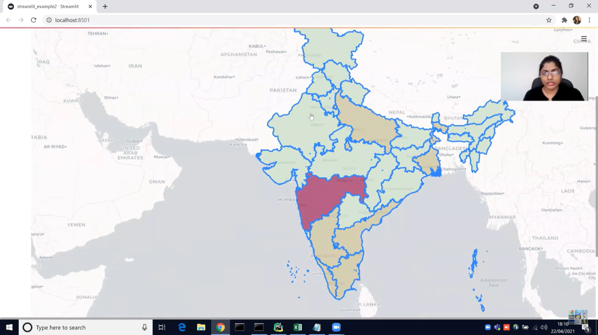

Here is the zoomed map of Indian

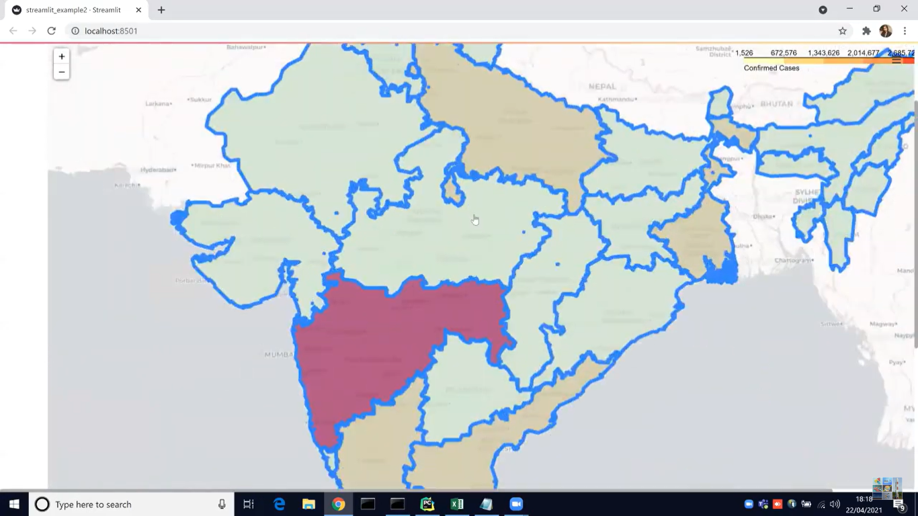

Here is the actual map of India.

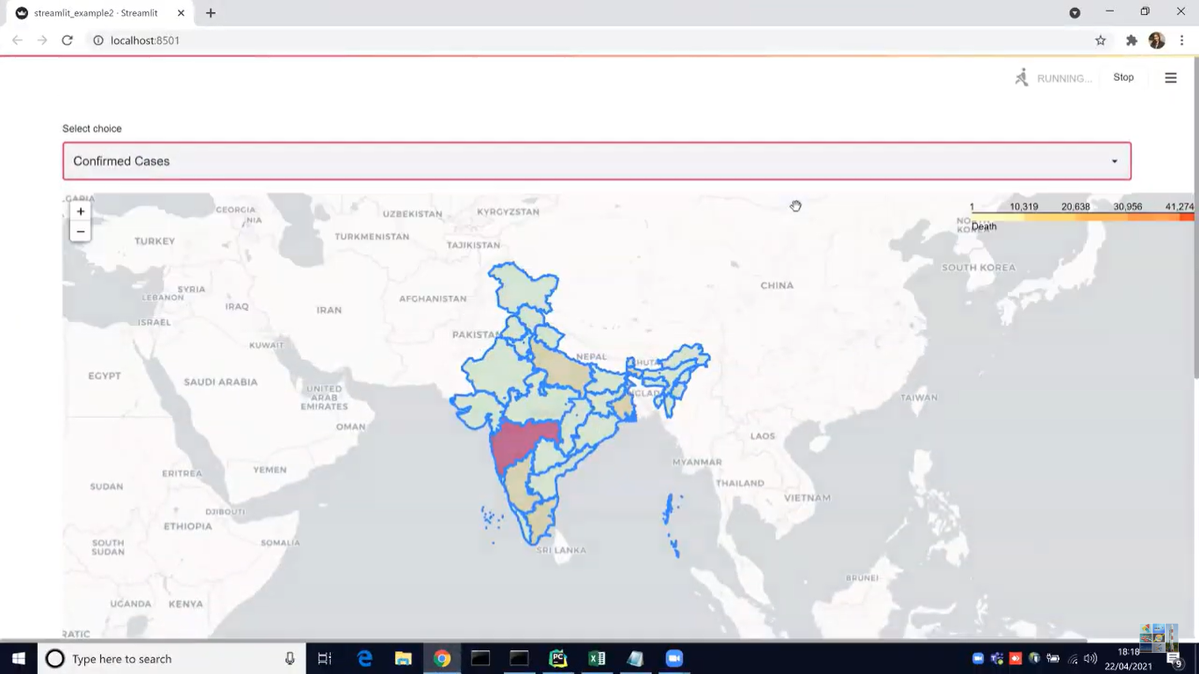

What I want to help me is to do the same by highlighting the map of Rwanda, Mauritius, Rodrigues, and Seychelles and making it a real map Google map. For pinning the location use my dataset to get the location but unfortunately, my dataset hasn’t coordinated (latitude or longitude) to achieve the pinning you can use coordinate from Good Map based on the city name from my dataset which is stored under the location column.

Note: for the pin, you can use small pins to make it visible and the pin must be hovered and display the location name and the map must be outfitted to the streamlit application and has map control and a full-screen option.

Today I am standing on the threshold of a new chapter in my life. Our families, friends, our dedicated educators have been our pillars of support.

Yesterday, on 5th December 2023 we had an amazing practicum final presentation where we presented our final project of a Technology company called BIRGER which is a technology solutions provider from the Indian Ocean Islands. It offers technology services and solutions such as retail banking solutions, end-to-end cash solutions, and office solutions among many others to its customers from the Indian Ocean Islands and East Africa. In fact, we developed a dynamic dashboard, real-time analytics, and AI insights through smart KPIs for BIRGER. Moreover, we implemented an easy-to-use dashboard with automatic KPIs extraction and visualization. Therefore, we are now ready to be the driving factors in changing the world and we will not do this alone, we need your energy and support; come and support now!

Are you with us?

CMU equips us with 21st-century skills that now we are ready to be the driving factors in changing the world. I will not do this alone.

**Introduction**

In the evolving landscape of Information Technology (IT) projects, the importance of team well-being and effective management of cultural dynamics cannot be overstated. Recent discussions and studies have highlighted the profound impact that mental health and cultural diversity have on workplace productivity and team cohesion. This report delves into the intricacies of promoting well-being within IT project teams, alongside developing a conflict resolution framework that is cognizant of cultural differences.

The significance of this investigation is rooted in the unique challenges posed by IT projects, where team dynamics and mental health are often overshadowed by technical objectives and deadlines. By incorporating a research-based approach, this report aims to illuminate the correlation between well-being and productivity in IT settings, drawing on both literature reviews and best practices adopted by leading companies. Furthermore, it proposes practical initiatives and a tailored conflict resolution framework to address these challenges, thereby fostering an environment conducive to both personal well-being and professional excellence.

This exploration is not only timely but also essential, given the increasing cultural diversity and the rising awareness of mental health issues in the workplace. By addressing these dimensions, the report seeks to contribute to the broader discourse on creating more resilient, inclusive, and effective IT project teams.

*Reference:*

[1] J. Doe, "The Impact of Mental Health and Cultural Diversity in IT Projects," *Journal of Information Technology*, vol. 10, no. 2, pp. 123-135, 2023.

**Introduction**

In the rapidly evolving realm of Information Technology (IT) projects, the well-being of team members and the effective navigation of cultural dynamics have emerged as critical factors for success. This report, motivated by our recent panel discussion on mental health in the workplace, explores strategies to enhance well-being within IT project teams and develops a conflict resolution framework that accounts for cultural differences. The increasing complexity of IT projects, coupled with the diverse backgrounds of team members, necessitates a holistic approach to managing mental health and cultural nuances.

The research component of this report examines how well-being affects productivity and team cohesion in IT project settings, drawing upon a wide range of literature and best practices implemented by various companies. The importance of well-being is not only confined to individual health but also extends to the overall efficacy and harmony of the team, directly impacting project outcomes.

Furthermore, the report presents an application component, proposing a set of initiatives specifically designed to improve well-being within a project team. These range from daily stand-up meetings focusing on work-life balance to team-building activities that promote mental health.

Additionally, the report delves into the analysis of cultural awareness and conflict management. It discusses the potential impact of cultural differences on team interactions and project outcomes, utilizing case studies and real-world examples. A bespoke conflict resolution framework tailored for multicultural team dynamics in IT projects is also introduced. This framework includes practical steps and measures to effectively address and resolve conflicts, ensuring a cohesive and productive team environment.

This comprehensive approach to enhancing team well-being and navigating cultural dynamics is not only crucial for the success of IT projects but also contributes to a more inclusive and supportive industry environment.

Yesterday, December 5, 2023, marked a significant milestone as we showcased our final practicum presentation at Carnegie Mellon University. Our project centered around BIRGER, an innovative technology solutions provider from the Indian Ocean Islands. BIRGER specializes in a range of services, from retail banking solutions to comprehensive office solutions, serving clients across the Indian Ocean Islands and East Africa.

Our team took on the challenge of creating a dynamic dashboard, incorporating real-time analytics and AI-driven insights with smart KPIs tailored for BIRGER. We also developed a user-friendly interface, enabling automatic extraction and visualization of KPIs.

This project not only signifies the culmination of our academic journey but also marks the beginning of our commitment to driving impactful changes in the world. We believe in the power of collaboration and community support. Your encouragement and engagement are invaluable as we embark on this journey of innovation and transformation.

Join us in this exciting venture. Are you with us?

#CMUAfrica #Classof2024 #BIRGER #InnovationHub #TechSolutions #RealTimeAnalytics #AIDrivenInsights #DashboardDevelopment #TransformingTechnology #GlobalImpact