Where are Sunspots?

The Practical Method of Galileo as an example of Mental Model

Tadeusz Sierotowicz

Copernicus Center for Interdisciplinary Studies,
Istituto di Scienze Religiose di Bolzano e
IISS Gandhi di Merano
sierotowicz@gmail.com

Abstract: After the publication of Sidereus Nuncius Galileo, in the controversy with Ch. Scheiner, developed several arguments on behalf of the hypothesis that sunspots are contiguous to the surface of the Sun, and presented them in his Istoria e dimostrazioni intorno alle macchie solari e loro accidenti (Roma 1613). One of them, named by Galileo a Practical Method, advocates very clearly the correctness of the hypothesis. In the paper the method in question is briefly described. It is argued that the Practical Method is not a thought experiment, but rather a mental model proposed precisely in order to solve the problem of sunspots’ location.

Key words: sunspots, Galileo’s practical method, mental models, early modern science

Introduction

After Galileo discovered many celestial novelties through his telescope, as described in the widely read Sidereus Nuncius, his vis polemica found a space in the sunspot dispute with the Jesuit priest Christopher Scheiner (Camerota, 2004, pp.238–259; Fantoli, 2003, chap.2.6; Heilbron, 2010, pp.183–192; Galilei and Scheiner, 2010; Shea, 1970; Sierotowicz, 2013). In this article, I pay special attention to a few pages from Istoria e dimostrazioni intorno alle macchie solari e loro accidenti (Galilei, 1613), which has been largely neglected by scholars. In the work, the Pisano presented what he himself called the most powerful reason in favour of his thesis about the location of sunspots. This is an original method, called the Practical Method (see OG V, 121.5; Galilei, 2010, p.112), through which Galileo tried to prove his hypothesis by combining in a paradigmatic way sensible experiences (observations) and necessary demonstrations (a geometrical model).
Galileo Galilei, in opposition to Christopher Scheiner, considered sunspots a phenomenon that exist on the surface of the Sun and, as a consequence, participate in the rotation of the solar globe. However, according to Scheiner, sunspots are just shadows of the passage of planets distant from the Sun through the solar disk. All these planets have to move with an angular velocity that is equal to the angular velocity of the rotation of the Sun.
To decide which of these two theories is right, Galileo proposed several arguments. One of them, a sort of cinematic and geometric reasoning, was based on the variation of the relative distance between the two spots moving along the same parallel from the edge of the solar disk towards its centre. The Pisano noted that the observed distance between such two sunspots changes in a particular way because of the projection on the observation plane of the segment between the spots according to the angle that the segment forms with the plane of observation. Galileo developed a geometrical model of this situation in his work on sunspots mentioned above (Fig 1).
The apparent distance between two sunspots is normally smaller than the actual distance between them. However, on one occasion, namely, when the segment between two spots is parallel to the observation plane, the length of the segment and the length of its orthogonal projection onto the observation plane will be the same. This happens when the straight line joining the observer’s eye with the centre of the Sun is aligned with the centre of the segment that joins the spots (Fig. 5). Of course, this situation is rather exceptional, but Galileo was lucky enough to observe it for two sunspots on 01 July 1613 and 05 July 1613, respectively (Fig. 2 and 3). Extraordinary, masterly executed drawings representing these observations were printed in Istoria e dimostrazioni…. In fact, on July 5, 1613, spots A and B appeared to be symmetrically located with respect to the centre of the solar disk. This particular observation allowed Galileo to develop and apply the Practical Method.

The Practical Method

First, Galileo noted that «because the distance between the Sun and us is very great in proportion to the diameter of its body» (OG V, 121; Galilei, 2010, p.112) some preliminary premises, also of a physical nature, for his model can be made:

(1) The rays that reach the eye of the terrestrial observer can be considered as parallel lines (see the rays ZDG, OLI, and QP in Fig. 1);
(2) Sunspots are located on the same latitude and pass through the centre of the solar disk or very close to it; and
(3) This situation occurs in the case of two spots, A and B (see Fig. 2 and 3).

Starting with these suppositions, Galileo constructed the geometric model of sunspot observations. The plane of the drawing (Fig. 1) corresponds to the plane passing through the observer, the centre of the Sun, and the parallel (practically the equator) on which the sunspots A and B are located. The GDZ line, coming out from the centre of the Sun G, goes towards the terrestrial observer to whom the spots appear projected on the plane perpendicular to the plane just mentioned and passing through the centre of the Sun (the observation plane). Let CDE be the semicircle representing the surface of the Sun, or the parallel on which the A and B spots move, and let the points on the CGE segment correspond to the observed positions of sunspots in an orthogonal projection on the observation plane. The points L and H are the sunspots A and B, respectively, observed on 01 July 1613 (Fig. 2). The actual distance between these spots is equal to the HL chord, but because of the projection effects, these spots are observed as points F and I, and their observed distance is equal to the length of the FI segment. It is easy to see that in a situation where the HL segment is symmetrical with respect to the GDZ line, the observed distance should be equal to the length of the HL segment because the HL, FI, and CGE segments are parallel. This situation actually occurred on 5 July 1613 (see Fig. 3 and 5).
Naturally, the construction described above corresponds to the hypothesis that sunspots are supposed to be located on the surface of the Sun, or very near to it. What if the spots are but the shadows of a distant planet (Scheiner’s hypothesis)? Let us now imagine that the phenomenon of the spots is caused by a transition through the solar disk of objects distant from the surface of the Sun that are about 1/20th of the diameter of the solar disk. The objects in question therefore move on the MNO semicircle (Fig. 1). In this case, sunspots should be collocated in points N and O, and their real distance should correspond to the segment NO. It is easy to find out using a compass that the segment NO is shorter than the HL one. Nevertheless, even in this case, the observed distance corresponds to the FI segment because the geometric construction represents the way in which the mind and the eye of the terrestrial observer builds images of the spots. How to decide which of the two situations, clearly different, reflects the real situation? To put it briefly: where are sunspots – on the MNO or on the CDE semicircle?
To answer this question, Galileo used a simple and ingenious method, inspired by the observation record of 05 July 1613. Let the observer execute the drawing that represents this observation and its geometrical reconstruction on the same scale; that is, let the observer trace the circle that represents the solar disk with the same opening of the compass for both the geometric reconstruction (Fig. 1) and the recording of the observations (Fig. 2 and 3). In these circumstances, the distance between spots A and B on 05 July directly gives the length of the chord that corresponds to the real distance between the sunspots in the scale adopted for the drawing.
Therefore, should the spots be on the surface of the Sun, it would correspond to the HL segment; otherwise, it would correspond to the NO segment. A graphical manipulation shown on Fig 1 and 4 clearly indicates that the AB distance observed on July 1 corresponds to the length of the FI segment. At the same time, reiterating the same operation for Fig 1 and 3, and thus arriving at Fig. 5, it becomes clear that the distance between spots A and B on 5 July 1613 are equal to the length of the HL segment, which is significantly greater than the length of the NO segment. This confirms Galileo’s hypothesis.
Galileo must have had this procedure in mind. In fact, in the Istoria e dimostrazioni… he wrote, «now if one looks at the illustration of the fifth day [Fig. 3], […] one will find that [the] distance [of the spots] A and B would be exactly equal to the chord HL. This can in no way happen if their revolution takes place along a circle at any distance whatsoever from the surface of the Sun» (see OG V, 122.34-36; Galilei, 2010, p.115). Then, he proposed the reasoning summarised above, calculating subsequently the numerical values of the difference between chords in question (see OG V, 123).

The Practical Method and its Application

The Practical Method is a brilliant argument that makes it possible to distinguish between two hypotheses on the location of sunspots based on observations using a simple and immediate measurement based on a properly scaled geometric model. The procedure seems to have innovative features. On the one hand, Galileo built a geometric model of the phenomenon, but on the other hand, the model itself acts as a sort of measuring instrument that allows one to resolve the dispute between two hypotheses with reference to the observations. It can therefore be said that the graphical reasoning based on the geometrical model of the event (Fig. 5) permits one to assign a numerical value to a physical quantity (a distance between sunspots) and solve the problem.
A sine qua non condition for such a reasoning to work is to assign the same value to the diameter of the solar disk both in the construction of the geometric model and for the drawings representing the observations. Galilei followed precisely this method. In fact, I have analysed a copy of Galileo’s treatise on sunspots from the Early Printed Books Collection of the Jagiellonian Library in Cracow (593892 II). Here are the results of my measurements performed on the drawing that corresponds to Fig. 1 (accuracy of ± 1 mm.):

HL = 60mm / ON= 52mm / GM = 69mm / FI = 42mm / CE = 123mm / CG = 62mm

In the same volume, the distance between the sunspots AB is, respectively, 42 mm (observation on 1 July: the diameter of the solar disk is 123 mm) and 61 mm (observation on 5 July: the diameter of the solar disk is 122 mm).
Therefore, my measurements within the margin of errors seem to indicate that the length of the HL segment is equal to the distance between the AB spots on 5 July, which in principle solves the ongoing dispute between Galileo and Scheiner. Of course, things are not that simple because, first, the spots are not exactly point like, and second, they change shape continuously, moving with their own motion.
In the Istoria e dimostrazioni… Galileo applied the Practical Method to other situations, using it as a starting point for the prediction of the probable results of some possible sunspots observations (see OG V, 124.13-21; Galilei, 2010, p.116). Suppose, for example, that spot A is collocated at the edge of the solar disk in point C (Fig. 1), and spot B in point H; then, the arc CGH would be equal to 4°. Assuming that the GC radius is of 10000 units and the GM radius is of 10100, then the lengths of both the CH, and the RN segments can be easily calculated; the CH segment would be of 419 units, and the RN of 94 units. The effect would then be extremely strong (CH/RN = 4.46 versus HL/ON = 1.12 in Fig. 5). Unfortunately, Galileo did not find any observations corresponding to the situation in question.

The Practical Method – Methodological Aspects

How to interpret Galileo’s reasoning? The Practical Method has some characteristics of what is defined in the literature as an epistemic image. Such visual structures usually serve as a starting point for the formulation and development of a given theory. The Feynman diagrams are often indicated as an example of this.
Galileo began with some hypotheses that simplified the description of the observational situation (e.g. the parallel rays that reach the observer) and then constructed a geometric model that, through some mathematical calculations, permits one to depict the evolution of the phenomenon. The model permits the prediction of the results of the observations. Galileo’s two-dimensional model becomes, in a sense, a sort of measuring instrument that allows one to compare directly the two hypotheses by referring them to the observations, solving in this manner a theoretical problem.
Thus, it seems reasonable to state that the Practical Method is a reasoning on which is based the argument in favour of Galileo’s thesis about the location of sunspots. Briefly, the Practical Method is a graphic solution of an analysed problem. At the beginning of his scientific career, Galileo, in the context of his studies on the centre of gravity of bodies, emphasised in his discussion with Clavius the importance of drawing in investigation procedures. Lodovico Cigoli, in a letter to Galileo dated 11 August 1611, wrote that a «mathematician, even the greatest, without the help of detailed sketch is only half a mathematician - more, a man without eyes» (OG XI, 168).
Galileo’s Practical Method thus offers a sort of geometrical reasoning on behalf of his thesis about the location of the spots. From the mathematical point of view, he constructed a univocal (isomorphic) model of some aspects of the phenomena that occur on the surface of a sphere. The accuracy of the thesis can be confirmed after having assigned a numerical value to the crucial physical quantities that assume different values in different scenarios (Galileo’s vs Scheiner’s hypothesis). Here, with great clarity, one can see the connection between geometry and observations inside a specific model. The Galileo’s Practical Method is therefore an example of model-based reasoning, which is not the reasoning referred to the figures of syllogism in Aristotelian terms, but – in this case – to the geometric considerations developed inside the model of a specific phenomenon.

Conclusion – Galileo’s Practical Method as a Mental Model

The Practical Method of Galileo assuredly is not an example, or perfect description of what later was called the Galilean method; the method in which insight into the universe is «gained through a self-reinforcing loop between experimental data and theoretical analysis, based on the use of mathematics and modelling» (Succi and Coveney, 2019, p.2). Nevertheless, it contains very valuable hints on how some natural problems can be solved.
Galileo’s protocol is based on a geometric model, which, starting from simplifying hypotheses, develops an isomorphic geometric structure of the evolution of a given phenomenon. It allows, as a consequence of some geometrical reasoning, a direct comparison between the model and the observations, thus providing graphic reasoning on behalf of a specific thesis as far as a particular aspect of the phenomenon in question (the location of sunspots) is considered. From that point of view Galileo’s procedure seems to be very similar to what is now called “mental models”, considered together with “mental/thought experiments”, a fundamental evolutionary achievement of the human race (see Nersessian, 1992, 2008; Stuart, Fehige and Brown, 2018).
The notion of mental models dates back to the ideas formulated by Charles Peirce and Ludwig Wittgenstein. Kenneth Craik developed the concept of mental models in a remarkably stimulating way. His theory identified the ability to predict events as a fundamental property of human thought and as a particularly advantageous adaptive conquest. Regarding mental models, Craik emphasised their ability to reflect the processes of the real world, both in terms of structure and in the processes that occur there: «By a model we thus mean any physical or chemical system which has a similar relation-structure to that of the process it imitates. By ‘relation-structure’ I do not mean some obscure non-physical entity which attends the model, but the fact that it is a physical working model which works in the same way as the process it parallels, in the aspects under consideration at any moment» (Craik, 1943, p.51). In short, mental models have a structure similar to the structure of a “fragment” of the reality they represent.
According to Craik, the construction of mental models belongs to the natural capacities of the human mind. The mental process that constitutes a model is based on three fundamental processes: translation of the processes of the external world into words, numbers, or symbols; reasoning, that is, the transition to other symbols through deduction, induction, etc.; and finally, re-translation of these symbols into external processes or the recognition of correspondence between symbols and external processes.
Since the 1980s, the concept of mental models has been an object of intense research in the fields of philosophy, literary criticism, computer science, and cognitive science. According to interpretations that follow Craik’s approach, especially those of Nancy Nersessian, mental models are the constructs of the human mind that represent situations, events, and processes designed to solve certain problems. These models can be manipulated, transformed, and dynamically developed through modes of reasoning that are quite different with respect to the forms of reasoning applied to systems of propositions, such as deduction or induction. In short, there is no strict equivalence between reasoning and logic, because in the case of mental models, ‘inferences are made through constructing and manipulating models that are structural, behavioral or functional analog models of target phenomena’ (Nersessian, 2008, p.184). Mental experiments are often referred to as an example of this type of “manipulation” understood here as a form of reasoning. Consequently “thought experimenting is a form of ‘simulative model-based reasoning’” (Nersessian, 1992, p.291).
Galileo’s Practical Method (OG V, 121-122), developed as a measurement tool to be used in the specific dispute on sunspots, as illustrated above using an example of the drawings from the Jagiellonian Edition, seems to be quite near to the aforementioned description of mental models. In that sense, his solution to the problem of the location of sunspots can be considered an example of the construction and the use of mental models. Such models are present in other discoveries of Galileo, and in the history of physics in the post-Galilean era. However, detailed analysis and investigation of this topic must be left for future research.
Illustrations

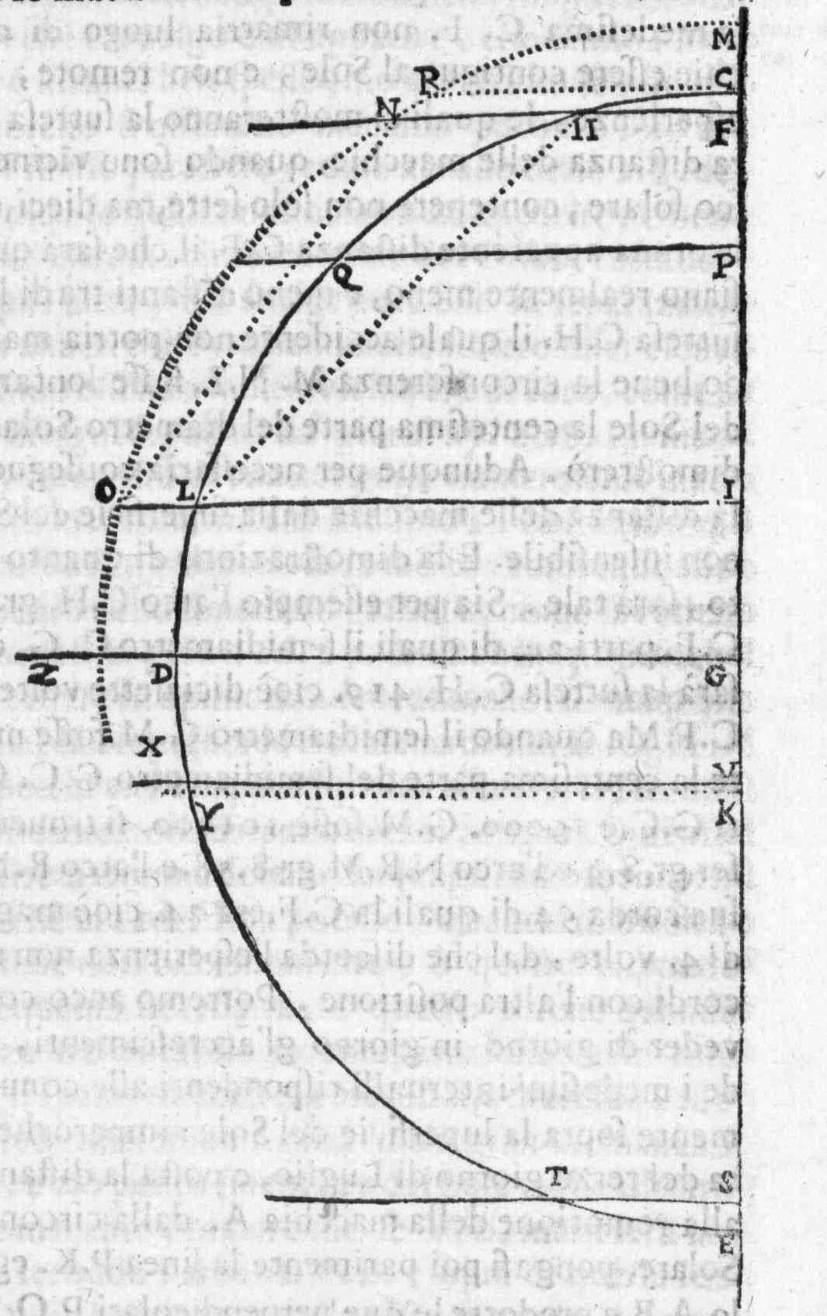
Fig. 1. Galileo’s Practical Method – the projection on the observational plane of the segment between two sunspots.

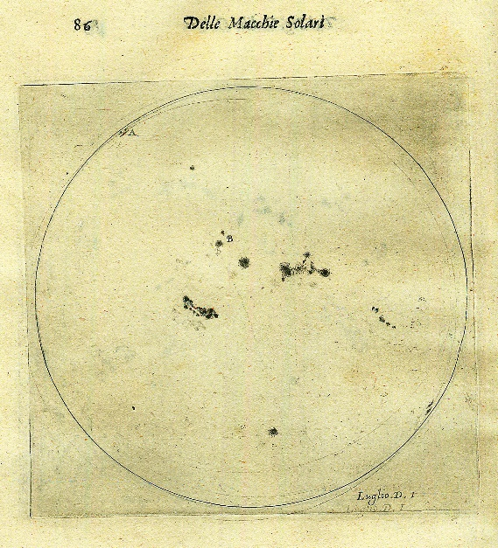
Fig. 2. Galileo’s observation on the 1st of July 1613.

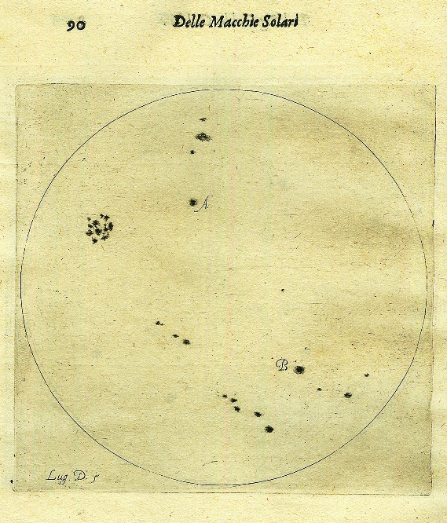
Fig. 3. Galileo’s observation on the 5th of July 1613.
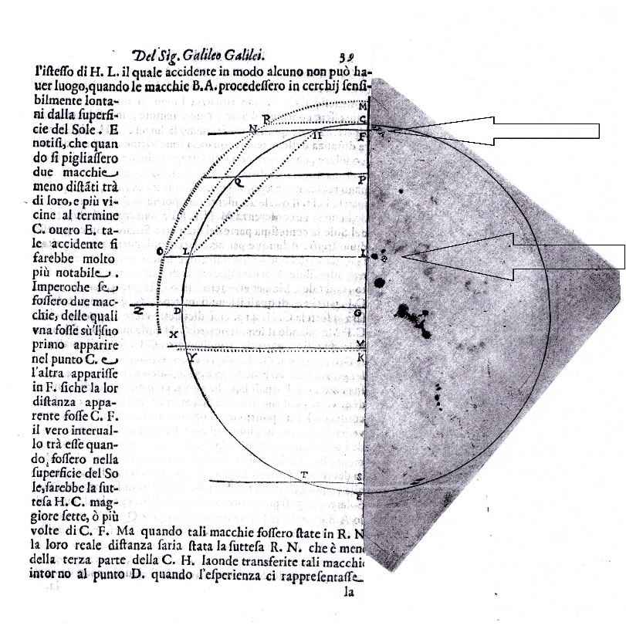
Fig. 4. Sunspots observation, and its geometrical model for the 1st of July 1613. The reconstruction by the Author.

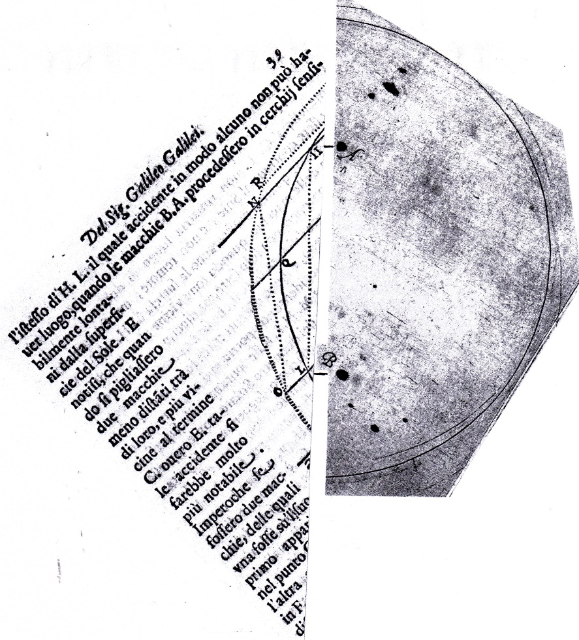
Fig. 5. Sunspots observation, and its geometrical model for the 5th July. The reconstruction by the Author.

References

Camerota, M., 2004. Galileo Galilei e la cultura scientifica nell’età della Controriforma [Galileo Galilei and scientific culture in the Counter-Reformation age]. Roma: Salerno Editore.
Camilleri, K., 2015. Knowing what would happen: The epistemic strategies in Galileo’s thought experiments. Studies in History and Philosophy of Science Part A, [online] 54, pp.102–112. Available at: <https://linkinghub.elsevier.com/retrieve/pii/S0039368115001028> [Accessed 3 Jun. 2019].
Craik, K.J.W., 1943. The Nature of Explanation. Cambridge: Cambridge University Press.
Fantoli, A., 2003. Galileo: For Copernicanism and for the Church. 3rd ed. Città del Vaticana: Vatican Observatory Publications.
Favaro, A. ed., 1895. Le opere di Galileo Galilei: Edizione Nazionale. Firenze: Tipografia di G. Barbèra.
Galilei, G., 1613. Istoria e dimostrazioni in torno alle macchie solari e loro accidenti. Roma: Appresso Giacomo Mascardi.
Galilei, G., 2010. On sunspots. In: E.A. Reeves and A. Van Helden, eds., On Sunspots. Chicago: University of Chicago Press, pp.59–304.
Galilei, G. and Scheiner, C., 2010. On Sunspots. Chicago: University of Chicago Press.
Heilbron, J.L., 2010. Galileo. Oxford: Oxford University Press.
Nersessian, N.J., 1992. In the Theoretician’s Laboratory: Thought Experimenting as Mental Modeling. PSA: Proceedings of the Biennial Meeting of the Philosophy of Science Association, [online] 1992(2), pp.291–301. Available at: <https://www.journals.uchicago.edu/doi/10.1086/psaprocbienmeetp.1992.2.192843> [Accessed 3 Jun. 2019].
Nersessian, N.J., 2008. Creating Scientific Concepts. Cambridge, MA: MIT Press.
Palmerino, C.R., 2018. Discussing what would happen: the role of thought experiments in Galileo’s dialogues. Philosophy of Science, [online] 85(5), pp.906–918. Available at: <https://www.journals.uchicago.edu/doi/10.1086/699717> [Accessed 3 Jun. 2019].
Palmieri, P., 2003. Mental models in Galileo’s early mathematization of nature. Studies in History and Philosophy of Science Part A, [online] 34(2), pp.229–264. Available at: <https://linkinghub.elsevier.com/retrieve/pii/S0039368103000256> [Accessed 3 Jun. 2019].
Shea, W.R., 1970. Galileo, Scheiner, and the Interpretation of Sunspots. Isis, [online] 61(4), pp.498–519. Available at: <https://www.journals.uchicago.edu/doi/10.1086/350682> [Accessed 3 Jun. 2019].
Sierotowicz, T.M., 2013. O położeniu plam słonecznych: literatura, dialektyka, retoryka, filozofia i astronomia w ‘Istoria e dimostrazioni intorno alle macchie solari’ Galileusza wraz z tłumaczeniem dzieła [On the Site of The Sunspots: Literature, Dialectics, Rhetoric, Philosophy and Astronomy in “Istoria e Dimostrazioni Intorno Alle Macchie Solari” of Galilei]. Tarnów: Wydawnictwo Diecezji Tarnowskiej Biblos.
Stuart, M.T., Fehige, Y. and Brown, J.R. eds., 2018. The Routledge companion to thought experiments. Routledge philosophy companions. London ; New York: Routledge/Taylor & Francis Group.
Succi, S. and Coveney, P.V., 2019. Big data: the end of the scientific method? Philosophical Transactions of the Royal Society A: Mathematical, Physical and Engineering Sciences, [online] 377(2142), p.20180145. Available at: <http://www.royalsocietypublishing.org/doi/10.1098/rsta.2018.0145> [Accessed 3 Jun. 2019].

Bibliographical note: the opera of Galileo Galilei discussed in the paper can be easily found on the Web: Istoria e dimostrazioni…, (Galilei, 1613) see, e.g., copy of the National Library of Florence: BNCF - II 461, the Nencini collection: brunelleschi.imss.fi.it/bibliotecagalileo; [Accessed 23 Dec. 2010]. In the national edition of the works of Galilei, Istoria e dimostrazioni… can be found in the fifth volume: (Favaro, 1895, pp.25–239). Favaro’s edition is cited here with the abbreviation OG, followed by the number of the volume, the page number, and the verse number. For the English translation, see (Galilei, 2010). Figures: For all details, see (Sierotowicz, 2013).
Galileo is often referred to as the Pisano, after the city of his birth.
The bibliography of thought experiments in Galileo is very extensive, e.g. (Camilleri, 2015; Palmerino, 2018; Palmieri, 2003).

