**DECENTRALISED INCENTIVE BASED WORKPLACE**

Philscurrency - A crypto token for incentive based decentralized workplace

Philscurrency - [admin@philscurrency.org](mailto:admin@philscurrency.org)Philscurrency_dev - [d](mailto:daniel@dash.org)[ev@philscurrency.org](mailto:dev@philscurrency.org)

***Abstract****. A decentralized workplace is a hub for developers, entrepreneurs, block-chain enthusiasts, startups and resources where each of them find their corresponding solutions to better their current projects or kick start new projects. At our decentralized incentive-based workplace, Philscurrency, our crypto token will be used in exchange for different services.*

*Join our workplace, all you need is an idea, you will find resource for your projects from global population, including funding for new ideas.*

**Introduction**

The idea of decentralized workplace began when we first started learning block-chain technology as we got amazed by every aspect in the structure of block-chain, starting from Bitcoin digging more into the code, its functionality, different use cases possible on block-chain technology. But it was very hard to find answers and resources for our development needs, which is when we realized the need for a hub for developers where answers can be exchanged for a token – Philscurrency in this case.

Apart from just developers, our decentralized workplace will be a platform for various resources to showcase their talents, create a value for their skills, work at their own schedule and pace as there is no centralized authority. One stop place to find talent.

We wanted our whitepaper to be simple and convey what we intend to do.

**Why a decentralized workplace?**

Lot of innovative ideas by unique brains are not still under implementation just because of regulations of different centralized authorities globally, lack of funds, insufficient resources about technology etc.

The possibilities are endless under this roof, we will be able to resolve many unanswered queries in the block-chain technology.

Decentralization gives every user in our platform more autonomy to make their own decision, it also allows them to make better use of their knowledge and experience.

At our workplace, you can find different categories where you can post your skills and connect with people who need your talent as resource for their corresponding projects.

All transactions will be validated in our discord channel, with free in-house escrow services.

As a developer, post your accomplishments, answer development related questions in exchange for PHILS.

Incentives for answering any questions in form of PHILS.

As an entrepreneur, find all resources for any projects be it developers, web designers, financial resources, writers, graphics, marketing, you name it you will find it on our platform.

If you are confident you have a unique talent, our workplace is the perfect platform to get paid for custom gigs in form of PHILS.

Under startups category, anyone can post new ideas, get upvotes and funding to get the project live. All possible resources can be found within the Philscurrency community.

Within few months we will gain huge momentum, people will come forward with various talents to post their skills, eventually we will be one of a kind where any talent can be hired.

**How it works?**

Decentralized workplace is our forum, with various categories corresponding to different topics.

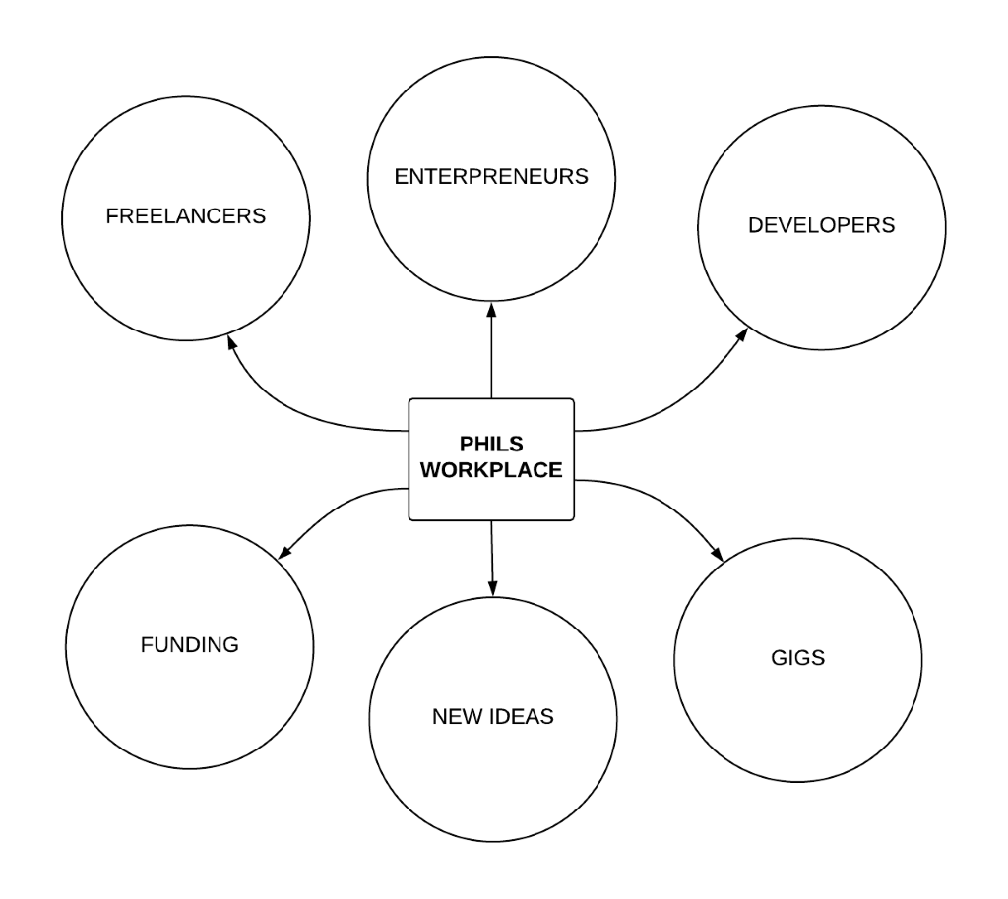

Once you sign into our workplace, you can choose your relevant categories. Those who need resources can browse through various tags, connect with talents, discuss requirements and work-related details.

Once a developer and entrepreneur get connected, further validation about payment and transaction will be carried by a validation committee in our discord channel. Once our committee validates both parties, in-house escrow committee will provide free escrow services and ensure product delivery making hassle free transactions.

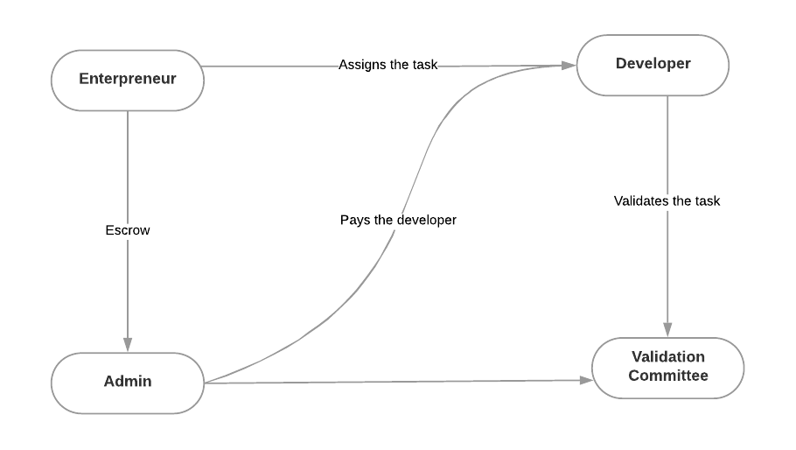

**Conclusion**

Our vision is that, PHILS will withstand any circumstances if this goes widespread and will remain as a tangible organization. This workplace acts as umbrella for multiple projects in diversified categories where every project holder has full-pledged authority on the project along with every user in the PHILS family.