To set up the appserver as a test environment ( ie on youre local machine you need to have Provison PLus installed or an appserver license.)
db config

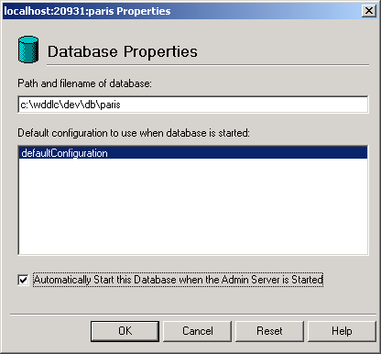

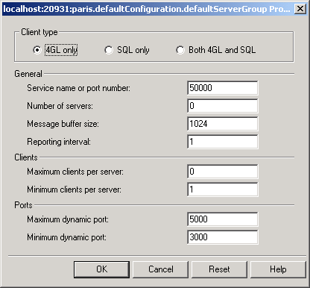

appserveronly those screens not takeing default values.

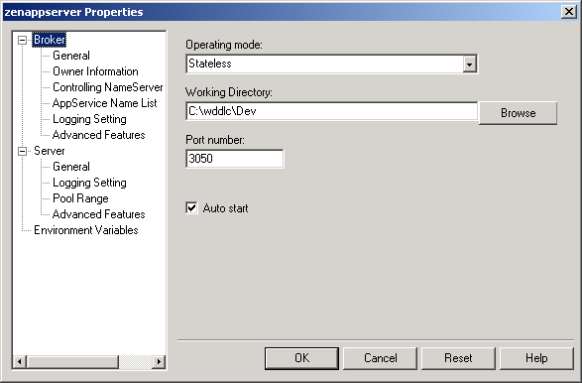

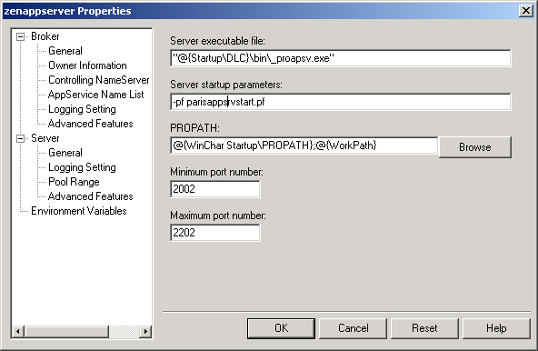

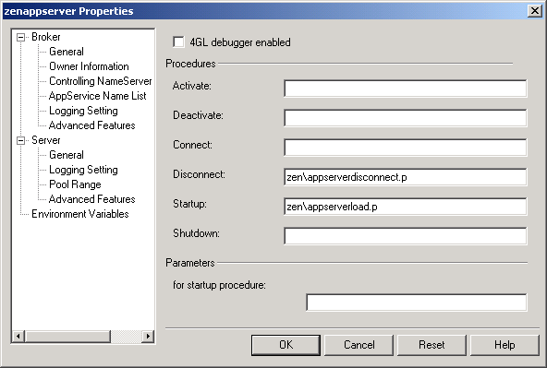

Settings are stored in \progress\openedge\properties\ubroker.properties

# Sample AppServer for Zen style

# Zen School Admin
[UBroker.AS.Schadm]
appserviceNameList=schadm
autoStart=1
workDir=c:\wddlc\schadm
brokerLogFile=@{WorkPath}\schadm.broker.log
controllingNameServer=NS1
initialSrvrInstance=1
operatingMode=Stateless
portNumber=3050
PROPATH=.;@{WinChar Startup\PROPATH};@{WorkPath}
srvrDisconnProc=zen\appserverdisconnect.p
srvrLogFile=@{WorkPath}\schadm.server.log
srvrStartupParam=-pf "{WorkPath}\pf\appsrvtart.pf"
srvrStartupProc=zen\appserverload.p

