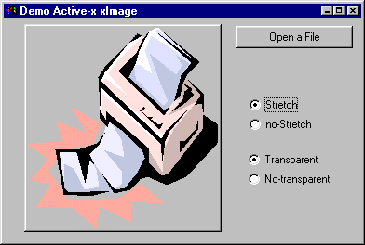
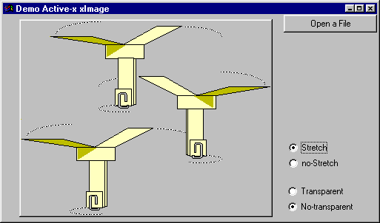

XImage is an Active-X developped by 4GL. This control allows you to display BMP, ICO, JPG/JPEG, WMF and EMF pictures in your screen.
We know that PROGRESS 9.1 already has this functions. But if you use a V8.2-8.3 version, this control will be useful.

You'll find a test program (sports database) : demoxImage.w wich demonstrate the use of this control. The Active-X is delivered with a *.tlb, giving more technical information about attributes and methods.

The use of this control is free. You can develop and distribute freely your applications with this control. However, an e-mail at m.fondacci@4gl.fr to inform of your xImage usage, comments and suggestions would be very appreciated.

This freeware is delivered as "as-is" software and no responsability can be assumed in any case of malfunctions.

I hope you enyou with xImage.

Marcel FONDACCI

Attributes, methods and Events

Image stretching :
<Com-handle>:STRETCH = TRUE/FALSE.

Tell the control to stretch and adapt the image to the size of the Active-X container.
You can know the current STRETCH setting by the same property :
IF <Com-handle>:STRETCH then …

Transparent display:
<Com-handle>:TRANSPARENT = TRUE/FALSE.

Controls the the image transparency.
You can know the current TRANSPARENT setting by the same property :
IF <Com-handle>:TRANSPARENT then …

Border Style:
You can change (or know) the image border style by the AxBorderStyle attribute :
<Com-handle>:axBorderStyle = afbNone | afbSingle | afbSunken | afbRaised
( 0 to 3)

LoadImage() method :
[ logical-return-value ] = <Com-handle>:loadImage( <Image-Name> ).

Is the main method to load an image in the window control.
The return value indicates if the operation has been succesfull (File name is correct AND this image format is supported by the Active-X).

You must specify an absolute file name.

Example :
FILE-INFO:FILE-NAME = filename.

IF NOT chCtrlFrame:ActiveFormX:LoadImage( FILE-INFO:FULL-PATHNAME ) then
Message FILE-INFO:FULL-PATHNAME
skip(1)
"File type not supported !"
view-as alert-box INFO.

OnClick :
This event is sent in case of 'MOUSE-SELECT-CLICK'.

/*------------------------------------------------------------------------------
Purpose:
Parameters: Required for OCX.
X
Y
Notes:
------------------------------------------------------------------------------*/

DEFINE INPUT PARAMETER p-X AS INTEGER NO-UNDO.
DEFINE INPUT PARAMETER p-Y AS INTEGER NO-UNDO.

The two parameters p-X and p-Y give the relative-to-start-of-image coordinates (pixels values).

OnDblClick :
This event is sent in case of 'MOUSE-SELECT-DBLCLICK'.
Note that this event occurs when no trigger for single mouse click is defined.

This two events are mutually exclusive.

Disclaimer

Permission to use, copy, modify, and distribute this software and its documentation without fee is hereby granted provided that this copyright notice appears in all copies/redistributions. Commercial usage of this software is at your own risk.
The author make no warranties about the suitability of this software, either express or implied.

The author and/or owner shall not be liable for any damages suffered by licensee as a result of using, modifying or distributing this software and application that uses it.

