QA TEST COMPLETION REPORT

Product Name | {{ product_name }}
Pre-master PR Link | {%p for l in pr_links %}  {{ l }}  {%p endfor %}
Version Number | {%p for v in version_numbers %}  {{ v }}  {%p endfor %}
Test URL | {{ test_url }}
Workitem/ Repo URL | {{ workitem_url }}
Jira Link | {{ jira_link }}
General Descriptio n | {{ general_description }}

Certificate Summary

Is this build certified for deployment? Yes {{ cert_yes_box }} No {{ cert_no_box }}

BRD/SWR/ITR FEATURE STATUS IN THIS BUILD

S/N | Feature | Description | Implemented? | Functional?

{%tr for f in features %}
{{ loop.index }}. | {{ f.name }} | {{ f.description }} | {{ f.impl_yes }} Yes {{ f.impl_no }} No | {{ f.func_yes }} Yes {{ f.func_no }} No
{%tr endfor %}

Exit Criteria

S/N | Description
{%tr for c in exit_criteria %}
{{ loop.index }}. | {{ c }}
{%tr endfor %}

Result Analysis

Test Status Summary
Test Cycles | {{ ra.test_cycles }}
Total Number of Test Cases | {{ ra.total }}
Passed Test Cases | {{ ra.passed }}
Failed Test Cases | {{ ra.failed }}
Un-executed Test Cases | {{ ra.unexecuted }}
Suspended Test Cases | {{ ra.suspended }}
Modification-Requiring Test Cases | {{ ra.modification }}

Automation-to-Manual Tests Ratio | {{ automation_ratio }}
Bugs Summary
Bugs Raised During Execution | {{ bugs.raised }}
Bugs Fixed and Retested | {{ bugs.fixed_retested }}
Opened Bugs | {{ bugs.open }}

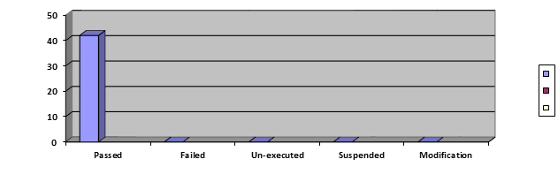

EXCEPTIONS & OBSERVATIONS

TestCase ID | Status Type | Description | SEVERITY | RISK ASSESSMENT
{%tr for e in exceptions %}
{{ e.id }} | {{ e.status_type }} | {{ e.description }} | {{ e.severity }} | {{ e.risk }}
{%tr endfor %}

Comments/Observation
{%p for p in comments %}
{{ p }}
{%p endfor %}

Reviews and Approvals

Action | Name | Staff ID | Signature | Date
{%tr for a in approvals %}
{{ a.action }} | {{ a.name }} | {{ a.staff_id }} | {{ a.signature }} | {{ a.date }}
{%tr endfor %}

