Weather-Index Insurance on Ethereum: The Sokoto Rainfall Cover Platform
BSc Software Engineering Capstone Project
Chinemerem Judith Ugbo · Supervisor: Dr Aaron Izang
African Leadership University
October 2026

Abstract
Smallholder farmers in Sokoto State, Nigeria, lose their harvests to drought with no reliable way to insure against them: traditional crop insurance needs loss assessors, paper claims and weeks of waiting, which makes it uneconomic at smallholder scale. Weather-index insurance replaces all of that with a rainfall measurement — if rainfall during the coverage period falls below a threshold agreed at purchase, the farmer is paid automatically. The problem moves from assessing losses to trusting the rainfall number. This project builds Sokoto Rainfall Cover, a decentralised application that settles weather-index insurance on the Ethereum test network (Sepolia) using smart contracts, and answers the trust question with three independent rainfall sources — CHIRPS, NASA POWER and Meteostat — aggregated by a reputation-weighted consensus so that no single source can decide a claim. The system comprises two Solidity contracts (insurance and oracle aggregation), an Express/TypeScript backend running an oracle relayer, settlement keeper and notification service, and a React frontend with separate farmer, field-agent and administrator portals. Farmers can buy cover themselves from a wallet, or through a field agent who collects the premium in naira; payouts are pushed automatically to the policy holder’s wallet at settlement, so no claim is ever filed. The test suite runs 280 tests — 56 Solidity tests (including fuzz and audit-regression tests), 13 contract-level integration tests, 191 backend tests and 20 frontend tests — and a manual security audit catalogued fourteen findings with the critical fixes regression-pinned. A backtest against the 2023 season shows the reputation-weighted design holding the payout decision within 9% of the sources’ own mean while a corrupted feed moves an equally weighted design by 59%. The platform is deployed and demonstrable end to end: one live policy was bought and paid out autonomously during evaluation.
Keywords: weather-index insurance, smart contracts, Ethereum, oracle problem, reputation weighting, decentralised applications, agricultural finance

Table of contents
(Generate in your word processor from the headings below.)

1. Introduction

1.1 Background and motivation
Drought is the dominant risk for rain-fed farming in northern Nigeria. Sokoto State’s growing season runs on a handful of wet months split into ten-day dekads, and a dry spell in any one of them can halve a millet or sorghum harvest. For a farming household earning a few hundred dollars a year, one bad season means selling assets, pulling children out of school or taking loans at usurious rates.
Insurance exists to smooth exactly this risk, but conventional crop insurance barely reaches smallholder farmers. It requires someone to visit the field, assess the loss, process a claim and pay out — a cost structure that only works for large farms (Jensen & Barrett, 2017). Weather-index insurance removes the assessment step entirely: the policy pays out when a measured weather variable — rainfall, in this project — falls below an agreed level, regardless of what actually happened to any individual farm (Hazell et al., 2010). The trade-off is well documented: index insurance is cheap and fast, but it exposes the farmer to basis risk — the index may say “no drought” while their particular field suffered — and it demands trust in whoever produces the number (Greatrex et al., 2015).
This project takes that trust problem as its central engineering question. A rainfall index is only fair if the number is honest. The design answers it in two moves. First, three independent data sources — the CHIRPS satellite–station blend, NASA POWER reanalysis, and Meteostat station interpolation — each report rainfall for the insured location directly to a smart contract. Second, the contract aggregates those reports with reputation weights derived from how well each source has historically agreed with the others, so one feed drifting (or lying) cannot move a payout decision on its own.
The settlement side removes a second layer of trust. Smart contracts on Ethereum execute exactly as written: premiums, reserves and payouts are held and moved by code that no party — not the insurer, not the agent, not the developer — can quietly change after the fact. A farmer’s payout is a deterministic function of the recorded rainfall and the threshold chosen at purchase, executed automatically at the end of the coverage window.

1.2 Problem statement
Smallholder farmers in Sokoto State lack access to affordable drought insurance because (1) claim assessment makes traditional policies uneconomic at their scale, (2) existing index products ask farmers to trust a single opaque data provider and a centrally operated payout process, and (3) payout delays under the very stress the insurance is meant to cushion. There is no deployed system that combines multi-source rainfall consensus with trust-minimised, automatic settlement for this population.

1.3 Objectives
- Design and implement an Ethereum smart-contract system that sells rainfall-index policies, reserves their payouts, and settles them automatically against aggregated multi-source rainfall data.
- Design and implement a reputation-weighted oracle aggregation mechanism in which three independent sources report each period and no single source can decide a payout.
- Implement an automated data pipeline (oracle relayer and settlement keeper) that fetches real rainfall data for the insured location and reports it on-chain.
- Implement a role-based web application (farmer, field agent, administrator) with wallet integration, covering purchase, monitoring, consensus research and backtesting.
- Evaluate the system through automated testing, a security audit, and a backtest of the aggregation designs against historical (2023) rainfall.

1.4 Scope and limitations of the prototype
The prototype runs on the Sepolia test network; premiums and payouts are testnet ETH and no real money is at stake. Payments between farmer and agent in naira are recorded as receipts against the on-chain policy but are settled off-chain. The insured location is a single point (Sokoto, 13.05°N 5.24°E) and the index is rainfall-only. Fiat on/off-ramps, mobile-money integration and a production key-management setup are out of scope and identified as future work in Chapter 9.

1.5 Report structure
Chapter 2 reviews weather-index insurance, blockchain settlement and the oracle problem. Chapter 3 derives requirements. Chapters 4 and 5 describe design and implementation. Chapter 6 evaluates the system against its objectives, Chapter 7 covers security, and Chapter 8 describes deployment and operations. Chapter 9 discusses limitations and future work, and Chapter 10 concludes.

2. Background and literature review

2.1 Weather-index insurance
Weather-index insurance (also called index-based crop insurance) pays out against a measured weather variable rather than an assessed farm loss. Its advantages for smallholder agriculture are well established: payouts are fast, assessment costs vanish, and the product can be sold at scale (Hazell et al., 2010; Jensen & Barrett, 2017). Its acknowledged weakness is basis risk — the gap between the index and the farmer’s actual experience — which is reduced by measuring rainfall close to where the farmer works and by choosing thresholds and windows that match local practice (Greatrex et al., 2015). In Sokoto State, farmers already reason in ten-day dekads within the June–September wet season; this project’s coverage windows follow that same dekad calendar, and its rainfall index is the summed rainfall over the window’s dekads.
Basis risk has two sources: design risk — the index’s windows and thresholds do not match the farmer’s actual exposure — and spatial risk — the measurement point is not the farm. Design risk is addressed here by making window and threshold explicit, farmer-chosen parameters aligned to local dekad practice, and by surfacing the live rainfall reading for the chosen window in the application so the farmer can see the index forming. Spatial risk cannot be removed from a single-point index; Chapter 6 quantifies it against a rain gauge 83 km from the insured location, and Chapter 9 names it as the product’s principal limitation.

2.2 Existing schemes and their trust problems
National and NGO index-insurance programmes (for example Africa Risk Capacity’s drought covers, and the long-running Indian and Ethiopian index schemes) show the model can work at scale, but they share an architecture in which one institution measures the index, decides the payout and holds the funds. The farmer’s recourse is to trust that institution’s data and processes. Independent reviews consistently identify transparency of the trigger and speed of payment as the two levers that determine farmer trust and renewal (Greatrex et al., 2015). Both levers are addressed directly in this project’s design: the trigger is computed from three public data sources reported on-chain where anyone can audit them, and payment is a contract-executed transfer, not a process.
Field evidence on uptake reinforces the point: demand for index insurance is highest where the trigger is legible to the farmer, where payment arrives without a claim, and where the product is bundled with something farmers already value — credit, inputs, or an agent they know (Jensen & Barrett, 2017; Greatrex et al., 2015). The agent model in this project’s design (Chapter 3) mirrors the last finding: distribution through a trusted local intermediary who collects premiums in the currency farmers actually use.

2.3 Blockchain and smart contracts as settlement infrastructure
A smart contract is a program deployed to a blockchain whose execution is replicated and verified by the network; its code is the agreement (Buterin, 2014). Ethereum adds a general-purpose virtual machine (the EVM) and a mature tooling ecosystem (Solidity, ethers.js, Hardhat, OpenZeppelin). For insurance, the relevant property is credible commitment: once deployed, the payout rules cannot be altered unilaterally, and every premium, reserve and payout is publicly traceable. Prior decentralised insurance projects — notably Etherisc’s flight-delay and crop products, and Arbol’s parametric weather covers for institutions — demonstrate the pattern commercially, but their aggregation and payout logic is typically operated by a single oracle or a permissioned operator. This project’s contribution is to make the rainfall measurement itself a multi-party, auditable input.
Ethereum specifically offers the EVM’s general-purpose execution, an established security tooling ecosystem (the Solidity compiler, Hardhat test harnesses, OpenZeppelin’s reviewed contract primitives), and public test networks such as Sepolia where contract behaviour — gas semantics, wallet signing, event logs — can be exercised at production fidelity with valueless currency. This project builds on that stack and treats its conventions (checks-effects-interactions, explicit reserve accounting, two-step ownership transfer) as baseline hygiene rather than optional polish.

2.4 The oracle problem
Blockchains cannot see the outside world; feeding external data on-chain requires oracles, and the reliability of that feed is the “oracle problem” (Halaburda et al., 2020). Standard mitigations include multiple independent sources and aggregation contracts. Chainlink’s decentralized oracle networks aggregate many node operators for a single data point, but each data point typically comes from one upstream vendor. For an insurance index, upstream source diversity matters as much as node diversity: two aggregators reading the same sensor share its failure modes. This project aggregates three structurally different upstream sources — satellite blends (CHIRPS), numerical reanalysis (NASA POWER) and station interpolation (Meteostat) — and weights them by observed agreement rather than fixed shares.

2.5 Related work and the gap
System | Index | Aggregation | Settlement | Gap addressed here
National index schemes (e.g. ARC, Indian WBCIS) | rainfall/drought | single agency | centralised, claims-institution payment | transparent trigger, automatic payment
Etherisc | flight delay, parametric | single oracle | smart contract | multi-source weather consensus for agriculture
Arbol | weather for institutions | vendor data | contract + off-chain agreements | smallholder, self-service and agent flows
Chainlink feeds | price/weather | node-network aggregation | any contract | upstream source diversity, on-chain audit trail
Sokoto Rainfall Cover | dekad rainfall | 3 sources, reputation-weighted, on-chain | push-payment contract | —
No reviewed system combines (a) farmer-facing self-service purchase, (b) an agent model for farmers without wallets, (c) on-chain multi-source rainfall consensus with reputation weighting, and (d) automatic push-payment settlement. That combination is this project’s scope.

2.6 The Nigerian smallholder context
Design choices in this project respond to the specific market it targets. Nigerian smallholder agriculture is overwhelmingly cash-based; digital payment adoption is growing fast but uneven, and formal insurance penetration among farming households is negligible. Where weather products have reached farmers, it has been through intermediaries — agricultural input dealers, cooperatives, mobile-money agents — rather than direct sales. Two consequences follow. First, an insurance product for this market must speak naira while settling in whatever asset guarantees the payout; the dual-quoting design (a naira figure fixed at a displayed rate, ETH as the settlement asset) follows. Second, the field agent role is not a convenience feature but the realistic distribution channel: the agent sells to a farmer who may never touch a wallet, while the blockchain keeps the agent honest — the receipt the agent records is verified against the on-chain policy, and the payout logic lives where the agent cannot reach it.

3. Requirements analysis

3.1 Stakeholders and personas
Stakeholder | Needs
Farmer (e.g. Amina, millet farmer, Wamakko LGA) | affordable cover, transparent trigger, fast automatic payment, no paperwork
Field agent (e.g. Fatima) | sell cover to farmers who have no wallet, collect naira premiums, keep a commission trail
Administrator (insurer operator) | manage windows and the pool, monitor oracle health, research consensus behaviour, audit policies
Operator/developer | deploy, configure relayer and settlement, monitor notifications

3.2 Functional requirements
Policy lifecycle
- FR1 The system shall sell a policy for a chosen coverage window, crop, LGA, rainfall threshold (mm) and payout amount, with the premium computed as 10% of the payout.
- FR2 The premium must be paid on-chain in ETH and the payout must be reserved at purchase so the pool can always honour it.
- FR3 A farmer shall be able to buy cover directly from their own wallet.
- FR4 A field agent shall be able to buy cover for a farmer, record the naira payment method and reference, and earn a commission; the receipt must be verifiable server-side against the on-chain policy.
- FR5 The system shall settle every policy automatically after its window ends and all dekads are finalized: payout if aggregated rainfall < threshold, otherwise no payout.
- FR6 Payouts shall be transferred to the policy holder’s wallet without any claim step.
Oracle and consensus
- FR7 Three independent rainfall sources (CHIRPS, NASA POWER, Meteostat) shall each report the dekad rainfall for the insured location to the oracle contract.
- FR8 Each source shall report a dekad at most once, and only after the dekad has ended with complete data.
- FR9 The oracle contract shall aggregate reports with reputation weights derived from inter-source agreement and expose per-source weights and finalized aggregates.
- FR10 No single source shall be able to finalize an extreme reading into a payout (regression-tested after the security audit).
Application
- FR11 The application shall provide farmer, agent and admin portals with the pages listed in Appendix B.
- FR12 The application shall show each policy’s live evaluation: per-source rainfall, weights, and whether the payout triggers.
- FR13 Administrators shall be able to simulate consensus strategies (single-source, equal weighting, reputation weighting) and stress-test them by corrupting one source’s reading.
- FR14 Administrators shall be able to backtest aggregation designs over historical rainfall.
- FR15 The application shall notify farmers of purchase, payout and settlement in-app, and optionally by SMS and Telegram.

3.3 Non-functional requirements
ID | Requirement | Realisation
NFR1 Trust | settlement rules cannot be changed after purchase | immutable contract logic; premium rate changes never apply retroactively
NFR2 Availability | purchase and monitoring work despite wallet/RPC faults | trusted read RPC, explicit gas limits, wallet-state preflights (Chapter 5.5)
NFR3 Security | sessions, roles and keys protected | httpOnly SameSite=Lax cookies, server-side role checks, Turnstile CAPTCHA, timing-safe API keys
NFR4 Data quality | one bad feed cannot decide a payout | reputation weighting + audit regression tests
NFR5 Operability | one backend instance runs relayer and settlement | env-gated relayer; documented deployment (Chapter 8)
NFR6 Usability | farmers and agents use it without crypto knowledge | naira quotes, agent model, plain-language errors
NFR7 Cost | free-tier infrastructure only | Sepolia testnet, Render free tier, Cloudflare Pages, free data APIs

3.4 Use cases
UC1 Farmer buys cover. Farmer signs in → Buy cover → chooses window, threshold, payout → confirms the wallet transaction → policy appears in My policies with its live evaluation.
UC2 Agent sells cover. Agent signs in → Buy cover for a farmer → selects farmer, crop, window, threshold, payout → collects the naira premium (cash/transfer/mobile money) and enters the payment reference → pays the premium from the agent wallet → receipt saved and verified against the chain.
UC3 Automatic settlement. The relayer reports each ended dekad → the settlement keeper calls checkAndSettle after the window finalizes → the contract pays or skips → farmer and admin are notified in-app and (optionally) by SMS.
UC4 Consensus research. Admin opens Oracle sources → runs the consensus simulator with one source corrupted → compares single, equal and reputation-weighted aggregates → compares against the sources’ uncorrupted mean.
(Use-case diagrams and sequence diagrams are generated as Mermaid sources in docs/figures/ — see Appendix A.)

4. System design and architecture

4.1 Architecture overview
The system has four layers: the Ethereum contracts (the source of truth for policies, oracle reports and money), an off-chain backend that feeds and drives them, a React frontend with three role-based portals, and external data (three rainfall APIs, an FX rate API, SMS/Telegram providers).
Rainfall sources Users
CHIRPS · NASA POWER Farmer · Agent · Admin
Meteostat │
│ (daily fetch) │ browser + MetaMask
▼ ▼
┌────────────────┐ txs/receipts ┌────────────────────┐
│ Backend (Render)│───────────────▶ │ React SPA (Pages) │
│ · REST API │◀─────────────── │ · farmer portal │
│ · oracle relayer│ JSON, same │ · agent portal │
│ · settlement │ origin proxy │ · admin console │
│ · notifier │ └─────────┬──────────┘
└────────┬───────┘ │ signed txs / reads
│ signed reports ▼
▼ ┌────────────────────┐
┌───────────────────────────────────┤ Ethereum Sepolia │
│ WeatherIndexInsurance · OracleAggregator (Solidity) │
└───────────────────────────────────┴────────────────────┘
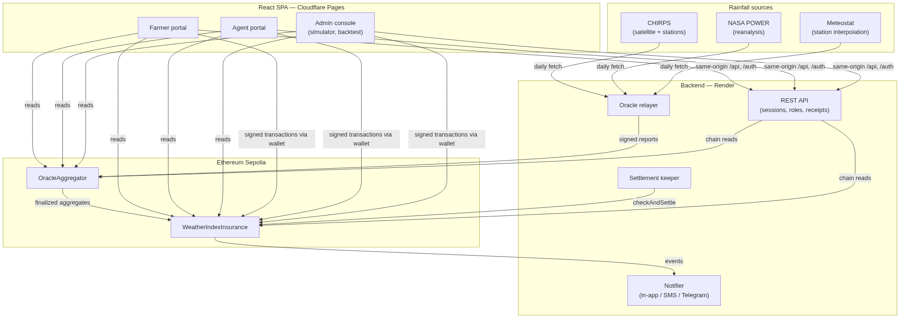
Figure 4.1 — System architecture
Trust boundaries: the contracts are the only components that hold value and are treated as adversarial-facing (audited, heavily tested); the backend is a convenience and liveness layer — it can delay data but cannot forge a payout, because every number a payout depends on is reported on-chain by distinct oracle accounts and is publicly auditable; the frontend never holds keys or sessions (the wallet signs, the server keeps httpOnly sessions).

4.2 Smart contract design
WeatherIndexInsurance holds the policy lifecycle.
- Coverage windows. The owner opens windows (addWindow) defined as a list of dekad period ids and a sales-close timestamp. This project’s windows follow the Sokoto calendar (e.g. window #19 = Sep D2–Oct D1).
- Purchase. buyPolicy(windowId, droughtThresholdMm, payoutAmount) requires msg.value == quotePremium(payoutAmount), where the premium is 10% of the payout (premiumRateBps = 1000), rounded up so it is never zero. The contract records farmer = msg.sender, and reserves the payout immediately: reservedPayouts grows by the payout amount and availableCapacity() (= balance − reserved) enforces that the pool can always honour every sold policy. A sale that would over-commit the pool reverts.
- Settlement. checkAndSettle(policyId) is callable by anyone exactly once per policy. It reverts until every dekad of the window is finalized in the oracle contract, then reads windowRainfall(windowId) — the reputation-weighted sum — and either transfers the payout to the policy holder (PayoutTriggered) or records no payout (PayoutSkipped). The transfer is a push payment: there is no withdrawal step and no claim to file.
- Administration. The premium rate can be changed but only affects future quotes; ownership moves via a deliberate two-step transfer (transferOwnership → accept), which the audit regression tests pin down.
OracleAggregator holds the measurement side.
- Registry. The owner registers the oracle accounts behind each source label (CHIRPS, NASA_POWER, Meteostat) and can retire a compromised account without losing its history.
- Reporting. Each oracle reports a dekad’s rainfall once, after the dekad ends. A report is rainfallMm × 100 (fixed-point, two decimals).
- Finalization and weights. When sufficient coverage exists, the dekad finalizes at a reputation-weighted aggregate. weightForPeriod(period, oracle) exposes the weight used per period; isFinalized / finalizedAggregate expose the outcome. Reputations are updated so that sources which agree with their peers gain weight and outliers lose it, and changes mid-dekad are ignored (audit finding M-2).

4.3 Oracle consensus: reputation weighting
For each finalized dekad, each reporting source receives a weight proportional to its reputation score, which is updated from its agreement with the other sources’ reports. The design intent is the property the simulator demonstrates (Chapter 6): a single corrupted feed shifts the single-source aggregate by the full corruption, the equal-weight aggregate by one third of it, and the reputation-weighted aggregate by much less — both because the corrupt source is down-weighted immediately and because its historical weight was already lower if it had drifted before. A source that never reports simply gets zero weight; the aggregate remains usable (regression-tested).

4.4 Backend services
An Express/TypeScript service (deployed on Render) exposes the REST API (Appendix B) and runs three background roles, all gated so that exactly one instance runs them:
- Oracle relayer — for each ended dekad, fetches daily rainfall for the insured point from each source and submits one signed report per source with that source’s dedicated oracle key. CHIRPS comes from the Climate Hazards Center’s daily GeoTIFF archive (cached, concurrency-limited), NASA POWER from its JSON API, and Meteostat from its RapidAPI point/daily endpoint (with a historical GHCN-series fallback when no key is configured). A dekad is only reported once every day of it is covered, because the aggregator accepts one report per source per dekad and a partial total could never be corrected. Meteostat is deliberately polled at most once per 6 hours to fit its free plan’s request budget.
- Settlement keeper — when every dekad of a sold policy’s window is finalized, it calls checkAndSettle, retrying through RPC hiccups.
- Notifier — watches new blocks for PolicyCreated, PayoutTriggered and PayoutSkipped, and dispatches in-app notifications plus optional SMS (Africa’s Talking) and Telegram messages to the policy holder (matched by wallet) and operator numbers.
Security-relevant API design: sessions are httpOnly, SameSite=Lax cookies; the Cloudflare Pages function proxies /api and /auth same-origin so that cookie flows on one origin (Chapter 8); role checks (requireRole) run server-side; the agent-receipt endpoint re-reads the chain and rejects receipts whose premium, payout or window do not match the on-chain policy; the manual SMS endpoint requires a bearer key compared in constant time and is rate-limited per hour.

4.5 Frontend design
A React + Vite + TypeScript single-page application with three role-based portals (Farmer, Agent, Admin) sharing an authentication context, an FX context (naira quotes), a notifications context and a policy context. The policy context has two providers: a chain provider that reads the deployed contracts through a trusted RPC and submits wallet-signed transactions, and a simulated provider used when no chain is reachable, which powers the consensus simulator and the demo mode. Wallet integration is described in 5.5. The admin console embeds the oracle research tools: the consensus simulator (which re-runs a real dekad under a chosen strategy with one source optionally corrupted) and the backtest runner over historical seasons.

4.6 Data model
On-chain: CoverageWindow { periods[], salesCloseAt }, Policy { farmer, windowId, droughtThresholdMm, payoutAmount, premiumPaid, settled }, oracle registry + per-period reports and weights. Off-chain: users (name, role, LGA, wallet, phone), agent sales receipts (policy id, farmer, premium/payout in ETH and naira, commission, payment method and reference, FX rate used, timestamp), sessions, and cached chain reads with short TTLs. The data-model page in the admin console renders this schema for inspection.

4.7 Key sequence flows
Purchase (agent). Agent fills the form → the app quotes the premium via Figure 4.2 shows the flow. quotePremium on the trusted RPC → pre-estimates gas and asks the wallet (with an explicit gas limit and a chain check) to send buyPolicy → the contract reserves the payout and emits PolicyCreated → the app saves the agent receipt (verified by the server against the chain) → farmer and admin are notified.
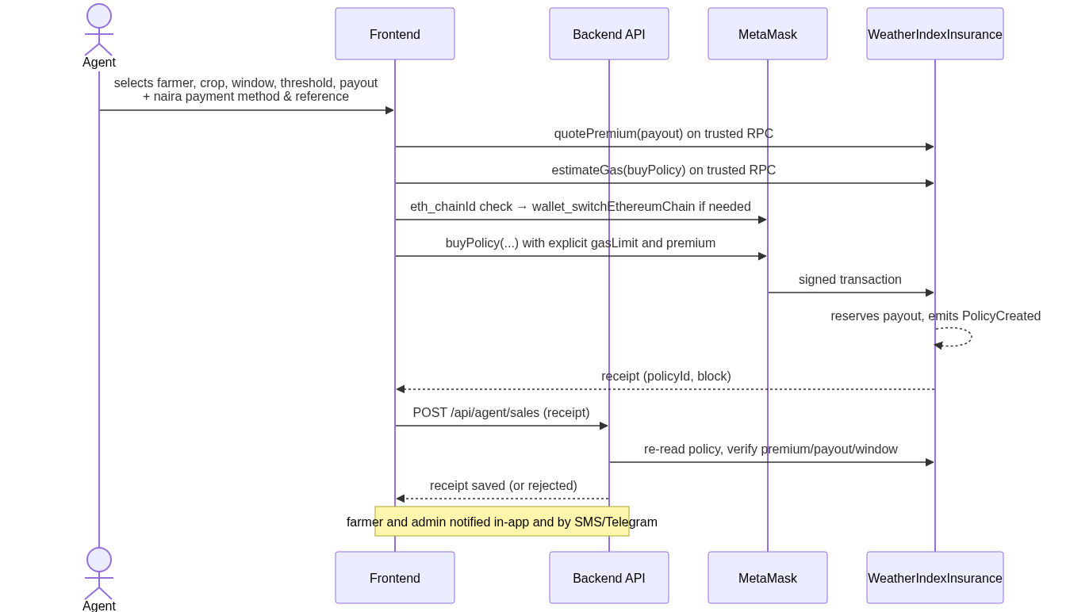
Figure 4.2 — Purchase sequence (agent flow)
Report. Relayer waits for the dekad to end with full source coverage → fetches daily rainfall from each source → submits one report per source → the aggregator finalizes the dekad with reputation weights.
Settlement. All dekads finalized → settlement keeper calls checkAndSettle → contract compares weighted rainfall to the threshold → pushes the payout to the policy holder or records no payout → notifier informs farmer and admin → the farmer’s Payouts page shows the amount, outcome and settlement transaction.
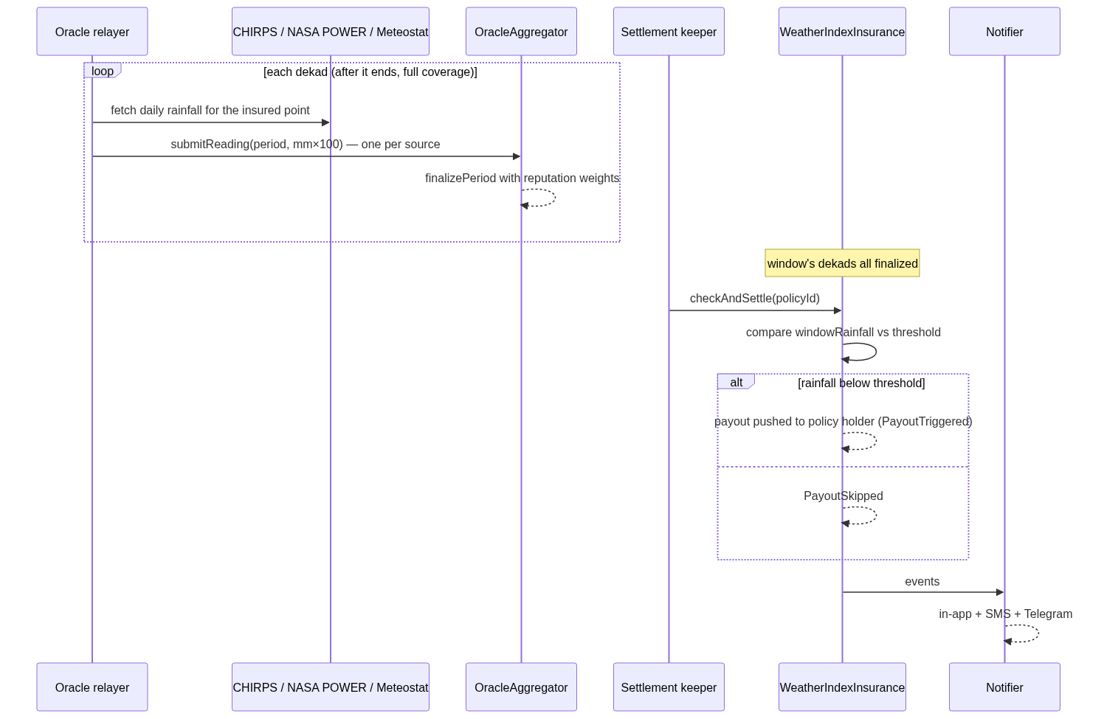
Figure 4.3 — Reporting and settlement sequence

5. Implementation

5.1 Technology stack and rationale
Layer | Choice | Why
Contracts | Solidity + Hardhat 3, ethers v6 | industry standard; Hardhat 3’s Solidity and TS test layers gave both fuzz tests and integration tests
Chain | Ethereum Sepolia | real network behaviour (gas, wallets) with no real-money risk
Backend | Node 22, Express, TypeScript | one language across the stack; the relayer needed mature HTTP/RPC tooling
Frontend | React + Vite + TypeScript | component ecosystem; strict typing end-to-end (tsc --noEmit in CI habits)
Hosting | Cloudflare Pages + Render free tier | zero cost, git-push deploys, fits NFR7
Data | CHIRPS, NASA POWER, Meteostat | three structurally different measurement families

5.2 Smart contracts
Both contracts are written to make failure modes explicit: purchases revert on wrong premium, unknown or closed windows, and on sales the pool cannot cover; reporting reverts on duplicates and early reports; settlement reverts on unknown, unsettled-again, or not-yet-finalized policies. Fixed-point rainfall (mm × 100) keeps precision in integers. The premium rounds up so it is never zero (regression-tested). Reserves are tracked explicitly so the invariant reserves ≤ pool balance holds — and is fuzz-tested.

5.3 Oracle relayer and data sources
The relayer treats each source’s quirks as first-class: CHIRPS daily GeoTIFFs are read for the exact insured pixel with a persistent cache and bounded concurrency; NASA POWER answers JSON directly; Meteostat lags up to a week and is polled conservatively, falling back to a bundled historical GHCN series (Birni N’Konni station) when unkeyed. Because the aggregator accepts exactly one report per source per dekad, the relayer only reports when every day of the dekad is covered — a partial total could never be corrected, so late-but-complete beats early-but-partial. RPC submissions go through a retry wrapper so a transient node failure does not skip a dekad.

5.4 Backend API and session security
The API layering is deliberately boring: cached chain reads for anonymous data, cookie sessions for personal data, role gates for agent/admin actions, and one bearer-keyed operational endpoint. Receipts written by agents are verified server-side against the chain before storage, so a tampered client cannot inflate commission or fake a sale.

5.5 Frontend and wallet hardening
Wallet integration proved the most failure-prone surface of the project, and the fixes generalise into four rules (full detail in Appendix C):
- Trust the chain’s RPC for reading and pricing. Wallet-side RPC endpoints returned stale balances (“insufficient funds” for a funded account) and failed gas estimation with reasonless errors (“missing revert data”). Reads and quotes now go through the app’s own RPC, and gas is pre-estimated there and passed to the wallet explicitly.
- Never cache wallet state. The account list captured at page load went stale on account switches; the app now follows accountsChanged, and a wallet/chain disagreement is a warning while the chain’s own view decides affordability.
- Check the wallet’s chain before signing. A confirmation prepared while MetaMask sat on Ethereum mainnet would have sent real ETH to an address holding no code there. The app now asks the wallet for its chain, requests a switch (wallet_switchEthereumChain) on mismatch, and refuses with plain language otherwise.
- Errors must name the layer that failed. Raw ethers jargon is translated into actionable sentences (which account, which network, what to do).

5.6 Cross-cutting concerns
- Naira quoting. An FX context fetches ETH→NGN rates with per-provider fallback and degrades to approximate figures with a visible notice — the contract always settles in ETH; naira figures are for the farmer conversation.
- Notifications. One activity pipeline feeds in-app notifications, SMS templates that fit a single 160-character SMS, and an operator Telegram channel.
- Internationalisation and preferences. English/Hausa/French strings and a language hint to the Google sign-in flow; theme and accessibility preferences persist per user.

6. Testing and evaluation

6.1 Test strategy
Testing is layered so that each failure class is caught where it is cheapest to find:
- Solidity unit, integration and fuzz tests (56) — contract invariants and edge cases, run on Hardhat’s in-process EVM.
- Contract-level integration tests in TypeScript (13, Mocha) — the application’s central stories against deployed-in-test contracts, plus the ABI-sync check and audit regression tests.
- Backend tests (191 across 25 files, node:test) — sessions, auth routes, sale verification against the chain, FX fallbacks, SMS templates, caching, the relayer’s feed handling and backtest statistics.
- Frontend tests (20, Vitest) — policy evaluation logic, formatting and context behaviour.
The full suite (npm run test) runs every workspace — 280 tests — and is green.

6.2 Smart contract tests (56)
Coverage includes the properties the product’s fairness rests on: the premium is exactly 10% of the payout and rounds up so it is never zero; a sale the pool cannot cover reverts (test_RefusesSaleThePoolCannotCover, test_ReservedPayoutsLimitLaterSales); reserves never exceed the pool balance (fuzzed, testFuzz_ReservesNeverExceedPoolBalance, 256 runs); windows validate; sales close on deadline; a policy pays exactly once (test_CannotSettleTwice) and only after every dekad finalizes (test_CannotSettleUntilEveryDekadIsFinalized); overlapping windows share dekad reports correctly; and a window whose rainfall meets the threshold pays nothing.

6.3 Integration, backend and frontend tests
The Mocha layer covers the end-to-end story (“collects the farmer’s premium into the pool and reserves the payout”, “pays out when the window’s rainfall is below threshold”, “still reaches a usable, correctly-weighted estimate if one oracle source never reports”), verifies the frontend ABI still matches the compiled contracts, and pins the audit fixes (M-1, M-2, L-3, L-5 — see 6.2/7.2). The backend suites exercise the security- relevant paths hardest: session fixation and cookie flags, role gates, timing-safe API keys, and — critically — that agent receipts are rejected when their premium, payout or window do not match the on-chain policy.

6.4 Backtest: does reputation weighting help? (2023 and the satellite era)
docs/backtest-results.md reports a backtest of the aggregation designs against the Birni N’Konni rain gauge (GHCN NG000001075), 121 dekads 1981–2024 with 81 rainy-season dekads, comparing NASA POWER and CHIRPS readings at the gauge’s location.
Per-source accuracy (rainy season, mm per dekad):
Source | MAE | RMSE | Bias | Correlation
NASA POWER | 30.3 | 52.4 | −15.9 | 0.34
CHIRPS | 24.4 | 47.4 | −11.8 | 0.50
Combined estimates (out-of-sample weights): reputation weighting reaches MAE 26.3 mm — 4.0 mm closer to the gauge than NASA POWER alone (95% bootstrap CI −6.4 to −1.7), 0.3 mm closer than equal weights (CI −0.5 to −0.1), and 1.9 mm further than the best single source (CHIRPS). The honest reading: combining sources guards against the weaker feed without knowing in advance which one is weaker, at a small accuracy cost versus the best source — exactly the insurance trade-off the design aims for, since the risk being hedged is a corrupted or failing source, not average noise.
Payout decisions (basis risk). Against the gauge’s dry dekads, single sources miss 25–50% of droughts and pay 15% false payouts; the combined estimates agree with the gauge on 78–79% of calls and cut false payouts to 13%. Basis risk at dekad scale is real and is stated as a limitation (Chapter 9).
Robustness demo (consensus simulator). Corrupting one source’s reading (NASA POWER inflated ×2.5) moves the single-source aggregate by the full corruption and the equal-weight aggregate by +59%, while the reputation-weighted aggregate moves +9% — the property FR10 asks for, demonstrated on real dekad data (Appendix A, 07-consensus-simulator).

6.5 Evaluation against the objectives
Objective | Evidence | Status
O1 contract system selling, reserving and auto-settling policies | 56 Solidity + 13 integration tests; live Policy #0 bought and paid out autonomously | met
O2 reputation-weighted multi-source aggregation | OracleAggregator weights; simulator (+9% vs +59%); backtest (6.4) | met
O3 automated data pipeline | relayer reporting 3 sources live; settlement keeper executed the live payout | met
O4 role-based web app with wallet integration | three portals; agent receipts verified server-side; wallet hardening (5.5) | met
O5 evaluation via tests, audit, backtest | 280 green tests; audit (Ch. 7); backtest (6.4) | met

7. Security and auditing

7.1 Method
A manual audit (documented in docs/security-audit.md) reviewed both contracts for the OWASP-class smart-contract risks (access control, reentrancy, oracle manipulation, economic attacks, griefing), the dependency tree for known advisories, and the deployment and key-handling practices. Each finding carries a severity, an affected location and a resolution status; resolved findings gained regression tests so they cannot silently return.

7.2 Findings and resolutions
ID | Severity | Finding | Status
H-1 | High | Fully centralised admin: owner controls payouts, oracles and weights | documented risk; mitigated by two-step ownership + public on-chain state (see 9)
H-2 | High | Settlement could occur arbitrarily late | partly resolved 2026-10-14; keeper automation reduces the window
H-3 | High | serialize-javascript RCE advisory (dev dependency) | resolved 2026-09-28
M-1 | Medium | Finalization race: a half-reported period could be finalized early | resolved 2026-09-30 — quorum enforced; regression: “won’t let one source finalize an extreme early reading into a payout”
M-2 | Medium | Owner could rewrite reputation weights after readings are in | resolved 2026-09-30 — mid-dekad weight changes ignored; regression-tested
M-3 | Medium | Reentrancy griefing of the payout pool at funding time | documented; reserves accounting (M-4) bounds the impact
M-4 | Medium | Payouts silently skipped when the pool was underfunded | resolved 2026-09-28 — reserve accounting at purchase
M-5 | Medium | No sanity bounds on submitted rainfall readings | resolved 2026-10-27
L-1…L-6 | Low | finalize-period edge case, division truncation, owner-key custody, key hygiene, oracle deregistration, npm advisories | L-3 partly resolved (two-step ownership regression-tested), L-4 resolved, L-5 resolved (compromised source can be retired without losing history — regression-tested); L-6 tracked
The regression suite is the audit’s long arm: tests named for M-1, M-2, L-3 and L-5 execute the fixed behaviour on every run.

7.3 Application and operational security
- Sessions. httpOnly, SameSite=Lax cookies; no tokens in JavaScript-reachable storage; the Pages function proxies API and auth on one origin so the cookie never crosses sites (the alternative — SameSite=None — would have given up CSRF protection).
- Authorisation. Role checks are server-side on every agent/admin route.
- Input and abuse. JSON bodies capped at 10 KB; the manual SMS endpoint requires a bearer key compared in constant time and is rate-limited per hour; Turnstile CAPTCHA guards authentication endpoints, verified server-side.
- Receipt integrity. Agent sale receipts are validated against the on-chain policy before storage, so a tampered client cannot inflate commission or fabricate sales.
- Wallet-side hardening. The purchase path distrusts wallet RPC state (stale balances, reasonless estimation failures), refuses to sign on the wrong chain, and translates errors into actionable text (5.5). A mis-configured wallet can no longer silently fail or misroute a real-value transaction.
- Key management. Secrets live only in per-service environment variables (Render, Pages); the deployer key uses Hardhat’s encrypted keystore; no key appears in the repository.

8. Deployment and operations

8.1 Topology
Component | Host | URL / address
Frontend + same-origin API proxy | Cloudflare Pages | https://sokoto-cover.pages.dev
API, oracle relayer, settlement keeper, notifier | Render web service (free tier) | https://sokoto-cover-api.onrender.com
WeatherIndexInsurance | Ethereum Sepolia | 0x8520A0697D018a380a91CB65096AB50F5B65D6D5
OracleAggregator | Ethereum Sepolia | 0x1b595A484A0a26eaC8764307c19bbfDaA2E4aDE1
Both web tiers deploy from main on push. Contracts were deployed with Hardhat Ignition; the deployer key lives in Hardhat’s encrypted keystore, never in the repository.

8.2 Configuration
Service configuration is environment-only (per-service .env locally, dashboard environment variables in production), documented in docs/deployment.md: chain RPC and contract addresses on the frontend; session secret, database paths, chain RPC and oracle private keys, rainfall coordinates, data-source keys and notification credentials on the backend. A Cloudflare Pages function proxies /api and /auth to Render on the same origin — the design decision that keeps the SameSite=Lax session cookie flowing while preserving CSRF protection.

8.3 Operations
Exactly one backend instance runs the relayer, settlement keeper and notifier (RELAYER_ENABLED). The relayer reports each dekad once its data is complete, Meteostat at most once per six hours to respect its free plan; FX rates refresh with per-provider fallback and the UI degrades to approximate naira figures when both providers are unavailable (Render’s free tier sleeps, and every consumer of its data tolerates that). Monitoring is deliberately lightweight for a prototype: an external uptime check on /health, structured console logs, and Telegram/SMS operator notifications for policy activity. Two operational hardening items are listed in Chapter 9 (npm advisory backlog, owner-key custody).

9. Discussion, limitations and future work

9.1 What the evaluation shows
The backtest supports the design honestly rather than triumphantly: reputation weighting is not more accurate than the best single source on average — it is 1.9 mm per dekad worse than CHIRPS — but it is significantly better than the weaker source and than equal weights, and, crucially, it is the design that survives a failing source: the simulator shows a corrupted feed moving the payout-relevant aggregate by 9% under reputation weights versus 59% under equal weights. For an insurance product whose risk is a wrong number, robustness is the right optimisation target. The deployed weights (CHIRPS 421, NASA 268, Meteostat 311) sit near the backtest’s inverse-MSE recommendation (CHIRPS 550, NASA 450).

9.2 Limitations
- Basis risk is substantial. Every estimate misses 45–50% of the gauge’s dry dekads at dekad scale; farmers can suffer a dry spell the index does not see. Shorter windows or field-level data would reduce this.
- One gauge, one location. Accuracy evidence comes from one station 83 km from the insured point, and the platform covers a single coordinate.
- Prototype money. Settlement is testnet ETH; the naira leg is receipted but off-chain. In the agent model the payout reaches the buying wallet and the agent settles with the farmer in naira — a production version should pay the farmer’s wallet directly or integrate a fiat off-ramp.
- Administrative trust remains (audit H-1): the owner controls windows, oracles and weights. Mitigations (public state, two-step ownership) reduce but do not remove it; a multisig or timelock is the obvious next step.
- Dependency advisory backlog (audit L-6) must be cleared before any real-money use.

9.3 Future work
- Pay the farmer’s own wallet as beneficiary in the agent flow (or embed a fiat off-ramp).
- Owner key → multisig/timelock; progressive decentralisation of the oracle registry.
- Multi-location and multi-index products (rainfall windows, heat, flood), per-LGA pricing.
- Mobile-money and USSD access for farmers without smartphones.
- More sources and satellite products (e.g. TAMSAT, GPM IMERG) to tighten consensus.
- Mainnet deployment economics: gas sponsorship or an L2, stablecoin premiums.

10. Conclusion
Sokoto Rainfall Cover demonstrates that weather-index insurance for smallholder farmers can be settled by code rather than institutions: premiums are collected and reserved on a public blockchain, rainfall is measured by three independent sources whose agreement — not any one reading — decides the payout, and payment is an automatic transfer at the end of the coverage window, with no claim to file. The engineering evidence is a tested (280 green tests), audited (findings fixed and regression-pinned), deployed system whose central economic behaviour — buy, measure, pay — has run live on Sepolia from purchase to payout without human intervention. The evaluation is equally honest about what remains: basis risk is real, administrative trust is reduced but not eliminated, and the naira leg is a receipt rather than a rail. Within those limits, the project answers its core question — can a farmer trust the rainfall number? — the way it deserves to be answered: not by asking for trust, but by making the measurement public, plural and auditable.

References
Buterin, V. (2014). Ethereum: A next-generation smart contract and decentralized application platform. https://ethereum.org/en/whitepaper/
Breidenbach, L., Daian, P., Juels, A., & Sirer, E. G. (2021). Chainlink 2.0: An expansion of hybrid smart contracts. https://chain.link/whitepaper-v2
Etherisc. (2017). Etherisc: Decentralized insurance protocol (Whitepaper).
Funk, C., Peterson, P., Landsfeld, M., Pedreros, D., Verdin, J., Shukla, S., Husak, G., Rowland, J., Harrison, L., Hoell, A., & Michaelsen, J. (2015). The climate hazards infrared precipitation with stations — a new environmental record for monitoring extremes. Scientific Data, 2, 150066. https://doi.org/10.1038/sdata.2015.66
Greatrex, H., Hansen, J., Garvin, S., Diro, R., Blakeley, M., Le Guen, M., Rao, K., & Osgood, D. (2015). Weather index insurance for agriculture: Past, present and future (Working Paper). CGIAR Research Program on Climate Change, Agriculture and Food Security.
Halaburda, H., He, G., & Miklósi, G. (2020). Blockchain and the oracle problem (SSRN working paper). https://papers.ssrn.com/
Hazell, P., Anderson, J., Balzer, N., Hastrup Clemmensen, A., Hess, U., & Rispoli, F. (2010). The potential for scale and sustainability in weather index insurance for agriculture and rural livelihoods. International Fund for Agricultural Development / World Food Programme.
Jensen, N. D., & Barrett, C. B. (2017). Agricultural index insurance for development. Applied Economic Perspectives and Policy, 39(2), 199–219. https://doi.org/10.1093/aepp/ppw016
Meteostat. (2026). Meteostat JSON API documentation. https://dev.meteostat.net/api
Sparks, A. H. (2018). nasapower: A NASA POWER Global Meteorology, Surface Solar Energy and Climatology Data Client for R. The Journal of Open Source Software, 3(30), 1035. https://doi.org/10.21105/joss.01035
Nakamoto, S. (2008). Bitcoin: A peer-to-peer electronic cash system.
OpenZeppelin. (2026). Contracts: Secure smart contract library. https://docs.openzeppelin.com/contracts
World Food Programme. (2024). R4 Rural Resilience Initiative. https://www.wfp.org
(Software documentation cited in text: Hardhat — https://hardhat.org; ethers.js — https://docs.ethers.org; React — https://react.dev; Express — https://expressjs.com. Verify all entries against your department’s APA 7 referencing guide before submission.)

Appendix A: Figures and screenshots
Screenshots are in docs/screenshots/ (captured 29 October 2026; live-chain shots read Sepolia, simulated shots run the consensus tooling):

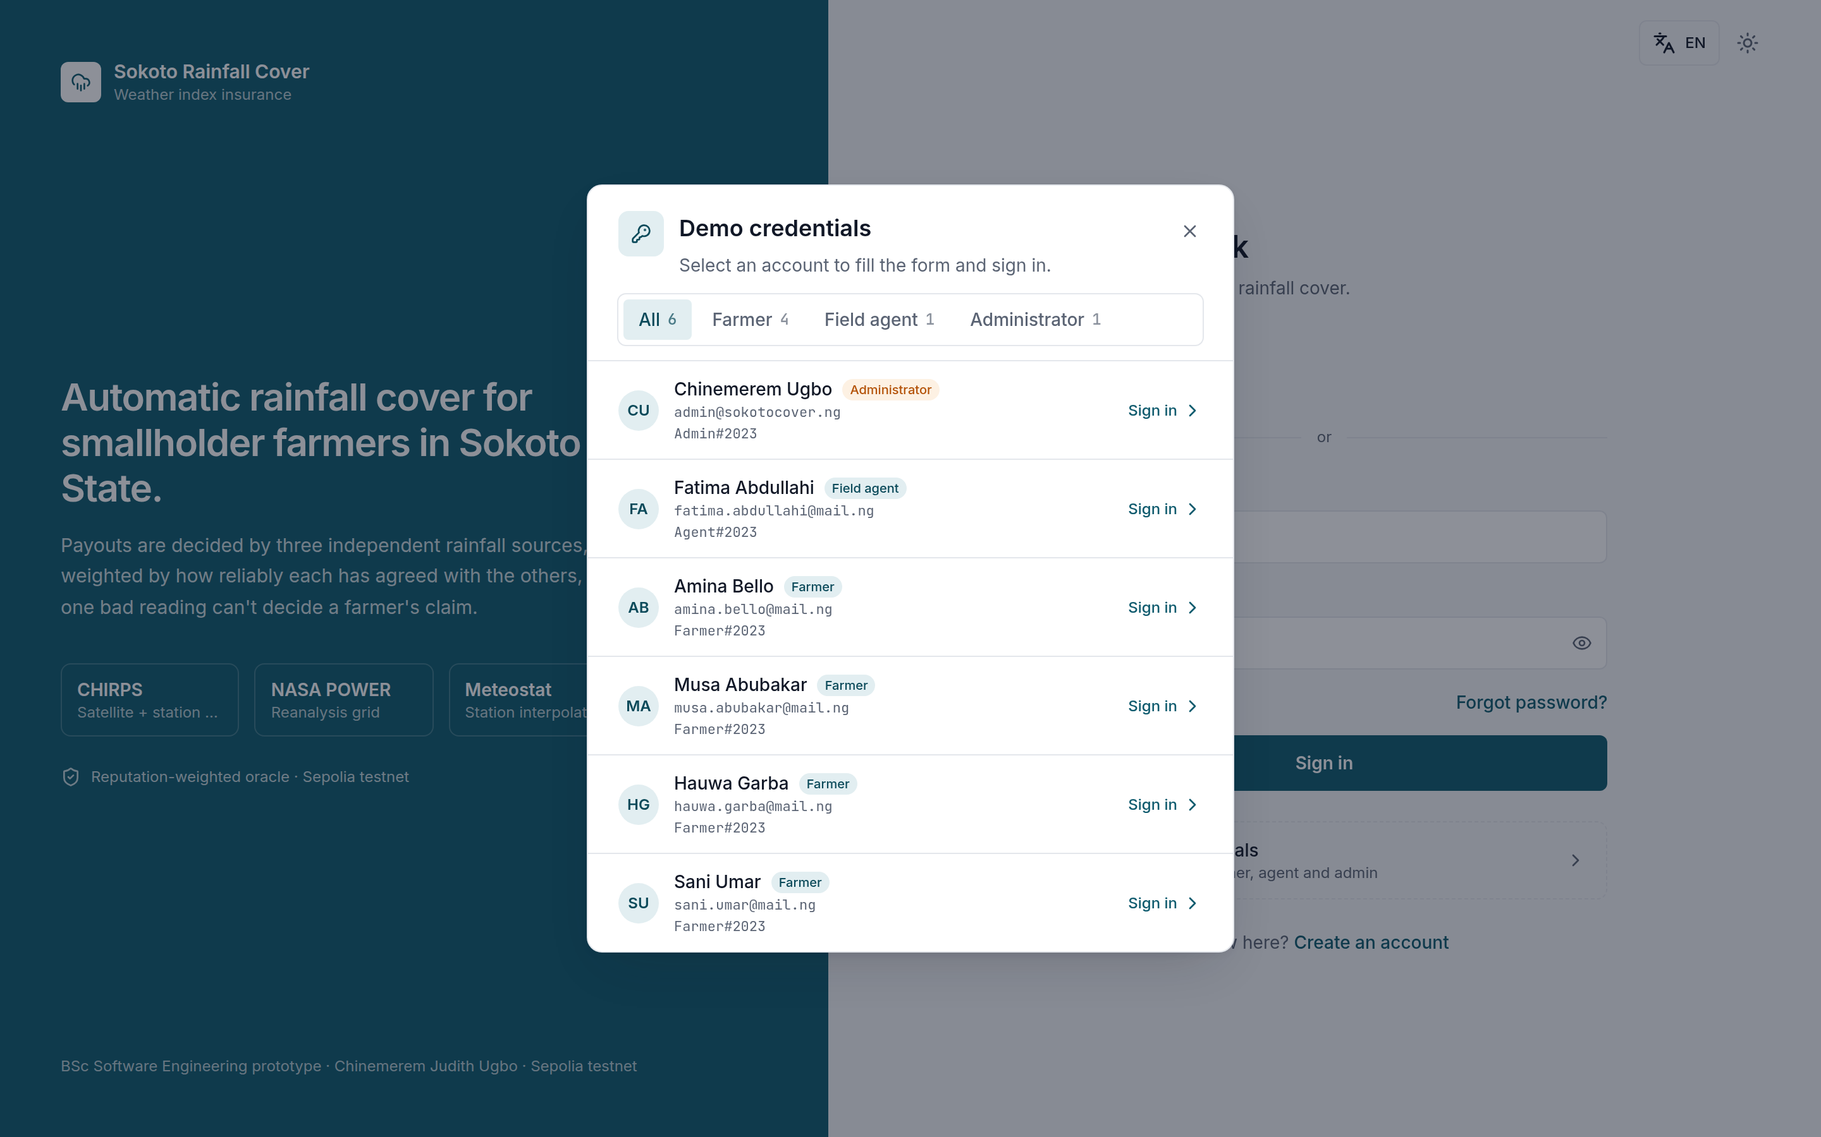
Figure A.1
Figure A.1 — Sign-in page with the demo-credentials panel (01-sign-in.png)

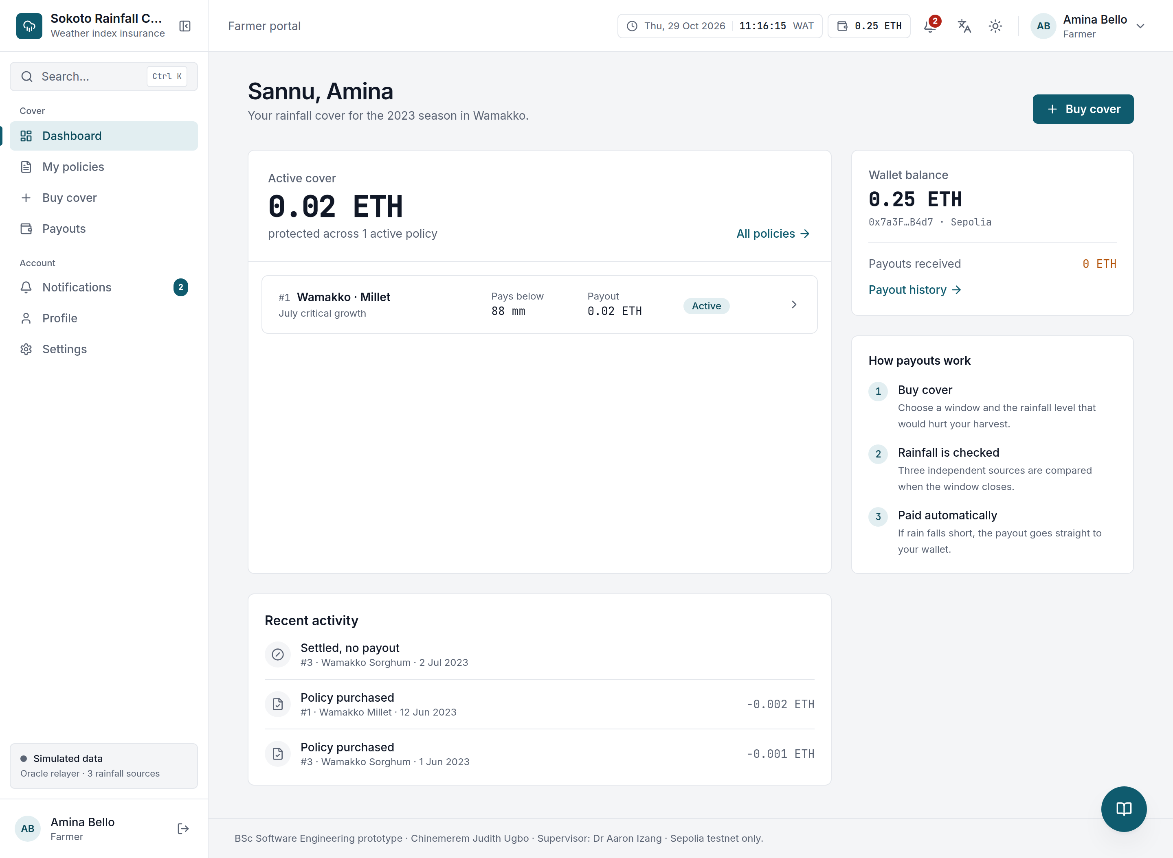
Figure A.2
Figure A.2 — Farmer dashboard (simulated data mode) (02-farmer-dashboard.png)

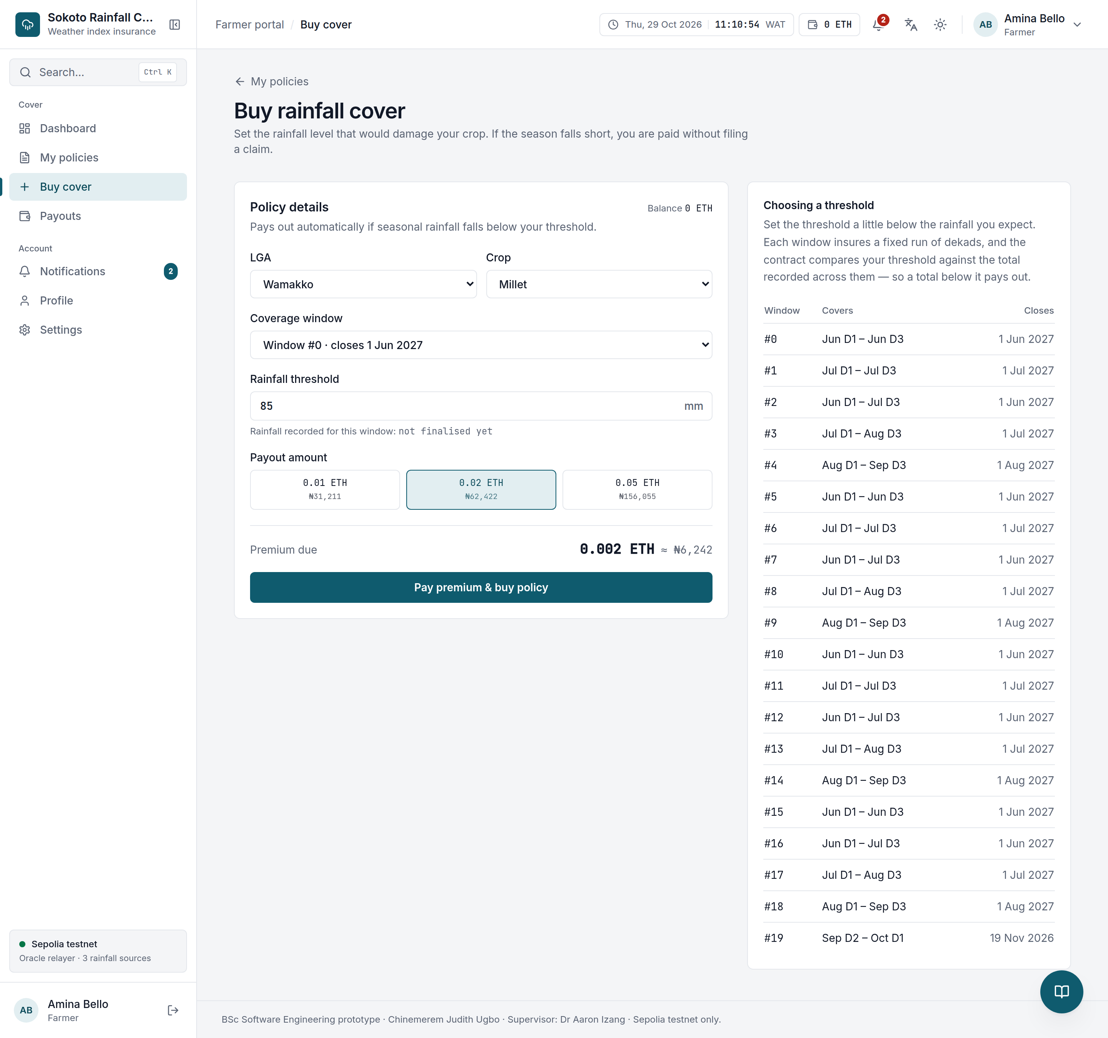
Figure A.3
Figure A.3 — Buy cover: coverage window, rainfall threshold and payout selection (03-buy-cover.png)

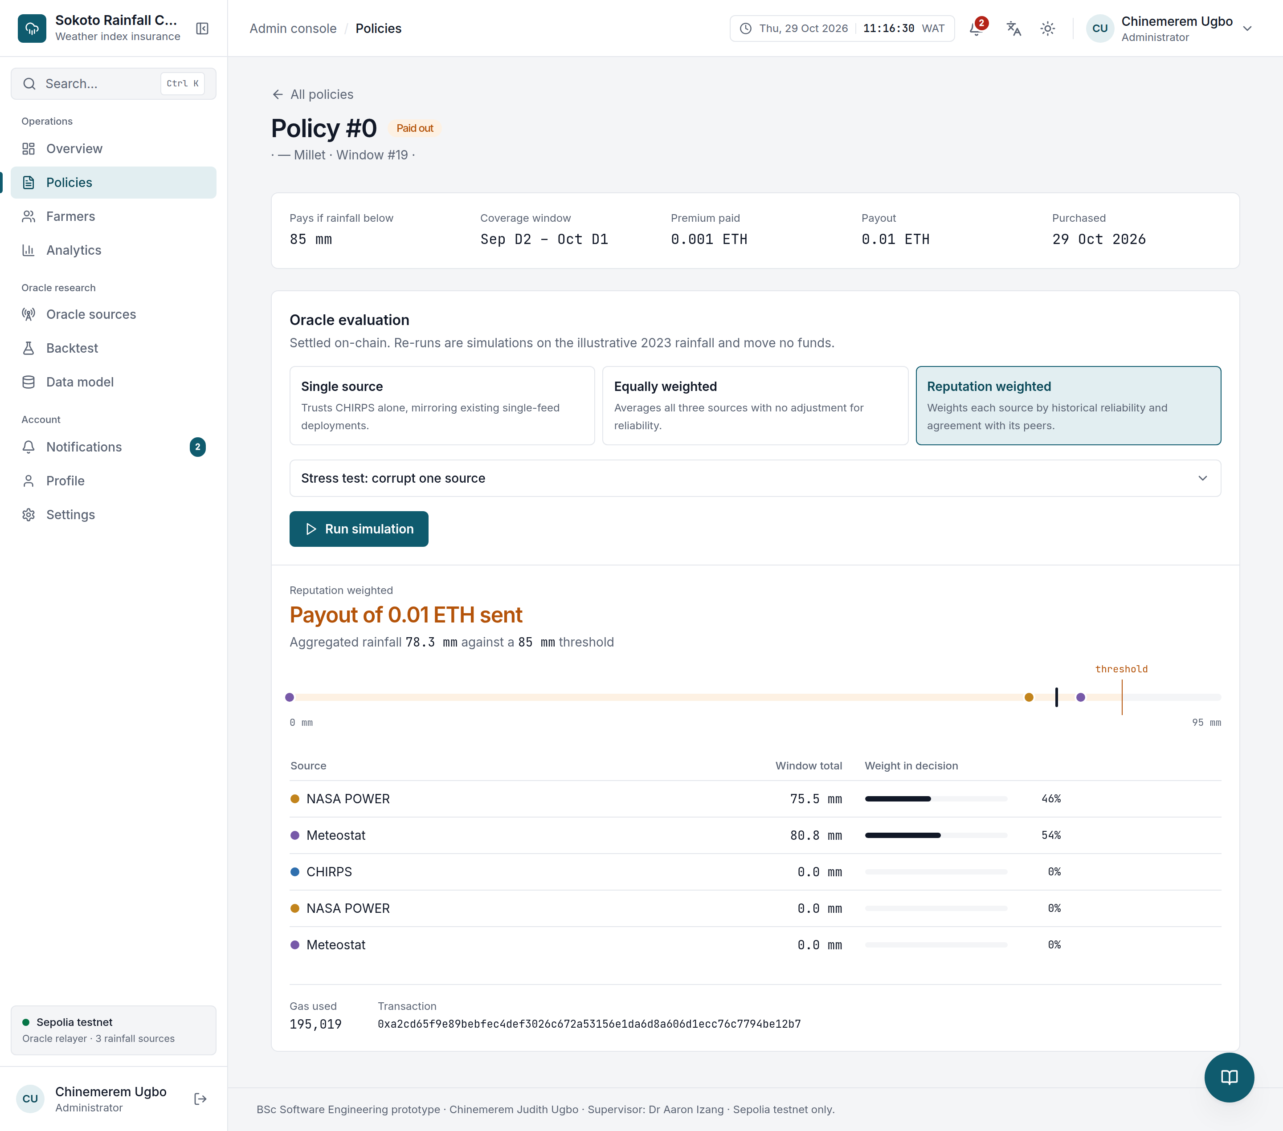
Figure A.4
Figure A.4 — Policy #0 — bought 29 Oct 2026, settled and paid out; oracle evaluation and settlement transaction (04-policy-detail.png)

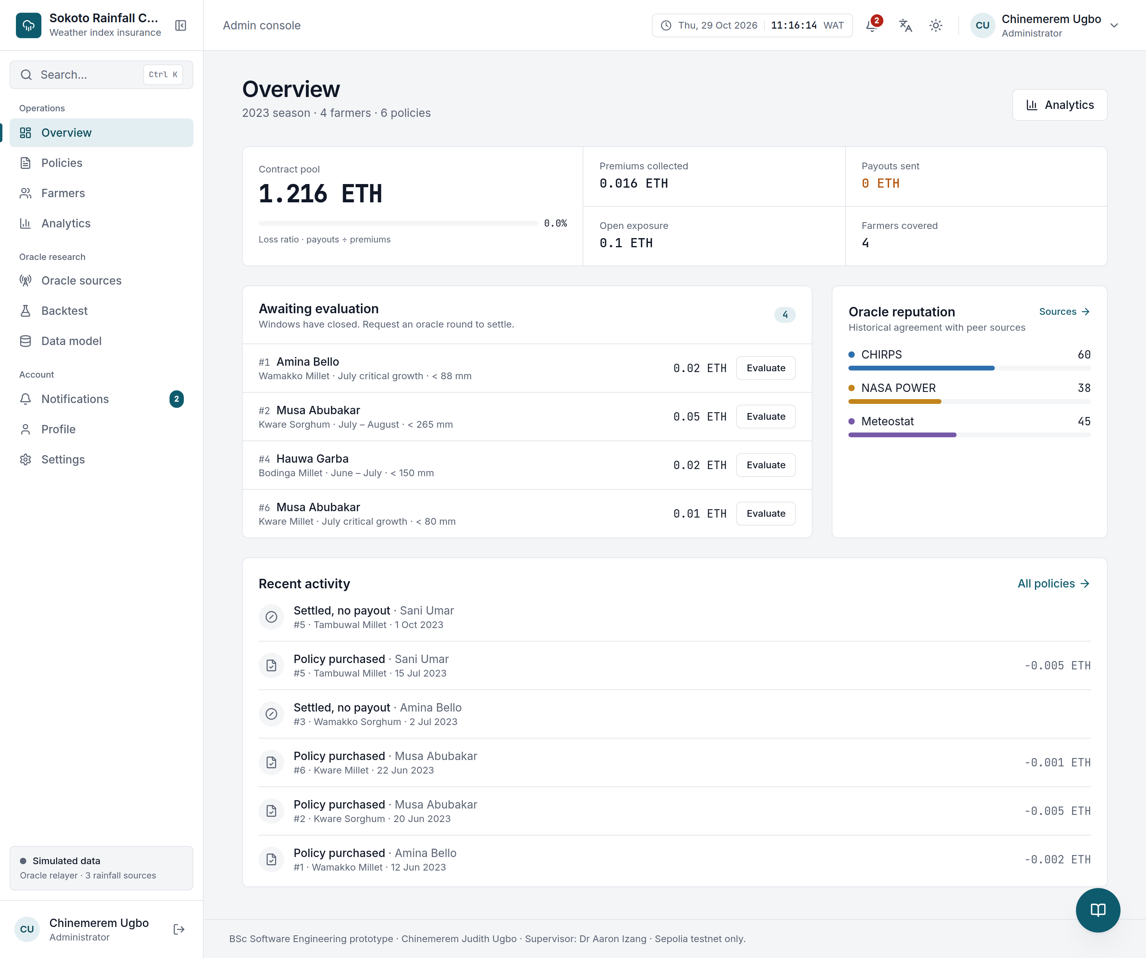
Figure A.5
Figure A.5 — Administrator overview (05-admin-overview.png)

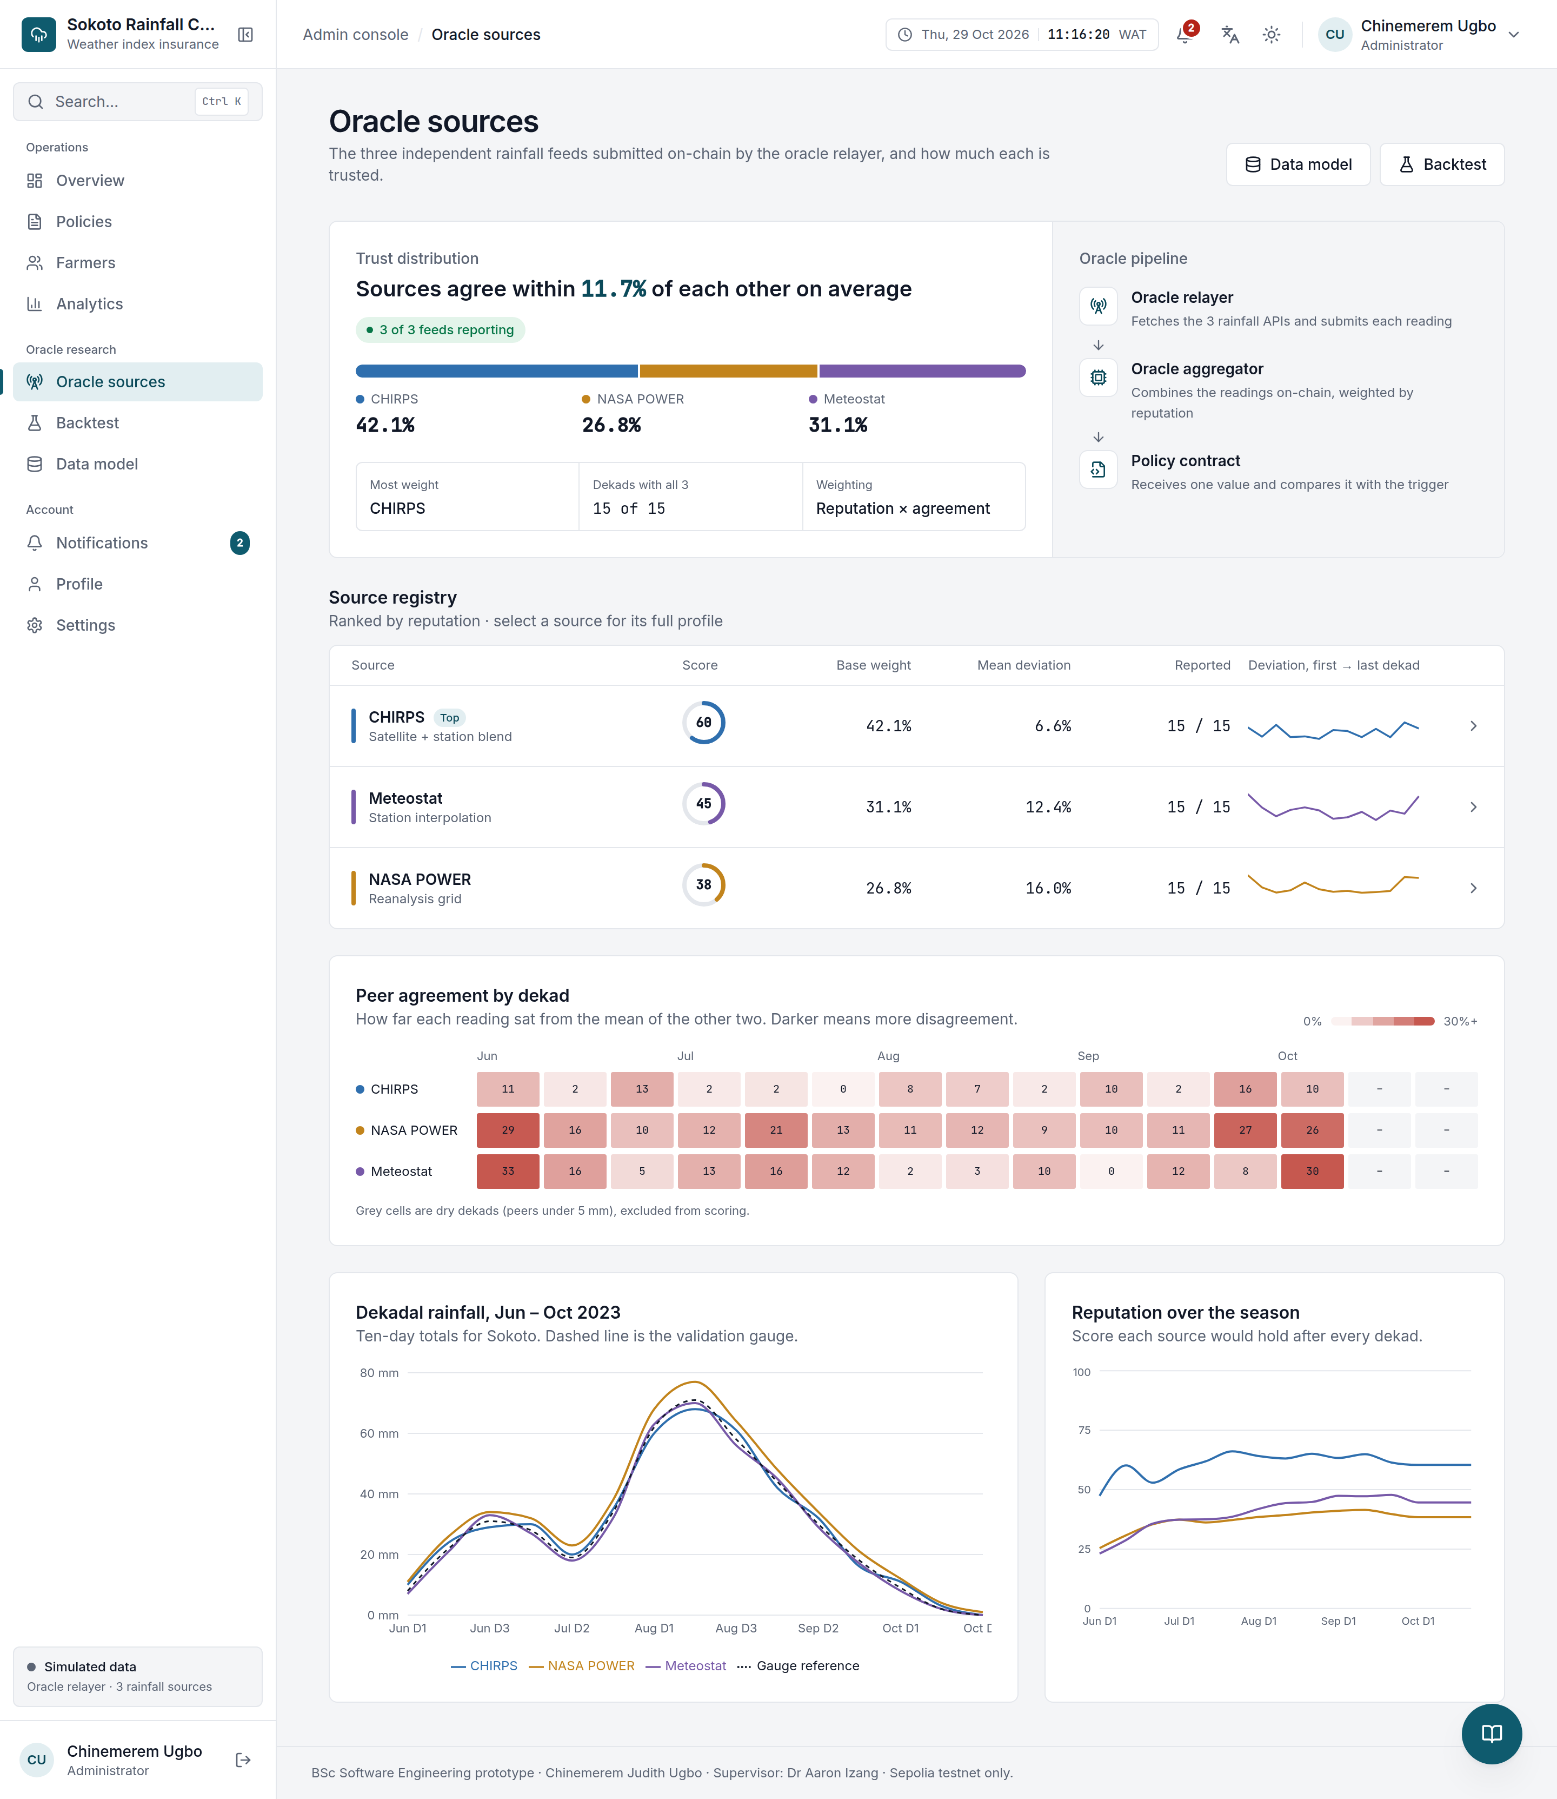
Figure A.6
Figure A.6 — Oracle sources and reputation weights (06-oracle-sources.png)

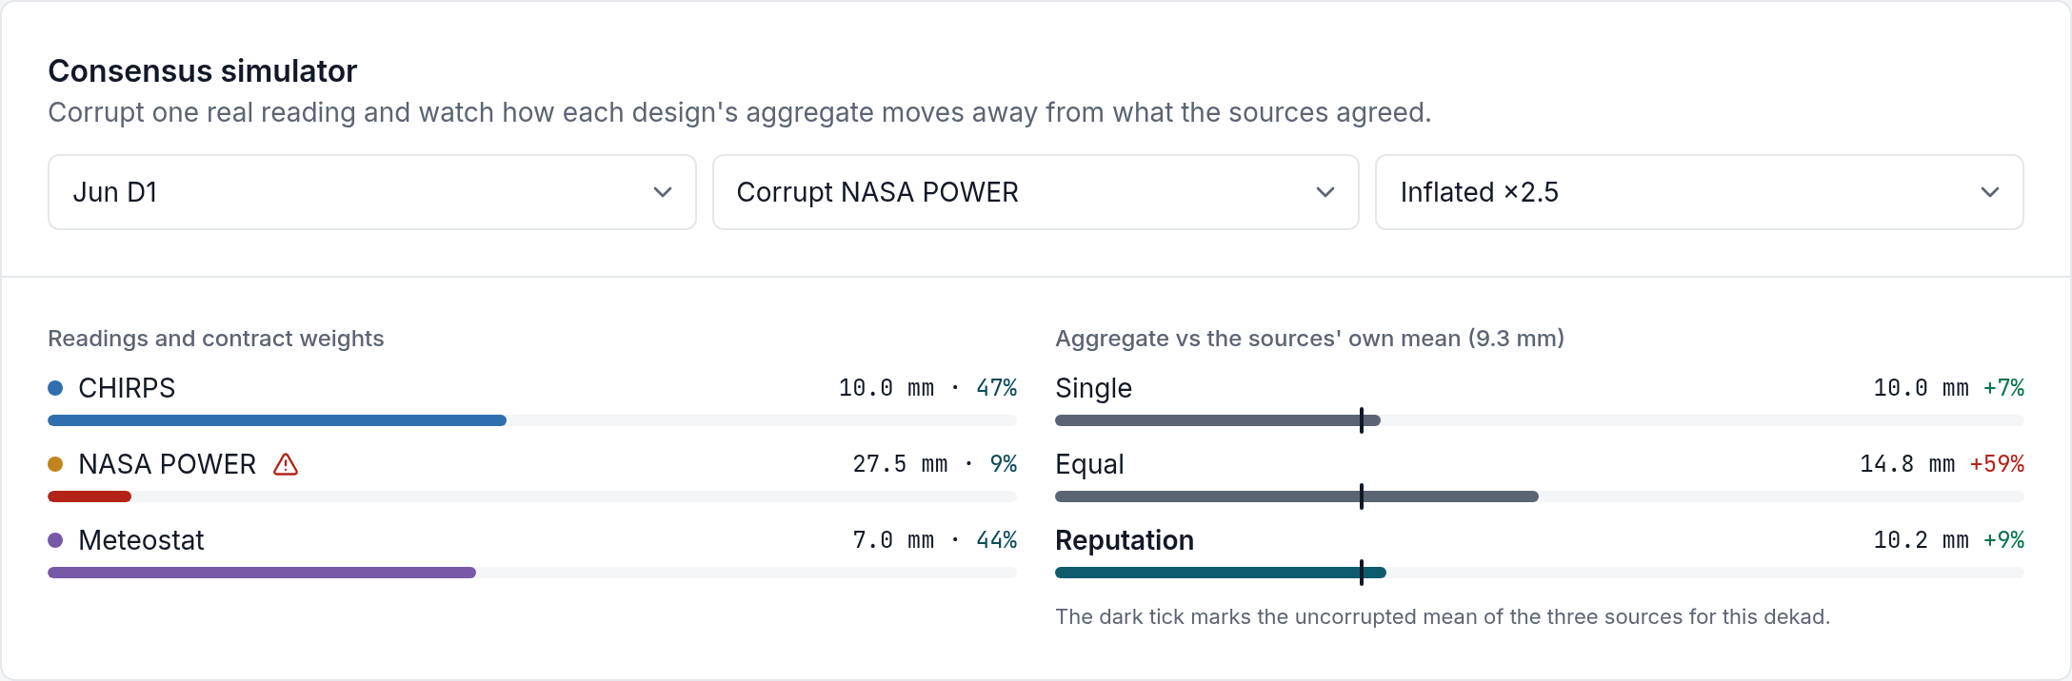
Figure A.7
Figure A.7 — Consensus simulator with one source corrupted (NASA POWER inflated ×2.5) (07-consensus-simulator.png)

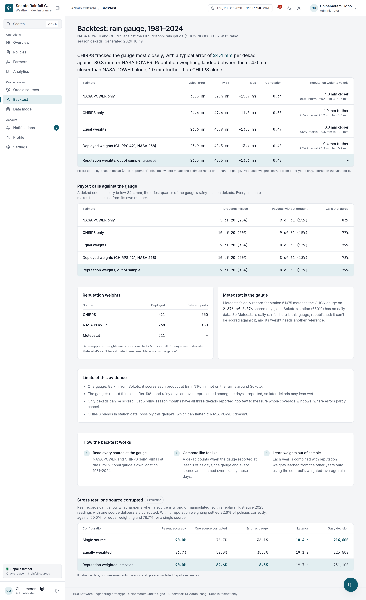
Figure A.8
Figure A.8 — Backtest of aggregation designs against historical rainfall (08-backtest.png)

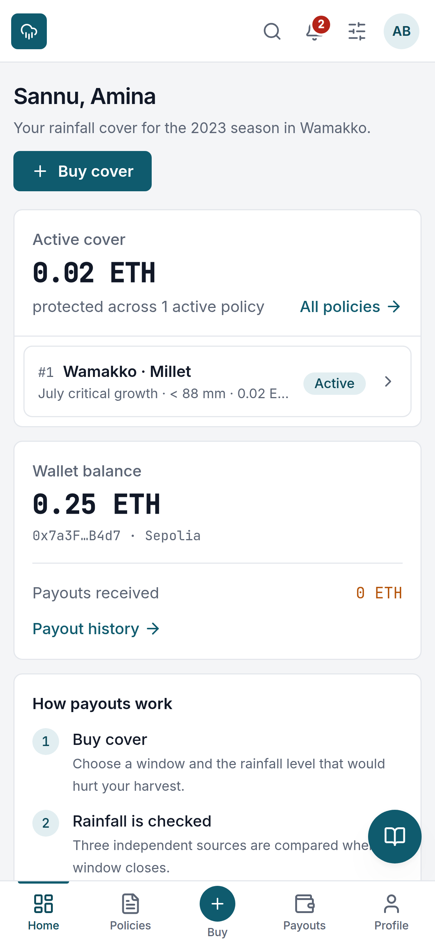
Figure A.9
Figure A.9 — Mobile layout of the farmer dashboard (09-mobile.png)

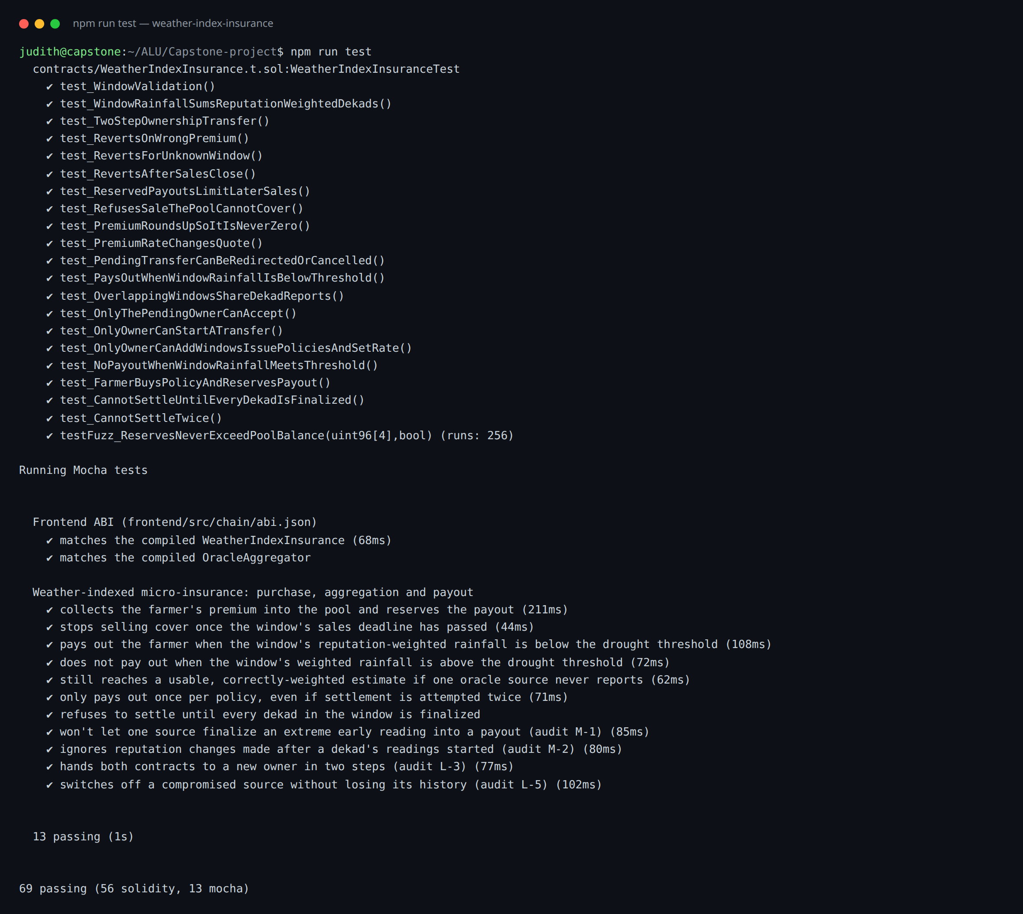
Figure A.10
Figure A.10 — npm run test — 69 passing (56 Solidity, 13 Mocha) in the blockchain workspace (10-tests.png)
Figures 4.1–4.3 are rendered in docs/figures/ as PNG and SVG, with Mermaid sources (architecture.mmd, sequence-purchase.mmd, sequence-settlement.mmd) alongside them.

Appendix B: Endpoints
Auth (/auth): GET session · POST login · POST register · POST google · POST verify-email · POST resend-verification · POST reset/request · POST reset/confirm · POST password · PATCH profile · DELETE account · POST logout
Data (/api): GET policies · GET oracles · GET windows · GET pool · GET settlements · GET readings · GET evaluations · GET fx · GET users/directory · GET demo-credentials · GET agent/sales · GET agent/sales/:policyId · POST agent/sales · POST notify/sms
Ops: GET /health. The Pages function proxies /api and /auth same-origin.
Contract (WeatherIndexInsurance): buyPolicy · quotePremium · checkAndSettle · windowRainfall · policies · getCoverageWindow · availableCapacity · owner functions (addWindow, setPremiumRate, two-step transferOwnership). OracleAggregator: oracle registry (registerOracle, retire), submitReading, finalizePeriod, isFinalized, finalizedAggregate, weightForPeriod.

Appendix C: Debugging journal (summary)
The full journal is docs/debugging-journal.md. In summary, live purchases initially failed in the wallet layer with four distinct faults — gas estimation routed through a failing wallet RPC (“missing revert data”), a stale wallet balance view (“insufficient funds” for a funded account), a stale account list after account switches, and a wallet sitting on the wrong network preparing a real-ETH transfer — while the contract accepted the call at every point. Fixes: estimate gas on the app’s trusted RPC and pass it explicitly; treat the chain’s view as authoritative; follow accountsChanged; check the wallet’s chain and request a switch before signing; translate all of it into plain-language errors. The episode is the strongest argument in the project for treating wallet infrastructure as untrusted input.

Appendix D: Licences
The project is MIT-licensed (LICENSE). Third-party components and their licences are listed in docs/licenses.md (data sources: CHIRPS, NASA POWER, Meteostat — attribution required; software: React, ethers.js, Hardhat, OpenZeppelin-derived patterns, Express). Meteostat data is used under its open licence with attribution; redistribution of raw data is not permitted commercially.

