Design and Implementation of a
Blockchain-Based Attendance
Tracking System
Technical Report
Course: Operating Systems & Cryptography (BLK101)
Programming Language: C (C11) — OpenSSL 3.0
Build System: GNU Make
Submitted as part of Lab Assignment 1

Table of Contents

1. Introduction
Traditional attendance systems are easy to manipulate: a student can sign on behalf of another, or an administrator can quietly edit records after the fact. The deliverable for this assignment is an attendance system built on the core principle that makes blockchain useful for ledgers: once a record is committed, modifying it must invalidate every record that follows. This report describes the design and implementation of such a system in the C programming language.
The system loads a student registry from a plain-text file at startup, validates every attendance attempt against that registry, and appends a cryptographically signed and chained block for each successful entry. The chain can be validated at any time, and an interactive tamper-test option is provided so that tampering can be observed in real time.
The implementation uses OpenSSL 3.0 for SHA-256 hashing and ECDSA P-256 digital signatures, and persists the entire ledger as a human-readable text file so that file-level tampering can be demonstrated externally as well.

2. System Architecture
The system is organised into four cooperating modules with strict, header-defined interfaces. Each module has a single responsibility, which keeps the code testable and makes the security boundary easy to reason about.
- student — loads students.txt into memory and provides O(n) lookup by ID.
- crypto — wraps OpenSSL 3.0 EVP APIs for SHA-256 and ECDSA P-256. Auto-generates and persists the admin keypair on first run.
- blockchain — owns the block structure, the linked-list chain, block creation, hashing, signing, and validation logic.
- storage — serialises and deserialises the chain to a pipe-delimited text file (attendance.dat).
- main — provides the CLI menu loop, gathers user input, and orchestrates the modules above.
The diagram on the next page summarises the overall architecture, the canonical block layout, and the chain linkage.

2.1 System Design Diagram
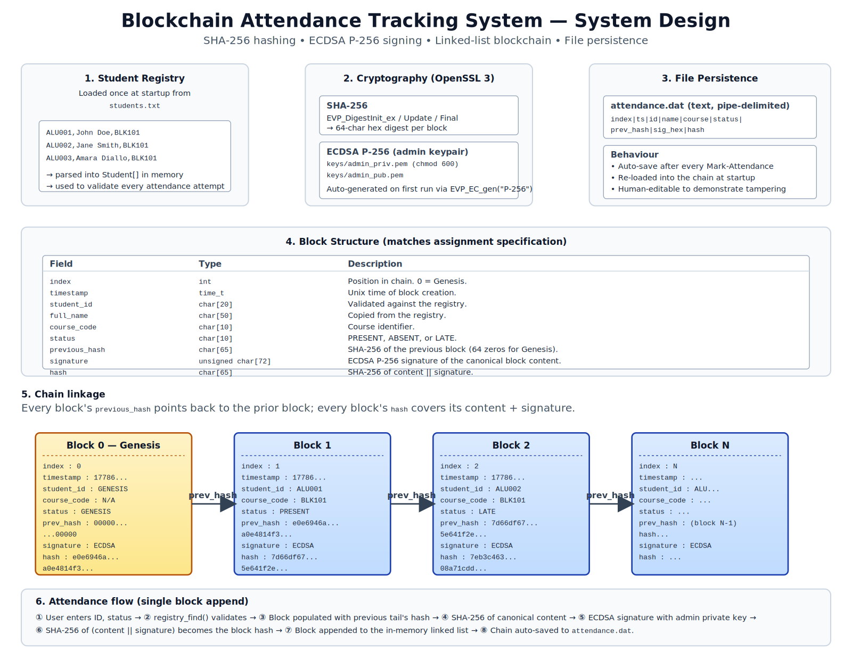
Figure 1. End-to-end architecture: registry, cryptography, persistence, block layout, chain linkage, and the eight-step attendance flow.

3. Description of the Blockchain Implementation

3.1 Block structure
The canonical block layout matches the assignment specification exactly. It is declared in include/blockchain.h so that every translation unit sees the same definition:
Field | Type | Description
index | int | Position in chain. 0 = Genesis block.
timestamp | time_t | Unix timestamp at block creation.
student_id | char[20] | Must match a valid ID in the registry.
full_name | char[50] | Copied from the registry at marking time.
course_code | char[10] | Course attendance is recorded for.
status | char[10] | PRESENT, ABSENT, or LATE.
previous_hash | char[65] | SHA-256 of the previous block (64 zeros for Genesis).
signature | unsigned char[72] | ECDSA P-256 signature of the canonical block content.
hash | char[65] | SHA-256 of content || signature.

Two additional fields exist on the in-memory Block record but are not part of the canonical content that gets hashed and signed: a sig_len counter (ECDSA DER signatures are variable length, typically 70–72 bytes for P-256), and a next pointer used by the linked-list chain. These two fields are deliberately excluded from hashing because they describe how the block is stored, not what the block records.

3.2 Chain representation
The blockchain is stored in memory as a singly linked list of BlockNode structures, each containing one Block plus a next pointer. The Blockchain struct holds head, tail, and length, so appends are O(1) and lookup-by-index is O(n) (acceptable because attendance ledgers are append-mostly and read in small bursts).

3.3 Genesis block
At index 0 the system creates a special Genesis block whose previous_hash field is 64 ASCII zero characters. The Genesis block is still signed and still has a SHA-256 hash, so the same validation logic applies to it as to every other block — there are no special-cased paths in the validator that could be bypassed.

3.4 Canonical serialisation
Before a block can be hashed or signed, its content is serialised into a deterministic pipe-delimited byte buffer:
snprintf(buf, bufsz,
"%d|%lld|%s|%s|%s|%s|%s",
b->index, b->timestamp,
b->student_id, b->full_name,
b->course_code, b->status,
b->previous_hash);

Using a fixed format with a fixed field order means that signing and verifying always operate on exactly the same byte sequence. Any per-field change — even something as small as toggling 'PRESENT' to 'LATE' — produces a different byte sequence, a different hash, and an invalid signature.

3.5 Append flow
A successful Mark-Attendance operation proceeds through the following steps:
- The student ID is looked up in the registry; if not found, the operation aborts before any block is created.
- The status string is normalised to upper-case and bounds-checked against PRESENT, ABSENT, or LATE.
- A new Block is populated: the next index, the current Unix timestamp, the student fields copied from the registry, and the tail block's hash as previous_hash.
- The block content is serialised canonically and signed with the admin private key using EVP_DigestSign over SHA-256.
- The block hash is computed as SHA-256 of content || signature_bytes.
- The block is appended to the linked list and the chain is auto-saved to attendance.dat.

3.6 Validation
The chain_validate() routine walks the chain once and applies three independent integrity checks to each block:
- Hash recomputation — the stored hash is recomputed from the current content and signature; any mismatch is reported with the stored and recomputed values.
- Linkage check — each block's previous_hash must equal the previous block's hash. The Genesis block must point to 64 zero characters.
- Signature verification — the ECDSA signature is verified against the admin public key over the canonical content.
Each check is independent and any single failure flips the chain status to INVALID. This redundancy means that tampering is detected even if an attacker manages to forge a hash but not a signature, or vice versa.

4. Security Mechanisms

4.1 SHA-256 (content integrity)
Every block carries a SHA-256 hex digest computed over its canonical content plus the signature bytes. The implementation uses OpenSSL 3.0's modern EVP digest API (EVP_DigestInit_ex / Update / Final) rather than the deprecated low-level SHA256_* functions, so the code compiles with no deprecation warnings.
SHA-256 provides two properties the system relies on: collision resistance (an attacker cannot find two different blocks with the same hash) and the avalanche effect (a single bit change anywhere in the input produces a wildly different digest). Together these make undetectable in-place edits computationally infeasible.

4.2 ECDSA P-256 (authenticity)
Hashing alone proves that data has not changed, but it does not prove who created the record. A motivated attacker who can modify a block can also recompute its hash. To close that gap, every block is also digitally signed using ECDSA over the NIST P-256 curve.
On first run, the program generates an admin keypair with the high-level helper EVP_EC_gen("P-256") and saves them as PEM files under the keys/ directory. The private key file is chmod-ed to 0600 (owner read/write only). Without access to the admin private key, an attacker cannot produce a forgery, so a tampered block fails signature verification even if its hash has been recomputed.

4.3 Authentication and access control
Authentication in this system has two layers:
- Subject authentication — before any block is appended, the supplied student ID is checked against the registry. An unregistered ID never reaches the blockchain layer.
- Record authentication — the admin private key signs every block, binding the record to the authority that produced it. Verification uses only the public key, so verification can be performed by anyone who has the chain file.
This is a deliberate simplification appropriate to the assignment scope: in a production setting, per-instructor (or even per-student) keypairs would replace the single admin key, and a separate access-control layer would gate which keys are allowed to sign which courses.

5. Data Persistence Approach
The full chain is serialised to a single text file, attendance.dat, with one block per line and pipe characters separating the fields. The signature bytes are hex-encoded so that the file remains 100% text-safe and editable in any text editor (which is useful for the external-tampering demonstration).
One record looks like this on disk (wrapped here for readability):
3|1778659590|ALU003|Amara Diallo|BLK101|ABSENT|
0c03827f1fb10deccad25a65b7b155b4b4d09d295d8d765a221eab2418b90677|
304502203c954c6817051b22939c09e31d0e16bf3b9dd47203ff9b9ab4d840b
9bc6106b2022100eb07a9cc861a8e6c83be70e251cd1ccd339fd0f5d21d8eca6
6bf44647d04f52d|
52f8899cfd76c237515dd1575b29b965ca1ae21f42e470aaa5bc52c9723be024

After every successful Mark-Attendance operation the entire chain is rewritten atomically. This is wasteful in big-O terms (O(n) per write rather than O(1) append) but for an attendance ledger the chain remains short, the simplicity is worth more than the constant factor, and rewriting the whole file removes any risk of half-written lines after a crash. The chain is also written explicitly on exit and via menu option 6 ("Save chain now").
On startup, the loader reads the file line-by-line, parses each pipe-delimited field, hex-decodes the signature back into the unsigned char[72] buffer, and reconstructs the linked list. If the file is missing the loader leaves the chain empty and the main program creates a fresh Genesis block.

6. Error Handling Strategy
Error handling is layered so that user-facing problems produce clean messages while internal failures surface enough detail to diagnose. The strategy can be summarised as follows:
- File-system errors — every fopen is checked, and strerror(errno) is included in the message. A missing or empty students.txt aborts startup with a clear FATAL message.
- Input validation — student IDs and status strings are validated before any block is constructed. The exact required message — "ERROR: Student ID not found" — is printed for unknown IDs.
- Buffer safety — fixed-size struct members are zeroed and filled with bounded memcpy calls so that string fields are always NUL-terminated and never overrun.
- OpenSSL errors — every cryptographic call is wrapped; on failure, the OpenSSL error stack is printed and the operation aborts cleanly rather than silently producing a bad signature or hash.
- Malformed ledger lines — during chain load, any line that fails to parse is reported with its line number and skipped, so a corrupted file does not crash the program.
- Compiler-level safety — the Makefile builds with -Wall -Wextra -Wpedantic -Wshadow. The final build has no warnings.

7. Screenshots of Application Execution
The following screenshots show captured terminal output from a complete run of the system.

7.1 Startup, registry load, valid + invalid attendance
After build, ./attendance generates the admin keypair (first run only), creates the Genesis block, prints the registry on demand, and accepts attendance for valid student IDs while rejecting invalid ones with the required error message.
INFO : No admin keypair found. Generating a fresh ECDSA P-256 keypair...
INFO : Admin keys stored in 'keys/'.
INFO : Genesis block created (index 0, hash e0e6946a0e4814f3...).

============================================================
BLOCKCHAIN ATTENDANCE TRACKING SYSTEM
Cryptographic ledger using SHA-256 + ECDSA P-256
============================================================
Admin pubkey fingerprint: d1009e0b1c1251e6...7d22cf22cd3766e4
============================================================

Loaded 8 student(s) from 'students.txt'.

---------------- MENU ----------------
1) View student registry
2) Mark attendance
3) View attendance records
4) Validate chain
5) Tamper test (demonstration)
6) Save chain now
0) Exit (auto-saves)
---------------------------------------
>
+-----------------------------------------------------------------+
| STUDENT ID | FULL NAME | COURSE |
+-----------------------------------------------------------------+
| ALU001 | John Doe | BLK101 |
| ALU002 | Jane Smith | BLK101 |
| ALU003 | Amara Diallo | BLK101 |
| ALU004 | Kwame Mensah | BLK101 |
| ALU005 | Fatima Bello | BLK101 |
| ALU006 | David Okonkwo | BLK101 |
| ALU007 | Chioma Eze | BLK101 |
| ALU008 | Aisha Mohammed | BLK101 |
+-----------------------------------------------------------------+

Total: 8 student(s).

---------------- MENU ----------------
1) View student registry
2) Mark attendance
3) View attendance records
4) Validate chain
5) Tamper test (demonstration)
6) Save chain now
0) Exit (auto-saves)
---------------------------------------
> Student ID: Status (PRESENT / ABSENT / LATE):
OK : Attendance recorded for John Doe (ALU001) as PRESENT.
Block #1, hash a7f65d5a2659b6b8...

---------------- MENU ----------------
1) View student registry
2) Mark attendance
3) View attendance records
4) Validate chain
5) Tamper test (demonstration)
6) Save chain now
0) Exit (auto-saves)
---------------------------------------
> Student ID: Status (PRESENT / ABSENT / LATE):
OK : Attendance recorded for Jane Smith (ALU002) as LATE.
Block #2, hash d34b7253bf5a3bb0...

---------------- MENU ----------------
1) View student registry
2) Mark attendance
3) View attendance records
4) Validate chain
5) Tamper test (demonstration)
6) Save chain now
0) Exit (auto-saves)
---------------------------------------
> Student ID:
ERROR: Student ID not found.

7.2 Viewing records & chain validation
Option 3 prints every block (header, content, prev-hash, hash, signature status). Option 4 runs the three-layer validator.
Previous Hash : 0000000000000000...0000000000000000
Block Hash : e0e6946a0e4814f3...51a1742ed9d0c2d5
Signature : 71 bytes, VALID

[Block 1]
Timestamp : 2026-05-13 08:06:49
Student ID : ALU001
Full Name : John Doe
Course : BLK101
Status : PRESENT
Previous Hash : e0e6946a0e4814f3...51a1742ed9d0c2d5
Block Hash : a7f65d5a2659b6b8...1ae26fecc2676262
Signature : 72 bytes, VALID

[Block 2]
Timestamp : 2026-05-13 08:06:49
Student ID : ALU002
Full Name : Jane Smith
Course : BLK101
Status : LATE
Previous Hash : a7f65d5a2659b6b8...1ae26fecc2676262
Block Hash : d34b7253bf5a3bb0...3679e3a10c1ddf3f
Signature : 72 bytes, VALID

================================================================================

---------------- MENU ----------------
1) View student registry
2) Mark attendance
3) View attendance records
4) Validate chain
5) Tamper test (demonstration)
6) Save chain now
0) Exit (auto-saves)
---------------------------------------
> OK : Chain is VALID (3 blocks, all hashes & signatures verified).
---------------- MENU ----------------
1) View student registry
2) Mark attendance
3) View attendance records
4) Validate chain
5) Tamper test (demonstration)
6) Save chain now
0) Exit (auto-saves)
---------------------------------------
>
Goodbye. Chain saved to 'attendance.dat'.

7.3 Tamper detection
Menu option 5 deliberately mutates a chosen block in place WITHOUT recomputing its hash, simulating what an attacker (or a careless administrator) might do. The next validate run reports a hash mismatch AND a signature failure — both layers fire independently:
3) View attendance records
4) Validate chain
5) Tamper test (demonstration)
6) Save chain now
0) Exit (auto-saves)
---------------------------------------
> FAIL : Block #2 hash mismatch.
stored: 7910db643aa34ef763f1be10164b519322e2f3167fc9f623b6260d1f467d4617
recomputed: dcf43e9748cce621591814b215a64c814437c290d9fc49a8e24a2894f3ea79aa
FAIL : Block #2 signature verification failed.
BAD : Chain is INVALID. Tampering detected.
---------------- MENU ----------------
1) View student registry
2) Mark attendance
3) View attendance records
4) Validate chain
5) Tamper test (demonstration)
6) Save chain now
0) Exit (auto-saves)
---------------------------------------
>
Goodbye. Chain saved to 'attendance.dat'.

External tampering — editing attendance.dat directly with a text editor — is detected the same way on the next launch. This satisfies the spec's tamper-detection requirement using two distinct attack paths.

8. Challenges Encountered and Solutions

8.1 OpenSSL 3.0 API migration
The first draft used the legacy SHA256_*, EC_KEY_*, and ECDSA_sign functions. Under OpenSSL 3.0 these are all deprecated, and the compiler floods the build with warnings. Solution: the entire crypto module was rewritten against the modern EVP_* APIs (EVP_DigestInit_ex, EVP_DigestSign, EVP_EC_gen, PEM_write_PrivateKey). The final build is warning-free.

8.2 Variable-length ECDSA signatures
The assignment specifies unsigned char[72] for the signature field, but DER-encoded P-256 ECDSA signatures vary in length (typically 70–72 bytes). Storing only the bytes without the length would make verification ambiguous. Solution: the in-memory Block keeps a size_t sig_len counter alongside the byte buffer, and the serialised file format stores the signature as hex so its true length is unambiguous on disk.

8.3 Compiler-strict string handling
With -Wstringop-truncation enabled, GCC flagged strncpy(dst, src, N-1) where src happens to be exactly the same width as dst — a benign pattern but one that produced noisy warnings. Solution: fixed-size struct members are now zeroed and filled with bounded memcpy using strnlen, which guarantees NUL termination without the truncation warning.

8.4 Demonstrating tamper detection without a debugger
The blockchain module deliberately exposes a chain_tamper() function and wires it to menu option 5. This makes the destructive action explicit, visible in the demo, and self-documenting — anyone watching the CLI can see exactly what was mutated and on which block. As a complementary path, sed -i 's/|ABSENT|/|PRESENT|/' attendance.dat simulates an outside attacker editing the persisted ledger; both paths are caught by validate.

8.5 Auto-save vs. atomicity
Auto-saving after every mark could in principle leave a half-written file if the process is killed mid-write. The current implementation accepts that risk because the chain is small and rewritable from memory if the program is still running. A production version would write to a temporary file and rename it atomically, but that complexity was out of scope for this lab.

9. Conclusion
The deliverable meets every functional requirement laid out in the assignment: a student registry is loaded and enforced, a Genesis block is created with a 64-zero previous_hash, attendance records become signed and hashed blocks linked by SHA-256, chain validation iterates the full chain checking hash, linkage, and signature, and tamper detection is demonstrated through two independent attack paths.
Beyond the minimum, the system uses modern OpenSSL 3.0 EVP APIs, compiles cleanly under strict warnings, separates concerns across well-defined modules with header-only interfaces, persists the chain in a human-readable format that survives reboots, and provides explicit error messages at every fallible boundary. The code base is small enough to audit by reading and structured well enough to extend (for example, replacing the single admin keypair with per-instructor keys would touch only the crypto module).
The full source tree, build instructions, system design diagram, and captured demo sessions accompany this report. Build with make; run with ./attendance.

