**Results and Findings**

**NB:**

**Please note that this file can be edited (*addition or questions*) with Red color text for easy identification.**

The data reveals a collection of 49 incidents recorded over a period of six-years from 2019 to 2024. The table below shows a cumulative cost of damaged components, total equipment downtime, cumulative mean time to repair (MTTR) and total production revenue lost.

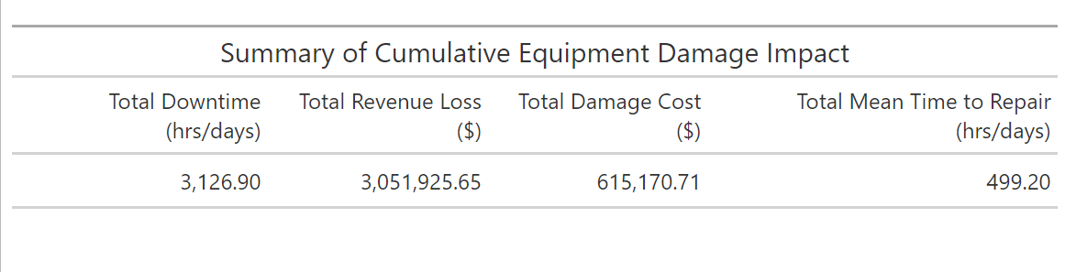

On average, each incident resulted in $62,284.20 in revenue lost, $12,554.50 cost of damaged components, 63.81 hours of equipment downtime and 10.19 hours of repair time as shown in the figure below

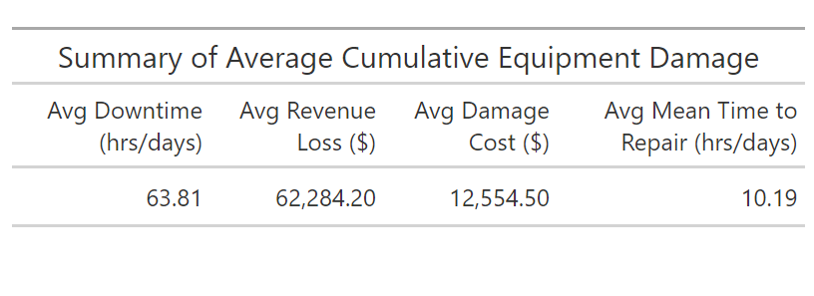

From the data analyzed, 2019 and 2024 had the least incident cases of two (2). From 2020 to 2023, there was an increasing frequency of incident cases from 12 to 15 as shown in the figure below.

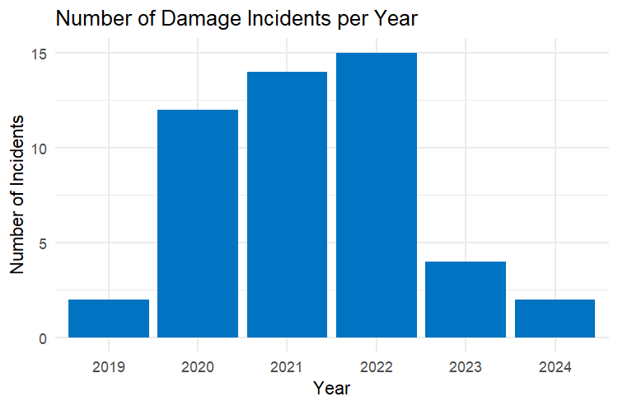

The chart below presents the total revenue loss per year resulting from equipment damage incidents. When combined with the incident count, we can derive the following insights.

In the year 2019, despite having only two recorded incidents, was the most financially devastating. These incidents resulted in a production lost of $1,570,552.04 revenue accounting for over half the total revenue loss over the study period.

In 2020, the number of incidents increased significantly to 12, yet the overall financial impact was much lower compared to 2019. The total revenue lost was $258,541.94 which suggest that although the frequency of incidents increased severely but the financial consequence was relatively minimal this is possibly due to less severe damage components.

2021 had a similar pattern to 2020, with a total revenue loss of $320,000.00 which is slightly above the revenue loss in 2020 but below that of 2019. Equipment damage frequency was about 14 incidents but less financially disruptive per incident.

2022 recorded the highest frequency of incidents with a total revenue loss of $764,644.83, making it the second-highest revenue.

In 2023, the frequency of incidents dropped significantly to 4. The revenue loss $130,815.14 which is about 5x lower to 2022.

2024 had 2 incidents recorded which shows continuous improvement with total revenue loss of $3,281.04 showing either incidents cases were relatively minor, or preventive measures were highly effective in minimizing losses.

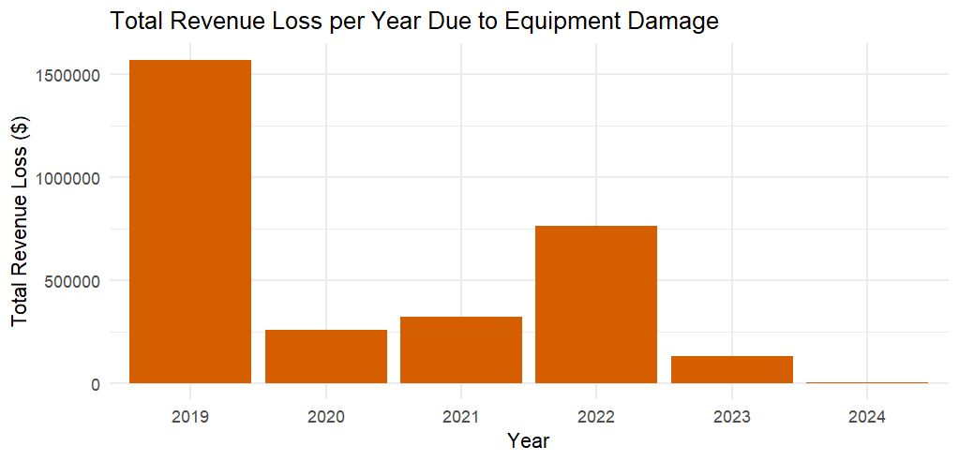

From the objective of the study it is essential to know the human contributing factors to key indicators of the financial crisis. Below is a plot of the incident count involving human and non-human factor

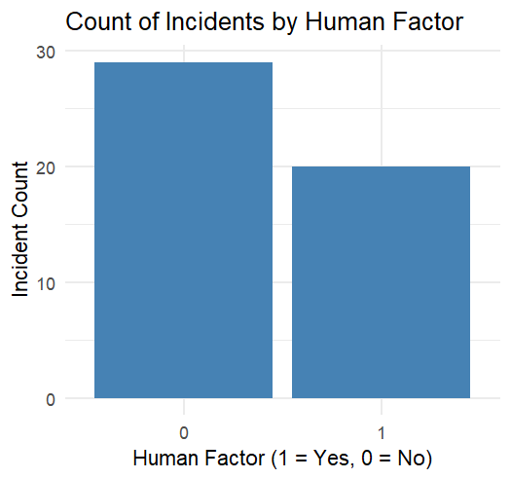

From the figure above, out of 49 incidents 20 of them involved human which is about 40.82% of the total incident count while 29 of them which is about 59.18% did not involve human factor.

Below is summary table of equipment damage by human factor relative to average cost of component damage, average equipment downtime, average revenue loss and expected hourly productivity of equipment (BCM).

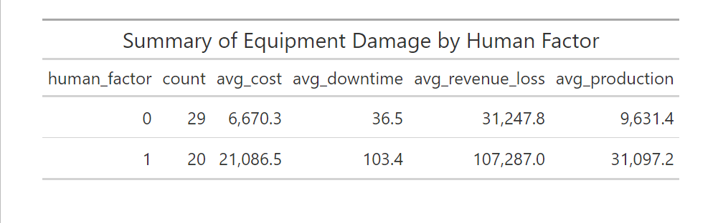

The summary table presents a compelling narrative about the impact of human involvement on equipment damage. While there were more incidents where human factors were not involved (29 cases), the fewer incidents that did involve human error (20 cases) were significantly more severe. On average, component damage costs in human-related incidents were more than three times (3x) higher, amounting to $ 21,086 compared to $ 6,670 in non-human-related cases. Equipment downtime followed a similar pattern, with human-related incidents resulting in an average of 103.4 hours lost, nearly triple the 36.5 hours observed in other cases. The financial consequences were equally stark average revenue losses for incidents involving human error were over $ 107,000, compared to just $ 31,000 for those that did not. The expected hourly productivity of equipment affected in human-related incidents also tended to be more productive, with average production levels significantly higher than in other cases. This suggests that when human error does occur, it tends to impact more critical and high-value machinery.

**Analysis of Cost of Damage by Presence of Human Factor**

To understand the impact of human involvement on cost of damage, the following box plot below provides insight into how the cost of equipment damage differs based on the involvement of human factors.

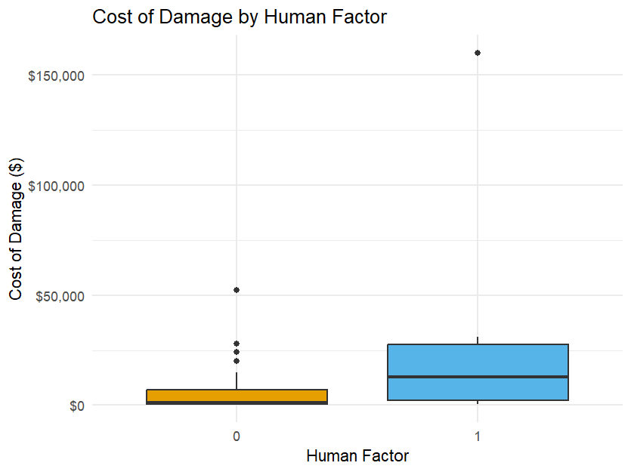

The median cost (50%) of these human-related incidents is noticeably higher than that of non-human-related ones, and the upper quartile extends far beyond that of the non-human cases, indicating that a significant number of these incidents were extremely expensive. In contrast, the box for non-human factors (represented by 0) is much smaller and closer to the lower end of the cost spectrum, suggesting more consistency and generally lower damage costs. The presence of multiple outliers in both categories, but especially in the non-human factor group, shows that while costly events do occasionally occur regardless of human involvement, the typical case is far more severe when human error is at play.

**Hypothesis Test**

To determine whether the observed difference is statistically significant, a hypothesis test was conducted. The hypotheses were defined as follows:

Let H0: be the null hypothesis and H1: be the alternative hypothesis.

H0: There is no difference in the distribution on cost of damages between incidents with and without human factor involvement

H1: There is a difference in the distribution on cost of damages between incidents with and without human factor involvement.

A non-parametric test (Wilcoxon rank-sum test) was employed due to the skewed distribution and presence of outliers in the data. The test yielded a **p-value of** 0.007449.

Based on the Wilcoxon rank sum test, the p-value was found to be 0.0074. Since this p-value is less than the commonly used significance level of 0.05, we reject the null hypothesis.

We conclude that there is a statistically significant difference in cost of damage between incidents that involved a human factor and those that did not. This result provides statistical evidence suggesting that human factors may be associated with increased damage cost and hence an increase in financial loss.

**Analysis of Revenue Loss by Presence of Human Factor**

This section examines the relationship between human factors and the extent of revenue loss resulting from operational incidents

To visualize the differences in revenue loss between incidents involving and not involving human factor, a boxplot was generated.

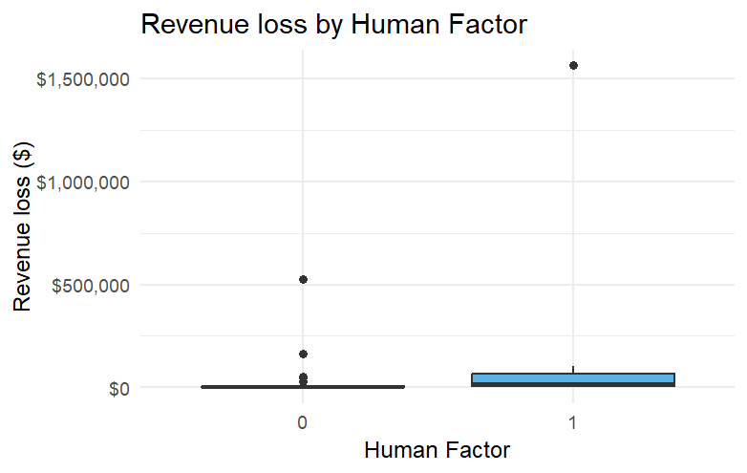

As shown in Figure above, incidents involving human factors are associated with higher median losses and a wider interquartile range compared to those without. Several extreme outliers are observed, particularly in the human factor group.

**Hypothesis Test**

To determine whether the observed difference is statistically significant, a hypothesis test was conducted. The hypotheses were defined as follows:

Let H0: be the null hypothesis and H1: be the alternative hypothesis.

H0: There is no difference in the distribution of revenue loss between incidents with and without human factor involvement

H1: There is a difference in the distribution of revenue loss between incidents with and without human factor involvement.

A non-parametric test (Wilcoxon rank-sum test) was employed due to the skewed distribution and presence of outliers in the data. The test yielded a **p-value of 0.01248**.

Based on the Wilcoxon rank sum test, the p-value was found to be 0.0124. Since this p-value is less than the commonly used significance level of 0.05, we reject the null hypothesis.

We conclude that there is a statistically significant difference in revenue loss between incidents that involved a human factor and those that did not. This result provides statistical evidence suggesting that human factors may be associated with increased financial loss.

**Correlation Between Key Metrics and Impact**

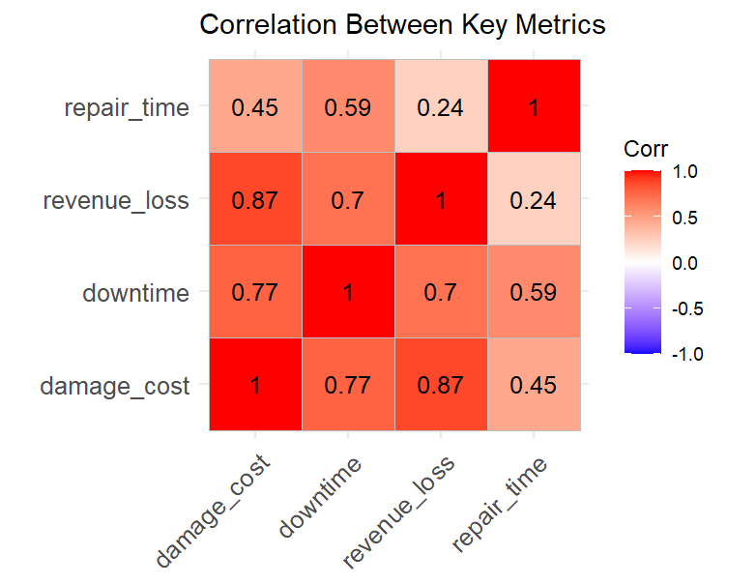

The heatmap represents the Pearson correlation coefficients between the following metrics:

* damage_cost = COST OF DAMAGED COMPONENT,
* repair_time = MEAN TIME TO REPAIR (HRS),
* downtime = EQUIPMENT DOWNTIME (HRS),
* revenue_loss = REVENUE (PRODUCTION) LOST ($)

The analysis reveals a very strong positive correlation between damage cost and revenue loss (0.87), indicating that higher damage costs are closely associated with greater financial losses, likely due to more severe disruptions. Similarly, damage cost and downtime (0.77) and downtime and revenue loss (0.70) also show strong correlations, suggesting that extensive damage not only prolongs equipment inactivity but also significantly affects revenue. A moderate correlation is observed between repair time and downtime (0.59), implying that longer repair time contribute to slightly increased equipment downtime. However, repair time shows a weaker correlation with revenue loss (0.24), indicating that while repair time influences operations, it may not be a major driver of financial impact on its own since damage components may have being purchased before repair time and does not necessarily result in further financial loss.

The findings suggest that minimizing equipment downtime and managing costly damages effectively are critical to reducing production-related revenue losses.

These relationships highlight that all damage metrics are closely connected, with an increase in one often accompanying an increase in the others.

The data highlights the substantial operational and financial risks associated with human-related equipment damage, and hence emphasizing the need for focused interventions like training, process im­­­­provements, and strict operational protocols in high-risk areas.