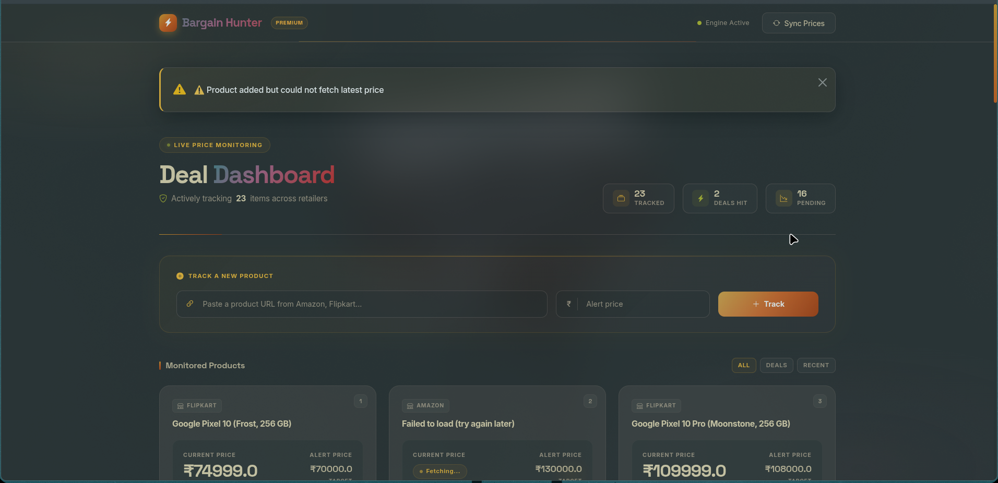
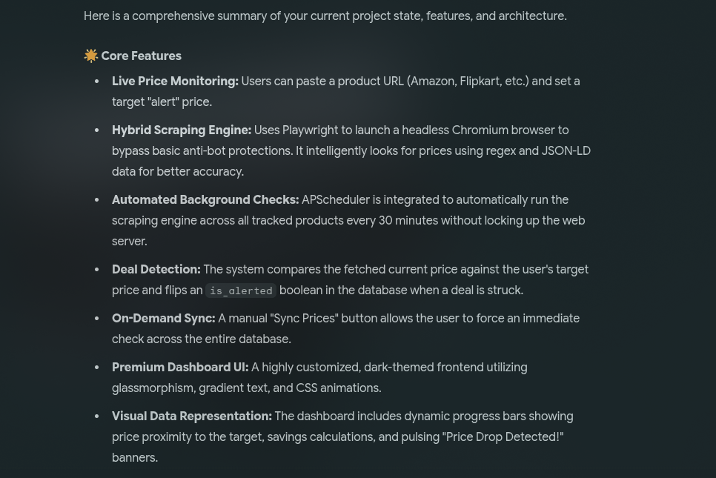
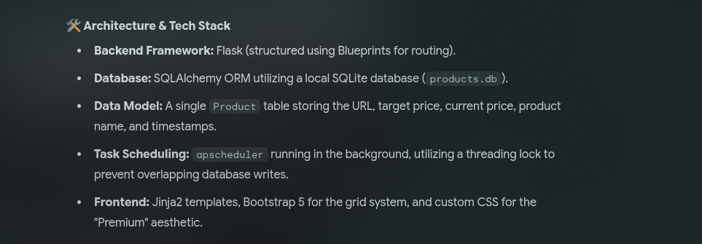

________________________________________________________________________________________

TERMINAL OUTPUT : 1
(BarginHunterBot) [phinix@archlinux bargain_hunter]$ python run.py ✅ Price checker started (every 30 minutes) 🚀 Starting Bargain Hunter Web App...
- Serving Flask app 'app'
- Debug mode: on WARNING: This is a development server. Do not use it in a production deployment. Use a production WSGI server instead.
- Running on http://127.0.0.1:5000 Press CTRL+C to quit
- Restarting with stat ✅ Price checker started (every 30 minutes) 🚀 Starting Bargain Hunter Web App...
- Debugger is active!
- Debugger PIN: 673-258-202 127.0.0.1 - - [18/Apr/2026 15:21:06] "GET / HTTP/1.1" 200 - [Playwright Failed] https://www.amazon.in/Samsung-Galaxy-Ultra-Storage-Offers/dp/B0GLGWFR89/ref=sr_1_10?s=electronics&sr=1-10 → TimeoutError: Page.goto: Timeout 30000ms exceeded. Call log:
- navigating to "https://www.amazon.in/Samsung-Galaxy-Ultra-Storage-Offers/dp/B0GLGWFR89/ref=sr_1_10?s=electronics&sr=1-10", waiting until "networkidle" . Falling to Gemini. [Attempting Gemini Fallback] [Gemini Success] https://www.amazon.in/Samsung-Galaxy-Ultra-Storage-Offers/dp/B0GLGWFR89/ref=sr_1_10?s=electronics&sr=1-10 → Name: Samsung Galaxy Ultra Storage Offers... | Price: ₹None 127.0.0.1 - - [18/Apr/2026 15:22:53] "POST / HTTP/1.1" 302 - 127.0.0.1 - - [18/Apr/2026 15:22:53] "GET / HTTP/1.1" 200 -

_______________________________________________________________________________________
TERMINAL OUTPUT : 2

(BarginHunterBot) [phinix@archlinux bargain_hunter]$ python run.py ✅ Price checker started (every 30 minutes) 🚀 Starting Bargain Hunter Web App...
- Serving Flask app 'app'
- Debug mode: on WARNING: This is a development server. Do not use it in a production deployment. Use a production WSGI server instead.
- Running on http://127.0.0.1:5000 Press CTRL+C to quit
- Restarting with stat ✅ Price checker started (every 30 minutes) 🚀 Starting Bargain Hunter Web App...
- Debugger is active!
- Debugger PIN: 673-258-202 127.0.0.1 - - [18/Apr/2026 15:30:02] "GET / HTTP/1.1" 200 - 127.0.0.1 - - [18/Apr/2026 15:30:36] "GET / HTTP/1.1" 200 - 127.0.0.1 - - [18/Apr/2026 15:30:56] "GET / HTTP/1.1" 200 - [Playwright Failed] https://www.myntra.com/shirts/nautica/nautica-men-premium-slim-fit-linen-shirt/33594240/buy → Error: Page.goto: net::ERR_HTTP2_PROTOCOL_ERROR at https://www.myntra.com/shirts/nautica/nautica-men-premium-slim-fit-linen-shirt/33594240/buy Call log:
- navigating to "https://www.myntra.com/shirts/nautica/nautica-men-premium-slim-fit-linen-shirt/33594240/buy", waiting until "networkidle" . Falling to Gemini. [Attempting Gemini Fallback] [Gemini Success] https://www.myntra.com/shirts/nautica/nautica-men-premium-slim-fit-linen-shirt/33594240/buy → Name: Nautica Men Premium Slim Fit Linen Shirt... | Price: ₹1767.0 127.0.0.1 - - [18/Apr/2026 15:34:06] "POST / HTTP/1.1" 302 - 127.0.0.1 - - [18/Apr/2026 15:34:06] "GET / HTTP/1.1" 200 - [Playwright Failed] https://www.myntra.com/shirts/nautica/nautica-men-premium-slim-fit-linen-shirt/33594240/buy → Error: Page.goto: net::ERR_HTTP2_PROTOCOL_ERROR at https://www.myntra.com/shirts/nautica/nautica-men-premium-slim-fit-linen-shirt/33594240/buy Call log:
- navigating to "https://www.myntra.com/shirts/nautica/nautica-men-premium-slim-fit-linen-shirt/33594240/buy", waiting until "networkidle" . Falling to Gemini. [Attempting Gemini Fallback] [Gemini Success] https://www.myntra.com/shirts/nautica/nautica-men-premium-slim-fit-linen-shirt/33594240/buy → Name: Nautica Men Premium Slim Fit Linen Shirt... | Price: ₹1767.0 127.0.0.1 - - [18/Apr/2026 15:34:53] "POST / HTTP/1.1" 302 - 127.0.0.1 - - [18/Apr/2026 15:34:53] "GET / HTTP/1.1" 200 -

