**UX/UI Evaluation Report**

**Display Information Scenario**

## ****1. Important UX Principles****

To make the design user-friendly, follow these principles:

* **Simplicity:** The interface should be easy to understand and navigate, avoiding unnecessary complexity.
* **Consistency:** UI components should follow a uniform pattern for better usability.
* **Accessibility:** Make sure everyone, including people with disabilities, can use the system.
* **Feedback:** Provide immediate responses to user actions, such as loading indicators, success messages, and error notifications.
* **Efficiency:** Minimize user effort to complete tasks.
* **Error Prevention:** Use clear instructions, input validation, and undo options to prevent mistakes.
* **Nielsen’s Usability Heuristics:** Key heuristics include visibility of system status, user control, flexibility, and error recovery.

## ****2. EVALUATE UI COMPONENTS****

### **2.1 Information Display Components**

* **Cards:**
  + **Advantages:** Visually appealing, good for grouping related content.
  + **Disadvantages:** May not be suitable for large datasets.
  + **Do’s & Don’ts:** Use for content categorization; avoid using too many on one screen.
* **Tables:**
  + **Advantages:** Ideal for structured data and comparisons.
  + **Disadvantages:** Can become overwhelming with excessive data.
  + **Do’s & Don’ts:** Use pagination for large datasets; avoid excessive scrolling.
* **Lists:**
  + **Advantages:** Simple and efficient for textual data.
  + **Disadvantages:** Harder to scan compared to tables.
  + **Do’s & Don’ts:** Use for ordered/unordered items; avoid excessive nesting.

**2.2 UI Components for Interaction:**

* **Bottom Sheets:**
  + **Advantages:** Good for temporary, quick interactions.
  + **Disadvantages:** Can be disruptive if overused.
  + **Do’s & Don’ts:** Use for contextual actions; avoid for core navigation.
* **Accordion:**
  + **Advantages:** Space-saving for categorized content.
  + **Disadvantages:** Hides content, requiring user interaction.
  + **Do’s & Don’ts:** Use for long-form FAQs; avoid nesting multiple accordions.
* **Carousel:**
  + **Advantages:** Visually appealing for showcasing content.
  + **Disadvantages:** Not optimal for essential navigation.
  + **Do’s & Don’ts:** Use for image slides; avoid for critical information.

**3. DECISION FACTORS**

When selecting UI components, consider:

* **Task Complexity:**
  + **Simple tasks benefit from lists.**
  + **Complex tasks require structured navigation, such as tables.**
* **Data Volume:**
  + **Large datasets require pagination or infinite scroll.**
  + **Small datasets can be effectively displayed using cards or lists.**
* **User Navigation Needs:**
  + **Accordions help declutter content.**
  + **Carousels work well for promotions but should not replace navigation.**
* **User Interaction Level:**
  + **Bottom sheets work well for temporary actions.**
  + **Tables provide advanced interactions for structured data handling.**
* **Empty State Handling:**
  + **Always design for scenarios where data may not be available.**
  + **Provide informative messages and actions (e.g., "No results found. Try a different search").**

**4. USE CASE EXAMPLES**

### **4.1 BlaBlaCar Ride Filtering and Sorting**

* **Component Used:** Bottom Sheet, Checkboxes, and Radio Buttons
* **Use Case:** A user wants to filter rides based on departure time and sort them by price or proximity.
* **UX Principles:**
  + **Simplicity:** The design is minimal and easy to navigate.
  + **Consistency:** Uses familiar UI patterns for filtering.
  + **Accessibility:** Large tap areas and clear labels help all users interact easily.

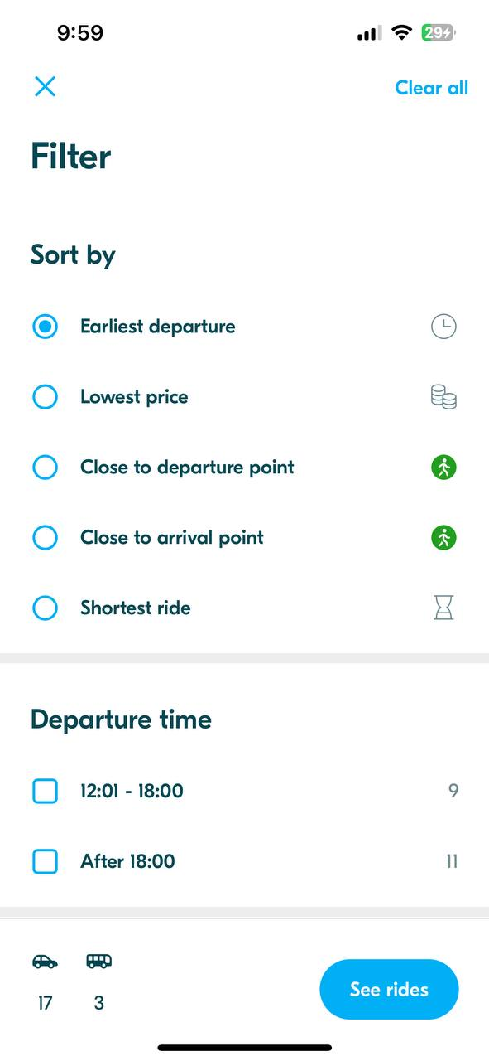

### **4.2 BlaBlaCar Ride Availability Status**

* **Component Used:** Cards and Status Labels
* **Use Case:** A user checks ride availability and sees if a ride is full.
* **UX Principles**:
  + **Feedback**: Shows the "Full" label to inform users about unavailable rides.
  + **Efficiency**: Users can quickly scan through available options without clicking on each ride.
  + **Error** **Prevention**: Avoids confusion by graying out unavailable rides instead of removing them.

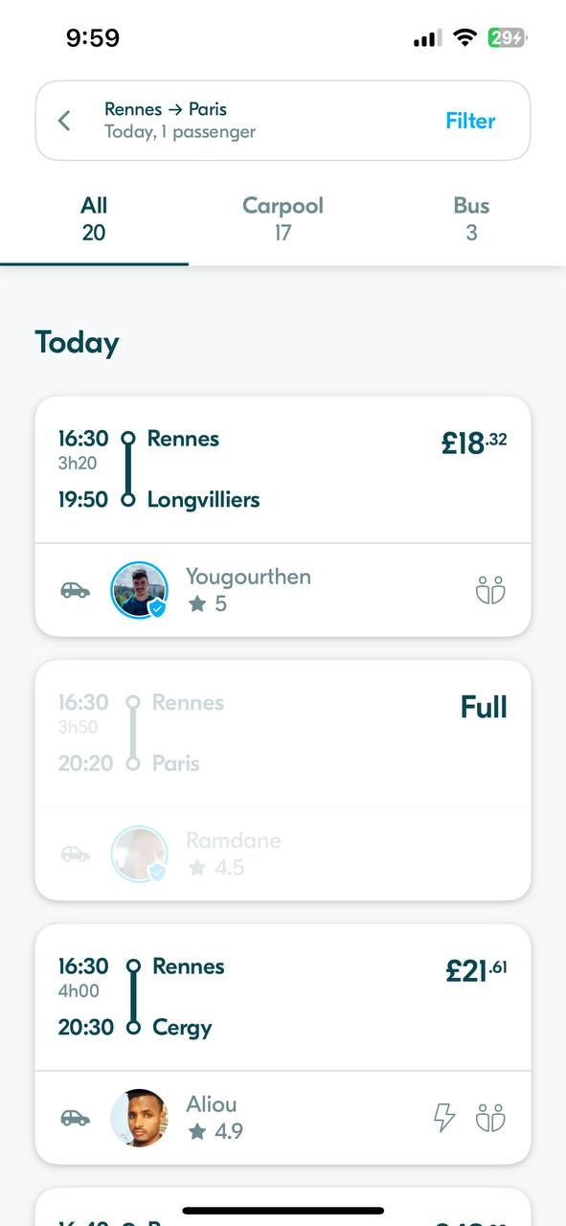

**5. REFERENCES**

* Nielsen Norman Group - [10 Usability Heuristics for User Interface Design](https://www.nngroup.com/articles/ten-usability-heuristics/)
* Material Guideline - [Lists – Material Design 3](https://m3.material.io/components/lists/)
* Google Material Design - [Material Design 3 - Google's latest open source design system](https://m3.material.io/)
* UX Design Principles - [UX Collective](https://uxdesign.cc/)
* BlaBlaCar - <https://www.blablacar.com/>
* Material Design Components - [Cards - Components - Material Design](https://m1.material.io/components/cards.html)