Phiraneish AT
23ISR039

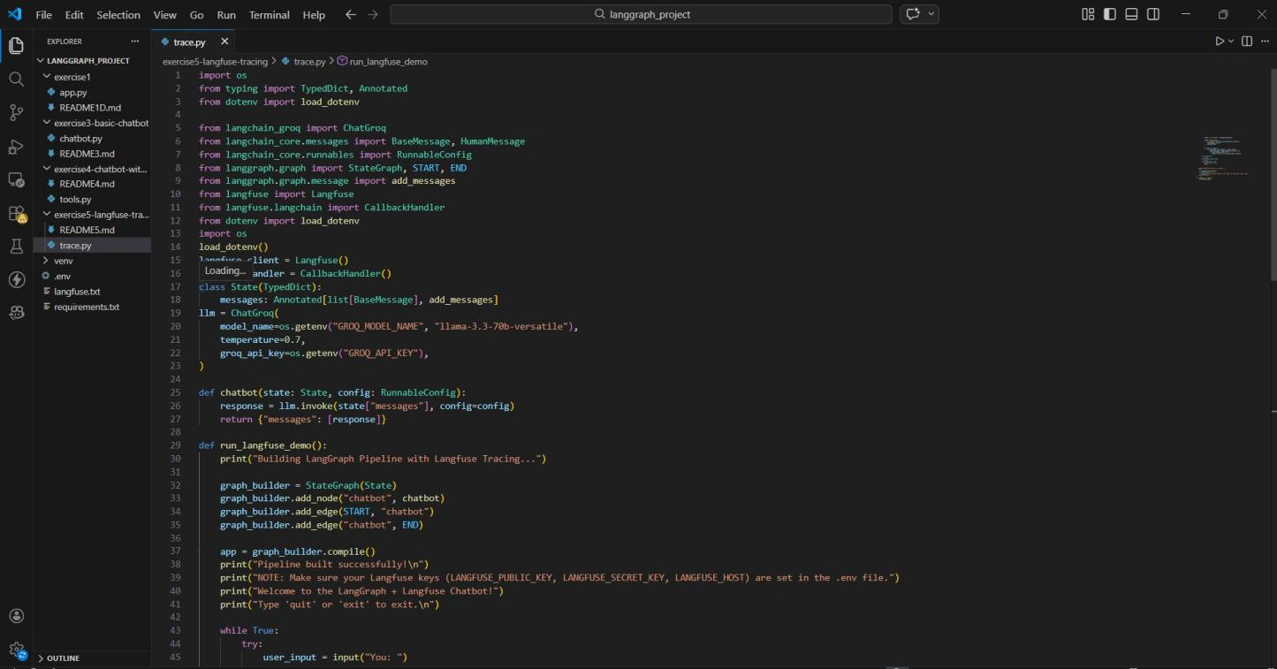
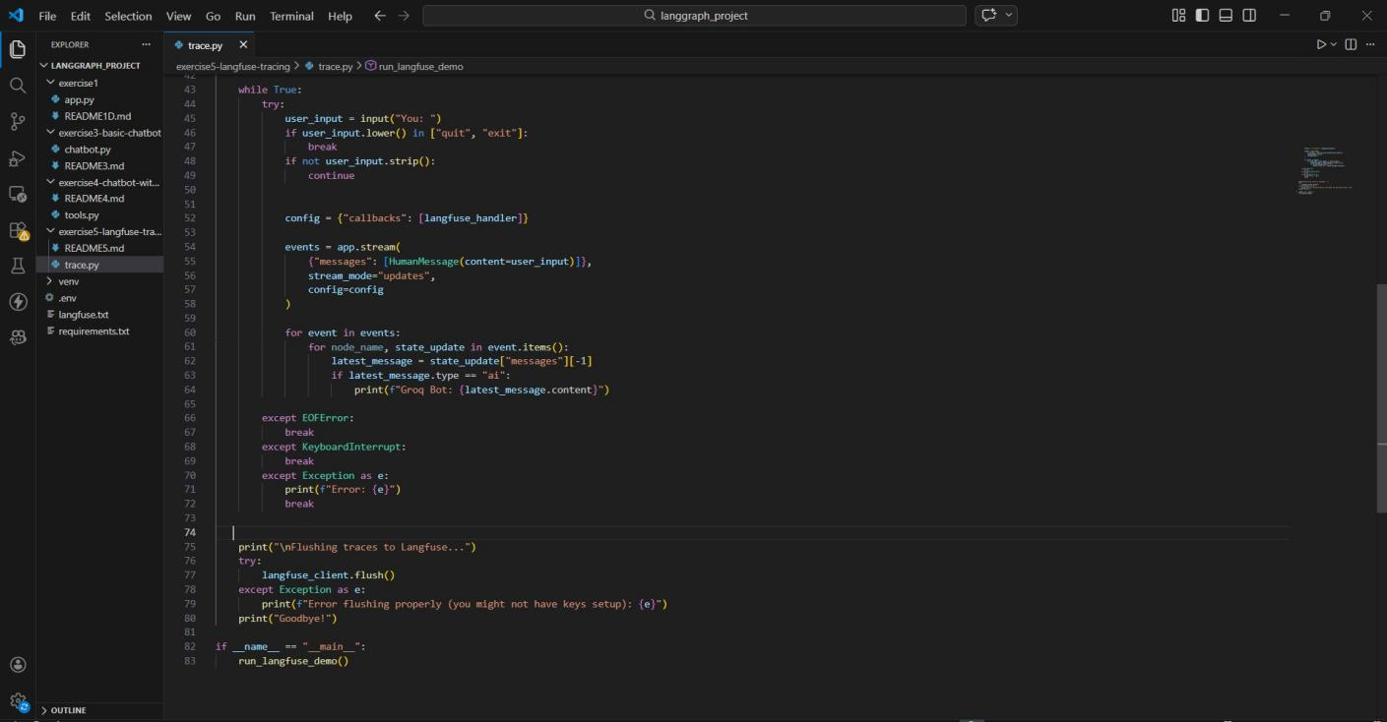

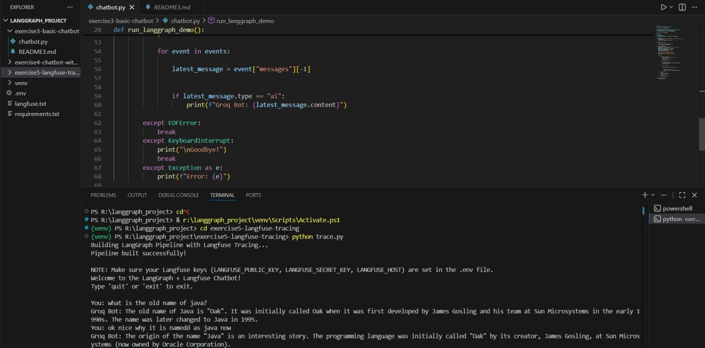

Langfuse Organization Dashboard
This screen shows the created organization and project used for monitoring the chatbot.
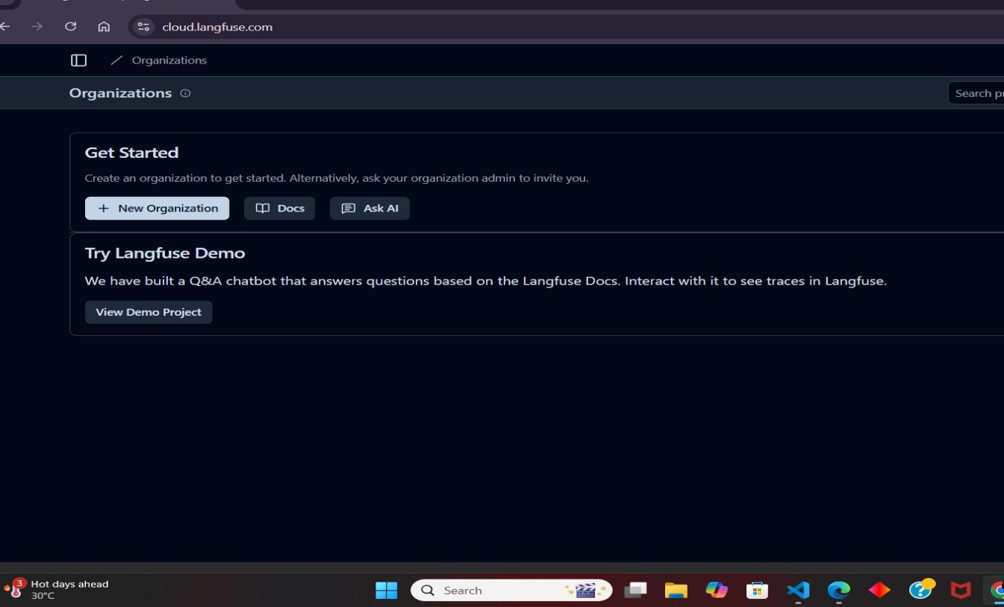

Langfuse Project Dashboard
The project dashboard shows information about traces, model cost, and token usage. Key observations:
- Total traces tracked: 3
- Model used: llama-3.3-70b-versatile
- Token usage recorded
- Cost monitoring available
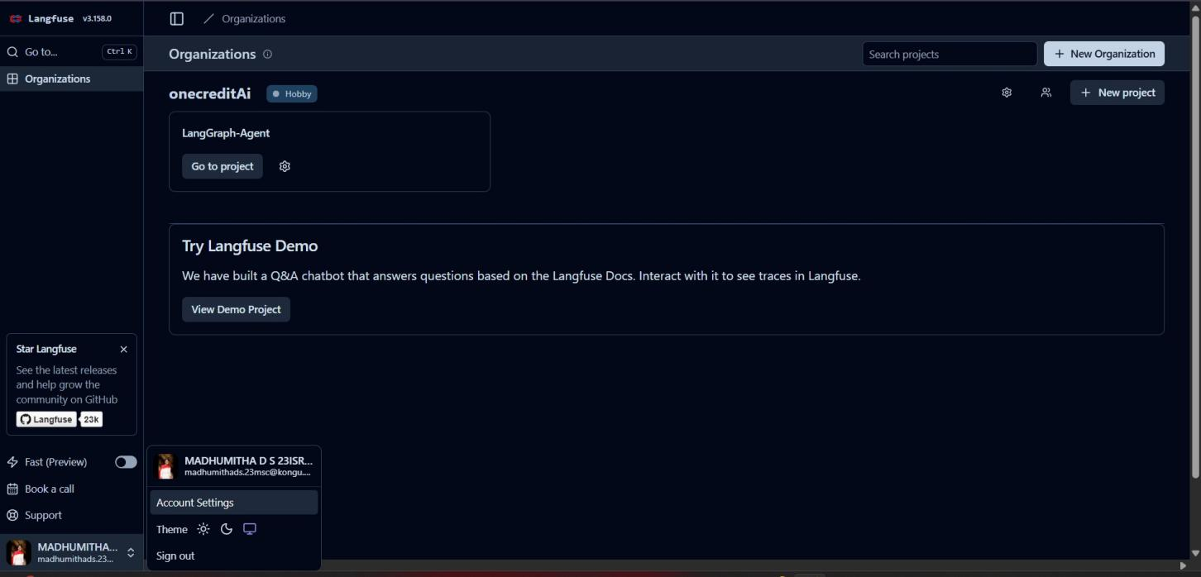

Trace Analytics
The trace analytics section shows the number of chatbot executions over time. The graph displays:
- Trace count
- Execution timestamps
- System performance

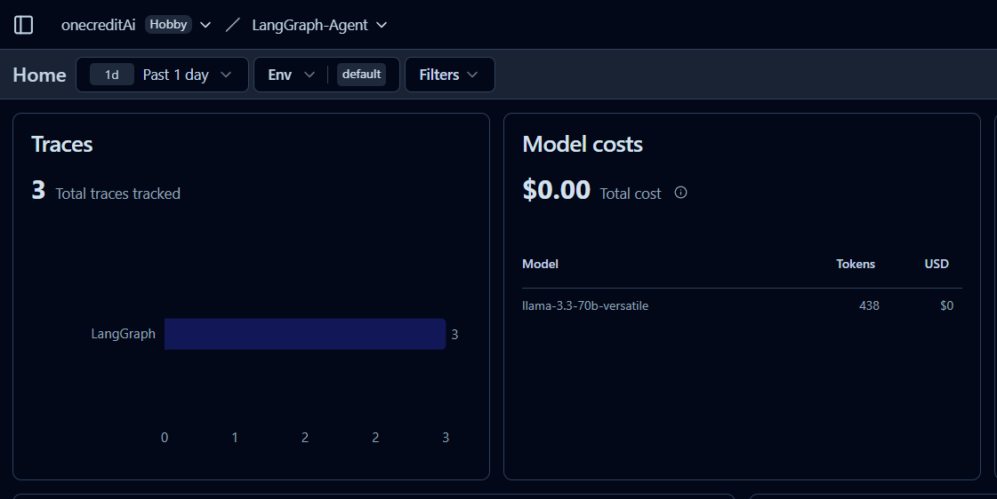
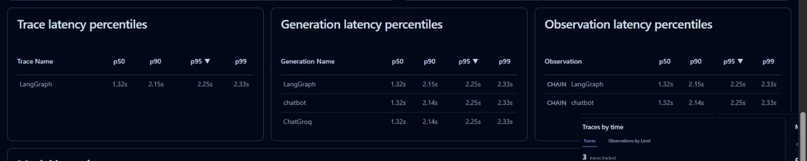

Key Features Demonstrated
This exercise demonstrates:

- LLM tracing and observability
- AI workflow monitoring
- Performance analytics
- Token usage tracking

Monitoring tools like Langfuse are important when deploying production AI systems.

