
Arsénio Ferraz - 1010137
Bruno Camarneiro - 1250422
César Vieira - 1241523
Gustavo Lima - 1221349
Rui Soares - 1221283

Preliminary Report

  - Challenge 1
Phishing Detection in Cybersecurity

Index
Contents
Index 2
Work Objectives 4
Knowledge Sources and Expert Characterization 4
Academic and Technical Sources 4
Expert Profile 5
Knowledge Acquisition Sessions 6
Session 1: Preparation and Framework Definition 6
Session 2: Expert Interview and Validation 6
Session 3: Rule Consolidation and Technical Implementation 6
Session 4: Iterative Refinement 6
Acquired Knowledge Representation 7
Phase 1: Static URL Analysis 7
Integration Framework 8
Bibliography 8
Specific Terminology 9
Challenges, Limitations and Future Perspectives 10
Technical Challenges 10
Expert-Identified Limitations 10
Technological Adequacy Assessment 10
Future Development Directions 10
Summary 11

Work Objectives
The primary objective is to develop an expert system capable of identifying malicious URLs and phishing pages through combinatorial analysis of technical indicators, external source integration, and application of symbolic reasoning and heuristic methods. The system aims to combine practical efficiency, decision explainability, and adaptation to evolving attack methodologies observed by the expert and in recent literature.
Specific objectives include:
- Model and formalize the main characteristics of phishing URLs and pages based on practical and academic knowledge
- Define a robust set of rules and techniques for automatic and explained risk assessment
- Explore the viability of integrating symbolic reasoning (Prolog, Drools) with machine learning in hybrid approaches
- Validate approaches with real examples provided by the expert and simulate complex cases (redirections, DOM behavior, homographs, shorteners)

Knowledge Sources and Expert Characterization

Academic and Technical Sources
- IEEE, arXiv, Computers & Security research papers
- ENISA, Kroll, Qualys threat landscape reports
- OpenPhish, PhishTank, VirusTotal APIs documentation
- State-of-the-art knowledge base documented in project repository

Expert Profile
David Marques – Head of Cybersecurity at Grupo Nabeiro / Delta Cafés
Professional Background:
With over 15 years of experience in advanced cybersecurity strategies, incident response, and awareness programs, the professional background involves leading multidisciplinary teams in complex enterprise environments. This experience includes designing adaptive policies and providing guidance on responding to threats such as phishing, supply chain attacks, identity management challenges, and application vulnerabilities.
Key Expertise Areas:
Key areas of expertise include real-world incident analysis and response coordination, implementing enterprise-scale phishing defense solutions, and developing risk communication strategies that prioritize thorough assessment over preventive blocking. Additionally, there is a strong focus on creating internal awareness programs, including the production of video content and interactive workshops, as well as developing cybersecurity portals and driving employee training initiatives.
Contribution to Project:
The contribution to the project included providing real attack examples and validating detection thresholds. Operational challenges and strategies for managing false positives were shared. Recommendations were made for implementing adaptive cycles for rule updates based on lessons learned from incidents. The work also emphasized the importance of identity management, supply chain security, and integrating innovation processes.

Knowledge Acquisition Sessions

Session 1: Preparation and Framework Definition
- Structured interview guide development focusing on real attack patterns
- Technical heuristics identification and operational challenge mapping
- Expert validation of proposed detection methodologies

Session 2: Expert Interview and Validation
- In-depth discussion of real-world phishing incidents and attack vectors
- Analysis of Domain Generation Algorithms (DGAs), CDN abuse, shortener manipulation
- Validation of detection rules and threshold recommendations
- Review of organizational response strategies and false positive handling

Session 3: Rule Consolidation and Technical Implementation
- Translation of expert insights into implementable Prolog and Drools rules
- Threshold calibration based on operational experience
- Integration strategies for external threat intelligence sources
Note: This session is going to be schedule with the Expert during this week.

Session 4: Iterative Refinement
- Continuous feedback integration from expert recommendations
- Rule optimization based on simulated attack scenarios
- Alignment of technical implementation with enterprise operational requirements
Note: Session that we intend to schedule in the upcoming weeks.

Acquired Knowledge Representation
The system architecture follows a two-phase approach validated by expert experience:
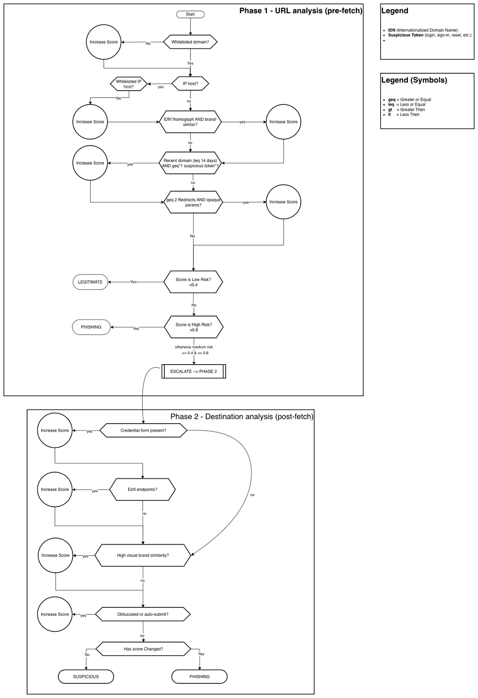
Figure 1 - Diagram

Phase 1: Static URL Analysis
Technical Implementation: Prolog-based rule engine
- Domain composition analysis (age, WHOIS, IP presence, subdomains)
- Encoding pattern detection and suspicious token identification
- Homograph and IDN abuse detection
- URL shortener chain analysis
- TLD reputation scoring

Key Rules Formalized:
```Drrols
rule "Malicious URL Detection"
when
$domain : DomainInfo(url == $url, age < 30)
$pattern : SuspiciousPattern(url == $url)
$token : CredentialToken(url == $url)
then
// Ação: marcar ou registrar URL como malicioso
System.out.println("Malicious URL detected: " + $url);
// Ou executar lógica de negócio relevante
end```

Phase 2: Dynamic DOM Analysis
Technical Implementation* Drools-based decision engine
- Rendered HTML inspection for sensitive fields
- External link ratio calculation
- JavaScript exfiltration pattern detection
- Page entropy analysis
- Visual brand impersonation detection

Scoring System:
- Risk scores: 0-49 (legitimate), 50-79 (suspicious), 80-100 (malicious)
- Weighted aggregation of multiple indicators
- Adaptive thresholds based on source context (email, QR, external link)

Integration Framework
- External API integration (VirusTotal, PhishTank, Cisco Talos)
- Dynamic whitelist/blacklist management
- Exception handling for legitimate edge cases (CDNs, corporate shorteners)

Bibliography

Academic Sources:
- Patil, D.R. & Dhage, S.N. "Framework for anti-phishing: URL feature extraction and classification"
- Aravindhan, K. et al. "Enhanced phishing detection through comprehensive URL analysis and machine learning techniques"
- Nishitha, U. et al. (2023). "Phishing Detection Using Machine Learning Techniques." IEEE Conference Proceedings
- Omolara, A.E. et al. (2025). "DaE2: Unmasking malicious URLs by leveraging diverse and efficient ensemble machine learning." Computers & Security, Vol. 147
- Rose, S. et al. (2022). "Real-time phishing detection through browser extension monitoring of DOM and network activity"
*Industry Reports:
- ENISA Threat Landscape 2024
- Kroll Q4 2024 Cyber Threat Landscape Report
- Qualys Cybersecurity Threat Landscape 2024 Midyear Review

Technical Documentation:
- OpenPhish, PhishTank, VirusTotal, Cisco Talos API documentation
- MXToolbox analysis tools documentation

Specific Terminology

Core Concepts: Phishing, Domain Generation Algorithm (DGA), Redirect Chains, Homographs, Document Object Model (DOM), Shannon Entropy, Data Exfiltration, URL Shortener, Top-Level Domain (TLD)

Technical Implementation: Prolog, Drools, Fuzzy Logic, Support Vector Machine (SVM), Random Forest, Reputation API, Blacklist/Whitelist, Adaptive Scoring

Operational Terms: Supply Chain Security, Identity Management, Incident Response, Risk Communication, Threat Intelligence, False Positive Management

Challenges, Limitations and Future Perspectives

Technical Challenges
- Sophisticated evasion techniques using legitimate infrastructure (CDNs, cloud platforms)
- High false positive rates in complex enterprise environments
- Real-time processing requirements vs. comprehensive analysis depth
- Dynamic threshold adjustment based on threat landscape evolution

Expert-Identified Limitations
- Traditional blacklist approaches insufficient for zero-day attacks
- Need for continuous rule adaptation based on incident learning
- Balance between security enforcement and user experience
- Integration challenges with existing enterprise security stacks

Technological Adequacy Assessment
The chosen symbolic reasoning approach (Prolog/Drools) proves particularly suitable for:
- Explainable decisions: Critical for enterprise security operations requiring audit trails
- Rule adaptability: Enables rapid response to new attack patterns identified by expert
- Hybrid integration: Supports combination with ML approaches for enhanced accuracy
- Performance scalability: Meets real-time processing requirements for URL analysis

Future Development Directions
- Enhanced machine learning integration for visual similarity detection
- Real-time threat intelligence feed integration
- Automated rule generation from incident analysis
- Extended supply chain and identity-based attack detection
- aplicação web com interactividade, etc

Summary

This preliminary report demonstrates the team's systematic approach to knowledge acquisition, combining rigorous academic research with practical expertise from enterprise cybersecurity operations. The expert collaboration with David Marques has been instrumental in validating theoretical approaches against real-world attack scenarios and operational constraints.

The chosen technical architecture effectively addresses the specific characteristics of phishing detection through its two-phase analysis model, while the symbolic reasoning implementation ensures both performance and explainability requirements. The continuous feedback loop with industry expertise positions the project to deliver practical value beyond academic achievement, contributing to the evolution of enterprise cybersecurity defense capabilities.

The knowledge representation framework developed captures not only technical detection mechanisms but also the operational context necessary for effective deployment in enterprise environments, reflecting the team's synthesis capability and deep understanding of the cybersecurity challenge domain.

