ST10465430
PHLOID RIKHOTSO

PROG6212
POE PART1

SECTION A
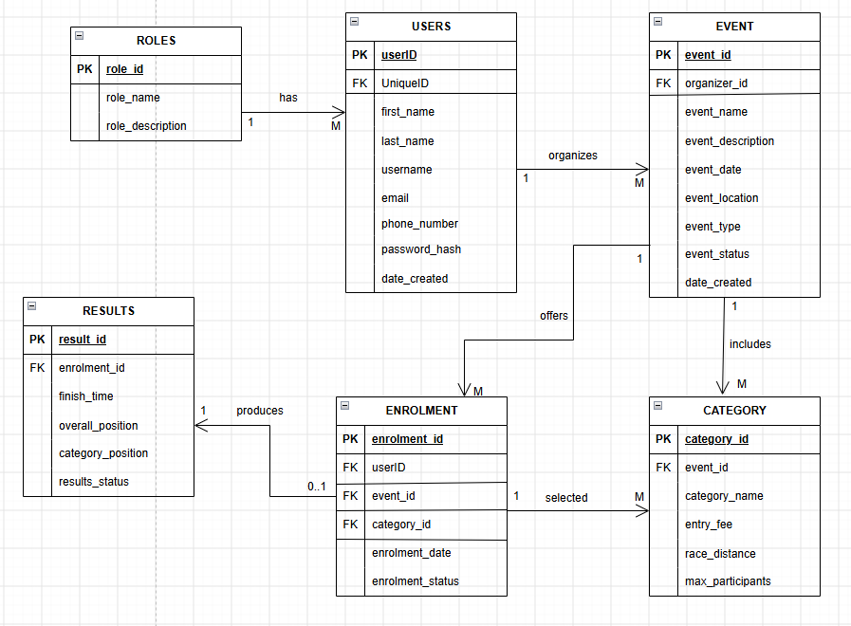

Authentication
Method  (HTTP) | Route | Description | Role required | Request body | Expected response
POST | /api/authenticator/register | Register a new user as either an organiser or participant | None | {role_name, first_name, last_name, username, email, phone_number, password} | 200 OK - returns a message: user registered successfully, role not found, or username or email already exists  (no password is returned)
POST | /api/authenticator/login | Authenticates a user with a username and password and starts a session storing their userID and role | None | {username, password} | 200 OK - returns a message: login successful (session started) or invalid username or password
POST | /api/authenticator/logout | Ends the current user’s session | Any | None | 200 OK - session cleared

Users

HTTP method | Route | Description | Role required | Request body | Expected response
GET | /api/users/me | Returns the logged in user’s own profile information | Any | none | 200 OK - user profile  401 Unauthorized - no active session
PUT | /api/users/me | Updates the logged in user’s own profile information | Any | {first_name, last_name, username, email, phone_number} | 200 OK - returns a message: profile updated successfully, or username or email already exists  400 Bad Request - validation failed  401 Unauthorized - no active session

Events

HTTP method | Route | Description | Role required | Request body | Expected response
GET | /api/events | Lists all upcoming events available on RaceDay events. | None | None | 200 OK – list of events returned
GET | /api/events/{event_id} | Returns full details for a single event | None | None | 200 OK – event details  404 Not Found – event does not exist
POST | /api/events | Creates a new event owned by the logged-in Organiser | Organizer | {event_name, event_description, event_date, event_location, distance, event_type, event_status} | 201 Created – event created  400 Bad Request – validation failed  401 Unauthorized – no active session  403 Forbidden – only an Organizer can create events
PUT | /api/events/{event_id} | Updates an event owned by the logged-in Organiser | Organizer | {event_name, event_description, event_date, event_location, distance, event_type, event_status} | 200 OK - event updated  400 Bad Request - validation failed  401 Unauthorized - no active session  403 Forbidden - not the owning Organizer  404 Not Found - event does not exist
DELETE | /api/events/{event_id} | Deletes an event owned by the logged-in Organiser | Organizer | None | 204 No Content - event deleted  401 Unauthorized - no active session  403 Forbidden - not the owning Organizer  404 Not Found - event does not exist  409 Conflict - event still has categories or enrolments

Categories

HTTP method | Route | Description | Role required | Request body | Expected respond
GET | /api/events/{event_id}/categories | Lists all categories available for a specific event | None | None | 200 OK - list of categories  404 Not Found - event does not exist
POST | /api/events/{event_id}/categories | Add a category to an event. | Organizer | {category_name, entry_fee, race_distance, max_participants} | 201 Created - category created  403 Forbidden - not the owning Organizer
PUT | /api/categories/{category_id} | Updates an existing category. | Organizer | {category_name, entry_fee, race_distance, max_participants} | 200 OK - category updated  403 Forbidden - not the owning Organizer  404 Not Found - category does not exist
DELETE | /api/categories/{category_id} | Removes a category from an event. | Organizer | none | 204 No Content - category deleted  403 Forbidden - not the owning Organizer  404 Not Found - category does not exist

Enrolments

HTTP method | Route | Description | Role required | Request body | Expected response
POST | /api/events/{event_id}/enrolments | Enrols the logged-in participants into an event under a chosen category. | Participant | {category_id} | 201 Created - enrolment recorded  400 Bad Request - invalid category for this event  409 Conflict - already enrolled
GET | /api/enrolments/me | Returns all events the logged-in participant has enrolled in. | Participant | None | 200 OK - list of the Participant's enrolments
GET | /api/events/{event_id}/enrolments | Returns all participants enrolled in a specific event, for the own organizer. | Organizer | None | 200 OK - list of enrolments  403 Forbidden - not the own Organizer
DELETE | /api/enrolments/{enrolment_id} | Cancels the logged-in participant’s own enrolment. | Participant | None | 204 No Content - enrolment cancelled  403 Forbidden - not the owning Participant  404 Not Found - enrolment does not exist

Results

HTTP method | Route | Description | Role required | Request body | Expected response
POST | /api/enrolments/{enrolment_id}/result | Captures the finish time and position for a participant’s enrolment | Organizer | {finish_time, overall_position, category_position, results_status} | 201 Created - result captured  403 Forbidden - not the own Organizer  404 Not Found - enrolment does not exist
PUT | /api/enrolments/{enrolment_id}/result | Updates a previously captured result. | Organizer | {finish_time, overall_position, category_position, results_status} | 200 OK - result updated  403 Forbidden - not the own Organizer  404 Not Found - result does not exist
GET | /api/results/me | Returns the logged-in participant’s full personal race history. | Participant | None | 200 OK - list of results across all completed events
GET | /api/events/{event_id}/results | Returns all published results for an event, for the owning organizer. | Organizer | None | 200 OK - list of results  403 Forbidden - not the own Organizer

Reference list
Connolly, T. and Begg, C. (2015) Database Systems: A Practical Approach to Design, Implementation, and Management. 6th edn. Harlow: Pearson.
Elmasri, R. and Navathe, S.B. (2016) Fundamentals of Database Systems. 7th edn. Boston: Pearson.
Microsoft (2024) CREATE TABLE (Transact-SQL). Available at: Microsoft Learn (Accessed: 4 September 2026).
Microsoft (2024) Primary and foreign key constraints. Available at: Microsoft Learn (Accessed: 4 September 2026).
Microsoft (2024) SQL Server documentation. Available at: Microsoft Learn – SQL Server (Accessed: 4 September 2026).
OpenAPI Initiative (2025) OpenAPI Specification. Available at: OpenAPI Specification (Accessed: 4 September 2026).
Satzinger, J.W., Jackson, R.B. and Burd, S.D. (2016) Systems Analysis and Design in a Changing World. 7th edn. Boston: Cengage Learning.

