Contract

# Name of the team:

Team 03 - Maaike GrassMowing

# The team members

* Keanu Tastenhoye
* Phloy Vandewyngaert
* Ruben Vandekerckhove
* Sander Louis

# Roles

* Keanu: Time manager
  + Person who makes sure everything is finished within the given time.
* Phloy: Communication manager
  + Person who communicates with third parties.
* Ruben: Quality controller
  + Person who does the last revision of the assignment.
* Sander: Group leader
  + Person who makes sure everybody does their role and motivates everybody. He also makes sure that the assignment is uploaded.

# Collaboration:

* What is good collaboration?

Good collaboration is working together in the most optimal way. We try to use our skills as efficiently as possible so that all the assignments are done as quickly as possible.

* How to collaborate?

It is also easier to help each other if the person that knows best, explains it for the others. That way there is no real leader during the making of the assignments, but someone that oversees the way we collaborate and turn in the assignment.

* What technologies to collaborate?

We use the messenger app to communicate. We use google drive to work efficiently together on the different assignments. That way, we can see who has done what and can work together in the same document at the same time.

* What to do when someone is absent

We let each other know when someone can’t be present in class. He/she will finish his/her part of the assignment before the next deadline.

Business Analysis

# The business

The following is the situation of the company as it is before we automate it.

The process of hiring a grass mower is as followed: A person is interested in hiring a grass mower. He/ she then contacts the company by phone to schedule an appointment with a representative. The representative is the person who will advise the potential client on hiring a specific type of grass mower for the client’s needs, the representative will also give extra information about the product that the potential client is interested in hiring. If the client decides to purchase a grass mower, he/ she will order one from the representative, given an advance depending on the type of grass mower. The representative then orders the specific grass mower from the supplier.

Once the grass mower has been ordered from the supplier, and it has arrived at the warehouse, the state of the grass mower is then thoroughly checked. If the mower passes the tests and everything works as it should, then the representative can deliver the grass mower to the client.

The grass mowers need to have yearly maintenance done as well. For this to be done the client will receive a letter that allows him/her to make an appointment with client service. On the day of his appointment he/she then has to visit the company with the grass mower, so that the mechanic can do the maintenance. The same process is used for reparation purposes.

All the maintenance dates, issues and repairs are noted in an overview. Because the the date of the last maintenance is recorded, all the representative needs to do is easy to send a letter to the client when the next maintenance is needed. By doing this the client doesn’t have to think about it himself.

There is no website where you can file a complaint or give some feedback about the service, so everything has to be handled by calling the client service, which can take a long time due to lack of staff.

# The stakeholders

* Investors
* The customers
* The owners
* Suppliers

# The PIECES framework

**Performance**

* Improve response time
  + E.g. when a person wants to order a grass mower, it takes at least a week before he/ she gets a response
  + Solution: A client can now use the application to subscribe to a mower

**Information (and data)**

* Inputs
  + Data is not received in time to be useful
    - Ground conditions (wet, dry, …) are received a week prior to mowing
    - Solution: the mower can communicate with the application giving live information about the weather conditions
  + Data contains errors
    - E.g. dimensions grass that needs to be mowed
    - Solution: the client can easily give in dimensions via the application
* Outputs
  + Lack of relevant information
    - E.g. whether or not client has pets that will intervene with Maaike when she is mowing the lawn
    - Solution: this kind of information can be inputted by the representative and or by the client him/ herself
* Stored data
  + Data is not well organized
    - E.g. unnecessary data from old clients are still in files
  + Data  is stored redundantly
    - E.g. client data is stored in multiple files, and in multiple locations
  + Data is not always accurate
  + Solution: the application makes it easier to store and organize data

**Economics**

* Costs
  + Costs are too high
  + Not all costs are not registered correctly
  + Some are unnecessary
  + Solution: all costs will be recorded in the app, in this manner the client and the company can easily view their costs
* Profits
  + Marketing can be improved (modernized)
    - Marketing is done in newspapers
    - Solution: marketing can be done via social media, the television, the radio, ...

**Control (and security)**

* Personal data can easily be accessed by unauthorized personnel
  + All data is stored in file cabinets
  + Solution: the application allows data to be secured

**Efficiency**

* Data must be checked (and double checked) unnecessarily
* Data is copied and printed redundantly
* Solution: all data will be kept in a server and sent via the secure network within the company

**Service**

* Service is not user-friendly
* System cannot handle change and or exceptional situations
* Solution: an application that is user friendly and easily adaptable

# The business events

The customer files a complaint;

- The client service helps the client with his problem

The mechanic receives a request of reparation;

- The warehouse manager has to order the replacement parts for the damaged grass mower

The customer asks for information;

- The client would like information about the product

The customer asks for an upgrade;

- The customer loves the product and wants the latest model

The customer places an order;

- The customer is really interested in our product and wants Maaike

The customer asks for a check-up on his/ her grass mower;

- The mechanic checks the grass mower for potential flaws

# Context diagram

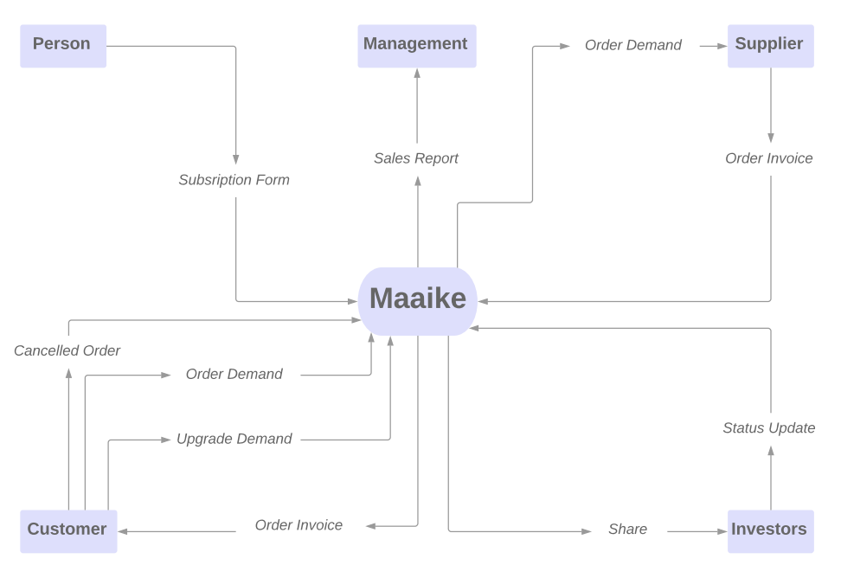

# Business use-cases

Event = Internal fault within the grass mower

--> A malfunction that needs to be looked at

Use Case = Visit the customer, explain and fix the problem.

Event = Receiving the demand for a reparation

--> Parts that ﻿may be damaged need to be changed or repaired if possible

Use Case = Visit the customer to check if the parts can be repaired. If so then make an appointment to repair them. If it can't be repaired, the machine can be replaced (if it occurs within the warranty period).

Event = Receiving the demand of information before purchase

--> The customer wants information about the product

Use Case = Establish contact with the customer and give him more information about the perks Maaike has.

Event = Receiving the demand of an upgrade

--> The customer loves the product and wants the latest model

Use Case = Give the customer all the information needed about the latest model to complete the upgrade. Perhaps with a discount.

Event = Receiving an order

--> The client is convinced and wants Maaike

Use Case = After all the paperwork is completed and the payment is received, our delivery service will deliver it to the customer.

Event = Regular annual check up

--> Just like cars, automatic lawn grass mowers need it as well

Use Case = Our system makes sure that every customer gets notified when it is their time for a check-up, they will just have to bring the machine to our warehouse were we check it immediately.

# TO-BE

**TO-BE:**

We are going to create an application for an automatic lawn mowing company, Maaike.

The application will be a digitized platform where not only customers can register their mowing specifications; area of grass that needs to be mown, preferred length that the grass should be cut, when the grass should be mown, direction grass should be mown, ... but also where Maaike as a company can improve, whereas now everything is done on paper.

If someone is interested in hiring a grass mower he/she just has to download the application, by doing this the person has become a member. A member receives newsletters from our marketing team. Once the member orders a subscription to a grass mower he/she is now a client. If the client doesn't have a grass mower already a representative will come visit the client to talk about the best type of grass mower for the client. the representative will also explain who the application works and give tips and tricks to improve how the grass mower works on the clients terrain.

The grass mowers need to have yearly maintenance, this will also be alerted through the application. Clients can also file a complaint through the application . This will be sent to the client service which will forward the complaint to the correct team.

We keep an overview of all the clients. In this overview we keep track of all their orders, maintenances, etc.

**Must- have:**

* Application
  + Runs smoothly
  + No bugs
  + User friendly
  + Compatible with a wide range of devices and operating systems
* Quick response to customer demands
* Clear communication within the company itself

**Nice-to-have:**

* The application needs to be up to date and responsive to real world changes.
* A business isn’t successful if they don’t communicate well with both the customers and external parties/partners. The response to our partners needs to be quick too.
* Different types of advertisements for a specific demographic
* The application can connect to local weather forecast and recommend the best time to let the grass mower do its job.
* The grass mower can do an analysis of the lawn, I.e. check for moss, bolt spots, diseases in the grass. This data is send to the application , where it can give some advice on which products can be used to get rid of it.

Requirements Analysis

# The scope of this project

* **Person**
  + - A person should be able to register himself/herself in the app and become a member. The member needs to give some personal info (age, name, surname,...) to register successfully. The app is available on every (mobile) platform.
* **Member**
  + - A member can read our newsletter. Also, they can start the renting process of a lawnmower. At that moment the member becomes a client. The member can make an appointment with a representative so they can finalize the process.
* **Client**
  + - The client can make an appointment with the client service for maintenance and other issues regarding the lawnmowers. If there are other problems, they can let us know through the app or call the client service.
* **Representative**
  + - Visits the client to persuade him/her into making an order
    - Delivering the mower to the customer alongside with some information on how to use it.
* **Marketing**
  + - People that are responsible for the advertisements and market research, sending newsletters.
    - Asks the client for feedback on the service after the order and delivery process is completed.
* **Client service**
  + - The client service team will make sure that every call/email from our customers will be answered. They will stay in contact with the managers, warehouse team, mechanics and representatives (depending on the customers’ question). If the questions can’t be answered, they make sure the customer will be forwarded to the right department.
    - They will make sure that all the appointments are made.
* **Mechanics**
  + After the customer has made an appointment with the client service and has explained the problem to them, the client service will notify the mechanic so he can prepare himself.
  + If the lawnmower is damaged beyond repair, they will replace it with a new model. They will have access to the clients’ information, the lawnmower and will stay in communication with the managers and the warehouse team.
* **Warehouse Manager**
  + Makes a list of all the parts and mowers that are needed.
  + At the end of the week it gets ordered from the supplier.
* **Supplier**
  + Is in direct contact with the warehouse manager.
  + The supplier delivers the items to the warehouse after he receives the order demand from the warehouse manager.
* **Manager**
  + The manager can keep track of the overviews at any given time.
  + He can adjust them to the current situation as well.

# 

# 

# 

# 

# 

# The functionalities

* **Person**
  + Becomes a member.
* **Member**
  + Becomes a client.
* **Client**
  + Makes an appointment with client service.
  + Orders / rents a mower.
* **Representative**
  + Makes an appointment with a possible client.
  + Delivers the mowers to the customer.
  + Explains the app and completes the mower setup.
  + Reports to the management for the sales overview.
* **Marketing**
  + Makes advertisements.
  + Sends newsletters to members.
  + Asks for feedback.
* **Client service**
  + Forwarding client reviews to the specific department.
  + Responds to a client request.
  + Making client appointments.
* **Mechanics**
  + Reparation / replacement of a lawnmower.
* **Warehouse Manager**
  + Controls the incoming and outgoing traffic of the warehouse and makes sure it runs smoothly.
  + Orders the parts and mowers that are needed.
* **Supplier**
  + Delivery of parts for reparations and complete mowers to fill our stock.
* **Manager**
  + Checks and updates the overviews.

# The actors

* Person
* Member
* Client
* Representative
* Marketing
* Client service
* Mechanics
* Manager

# The use-case diagram

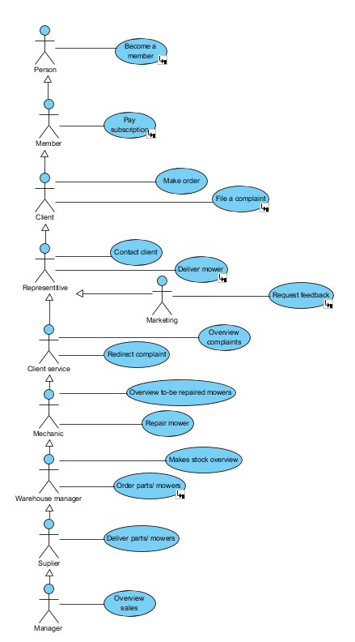

# Use-case descriptions

|  |  |
| --- | --- |
| Name | Become a member |
| Summary | Person wants to become member |
| Actors | Person |
| Precondition | None |
| Scenario | Person downloads app, enters personal data and becomes a member |
| Exceptions | Person can only become a member once, an error message will be shown if member already exists |
| Post Condition | Person is now a member |

|  |  |
| --- | --- |
| Name | Pay subscription |
| Summary | Member pays subscription |
| Actors | Member |
| Precondition | None |
| Scenario | Member decides to order a mower. After being in contact with the representative he becomes a client by paying the subscription (rent) for the mower he has ordered. |
| Exceptions | None |
| Post Condition | Member is now a client |

|  |  |
| --- | --- |
| Name | Make order |
| Summary | Client makes an order |
| Actors | Client, Representative |
| Precondition | None |
| Scenario | Client makes appointment with representative to order mower |
| Exceptions | Mower has to be in stock |
| Post Condition | Client has ordered a mower |

|  |  |
| --- | --- |
| Name | File a complaint |
| Summary | If necessary client can file a complaint |
| Actors | Client |
| Precondition | None |
| Scenario | * When an error occurs in the mower’s system, a certain part is damaged or there is a problem with the application * The client will contact the Client Service to file a   complaint   * This complaint will be redirected by the client   service and they will make sure this problem will be solved ASAP |
| Exceptions | None |
| Post Condition | Client has filed complaint and is being handled by the appropriate people |

|  |  |
| --- | --- |
| Name | Contact client |
| Summary | Representative contacts the client |
| Actors | Representative, client |
| Precondition | Client has to have made an order |
| Scenario | The representative makes an appointment  with the client for the delivery process |
| Exceptions | None |
| Post Condition | Client has a delivery date and an ETA on the delivery of the mower |

|  |  |
| --- | --- |
| Name | Deliver mower |
| Summary | Representative delivers mower to client |
| Actors | Representative |
| Precondition | Delivery appointment has to have been made with client |
| Scenario | The delivery process is being completed by the  representative |
| Exceptions | None |
| Post Condition | Client has new mower |

|  |  |
| --- | --- |
| Name | Request feedback |
| Summary | Marketing requests feedback from clients |
| Actors | Marketing, client |
| Precondition | None |
| Scenario | Every client that has recently placed an order will automatically receive an email/“rate me” from the Marketing department in order to get feedback on the app and the mowers. |
| Exceptions | None |
| Post Condition | Feedback is going to be given by the client |

|  |  |
| --- | --- |
| Name | Overview complaints |
| Summary | Client service makes overview |
| Actors | Client service |
| Precondition | At least 1 complaint has to have been filed |
| Scenario | Each filed complaint is added to this overview |
| Exceptions | None |
| Post Condition | Overview is made |

|  |  |
| --- | --- |
| Name | Redirect complaint |
| Summary | Client service redirects complaint to necessary  team |
| Actors | Client service, client |
| Precondition | None |
| Scenario | * First they add the complaint to the overview of all the complaints * Afterwards the Client service redirects the complaint to the mechanics so they can handle the problem |
| Exceptions | None |
| Post Condition | Complaint is going to be handled by the appropriate  people |

|  |  |
| --- | --- |
| Name | Overview TO-BE repaired mowers |
| Summary | Mechanic makes overview |
| Actors | Mechanic |
| Precondition | None |
| Scenario | Mechanic makes overview of the TO-BE repaired mowers |
| Exceptions | None |
| Post Condition | Overview is made |

|  |  |
| --- | --- |
| Name | Repair mower |
| Summary | Mechanics repair mowers |
| Actors | Mechanic, warehouse manager |
| Precondition | None |
| Scenario | * The mechanic receives note from the Client service that a client has called them about a possible reparation * Mower is added to the TO-BE repaired overview * An appointment is made with the client * If possible, the mechanic fixes the mower * If new parts are needed they will be ordered by the warehouse manager |
| Exceptions | When the mower is unable to be fixed. The client can order a new one |
| Post Condition | Mower is fixed |

|  |  |
| --- | --- |
| Name | Make stock overview |
| Summary | Warehouse manager makes overview |
| Actors | Warehouse manager |
| Precondition | None |
| Scenario | Warehouse manager makes overview of all the items that are left in the warehouse |
| Exceptions | None |
| Post Condition | Warehouse manager has made an overview |

|  |  |
| --- | --- |
| Name | Order parts and or mowers |
| Summary | Warehouse manager orders parts and or mowers |
| Actors | Warehouse Manager |
| Precondition | None |
| Scenario | After the stock overview is checked. The warehouse manager orders new mower parts and or mowers that have been requested by the mechanics. The order is made at the end of the week. |
| Exceptions | None |
| Post Condition | Parts and or mowers have been ordered |

|  |  |
| --- | --- |
| Name | Deliver parts / mowers |
| Summary | New parts and or mowers are delivered to the  warehouse |
| Actors | Warehouse manager |
| Precondition | Warehouse manager has to have made an order |
| Scenario | After the warehouse manager has checked the order, the supplier delivers the parts and or machines to the warehouse. |
| Exceptions | When incorrect parts and or mowers are delivered they will be returned to the supplier. This happens through the warehouse manager. He will notify the supplier of this problem. |
| Post Condition | Parts and or mowers have been ordered |

|  |  |
| --- | --- |
| Name | Overview sales |
| Summary | Manager makes an overview of the sales |
| Actors | Manager |
| Precondition | None |
| Scenario | Manager creates sales report with all the available information |
| Exceptions | None |
| Post Condition | Sales overview has been made |

Business Model

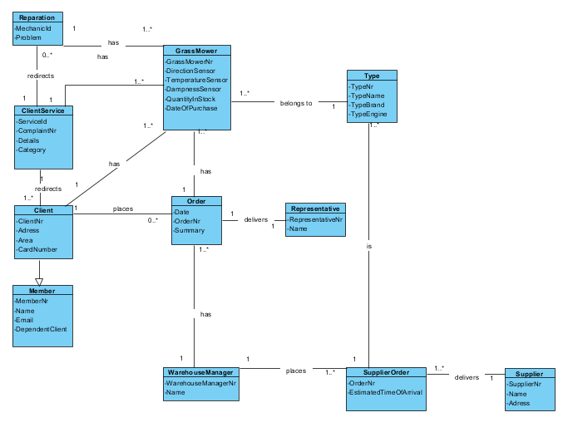1. The class diagram

2.   The model dictionary

**Member:**

When someone becomes a member, they are subscribed to the newsletter.

**Client:**

Before someone can order a mower, they have to become a member.

When they are a member they are automatically subscribed to the newsletter.

As soon as they place an order they become a client.

A client has the options to order a new mower, ask for an upgrade, ask for

a reparation and file a complaint (give feedback). When the client has a

question, a complaint, wants to make an appointment or wants to give some

feedback on the service he/she has to call the ClientService.

**ClientService:**

When a customer wants to file a complaint or give some feedback it is the Client service department that takes care of it. They make sure the customer doesn’t have any discomforts. When they receive a complaint they will help the customer so he will be satisfied with the product and our company.

**Order:**

Every order is made and delivered by the representative and passed on to the warehouse manager.

**Reparation:**

The reparation is done by a mechanic. An appointment is made by the customer in communication with the Client service. During the process of making an appointment the customer will describe the problem so the mechanic can prepare for the reparation.

**GrassMower:**

A grass mower has to go through a yearly maintenance every year. So that it’s

features are all working perfectly. If damaged, it can be repaired by the mechanic. It is possible that it can’t be repaired, when this happens the warehouse manager can order a new mower.

**Type:**

The customer can choose between a few types of grass mowers. The representative will help the customer choose the best type that fits his/her needs. The warehouse manager orders different types of mowers not the parts itself.

**Representative:**

When a member is thinking about hiring a mower the representative will try to convince and advise him. If the member (and potential client) has decided to hire a mower, the representative will order it for him and make sure the mower is in perfect state and is correctly configured upon delivery.

**Warehouse Manager:**

When an order is made the warehouse manager will check if we have it in stock. If not it will be added on the list of parts/mowers that have to be ordered at the end of the week.

**Supplier:**

At the end of the week the warehouse manager will order the needed parts/mowers from our supplier.

**SupplierOrder**:

This is the order that the warehouse manager made from the supplier.

Dynamic layer

1.   State diagram: Grassmower

# https://lh3.googleusercontent.com/KYGWIa-dePKhbUFiIPJVbBsAwKz9q42WBhDM3sTfqUavMRnuYFs6yDqKyXnx96-ZkxNDjS5rdO-UwPtwcxx8F0BHf5Pmti5Mv1h1gySaNtylwNZHmEsK4JLRJEuD9Q6wBqYegrkl

2.   State diagram: Member

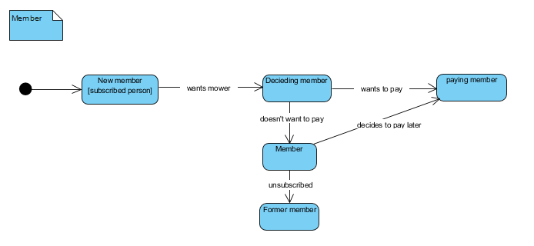

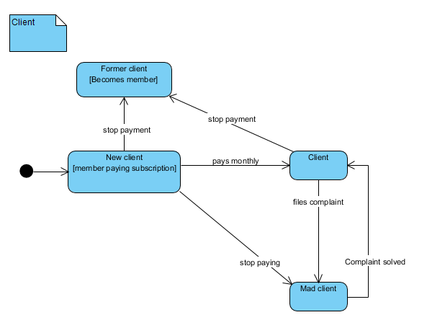3.   State diagram: Client

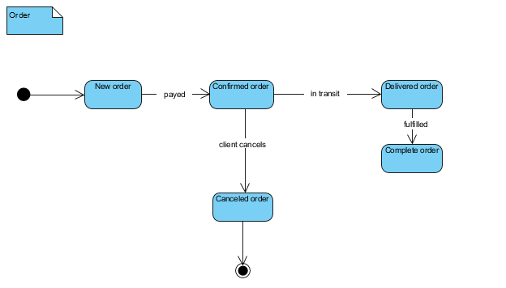4.  State diagram: Order

5.  State diagram: Supply order

# https://lh6.googleusercontent.com/8nmrTMZ4BiQTFvEjUFZ5GYgqFLdR1o1cYNI7Dyv0TyNXhOLLCz_h8RTVomExv1k-JJc1CjTUza8dvXaVUTqjv7BAESt6a5f0V9ppeQyO0FK0Tfh9JkQ-4stO3BJ_sk3UOUPe743a

* + - 1. 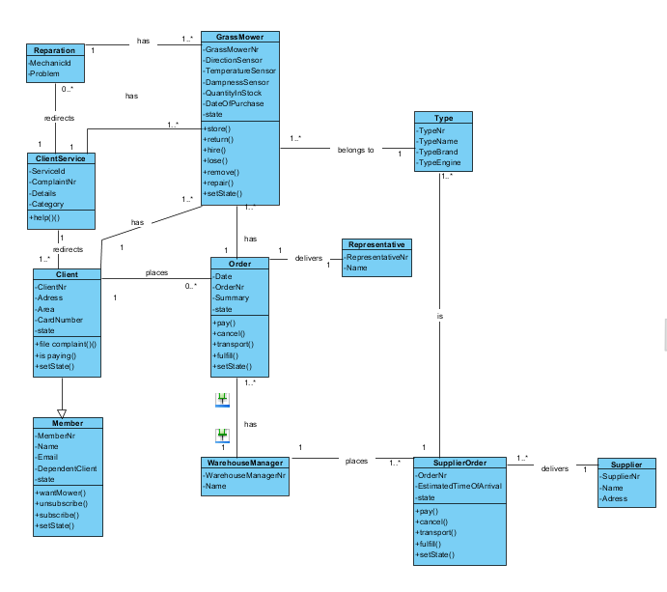The class diagram V2

7. Activity diagram: add new grass mower

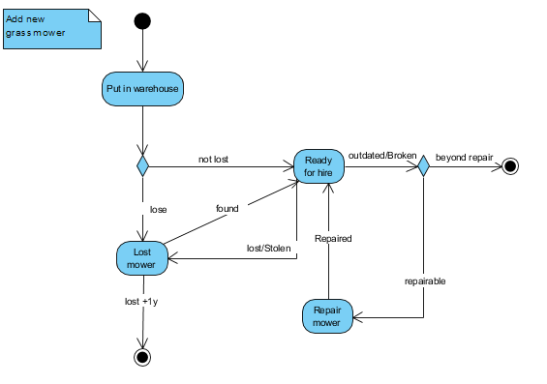

8. Activity diagram: add new member

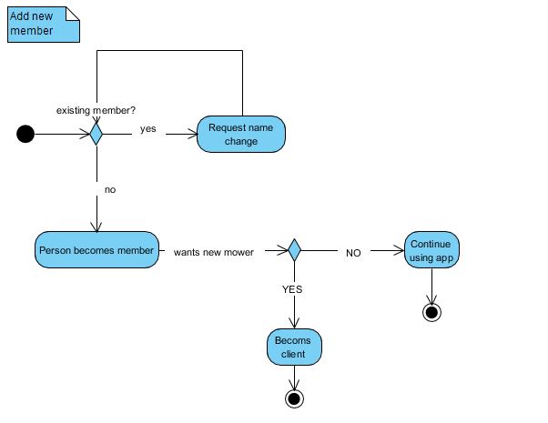

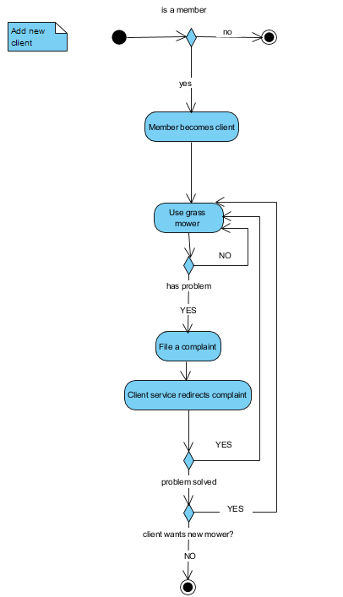9.  Activity diagram: add new client

10. Activity diagram: Order

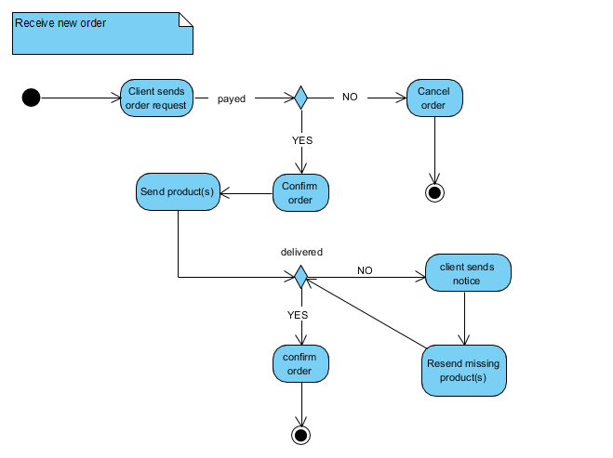

11. Activity diagram: Supply order

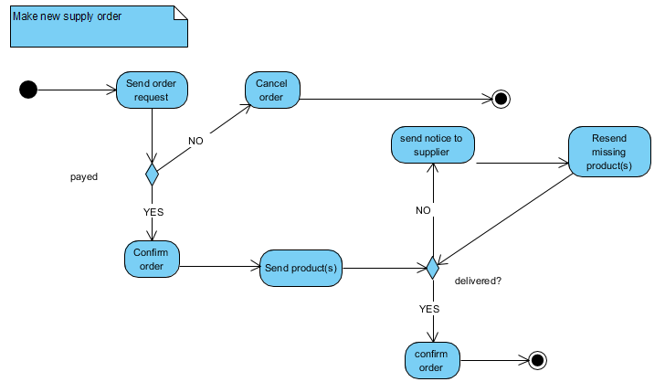

Application layer

# Sequence diagram: Person becomes member

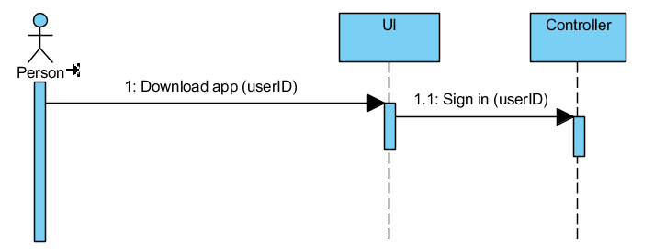

# Sequence diagram: Member pays subscription

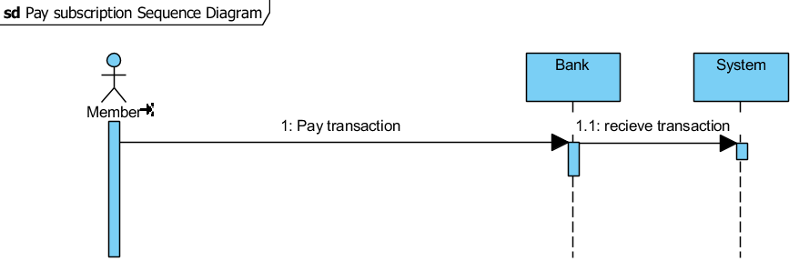

# Sequence diagram: Client files complaint

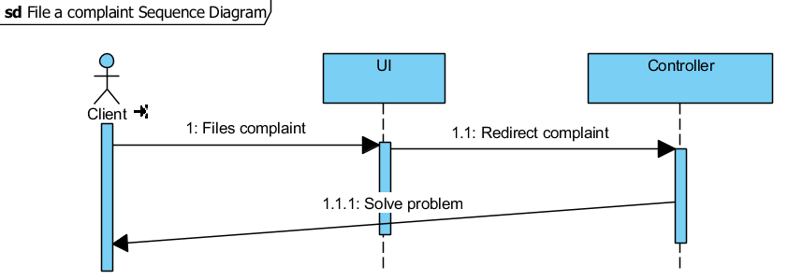

# Sequence diagram: Deliver mower

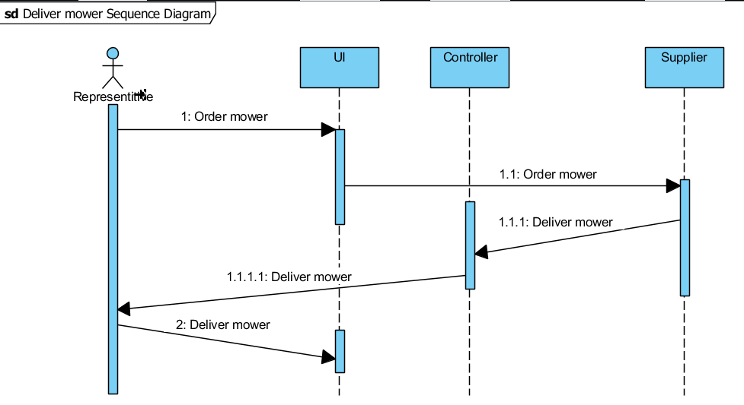

# Sequence diagram: Request feedback

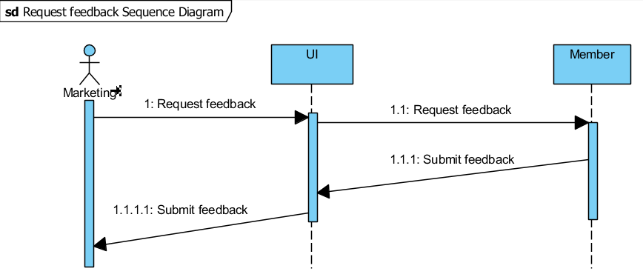

# Sequence diagram: Order parts/mowers

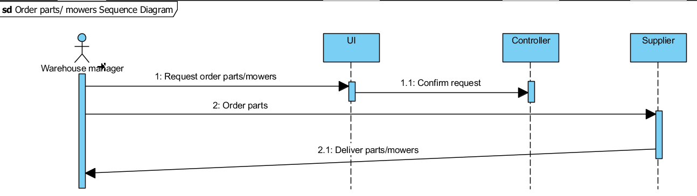

# Collaboration diagram: Become member

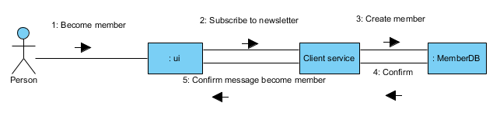

# Collaboration diagram: Make order

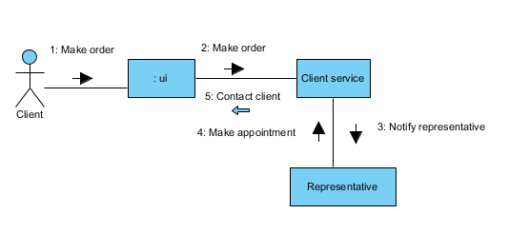

# Collaboration diagram: File complaint

10. Collaboration diagram: Request feedback

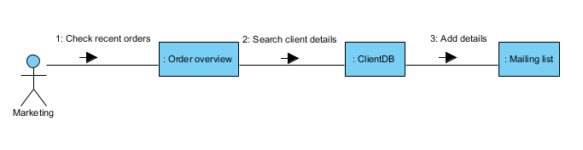

1. Collaboration Diagram: Parts of different use cases (Pay subscription, Order mower, Deliver mower/parts, Request feedback)

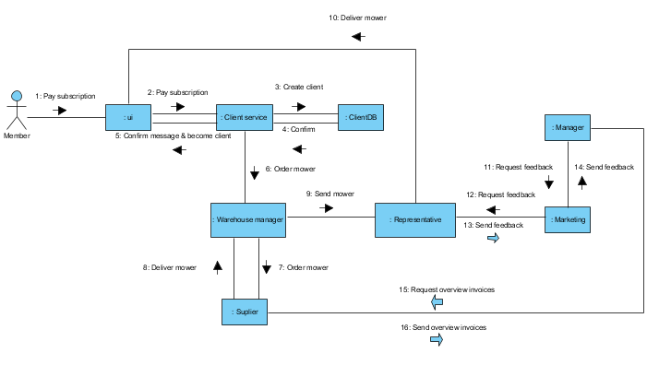

# The class diagram for application layer

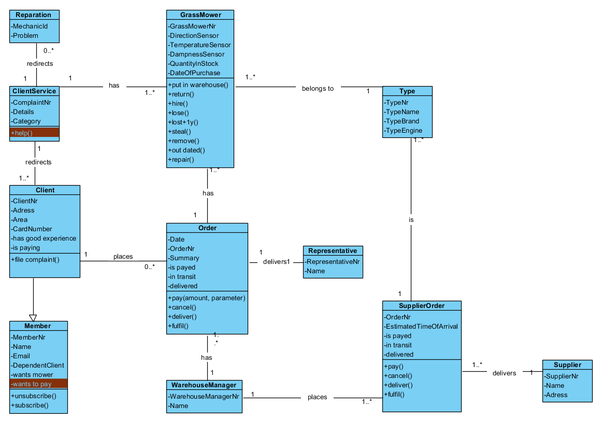

# The model dictionary for application layer

**Person:**

They can become a member.

**Member:**

When someone becomes a member, they are subscribed to the newsletter. A member can request to become a client if they pay a subscription.

**Client:**

Before someone can order a mower, they have to become a member.

When they are a member they are automatically subscribed to the newsletter.

As soon as they place an order and pay a monthly subscription they become a

client. A client has the options to order a new mower or extra mower, and file a

complaint (give feedback). When they give feedback it can either mean that

the client service has to contact the mechanic for a reparation or they have a

question and the client service solves it.

**ClientService:**

When a customer wants to file a complaint (give feedback), the Client service department that takes care of it. They make sure the customer doesn’t have any discomforts. When the client gives feedback it can either mean that the client service has to contact the mechanic for a reparation or they have a question and the client service tries solves it as good as possible.

They also make sure that, when a client orders a mower, the mower is send to

The representative.

**Order:**

Every order is made and delivered by the representative and passed on to the warehouse manager.

**Reparation (mechanic):**

The reparation is done by a mechanic. An appointment is made by the customer in communication with the Client service. During the process of making an appointment the customer will describe the problem so the mechanic can prepare for the reparation. If the mechanic needs any parts he contacts the warehouse manager to have those parts delivered.

**GrassMower:**

A grass mower has to go through a yearly maintenance every year. So that it’s

features are all working perfectly. If damaged, it can be repaired by the

mechanic. It is possible that it can’t be repaired, when this happens the

warehouse manager can order a new mower.

**Type:**

The customer can choose between a few types of grass mowers. The representative

will help the customer choose the best type that fits his/her needs. The warehouse manager orders different types of mowers not the parts itself.

**Representative:**

When a member is thinking about hiring a mower the representative will try to convince and advise him. If the member (and potential client) has decided to hire a mower, the representative contacts the client service and they will order it. The representative also makes sure the mower is in perfect state and is correctly configured, afterwards he delivers it.

**Warehouse Manager:**

When an order is made the warehouse manager will check if we have it in stock. If not it will be added on the list of mowers that have to be ordered at the end of the week. When the mechanic request certain parts, the warehouse manager checks if they are in stock. Otherwise he will order them with the supplier.

**Supplier:**

At the end of the week the warehouse manager will order the needed parts/mowers from our supplier. The supplier will make sure that the parts and mowers are delivered correctly as requested. If not he has to deliver them the day after. When the manager asks for an overview of the invoices the supplier will send those to the manager.

**SupplierOrder**:

This is the order that the warehouse manager made from the supplier.

**Marketing**

The marketing division is responsible for all the advertisements in the company. They also request feedback from the representative to know which target group they should focus their product on. They also get a overview of the sales and send those to the manager.

**Manager**

The manager supervises the company, he requests overviews of sales from the marketing division and he receives invoices from the supplier. The manager makes final decisions that determine the future of the company.