# Project Exam 1

Phillip Mikalsen

Word count: 597

## Design

### **What went well on the project**

My design is more or less very simple, but I like the simplicity so users can easily navigate them self throughout the page.

I used a minimal of colours, but tried to use the few I had over more concepts so it makes the user feel they stay on the same page, must add that I enjoy the colour combinations.

I found the images I wanted rather early, and made them ready for the web.

### **What was difficult/didn’t go well on the project**

I tried making multiple logos, and everytime I put it into the page it just wasn’t a fit for my blog page, so I went back into photoshop to make another try at it. I am more or less happy about the result I ended up with, except I should probably have made it better in illustrator so I could have vector graphics.

### **What would you do differently next time**

I would make my logo in illustrator instead of Photoshop, I would plan my image use better so I don’t end up having some pictures with really low quality and some with really high quality.

I would try and make more use of the space for web resolutions. I see after I am done that I could fit more into it without clustering the entire page.

## Technical

### **What went well on the project**

Some of the Javascript went really well, and I didn’t have any brainclusters and I am happy with what I came up with.

Loading the API’s was easier than expected after using custom posts, learning new plugins from Wordpress was not something I foresaw that I had to do, but it worked out great, even better than the normal fetching.

I have also managed to understand loops better during the project, and how to catch more than one result from the loop.

### **What was difficult/didn’t go well on the project**

Carousel didn’t work out exactly as intended, and as this was something I was starting out with, I have more than one loop to put the correct info into the correct slide. So I have a upgrade potential on how to make carousels and how to fit the info. I also misread the intro text, so I tried soo hard to make it be 12 posts with 4 in each slide. I think it could have been better if I was doing only 1 post per slide. But the time spent made it look decent though, so I’m happy enough for now.

### **What would you do differently next time**

Read the intro text even better. So I don’t misread what the requirements are. I have to plan better. I’m rather busy during the day, so my mornings/nights is my shining hours to make things go through. But living like that is hard in the long run, so for further projects I am gonna plan better.

I also managed to make my own Github project for this, so I had to clone the classroom and copy my files in.

## WCAG guidelines, content management and SEO

### **What went well on the project**

Following the WCAG seems alright, making pictures to less than 200kb/s can be a hazzle depending on how the size of the image is.

### **What was difficult/didn’t go well on the project**

Thought my image was the issue with my carousel slider, but I noticed not all pictures wants to stick to the same frame because of a div being a flex. So it tries to make the last picture abit bigger.

Making the keywords for the “meta” tag.

### **What would you do differently next time**

Go further in how to be a user, instead of just a developer. See what they might see.

## References

(place references to websites, books, forums etc. that helped you in the project)

* Youtube – Kevin Powell (My favourite to watch for CSS / JS)  
  Kevin had a video on how to make a carousel
* Google – Carousels, modal searches.
* Codepen – Looked over a Modal image.
* Wallpaperpass.com – for images. (Many wallpapers are free to use)

Added my prototype in the next pages.

Blog page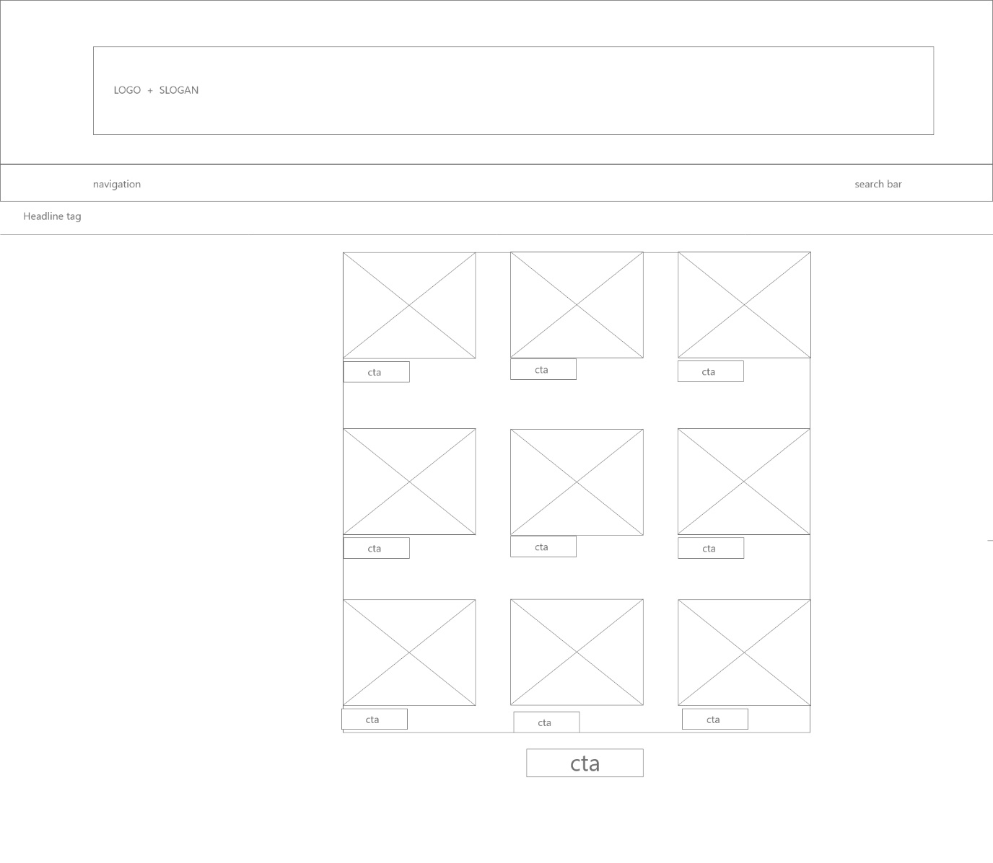

Blog specific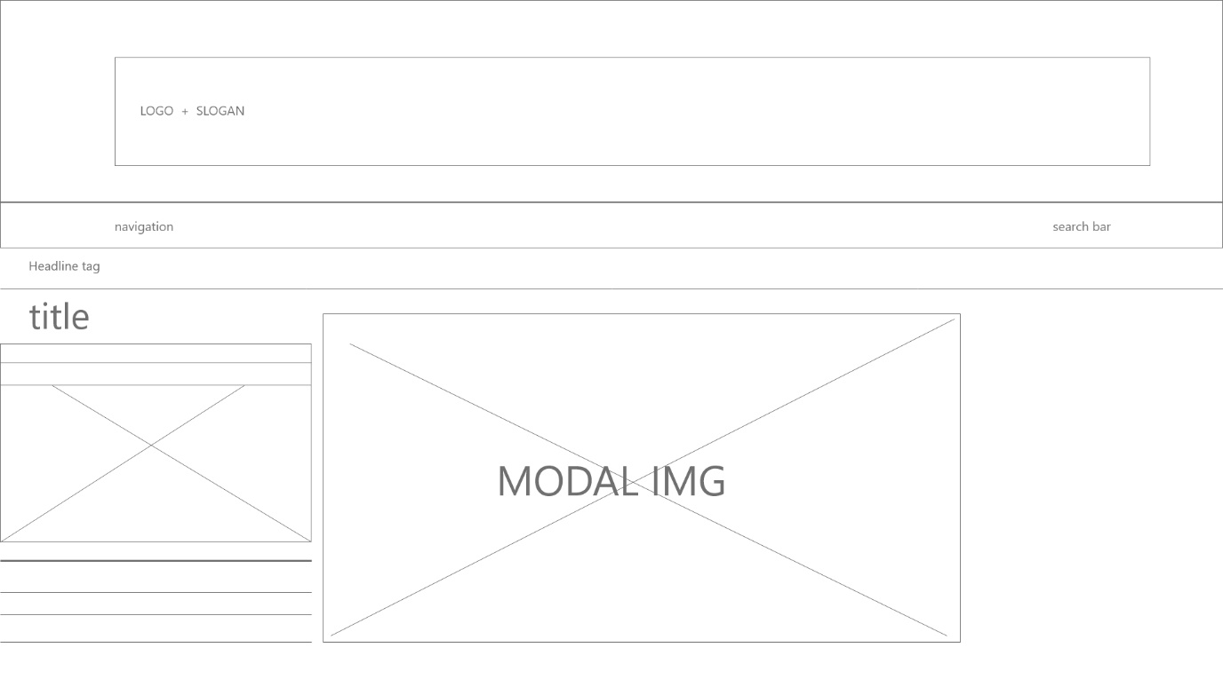

Contact page

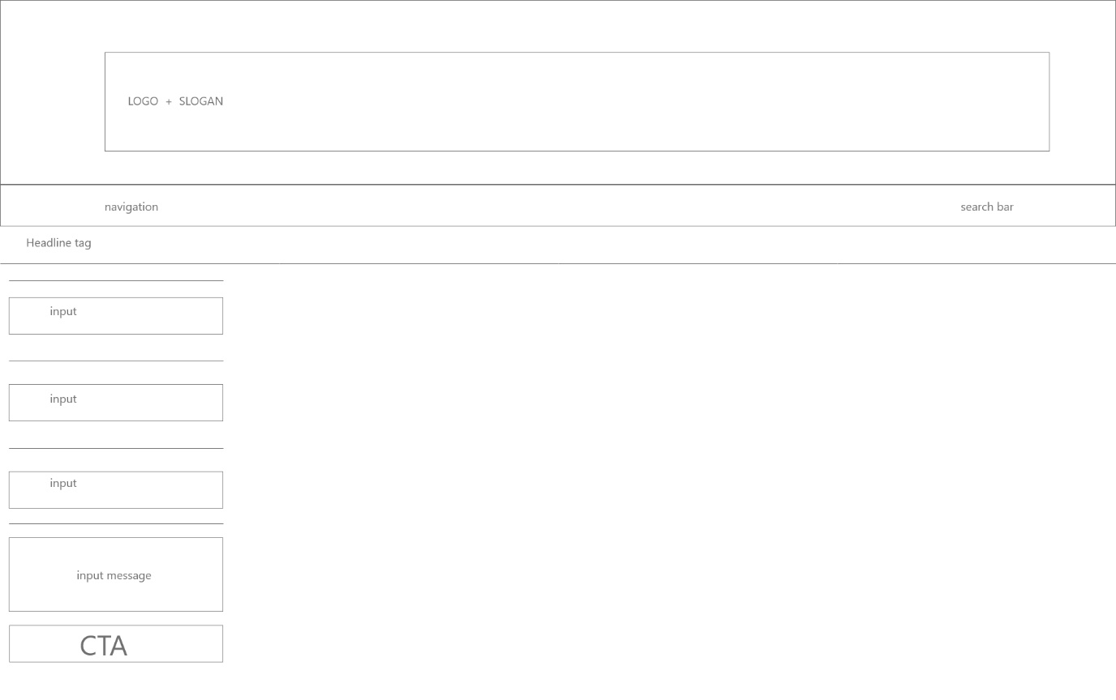

Home page

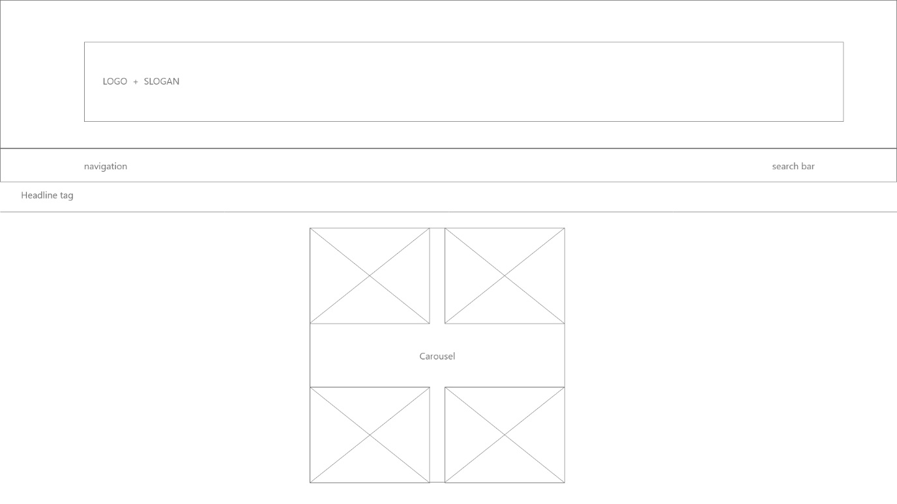

About page

