

ARTIFICIAL INTELLIGENCE LAB

**(Subject Code: (18CSC305J)**

B.TECH III Year / VI Semester

**NAME-** 

**REG. No.-RA**

## DEPARTMENT OF COMPUTER SCIENCE ENGINEERING FACULTY OF ENGINEERING & TECHNOLOGY

SRM INSTITUTE OF SCIENCE TECHNOLOGY,

Delhi NCR CAMPUS, MODINAGAR

SIKRI KALAN, DELHI MEERUT ROAD, DIST. – GHAZIABAD - 201204

[**www.srmup.**](http://www.srmup./)**in**



**Even Semester (Jan-June 2022)**

**BONAFIDE CERTIFICATE**

## Registration No.RA

*Certified to be the bonafide record of work done by*

*Of 6th semester 3rd year B.TECH degree course in SRM INSTITUTE OF SCIENCE & TECHNOLOGY, DELHI-NCR Campus for the Department of* ***Computer Science &Engineering,*** *in Artificial Intelligence Laboratory during the academic year* ***2021-22.***

**Lab In charge Head of the department**

*Submitted for end semester examination held on / / at SRM INSTITUTE OF SCIENCE & TECHNOLOGY, DELHI-NCR Campus.*

***Internal Examiner-I Internal Examiner-II***

## INDEX

| Exp. No. | Title of Experiment | Page No. | Date of Experiment | Date of Completion of  Experiment | Teacher’s Signature |
| --- | --- | --- | --- | --- | --- |
| **1** | Implementation of Toy problem  Example-Implement water jug problem | 4-5 |  |  |  |
| **2** | Developing Agent Program for Real World Problem. | 6-7 |  |  |  |
| **3** | Implementation of Constraint satisfaction problem, Example: Implement N- queen Problem | 8-9 |  |  |  |
| **4** | To Implementation and Analysis of BFS and DFS for Application. | 10-11 |  |  |  |
| **5** | To implement Best first search and A*  algorithm. | 12-19 |  |  |  |
| **6** | To implement Minimax Algorithm. | 20-21 |  |  |  |
| **7** | Implementation of unification and resolution  for real world problems. | 22-24 |  |  |  |
| **8** | Implementation of knowledge representation  schemes – use cases. | 25-28 |  |  |  |
| **9** | Implementation of uncertain methods for an  application. | 29-30 |  |  |  |
| **10** | Implementation of block world problem. | 31-32 |  |  |  |
| **11** | Implementation Of learning algorithm | 33-35 |  |  |  |
| **12** | Development of ensemble model | 36-37 |  |  |  |
| **13** | Implementation of NLP Program | 38 |  |  |  |
| **14** | Deep learning Project in Python | 39-42 |  |  |  |

**Experiment 1**

* **Aim –**Implementation of Toy problem Example-Implement water jug problem.
* **Algorithm –**

| **Rule** | **State** | **Process** |
| --- | --- | --- |
| **1** | (X,Y | X<4) | (4,Y)  {Fill 4-gallon jug} |
| **2** | (X,Y |Y<3) | (X,3)  {Fill 3-gallon jug} |
| **3** | (X,Y |X>0) | (0,Y)  {Empty 4-gallon jug} |
| **4** | (X,Y | Y>0) | (X,0)  {Empty 3-gallon jug} |
| **5** | (X,Y | X+Y>=4 ^ Y>0) | (4,Y-(4-X))  {Pour water from 3-gallon jug into 4-gallon jug until 4-gallon jug is full} |
| **6** | (X,Y | X+Y>=3  ^X>0) | (X-(3-Y),3)  {Pour water from 4-gallon jug into 3-gallon jug until 3-gallon jug is full} |
| **7** | (X,Y | X+Y<=4  ^Y>0) | (X+Y,0)  {Pour all water from 3-gallon jug into 4-gallon jug} |
| **8** | (X,Y | X+Y <=3^ X>0) | (0,X+Y)  {Pour all water from 4-gallon jug into 3-gallon jug} |
| **9** | (0,2) | (2,0)  {Pour 2 gallon water from 3 gallon jug into 4 gallon jug} |

* **Code –**

print("Water jug problem") x=int(input("Enter X : "))

y=int(input("Enter Y : ")) while True:

rn=int(input("Enter the rule no. : ")) if rn==2:

if y<3:

x=0y=3 if rn==3: if x>0:

x=0 y=3

if rn==5:

if x+y>4: x=4

y=y-(4-x) if rn==7:

if x+y<4: x=x+y y=0

if rn==9: x=2 y=0

print("X=",x)

print("Y=",y) if x==2:

print("The result is a goal state") break

### Result –

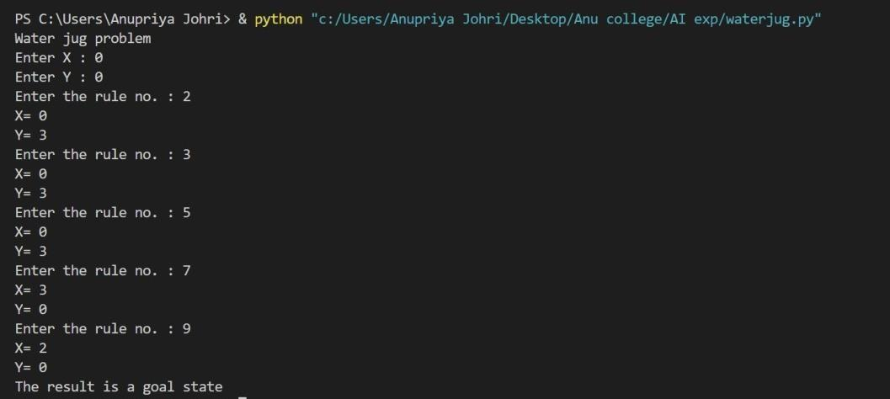



**Experiment 2**

* **Aim –**Developing Agent Program for Real World Problem.

### Algorithm –

* **Code –**

import random

class Environment(object): definit(self):

self.locationCondition = {'A': '0', 'B': '0'} self.locationCondition['A'] = random.randint(0, 1) self.locationCondition['B'] = random.randint(0, 1)

class SimpleReflexVacuumAgent(Environment): definit(self, Environment):

print (Environment.locationCondition)

Score = 0

vacuumLocation = random.randint(0, 1) if vacuumLocation == 0:

print ("Vacuum is randomly placed at Location A") if Environment.locationCondition['A'] == 1:

print ("Location A is Dirty. ") Environment.locationCondition['A'] = 0;

Score += 1

print ("Location A has been Cleaned. :D") if Environment.locationCondition['B'] == 1:

print ("Location B is Dirty.") print ("Moving to Location B...") Score -= 1

Environment.locationCondition['B'] = 0;

Score += 1

print ("Location B has been Cleaned :D.")

else:

if Environment.locationCondition['B'] == 1: print ("Location B is Dirty.")

Score -= 1

print ("Moving to Location B...") Environment.locationCondition['B'] = 0;

Score += 1

print ("Location B has been Cleaned. :D") elifvacuumLocation == 1:

print ("Vacuum is randomly placed at Location B. ") if Environment.locationCondition['B'] == 1:

print ("Location B is Dirty") Environment.locationCondition['B'] = 0;

Score += 1

print ("Location B has been Cleaned")

if Environment.locationCondition['A'] == 1: print ("Location A is Dirty")

Score -= 1

print ("Moving to Location A") Environment.locationCondition['A'] = 0;

Score += 1

print ("Location A has been Cleaned")

else:

if Environment.locationCondition['A'] == 1: print ("Location A is Dirty")

print ("Moving to Location A") Score -= 1

Environment.locationCondition['A'] = 0;

Score += 1

print ("Location A has been Cleaned") print (Environment.locationCondition)

print ("Performance Measurement: " + str(Score)) theEnvironment = Environment()

theVacuum = SimpleReflexVacuumAgent(theEnvironment)

### Result –

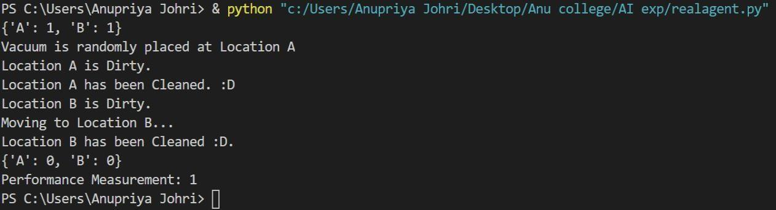



**Experiment 3**

* **Aim –**Implementation of Constraint satisfaction problem Example: Implement N- queen Problem

### Algorithm –

while there are untried configurations

{

generate the next configuration

if queens don't attack in this configuration then

{

print this configuration;

}

}

### Code –

global N

N=int(input("enter no of queens : ")) def printSolution(board):

for i in range(N): for j in range(N):

print(board[i][j],end=" ") print(" ")

def isSafe(board,row,col): for i in range(col):

if board[row][i]=='Q': return False

for i,j in zip(range(row,-1,-1), range(col,-1,-1)): if board[i][j]=='Q':

return False

for i,j in zip(range(row,N,1), range(col,-1,-1)): if board[i][j]=='Q':

return False return True

def solveNQUtil(board,col): if col>=N:

return True

for i in range(N):

if isSafe(board,i,col): board[i][col]='Q'

if solveNQUtil(board,col+1) == True: return True

board[i][col]=0

return False

def solveNQ():

board = [[0 for i in range(N)] for j in range(N)]

if solveNQUtil(board,0)==False: print("Solution does not exist") return False

printSolution(board) return True

solveNQ()

### Result –

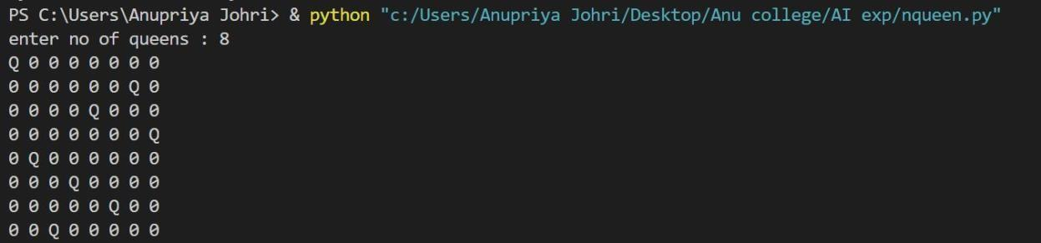



**Experiment 4**

* **Aim –**To Implementation and Analysis of BFS and DFS for Application.

### Algorithm –

1. Create a node list (Queue) that initially contains the first node N and mark it as visited.
2. Visit the adjacent unvisited vertex of N and insert it in a queue.
3. If there are no remaining adjacent vertices left, remove the first vertex from the queue mark it as visited, display it.
4. Repeat step 1 and step 2 until the queue is empty or the desired node is found.

### Code –

graph = {

'S': ['A', 'B'],

'A': ['C', 'D'],

'B': ['G','H'],

'C': ['E','F'], 'D': [],

'G': ['I'],

'H': [],

'E': ['K'],

'F': [],

'I': [],

'K': []

}

visited =[] queue=[]

def bfs(visited,graph,node): visited.append(node) queue.append(node)

while queue: P=queue.pop(0) print(P,end=" ")

for neighbour in graph[P]:

if neighbour not in visited: visited.append(neighbour) queue.append(neighbour)

avisit=set()

def dfs(avisit,graph,node): if node not in avisit:

print(node,end=" ") avisit.add(node)

for neighbour in graph[node]: dfs(avisit,graph,neighbour)print("Breadth first search") bfs(visited,graph,'S') print("\nDepth first search") dfs(avisit,graph,'S')

### Result –

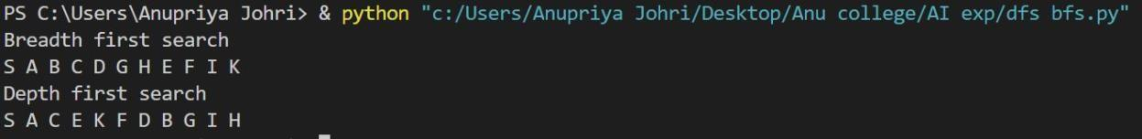



**Experiment 5**

* **Aim-**To implement Best First Search and A* algorithm.

### Algorithm-

**1. Best First Search-**

Step 1: Place the starting node into the OPEN list.

Step 2: If the OPEN list is empty, Stop and return failure.

Step 3: Remove the node n, from the OPEN list which has the lowest value of h(n), and places it in the CLOSED list.

If node n is goal then return else

Step 4: Expand the node n, and generate and check the successors of node n. and find whether any node is a goal node or not. If any successor node is goal node, then return success and terminate the search, else proceed to Step 5.

Step 5: For each successor node, algorithm checks for evaluation function f(n), and then check if the node has been in either OPEN or CLOSED list. If the node has not been in both list, then add it to the OPEN list.

Step 6: Return to Step 2.

### 2. A*-

Step1: Place the starting node in the OPEN list.

Step 2: Check if the OPEN list is empty or not, if the list is empty then return failure and stops.

Step 3: Select the node from the OPEN list which has the smallest value of evaluation function (g+h), if node n is goal node then return success and stop, otherwise

Step 4:Expand node n and generate all of its successors, and put n into the closed list. For each successor n', check whether n' is already in the OPEN or CLOSED list, if not then compute evaluation function for n' and place into Open list.

Step 5: Else if node n' is already in OPEN and CLOSED, then it should be attached to the back pointer which reflects the lowest g(n') value.

Step 6: Return to Step 2.

### Code-

**1. Best First Search-**

# This class represent a graph class Graph:

# Initialize the class

definit(self, graph_dict=None, directed=True): self.graph_dict = graph_dict or {}

self.directed = directed if not directed:

self.make_undirected()

# Create an undirected graph by adding symmetric edges def make_undirected(self):

for a in list(self.graph_dict.keys()):



for (b, dist) in self.graph_dict[a].items(): self.graph_dict.setdefault(b, {})[a] = dist

# Add a link from A and B of given distance, and also add the inverse link if the graph is undirected

def connect(self, A, B, distance=1): self.graph_dict.setdefault(A, {})[B] = distance if not self.directed:

self.graph_dict.setdefault(B, {})[A] = distance # Get neighbors or a neighbor

def get(self, a, b=None):

links = self.graph_dict.setdefault(a, {}) if b is None:

return links else:

return links.get(b)

# Return a list of nodes in the graph def nodes(self):

s1 = set([k for k in self.graph_dict.keys()])

s2 = set([k2 for v in self.graph_dict.values() for k2, v2 in v.items()]) nodes = s1.union(s2)

return list(nodes)

# This class represent a node class Node:

# Initialize the class

definit(self, name:str, parent:str): self.name = name

self.parent = parent

self.g = 0 # Distance to start node self.h = 0 # Distance to goal node self.f = 0 # Total cost

# Compare nodes

defeq(self, other):

return self.name == other.name # Sort nodes

deflt(self, other): return self.f<other.f

# Print node

defrepr(self):

return ('({0},{1})'.format(self.position, self.f)) # Best-first search

def best_first_search(graph, heuristics, start, end): # Create lists for open nodes and closed nodesopen = [] closed = []

# Create a start node and an goal node start_node = Node(start, None) goal_node = Node(end, None)

# Add the start node open.append(start_node)

# Loop until the open list is empty while len(open) > 0:

# Sort the open list to get the node with the lowest cost first open.sort()

# Get the node with the lowest cost current_node = open.pop(0)

# Add the current node to the closed list closed.append(current_node)

# Check if we have reached the goal, return the path if current_node == goal_node:

path = []

while current_node != start_node: path.append(current_node.name + ': ' + str(current_node.g)) current_node = current_node.parent

path.append(start_node.name + ': ' + str(start_node.g)) # Return reversed path

return path[::-1] # Get neighbours

neighbors = graph.get(current_node.name) # Loop neighbors

for key, value in neighbors.items(): # Create a neighbor node

neighbor = Node(key, current_node)

# Check if the neighbor is in the closed list if(neighbor in closed):

continue

# Calculate cost to goal

neighbor.g = current_node.g + graph.get(current_node.name, neighbor.name) neighbor.h = heuristics.get(neighbor.name)

neighbor.f = neighbor.h

# Check if neighbor is in open list and if it has a lower f value if(add_to_open(open, neighbor) == True):

# Everything is green, add neighbor to open list open.append(neighbor)

# Return None, no path is found return None

# Check if a neighbor should be added to open list def add_to_open(open, neighbor):

for node in open:

if (neighbor == node and neighbor.f>= node.f): return False

return True

# The main entry point for this module def main():

# Create a graph graph = Graph()

# Create graph connections (Actual distance) graph.connect('Jaipur', 'Gurugram', 111)

graph.connect('Jaipur', 'Mumbai', 85)

graph.connect('Gurugram', 'Noida', 104)

graph.connect('Gurugram', 'Sitapur', 140)

graph.connect('Gurugram', 'Delhi', 183)

graph.connect('Mumbai', 'Noida', 230)

graph.connect('Mumbai', 'Kolkata', 67)

graph.connect('Kolkata', 'Bilaspur', 191)

graph.connect('Kolkata', 'Sitapur', 64)

graph.connect('Noida', 'Delhi', 171)

graph.connect('Noida', 'Madurai', 170)

graph.connect('Noida', 'Pondicherry', 220)

graph.connect('Sitapur', 'Delhi', 107)

graph.connect('Bilaspur', 'Bern', 91)

graph.connect('Bilaspur', 'Zurich', 85)

graph.connect('Bern', 'Zurich', 120)

graph.connect('Zurich', 'Memmingen', 184)

graph.connect('Memmingen', 'Delhi', 55)

graph.connect('Memmingen', 'Madurai', 115)

graph.connect('Madurai', 'Delhi', 123)

graph.connect('Madurai', 'Pondicherry', 189)

graph.connect('Madurai', 'Raipur', 59)

graph.connect('Raipur', 'Shimla', 81)

graph.connect('Pondicherry', 'Lucknow', 102)

graph.connect('Shimla', 'Lucknow', 126)

# Make graph undirected, create symmetric connections graph.make_undirected()

# Create heuristics (straight-line distance, air-travel distance) heuristics = {}

heuristics['Bilaspur'] = 204

heuristics['Bern'] = 247

heuristics['Jaipur'] = 215

heuristics['Kolkata'] = 137

heuristics['Lucknow'] = 318

heuristics['Mumbai'] = 164

heuristics['Madurai'] = 120

heuristics['Memmingen'] = 47

heuristics['Noida'] = 132

heuristics['Pondicherry'] = 257

heuristics['Raipur'] = 168

heuristics['Sitapur'] = 75

heuristics['Shimla'] = 236

heuristics['Gurugram'] = 153

heuristics['Zurich'] = 157

heuristics['Delhi'] = 0 # Run search algorithm

path = best_first_search(graph, heuristics, 'Jaipur', 'Delhi') print(path)

print()

# Tell python to run main method

ifname == "main": main()

### 2. A*-

from queue import PriorityQueue

#Creating Base Class class State(object):

definit(self, value, parent, start = 0, goal = 0): self.children = []

self.parent = parent self.value = value self.dist = 0

if parent:

self.start = parent.startself.goal = parent.goalself.path = parent.path[:] self.path.append(value)

else:

self.path = [value] self.start = start self.goal = goal

def GetDistance(self):

pass

def CreateChildren(self): pass

# Creating subclass

class State_String(State):

definit(self, value, parent, start = 0, goal = 0 ): super(State_String, self).init(value, parent, start, goal) self.dist = self.GetDistance()

def GetDistance(self):

if self.value == self.goal: return 0

dist = 0

for i in range(len(self.goal)): letter = self.goal[i]

dist += abs(i - self.value.index(letter)) return dist

def CreateChildren(self): if not self.children:

for i in range(len(self.goal)-1): val = self.value

val = val[:i] + val[i+1] + val[i] + val[i+2:] child = State_String(val, self) self.children.append(child)

# Creating a class that hold the final magic class A_Star_Solver:

definit(self, start, goal): self.path = [] self.vistedQueue =[]

self.priorityQueue = PriorityQueue() self.start = start

self.goal = goal

def Solve(self):

startState = State_String(self.start,0,self.start,self.goal)

count = 0

self.priorityQueue.put((0,count, startState)) while(not self.path and self.priorityQueue.qsize()):

closesetChild = self.priorityQueue.get()[2] closesetChild.CreateChildren() self.vistedQueue.append(closesetChild.value) for child in closesetChild.children:

if child.value not in self.vistedQueue: count += 1

if not child.dist:

self.path = child.path break

self.priorityQueue.put((child.dist,count,child)) if not self.path:

print("Goal Of is not possible !" + self.goal ) return self.path

# Calling all the existing stuffs ifname== "main":

start1 = "anupriya" goal1 = "ayirpuna" print("Starting. ")

a = A_Star_Solver(start1,goal1) a.Solve()

for i in range(len(a.path)): print("{0}){1}".format(i,a.path[i]))

Result-

1. **Best First Search-**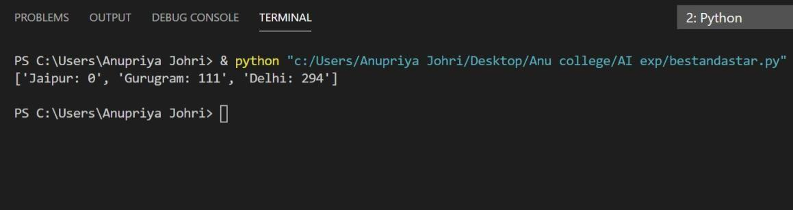

**2. A*-**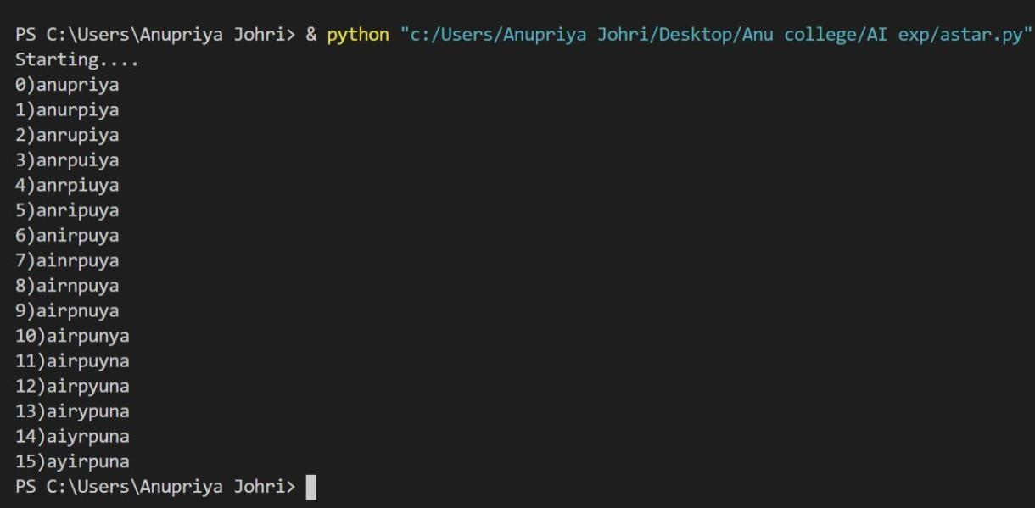



**Experiment 6**

* **Aim –**To implement Minimax Algorithm.

### Algorithm –

function minimax(node, depth, Player)

* 1. if depth ==0 or node is a terminal node then return value(node)
  2. If Player =‘Max’ // for **Maximizer Player**

set **α = -∞** //**worst case value for MAX**

for each child of node do

value= minimax(child, depth-1, ’MIN’)

α= max(α, Value) //gives Maximum of the values return (α)

**else** // for **Minimizer player**

set **α = +∞** //**worst case value for MIN**

for each child of node do

value= minimax(child, depth-1, ’MAX’)

α = min(α, Value) //gives minimum of the values return (α)

### Code –

import math

def minimax (curDepth, nodeIndex, maxTurn, scores,targetDepth) : if(curDepth==targetDepth):

return scores[nodeIndex] if(maxTurn):

return max(minimax(curDepth+1, nodeIndex*2,False,scores,targetDepth),minimax(curDepth+1, nodeIndex*2+1,False,scores,targetDepth))

else:

return min(minimax(curDepth+1, nodeIndex*2,True,scores,targetDepth),minimax(curDepth+1, nodeIndex*2+1,True,scores,targetDepth))

scores=[-1,4,2,6,-3,-5,0,7]

treeDepth=math.log(len(scores),2) print("Optimal value is : ",end=" ") print(minimax(0,0,True,scores,treeDepth))



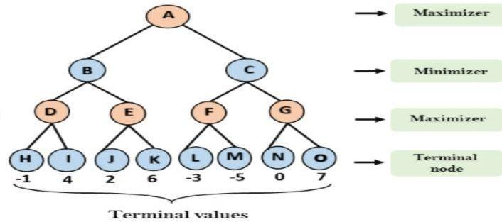

### Result –minimaxop.JPG



**Experiment 7**

* **Aim –**Implementation of unification and resolution for real world problems.

### Algorithm–

**Prolog unification**

When programming in Prolog, we spend a lot of time thinking about how variables and rules "match" or "are assigned." There are actually two aspects to this. The first, "unification," regards how terms are matched and variables assigned to make terms match. The second, "resolution," is described in [separatenotes.](https://cse3521.artifice.cc/prolog-resolution.html) Resolution is only used if rules are involved. You may notice in these notes that no rules are involved since we are only talking about unification.

**Terms**

Prolog has three kinds of **terms**:

1. Constants like 42 (numbers) and franklin (atoms, i.e., lower-case words).
2. Variables like X and Person (words that start with upper-case).
3. Complex terms like parent(franklin, bo) and baz(X, quux(Y)) Two terms **unify** if they can be matched. Two terms can be matched if:
   * they are the same term (obviously), or
   * they contain variables that can be unified so that the two terms without variables are the same.

For example, suppose our knowledge base is:



* + mia and mia unify because they are the same.
  + mia and X unify because X can be given the value mia so that the two terms (without variables) are the same.
  + woman(mia) and woman(X) unify because X can be set to mia which results in identical terms.
  + loves(X, mia) and loves(vincent, X) **cannot** unify because there is no assignment for X (given our knowledge base) that makes the two terms identical.
  + loves(X, mia) and loves(franklin, X) also cannot unify (can you see why?).

We saw in the [Prolog](https://cse3521.artifice.cc/prolog.html)notes that we can "query" the knowledge base and get, say, all the people who love mia. When we query with loves(X, mia). we are asking Prolog to give us all the values for X that unify. These values are, essentially, the people who love mia.

**Rule :**

term1 and term2 unify whenever:

1. If term1 and term2 are **constants**, then term1 and term2 unify if and only if they are the same atom, or the same number.
2. If term1 is a **variable** and term2 is any type of term, then term1 and term2 unify, and term1 is instantiated to term2. (And vice versa.) (If they are both variables, they're both instantiated to each other, and we say that they share values.)
3. If term1 and term2 are **complex terms**, they unify if and only if:
   1. They have the same **functor** and **arity**. The functor is the "function" name (this functor

is foo: foo(X, bar)). The arity is the number of arguments for the functor (the arity for foo(X, bar) is 2).

* 1. All of their corresponding arguments unify. **Recursion!**
  2. The variable instantiations are compatible (i.e., the same variable is not given two different unifications/values).

1. Two terms unify if and only if they unify for one of the above three reasons (there are no reasons left unstated).

**Example**

We'll use the = predicate to test if two terms unify. Prolog will answer "Yes" if they do, as well as any sufficient variable assignments to make the unification work.

**Do these two terms unify?**

**1.**



**o/p Ans:- Yes from Rule 1 2.**

**o/p Ans:-**Yes, from rule 2. 3.

o/p Yes, from rule 2.



4.



o/p No, these two terms do not unify because arity of s(g) do not match with the arity of s(g,X) due to which rule 3 fails in recursion.



# Experiment 8

* **Aim –**Implementation of knowledge representation schemes – use cases.

### Semantic relations –

* 1. 1. Ram has a cycle.

1. Ram is a boy.
2. Cycle has a bell.
3. Ram is 12 years old.
4. Cycle has two paddles.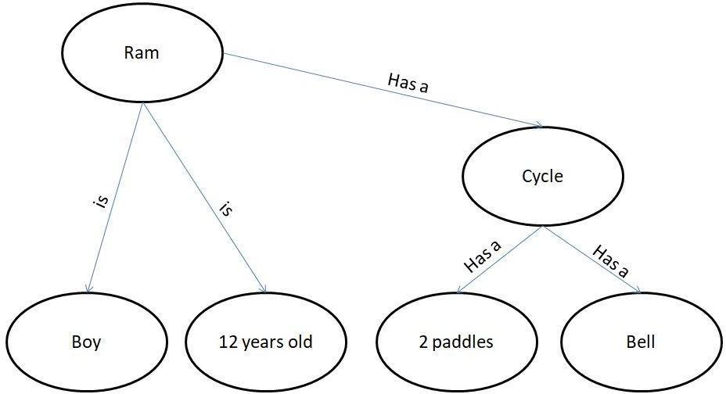



* 1. 1. Gita likes all kinds of food.

1. Mango and chapati are food.
2. Gita eats almond and is still alive.
3. Anything eaten by anyone and is still alive is food.

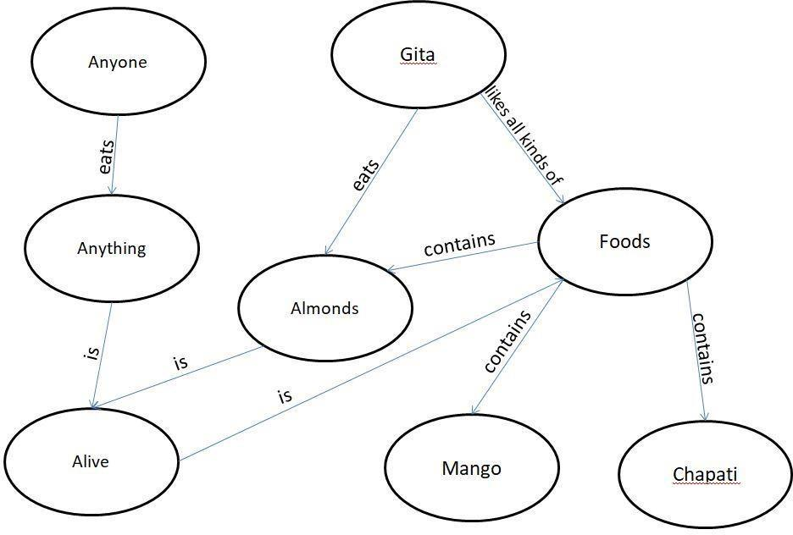



* 1. 1. Jerry is a cat.

1. Jerry is a mammal
2. Jerry is owned by Priya.
3. Jerry is brown colored.
4. All Mammals are animal.

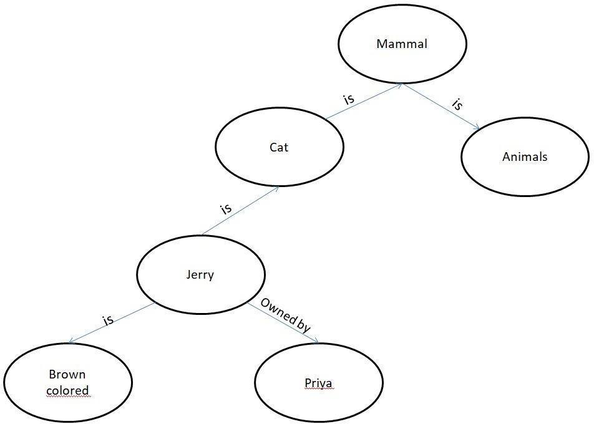



* 1. 1. Ritz is a car.

1. Car has 4 wheels.
2. Car is a vehicle.
3. Car has engine.
4. Car has battery.
5. Ritz has power steering.

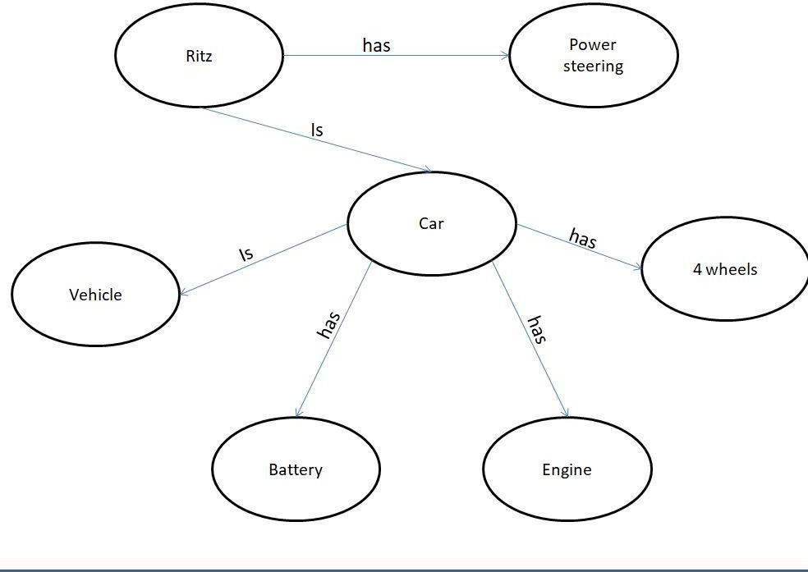



# Experiment 9

* **Aim –**Implementation of uncertain methods for an application.

### Algorithm–

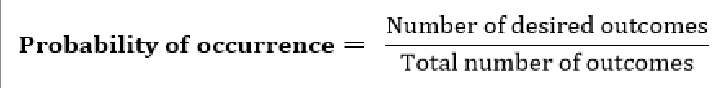

we can find the probability of an uncertain event by using the above formula.

### Code – Problem1:-

Calculate the Probability of finding how many students got the 60 marks for given data set .

import numpy as np import collections

npArray= np.array([60, 70, 70, 70, 80,90,60])

c=collections.Counter(npArray) # Generate a dictionary {"value":"nbOfOccurrences"} arraySize=npArray.size

nbOfOccurrences=c[60] #assuming you want the proba to get 10 proba=(nbOfOccurrences/arraySize)*100

print(proba) #print 60.0

output:- 28.57

**Problem2:-**

If In class 80 students and 60 students got 60 % marks then Calculate the Probability of finding how many students got the 60 marks for given data set .

#!/usr/bin/env python3 import sys

Marksprob = {}

for line in sys.stdin: line = line.strip()

ClassA, Marks = line.split('\t', 1)

def event_probability(event_outcomes, sample_space): probability = (event_outcomes / sample_space) * 100 return round(probability, 1)

ClassA = 30

Marks = 15

grade_probability = event_probability(Marks, ClassA) print(str(grade_probability) + '%')

output:48%

**5. Result –**The program has been executed successfully.



# Experiment 10

* **Aim –**Implementation of block world problem.

### Algorithm –

* + 1. MOVE(B,A)- To lift block from B to A.
    2. ON(B,A)- To place block B on A.
    3. CLEAR(B)- To lift block B from the table.
    4. PLACE(B)- To put the block B on table.

### Code –

class Strips(object):

definit(self, name, preconds, effects, cost=1):

self.name = name self.preconds = precondsself.effects = effects self.cost = cost

defrepr(self): return self.name

class STRIPS_domain(object):

definit(self, feats_vals, actions): self.feats_vals = feats_valsself.actions = actions

class Planning_problem(object):

definit(self, prob_domain, initial_state, goal): self.prob_domain = prob_domainself.initial_state = initial_state

self.goal = goal boolean = {True, False} ### blocks world

def move(x,y,z):

"""string for the 'move' action""" return 'move_'+x+'_from_'+y+'_to_'+z

def on(x):

"""string for the 'on' feature""" return x+'_is_on'

def clear(x):

"""string for the 'clear' feature""" return 'clear_'+x

def create_blocks_world(blocks = {'a','b','c','d'}): blocks_and_table = blocks | {'table'}

stmap = {Strips(move(x,y,z),{on(x):y, clear(x):True, clear(z):True},

{on(x):z, clear(y):True, clear(z):False})} for x in blocks:

for y in blocks_and_table: for z in blocks:

if x!=y and y!=z and z!=x:

stmap.update({Strips(move(x,y,'table'), {on(x):y, clear(x):True},{on(x):'table', clear(y):True})}) for x in blocks:

for y in blocks: for z in blocks:

if x!=y:

feats_vals = {on(x):blocks_and_table-{x} for x in blocks} feats_vals.update({clear(x):boolean for x in blocks_and_table})

return STRIPS_domain(feats_vals, stmap) blocks1dom = create_blocks_world({'a','b','c'}) blocks1 = Planning_problem(blocks1dom,

{on('a'):'table', clear('a'):True,

on('b'):'c', clear('b'):True,

on('c'):'table', clear('c'):False}, # initial state

{on('a'):'b', on('c'):'a'}) #goal

blocks2dom = create_blocks_world({'a','b','c','d'})

tower4 = {clear('a'):True, on('a'):'b',

clear('b'):False, on('b'):'c',

clear('c'):False, on('c'):'d',

clear('d'):False, on('d'):'table'}

blocks2 = Planning_problem(blocks2dom, tower4, # initial state

{on('d'):'c',on('c'):'b',on('b'):'a'}) #goal blocks3 = Planning_problem(blocks2dom, tower4, # initial state

{on('d'):'a', on('a'):'b', on('b'):'c'}) #goal

* **Result –**Goal achieved.

### Output –blocks.JPG

**Experiment 11**

* **Aim –**Implementation of Learning algorithm**.**
* **Code –**

List of Common Machine Learning Algorithms

* + Linear Regression
  + Logistic Regression
  + Decision Tree
  + SVM
  + Naive Bayes
  + KNN
  + K-Means
  + Random Forest
    - 1. Linear Regression

Linear regression is used to estimate real world values like cost of houses, number of calls, total sales etc.

Example

The best way to understand linear regression is by considering an example. Suppose we are asked to arrange students in a class in the increasing order of their weights.

# sample points

X = [0, 6, 11, 14, 22]

Y = [1, 7, 12, 15, 21]

# solve for a and b def best_fit(X, Y):

xbar = sum(X)/len(X) ybar = sum(Y)/len(Y) n = len(X) # or len(Y)

numer = sum([xi*yi for xi,yi in zip(X, Y)]) - n * xbar * ybardenum = sum([xi**2 for xi in X]) - n * xbar**2

b = numer / denum a = ybar - b * xbar

print('best fit line:\ny = {:.2f} + {:.2f}x'.format(a, b)) return a, b

# solution

a, b = best_fit(X, Y) #best fit line:

#y = 0.80 + 0.92x



# plot points and fit line import matplotlib.pyplot as pltplt.scatter(X, Y)

yfit = [a + b * xi for xi in X] plt.plot(X, yfit)

plt.show() best fit line:

y = 1.48 + 0.92x

* **Output:-**

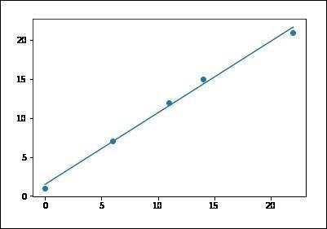

* + - 1. KNN (K-Nearest Neighbours)

K-Nearest Neighbors, KNN for short, is a supervised learning algorithm specialized in classification. It is a simple algorithm that stores all available cases and classifies new cases by a majority vote of its k neighbors.

#Importing Libraries

from sklearn.neighbors import KNeighborsClassifier

#Assumed you have, X (predictor) and Y (target) for training data set and x_test(predictor) of test_dataset

# Create KNeighbors classifier object model KNeighborsClassifier(n_neighbors=6) # default value for n_neighborsis 5 # Train the model using the training sets and check score

model.fit(X, y) #Predict Output

predicted= model.predict(x_test)

from sklearn.neighbors import KNeighborsClassifierdf = pd.read_csv('iris_df.csv')

df.columns = ['X1', 'X2', 'X3', 'X4', 'Y']

df = df.drop(['X4', 'X3'], 1) df.head()

sns.set_context('notebook', font_scale=1.1) sns.set_style('ticks')

sns.lmplot('X1','X2', scatter=True, fit_reg=False, data=df, hue='Y') plt.ylabel('X2')

plt.xlabel('X1')

from sklearn.cross_validation import train_test_split neighbors = KNeighborsClassifier(n_neighbors=5) X = df.values[:, 0:2]

Y = df.values[:, 2]

trainX, testX, trainY, testY = train_test_split( X, Y, test_size = 0.3) neighbors.fit(trainX, trainY)

print('Accuracy: \n', neighbors.score(testX, testY)) pred = neighbors.predict(testX)

* **Result:-**

('Accuracy: \n', 0.75555555555555554)

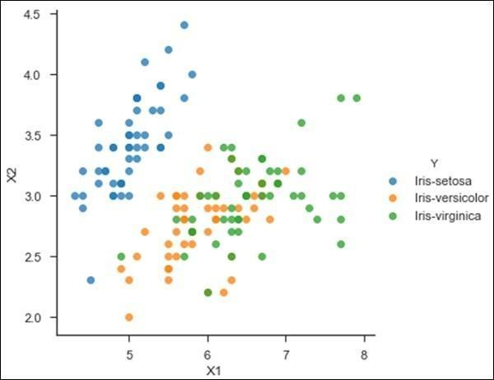



# Experiment 12

* **Aim –**Development of ensemble model.
* **Code –**

An Ensemble method creates multiple models and combines them to solve it. Ensemble methods help to improve the robustness of the model.

**Basic Ensemble Techniques**

* + - * 1. Max Voting
        2. Averaging
        3. Weighted Average

Problem: Development of ensemble model using Averaging Technique.

**Averaging method:** It is mainly used for regression problems. The method consists of build multiple models independently and returns the average of the prediction of all the models. In general, the combined output is better than an individual output because variance is reduced.

In the below example, three regression models (linear regression, xgboost, and random [forest](https://text-to-search.com/s/?q=forest)) are trained and their predictions are averaged. The final prediction output is pred_final.

# importing utility modules import pandas as pd

from sklearn.model_selection import train_test_split from sklearn.metrics import mean_squared_error

# importing machine learning models for prediction from sklearn.ensemble import RandomForestRegressor import xgboost as xgb

from sklearn.linear_model import LinearRegression

# loading train data set in dataframe from train_data.csv file df = pd.read_csv("train_data.csv")

# getting target data from the dataframe target = df["target"]

# getting train data from the dataframe train = df.drop("target")

# Splitting between train data into training and validation dataset X_train, X_test, y_train, y_test = train_test_split(

train, target, test_size=0.20)

# initializing all the model objects with default parameters model_1 = LinearRegression()

model_2 = xgb.XGBRegressor() model_3 = RandomForestRegressor()

# training all the model on the training dataset model_1.fit(X_train, y_target) model_2.fit(X_train, y_target) model_3.fit(X_train, y_target)

# predicting the output on the validation dataset pred_1 = model_1.predict(X_test)

pred_2 = model_2.predict(X_test)

pred_3 = model_3.predict(X_test)

# final prediction after averaging on the prediction of all 3 models pred_final = (pred_1+pred_2+pred_3)/3.0

# printing the root mean squared error between real value and predicted value print(mean_squared_error(y_test, pred_final))

Input:-

|  | Colleague 1 | Colleague 2 | Colleague 3 | Colleague 4 | Colleague 5 | Fina l ratin  g |
| --- | --- | --- | --- | --- | --- | --- |
| Ratin g | 5 | 4 | 5 | 4 | 4 | 4.4 |

Output: - final rating will be 4.4

* **Result –**Program compiled successfully.



# Experiment 13

* **Aim –**Implementation of NLP problem.
* **Code –**

**Problem**:-

Count total number of adjective and noun

# Import data and tagger

from nltk.corpus import twitter_samples from nltk.tag import pos_tag_sents

# Load tokenized tweets

tweets_tokens = twitter_samples.tokenized('positive_tweets.json')

# Tag tagged tweets

tweets_tagged = pos_tag_sents(tweets_tokens)

# Set accumulators JJ_count = 0

NN_count = 0

# Loop through list of tweets for tweet in tweets_tagged:

for pair in tweet: tag = pair[1] if tag == 'JJ':

JJ_count += 1 elif tag == 'NN':

NN_count += 1

# Print total numbers for each adjectives and nouns print('Total number of adjectives = ', JJ_count) print('Total number of nouns = ', NN_count)

* **Result –**

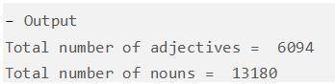



# Experiment 14

* **Aim –**Deep learning Project in Python
* **Code –**

The steps to cover in this are as follows:

1. Load Data.
2. Define Keras Model.
3. Compile Keras Model.
4. Fit Keras Model.
5. Evaluate Keras Model.
6. Tie It All Together.
7. Make Predictions

* **Load Data.**
  1. **Dataset used –**

# first neural network with keras tutorial from numpy import loadtxt

from keras.models import Sequential from keras.layers import Dense

* 1. **Code –**

# load the dataset

dataset = loadtxt('pima-indians-diabetes.csv', delimiter=',') # split into input (X) and output (y) variables

X = dataset[:,0:8] y = dataset[:,8]

* **Define Keras Model.**

1. **Code –**

# define the keras model model = Sequential()

model.add(Dense(12, input_dim=8, activation='relu')) model.add(Dense(8, activation='relu')) model.add(Dense(1, activation='sigmoid'))

* **Compile Keras Model.**
  1. **Code –**

# compile the keras model

model.compile(loss='binary_crossentropy', optimizer='adam', metrics=['accuracy'])

* **Fit Keras Model.**

**a. Code –**

# fit the keras model on the dataset

model.fit(X, y, epochs=150, batch_size=10,verbose=0)

* **Evaluate Keras Model.**

**a. Code –**

# evaluate the keras model

_, accuracy = model.evaluate(X, y, verbose=0)

print('Accuracy: %.2f' % (accuracy*100))

* **Tie It All Together.**

1. **Code-**

# first neural network with keras tutorial from numpy import loadtxt

from keras.models import Sequential from keras.layers import Dense

# load the dataset

dataset = loadtxt('pima-indians-diabetes.csv', delimiter=',') # split into input (X) and output (y) variables

X = dataset[:,0:8] y = dataset[:,8]

# define the keras model model = Sequential()

model.add(Dense(12, input_dim=8, activation='relu')) model.add(Dense(8, activation='relu')) model.add(Dense(1, activation='sigmoid'))

# compile the keras model

model.compile(loss='binary_crossentropy', optimizer='adam', metrics=['accuracy'])

# fit the keras model on the dataset

model.fit(X, y, epochs=150, batch_size=10,verbose=0)

# evaluate the keras model

_, accuracy = model.evaluate(X, y, verbose=0) print('Accuracy: %.2f' % (accuracy*100))

1. **Output –**

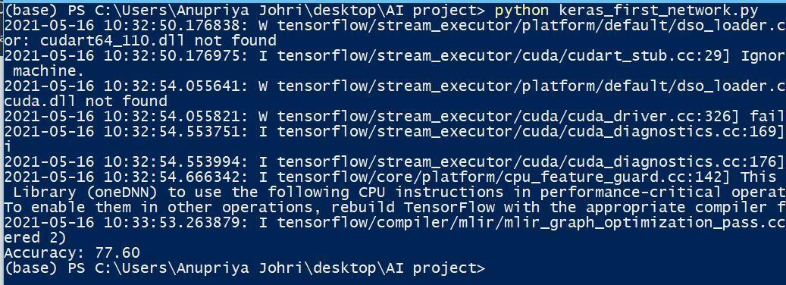

* **Make Predictions**

1. **Code –**

# first neural network with keras make predictions from numpy import loadtxt

from keras.models import Sequential from keras.layers import Dense

# load the dataset

dataset = loadtxt('pima-indians-diabetes.csv', delimiter=',') # split into input (X) and output (y) variables

X = dataset[:,0:8] y = dataset[:,8]

# define the keras model model = Sequential()

model.add(Dense(12, input_dim=8, activation='relu')) model.add(Dense(8, activation='relu')) model.add(Dense(1, activation='sigmoid'))

# compile the keras model

model.compile(loss='binary_crossentropy', optimizer='adam', metrics=['accuracy']) # fit the keras model on the dataset

model.fit(X, y, epochs=150, batch_size=10, verbose=0) # make class predictions with the model

predictions = model.predict_classes(X) # summarize the first 5 cases

for i in range(5):

print('%s => %d (expected %d)' % (X[i].tolist(), predictions[i], y[i]))

1. **Output –**

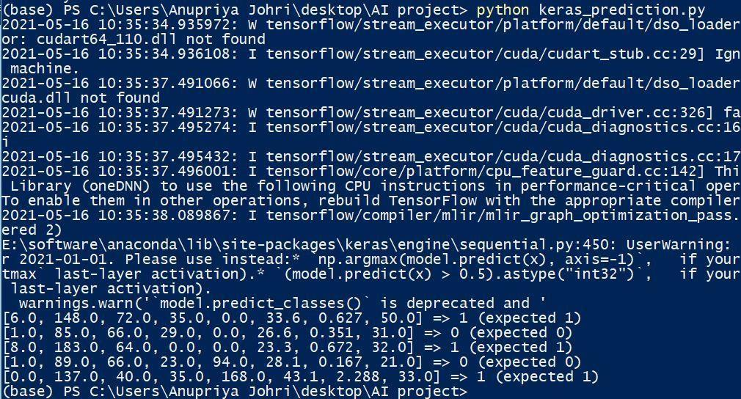

### Keras Project Summary –

In this project, we discovered how to create our first neural network model using the powerful Keras Python library for deep learning.

Specifically, we learnt the six key steps in using Keras to create a neural network or deep learning model, step-by-step including:

* + How to load data.
  + How to define a neural network in Keras.
  + How to compile a Keras model using the efficient numerical backend.
  + How to train a model on data.
  + How to evaluate a model on data.
  + How to make predictions with the model.
* **Result –**The program executed successfully.