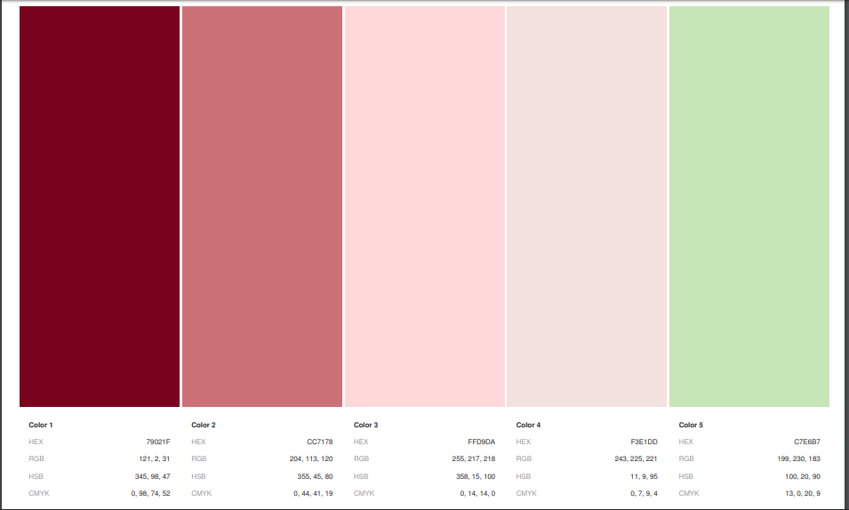

Header text

Footer Text

Link Hover

Icons – if I can figure that out.

Link: Active

Border Colors  
Nav Bar Background

Form fields?

Background

Main Text

Link text

Link visited



Be my friend?

Here are some lies I’ll tell you to make me seem employable!

Here are some lies I’ll tell you to make me seem employable!

Here are some lies I’ll tell you to make me seem employable!

Home Say Hi

ANNA COLE

Contact Me



Be my friend?

Home Say Hi

ANNA COLE