Entry Notes
How to read these notes
The numbers of each entry pertain to the parameter sets that I have been playing around with. The associated number can be seen in the ‘parameters.csv’ file under the EntryNumber column. This number is also what I use to pull each parameter value set in my code. For example:
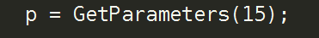

This is the only way that I reference the parameter set; with the function that I made called GetParameters().
Most of these were just parameters that I played around with when I started coding up the model in python. This page is deprecated and is only useful to me (Jonathan Anzules), I doubt it’ll ever come to use for anyone else.
(0) – The parameters used for my proposal, and the one that has most of the Khailaie parameters
(1) – I increased the mu parameter to 750. For some reason, using parameter set 0 to test 60 to 100, after a value of 850 the populations dies. But when I tested (2) using parameter set (1), it doesn’t die.
(2) – I could get even bigger population sizes here by using the parameter set (1). Increased mu to 1000
(3) – I added the naive growth rate as the mu. This growth rate came from the data that I have collected. The unit vales are given in the thousands. So, 298.2543/day = 298,2543/day. Another way to mention this is 298.2543x10^3. Each individual cell that is created in the PlayTime function will represent one thousand cells.
(4) - adding 6.938 to beta
(5) – Calculated a lot of the rates from data and found some from papers. I’m putting in all of the values that I have found so far into the model to see how it behaves. Suppression values I have no idea what to do with, so I kept it the same. Activated T cell death rate value is still a work in progress so I kept it the same as everything else. I’m keeping it similar to naive T cells for now.
(6) – Since parameter set 5 failed, and all of the cellular populations are dying I’m going to mess around with parameters to see what the sources are. It looks like the reason 5 failed is because I messed up with the parameters. C was 11184 instead of 598. I was tired when I did this.
(7) – It looks like the IL-2 expression rates that I found will not work for my model. Because the combined consumption of IL-2 by T and R is far greater than the production. Each T makes 1 while each T consumes 3 and each R consumes 8. So, if we just consider the activated T cells, we are met with -2 cytokine per cycle. I will change the numbers so it makes better sense.
(8) – epsilon should be the ratio of tregs and t actives, comes out to 0.23. I made Tregs differentiation be 0 (c), to find out why activated T cells are dying so fast. It turns out that the the death rate, b_T, of activated T cells is too high . Between 19 an 20 seems to be the sweet spot for the parameter set that I have.
19 - the activated T cell population grows out of control
20 - The activated T cell population crashes.
(9) - based on (8) parameters, and I’m going to try to see if the IL-2 cytokine can rescue the activated T cell population crash with out changing Treg parameters. C, will stay at 0, and b_T at 20.
Changes Made
- e_T, e_R, and d dropped down by ten fold
- Turns out the alpha values was wrong. 664 - > 66
- Completely eliminating the Treg population
(10)
Rational - Coming from 8. It seems that there is a problem with naive T cells; they instantly die. I suspect the problem is because of their death rate. I might need to use some other type of data, but first let’s see if we can stabilize the naive T cell population.
Purpose – Stabilize the naive T cell populations
Observations
- z – A vestigial parameter from way long ago, and actually serves no purpose. This one was replaced by n. I will have to leave it lying around because my functions are entirely dependent on the order of the parameters, so deleting z anywhere will ruin that order. TO DO: remove the z parameters from everything
- β – this parameter set at 100 is literally killing off the naive T cells completely.
- Apparently I didn’t know how my own fucking function works (Speculator)
- Using my Speculator, beta only works well between 0.01 and 0.1.
Results - I stabilized the naive T cell population. It turns out that the beta parameter is too high and we need to keep it really small. I really don’t know how this works.
Next Step – Try to get Naive T cells to stabilize at 6 million

(11) – Utilizing fmincon
Purpose – Fit model only to naive T cells and activated T cells. I zeroed out all of the parameters associated with Tregs.
Rational – I want to try to fit my model to the data in a way that I can focus on the smallest part of the model. Instead of trying to fit all of the parameters, I tried only one or two.
Observations – Using the ((model – data)/data)^2 didn’t work. Granted I was never told to use this method of calculation. I only tried it because I found it in this tutorial. The dividing by data is what didn’t work. Removal of that portion of the calculation worked.
Results – Naive T cells fit pretty well to the data, it does not fit the activated portion well at all. I think that since it is trying to find the lowest Rsquare value; the lowest R square value if found only with the naive T cell data being fitted. I am going to keep the optimized naive T cell parameters associated with its production rate and death rate; mu and g respectively. Next, I will only calculate the Rsquare value associated with Activated T cells.
The death rate of naive T cells seems to need to be dropped down to essentially a zero. Optimized g (Naive death rate) is 9.4 * 10^-19.

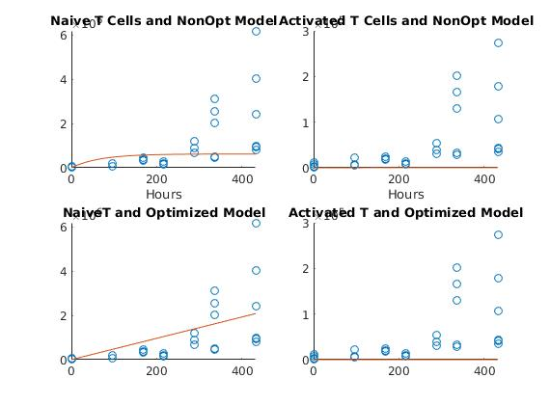

(12&13) – Optimizing only activated T cells
Purpose – It seemed that optimizing for two data types, like in entry 11, didn’t work for activated T cells. So here we will optimize only for activated T cells and will only look at the variables beta (activation rate) and b_T (Activated T cell death rate) while only calculating r square value with activated T cell data
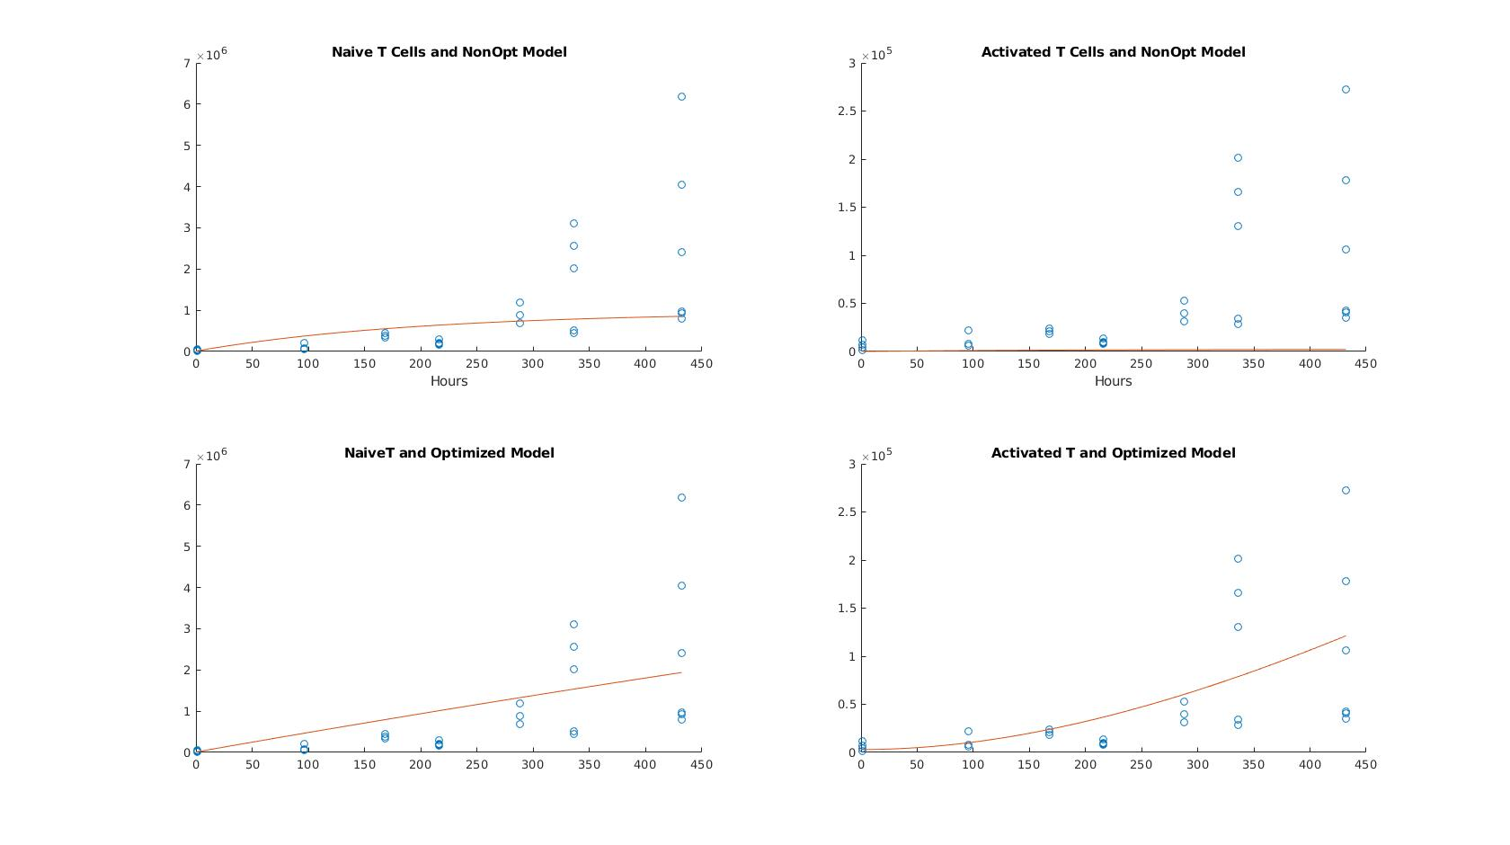
Rational – on step 11 it didn’t work right for both naive and activated T cell data
Observation – It worked nicely. Activated T cells were fitted nicely, check out plot. What is also cool is that it looks like naive T cells got fit a little better, even when we were not calculating the R square value for naive T cell population.
Conclusion – I think I will have to optimize to each population at a time. Will be keeping the new parameters in entry 13

(14) – Same as 13, I had trouble with my plots and copied it twi

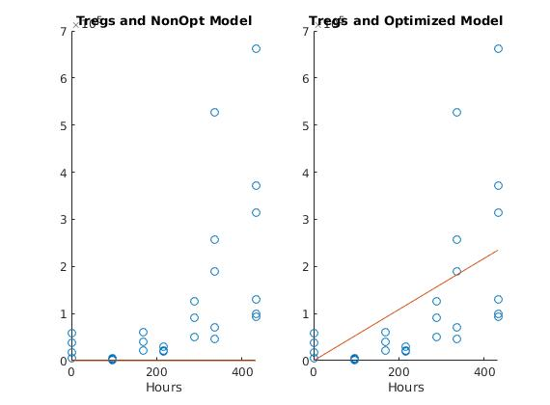
(15) – Fitting alpha (Treg production rate) to model
It worked.
Conclusion – Well, for both the naive and Treg data it seems that the cells don’t grow linearly. The model looks like it should be exponential.

(16) –
added the thymus ODE to control the growth trajectory of things. I optimized ran my optimization script for alpha and mu. The numbers I am getting for and alpha are just so big. I’m not sure how to think about this.
Purpose -
Rational -
Observation -
Conclusion -

(15) –
Purpose -
Rational -
Observation -
Conclusion -

(16) –
Purpose -
Rational -
Observation -
Conclusion -

