# **Background**

CSS Backgrounds

* background-color
* background-image
* background-repeat (background-repeat: repeat-x; | background-repeat: repeat-y; | background-repeat: no-repeat;)
* background-attachment (background-attachment: fixed; 🡪스크롤 되지 않는다)
* background-position (background-position: right top; )

|  |
| --- |
| <!DOCTYPE html>  <html>  <head>  <title></title>  <!--style은 글자 색을 먼저하고 style css 설명한 후 -->  <style type="text/css">  div {height:50px;width:100%;}  </style>  </head>  <body>  <h1> color 는 여러가지 방식으로 사용됩니다. </h1>  <h2> By color names</h2>  <div style="background-color:red"></div>  <div style="background-color:orange"></div>  <div style="background-color:yellow"></div>  <div style="background-color:cyan"></div>  <div style="background-color:blue"></div>    <h1 style="color:red">Heading</h1>  <h1 style="color:orange">Heading</h1>  <h1 style="color:yellow">Heading</h1>  <h1 style="color:cyan">Heading</h1>  <h1 style="color:blue">Heading</h1>  <hr>  <h2> As RGB values</h2>  <div style="background-color:rgb(255,0,0)"></div>  <div style="background-color:rgb(255,255,0)"></div>  <div style="background-color:rgb(0,255,0)"></div>  <div style="background-color:rgb(0,255,255)"></div>  <div style="background-color:rgb(0,0,255)"></div>  <div style="background-color:rgb(0,0,0)"></div>  <div style="background-color:rgb(64,64,64)"></div>  <div style="background-color:rgb(128,128,128)"></div>  <div style="background-color:rgb(192,192,192)"></div>  <h1 style="color:rgb(255,0,0)">Heading</h1>  <h1 style="color:rgb(255,255,0)">Heading</h1>  <h1 style="color:rgb(0,255,0)">Heading</h1>  <h1 style="color:rgb(0,255,255)">Heading</h1>  <h1 style="color:rgb(0,0,255)">Heading</h1>  <h1 style="color:rgb(0,0,0)">Heading</h1>  <h1 style="color:rgb(64,64,64)">Heading</h1>  <h1 style="color:rgb(128,128,128)">Heading</h1>  <h1 style="color:rgb(192,192,192)">Heading</h1>  <hr>  <h2> As hexadecimal (16진수 값 )</h2>  <div style="background-color:#ff0000"></div>  <div style="background-color:#ffff00"></div>  <div style="background-color:#00ff00"></div>  <div style="background-color:#00ffff"></div>  <div style="background-color:#0000ff"></div>  <div style="background-color:#000000"></div>  <div style="background-color:#404040"></div>  <div style="background-color:#808080"></div>  <div style="background-color:#c0c0c0"></div>  <h1 style="color:#ff0000">Heading</h1>  <h1 style="color:#ffff00">Heading</h1>  <h1 style="color:#00ff00">Heading</h1>  <h1 style="color:#00ffff">Heading</h1>  <h1 style="color:#0000ff">Heading</h1>  <h1 style="color:#000000">Heading</h1>  <h1 style="color:#404040">Heading</h1>  <h1 style="color:#808080">Heading</h1>  <h1 style="color:#c0c0c0">Heading</h1>  </body>  </html> |

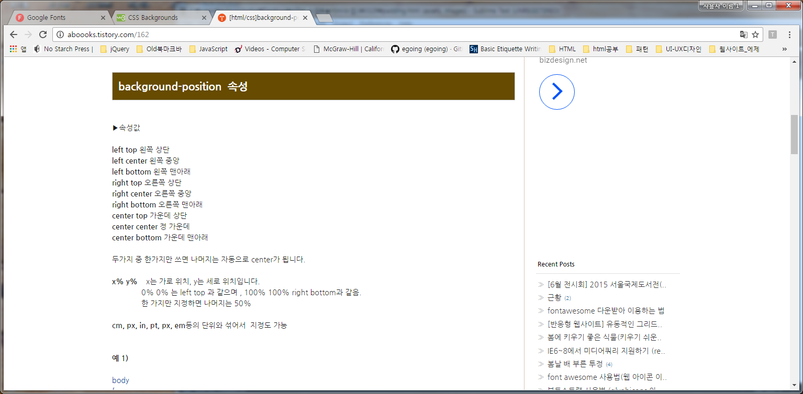

# 단위

## Length Values

## Absolute Lengths

* **mm** ( millimeter ) - smallest standard unit of length in the metric system
* **cm** ( centimeter ) - 1cm = 10mm
* **in** ( inch ) - 1in = 2.54cm
* **px** ( pixel ) - 1px = 1/96in
* **pt** ( point ) - 1pt = 1/72in
* **pc** ( pica ) - 1pc = 12pt

font-size 가 지정되지 않으면 16px의 크기를 갖는다

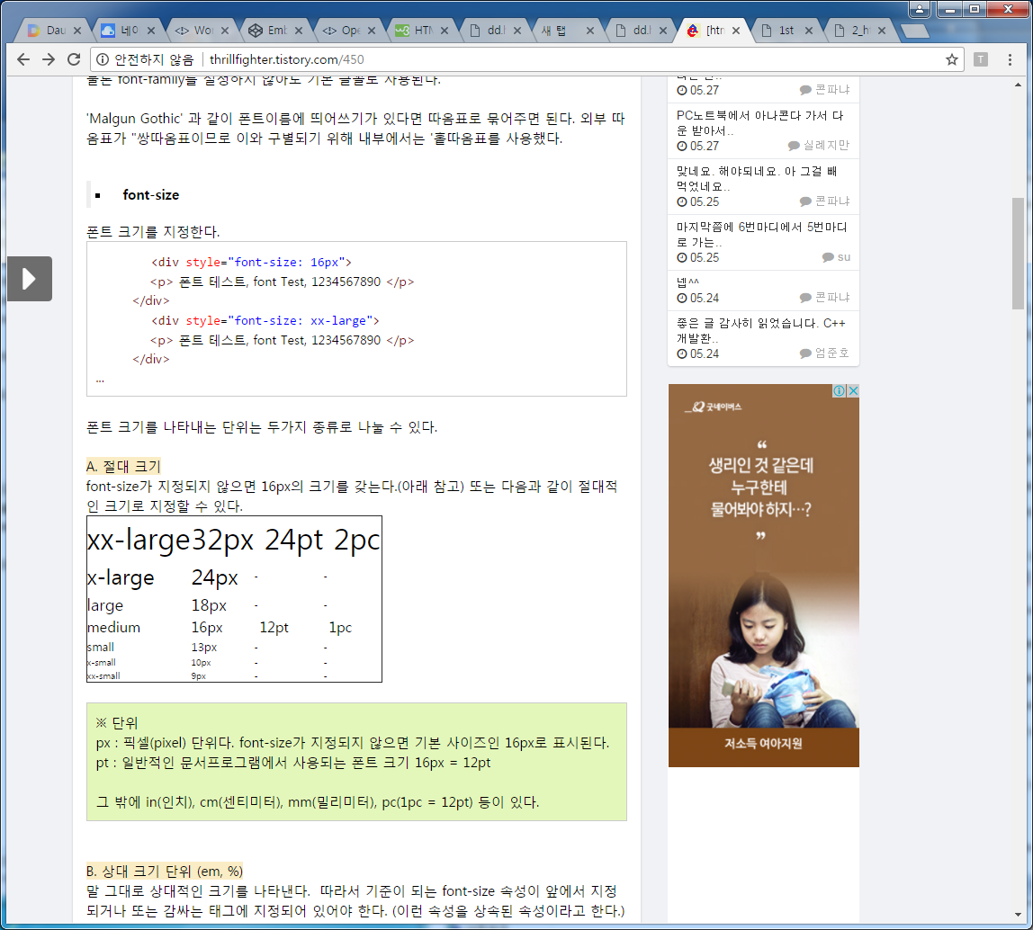

## Font Relative Lengths

* em - ( font size ) - unit relative to font-size
* ex ( x-height ) - unit relative to the height of the lowercase "x" of the font applied
* ch ( zero-measure ) - unit relative to the size of the "0"(zero) of the font applied
* *CSS3* rem ( root em ) - unit equal to the font-size of the root element

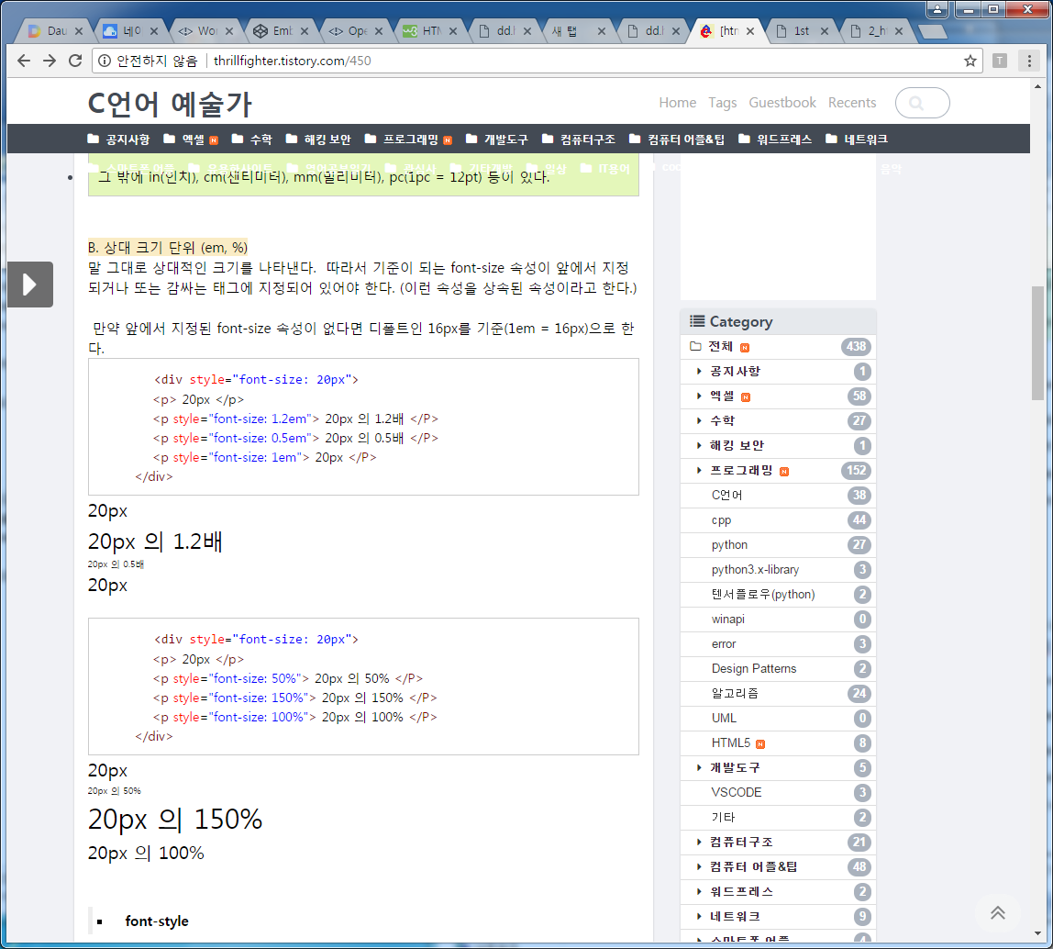

## Percentage lengths : 위의 절대 길이형태와 달리 퍼센트 길이는 유동적으로 부모 엘리먼트안의 사용가능한 공간을 정해진 퍼센트만큼만 차지한다.

<style> #box1 { width: 50%; height: 50%; } </style>

## Viewport Percentage Lengths

* *CSS3* vw ( viewport width ) - unit equal to 1% of the window width
* *CSS3* vh - ( viewport height ) - unit equal to 1% of the window height
* *CSS3* vmin ( viewport minimum ) - unit equal to 1% of whichever is smaller of "vw" and "vh"
* *CSS3* vmax ( viewport maximum ) - unit equal to 1% of whichever is larger of "vw" and "vh"

예) <style> #box1 { width: 50vw; height: 50vh; } </style>

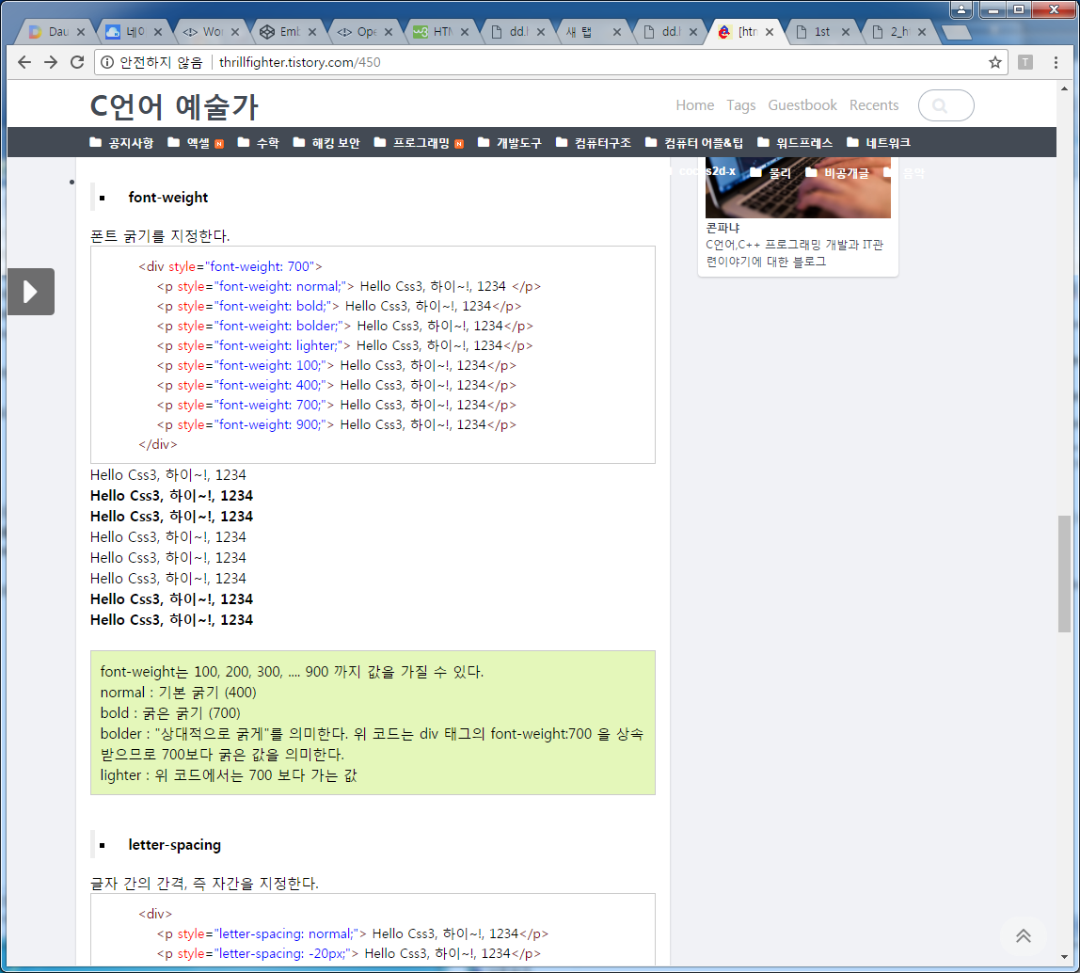

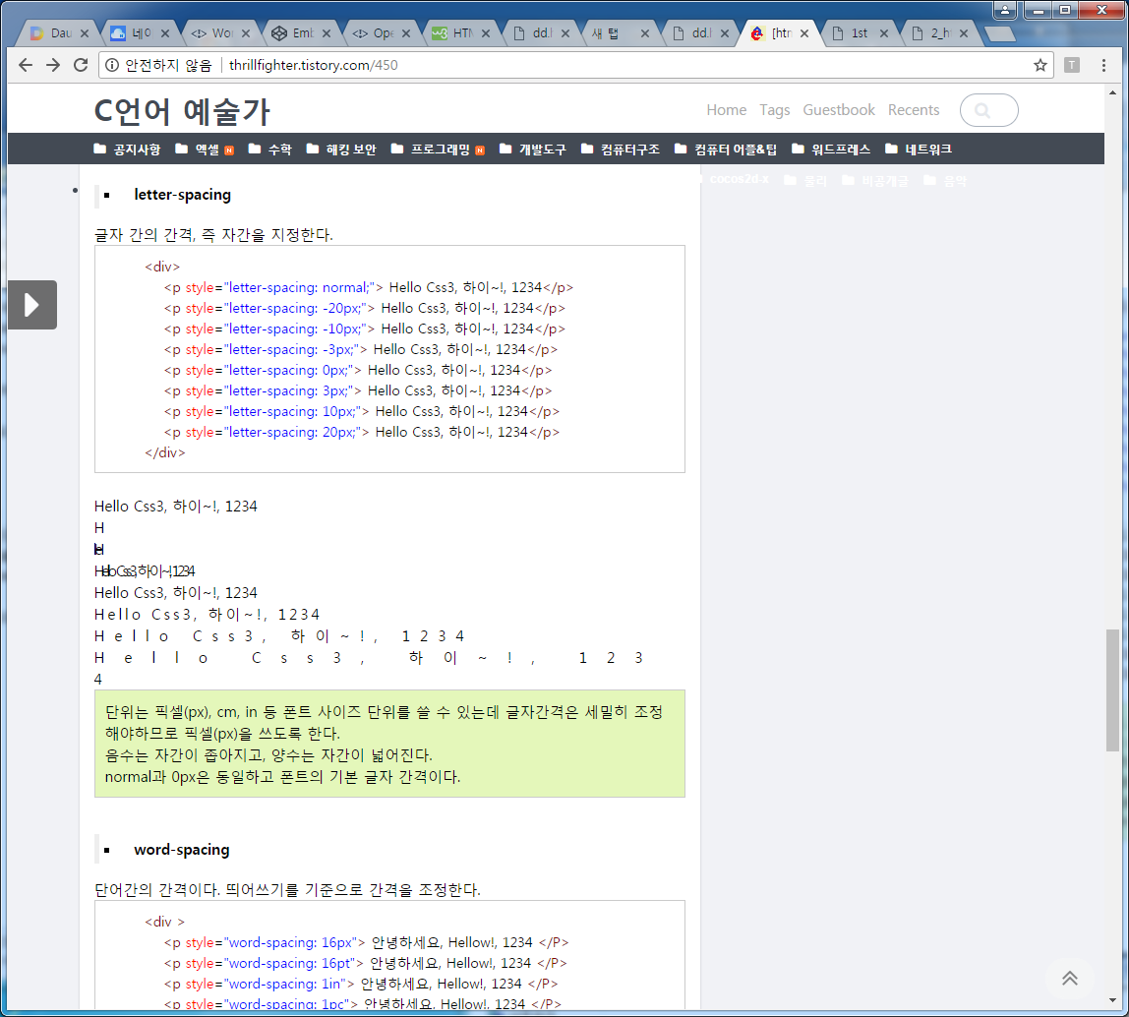

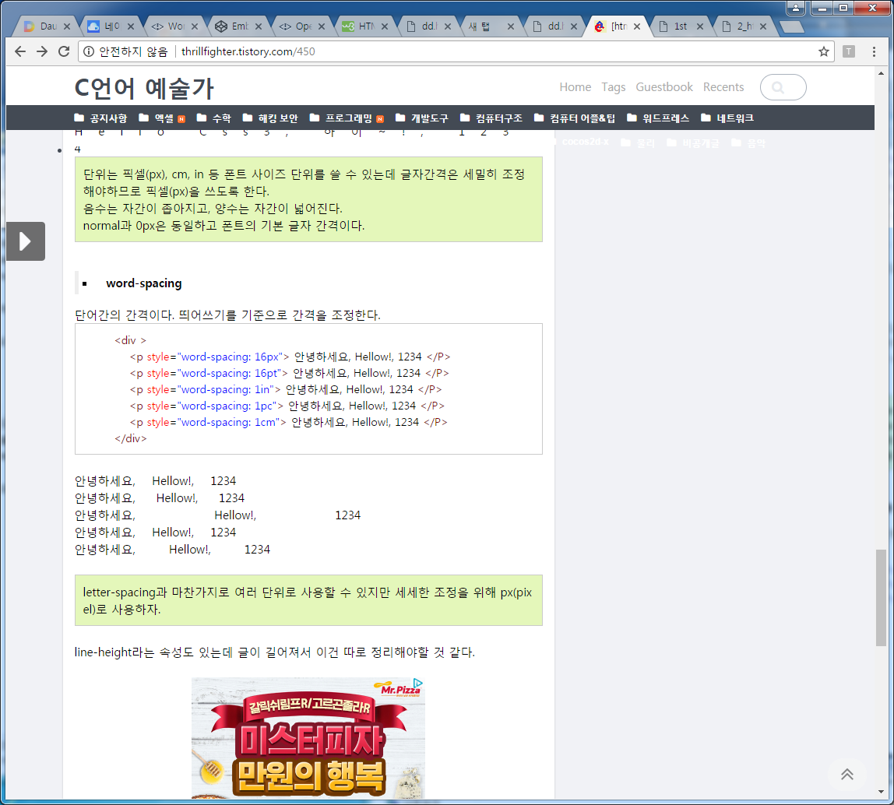

# Image

|  |
| --- |
| <!DOCTYPE html>  <html>  <head>  <style>  img {  width:100%;  }  </style>  </head>  <body>  <p>It is better to use the style attribute to set the width and height of an image  (instead of using the width and height attributes), because it prevents  internal or external styles sheets to change the original size of an image:</p>  <p>Using the style attribute:</p>  <img src="html5.gif" alt="HTML5 Icon" style="width:128px;height:128px;">  <p>Using the width and height attributes:</p>  <img src="html5.gif" alt="HTML5 Icon" width="128" height="128">  </body>  </html> |

# Rounded images

|  |
| --- |
| <!DOCTYPE html>  <html>  <head>  <style>  img {  border-radius: 8px; /*     border-radius: 50%; */  }  </style>  </head>  <body>  <h2>Rounded Images</h2>  <p>Use the border-radius property to create rounded images:</p>  <img src="paris.jpg" alt="Paris" width="400" height="300">  </body>  </html> |

Thumbnail images

위의 예제에서 css만 바꾼다.

|  |
| --- |
| img {     border: 1px solid #ddd;     border-radius: 4px;     padding: 5px;     width: 150px; } |

Thumbnail Image as Link:

|  |
| --- |
| Css 에서  img {     border: 1px solid #ddd;     border-radius: 4px;     padding: 5px;     width: 150px; }  img:hover {     box-shadow: 0 0 2px 1px rgba(0, 140, 186, 0.5); }  html 에서  <a href="paris.jpg">   <img src="paris.jpg" alt="Paris"> </a> |

# Responsive Images

|  |
| --- |
| <!DOCTYPE html>  <html>  <head>  <style>  img {  max-width: 100%;  height: auto;  }  </style>  </head>  <body>  <h2>Responsive Images</h2>  <p>Responsive images will automatically adjust to fit the size of the screen.</p>  <p>Resize the browser window to see the effect:</p>  <img src="trolltunga.jpg" alt="Norway" width="1000" height="300">  </body>  </html> |

# center images

|  |
| --- |
| <!DOCTYPE html>  <html>  <head>  <style>  img {  display: block;  margin: auto;  }  </style>  </head>  <body>  <img src="paris.jpg" alt="Paris" style="width:50%">  </body>  </html> |

## **Polaroid Images / Cards**

box-shadow 하고 한다.

|  |
| --- |
| <!DOCTYPE html>  <html>  <head>  <style>  body {margin:25px;}  div.polaroid {  width: 80%;  background-color: white;  box-shadow: 0 4px 8px 0 rgba(0, 0, 0, 0.2), 0 6px 20px 0 rgba(0, 0, 0, 0.19);  margin-bottom: 25px;  }  div.container {  text-align: center;  padding: 10px 20px;  }  </style>  </head>  <body>  <h2>Responsive Polaroid Images / Cards</h2>  <div class="polaroid">  <img src="rock600x400.jpg" alt="Norway" style="width:100%">  <div class="container">  <p>The Troll's tongue in Hardanger, Norway</p>  </div>  </div>  <div class="polaroid">  <img src="lights600x400.jpg" alt="Norway" style="width:100%">  <div class="container">  <p>Northern Lights in Norway</p>  </div>  </div>  </body>  </html> |

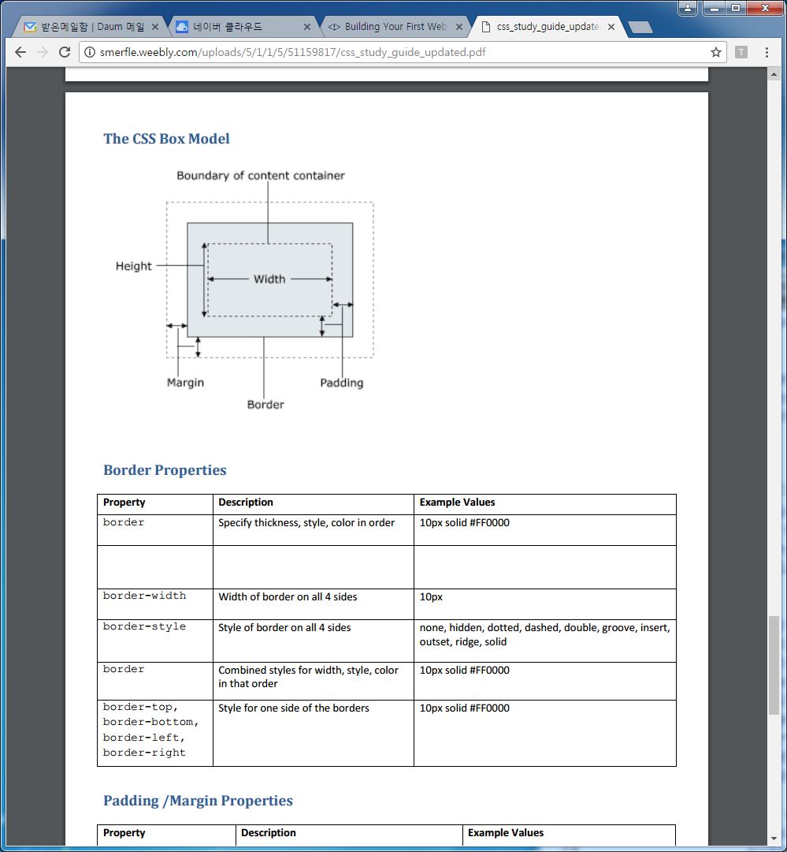

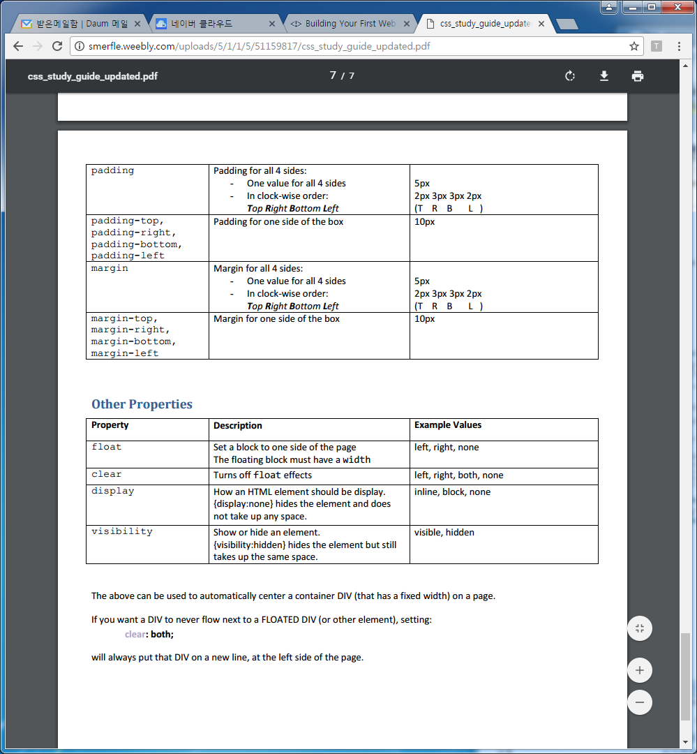

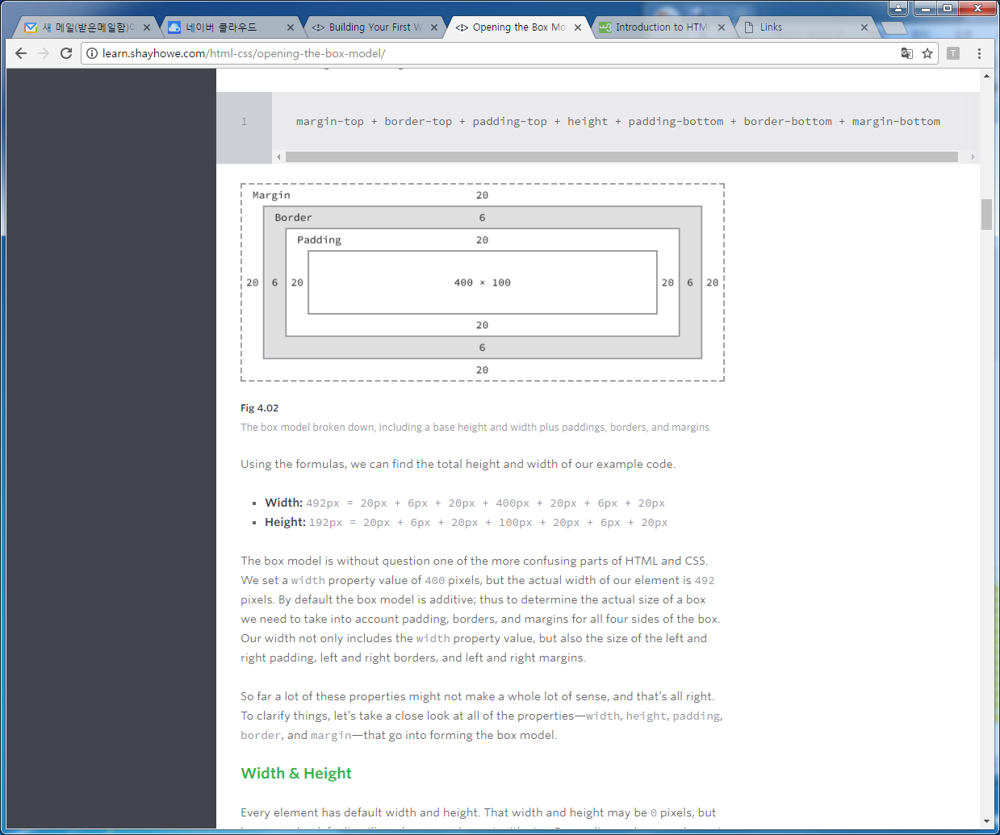

box 실습예제

|  |
| --- |
| <!DOCTYPE html>  <html>  <head>  <title></title>  <style type="text/css">    span {  background: #eaeaed;  color: #666;  font: 14px/24px "Source Code Pro", Inconsolata, "Lucida Console", Terminal, "Courier New", Courier;  display: inline-block;  height: 70px;  margin: 0 14px;  padding-top: 20px;  text-align: center;  width: 90px;  }  .border-solid {  border: 2px solid #9799a7;  }  .border-double {  border: 6px double #9799a7;  }  .border-dashed {  border: 8px dashed #9799a7;  }  .border-dotted {  border: 4px dotted #9799a7;  }  </style>  </head>  <body>  <span class="border-solid">2px <br> solid</span>  <span class="border-double">6px <br> double</span>  <span class="border-dashed">8px <br> dashed</span>  <span class="border-dotted">4px <br> dotted</span>  </body>  </html> |

# Borders

|  |
| --- |
| <!DOCTYPE html>  <html>  <head>  <style>  p.dotted {border-style: dotted;}  p.dashed {border-style: dashed;}  p.solid {border-style: solid;}  p.double {border-style: double;}  p.groove {border-style: groove;}  p.ridge {border-style: ridge;}  p.inset {border-style: inset;}  p.outset {border-style: outset;}  p.none {border-style: none;}  p.hidden {border-style: hidden;}  p.mix {border-style: dotted dashed solid double;}  </style>  </head>  <body>  <h2>The border-style Property</h2>  <p>This property specifies what kind of border to display:</p>  <p class="dotted">A dotted border.</p>  <p class="dashed">A dashed border.</p>  <p class="solid">A solid border.</p>  <p class="double">A double border.</p>  <p class="groove">A groove border.</p>  <p class="ridge">A ridge border.</p>  <p class="inset">An inset border.</p>  <p class="outset">An outset border.</p>  <p class="none">No border.</p>  <p class="hidden">A hidden border.</p>  <p class="mix">A mixed border.</p>  </body>  </html> |

So, here is how it works:

If the margin property has four values:

* **margin: 25px 50px 75px 100px;**
  + top margin is 25px
  + right margin is 50px
  + bottom margin is 75px
  + left margin is 100px

If the margin property has three values:

* **margin: 25px 50px 75px;**
  + top margin is 25px
  + right and left margins are 50px
  + bottom margin is 75px

If the margin property has two values:

* **margin: 25px 50px;**
  + top and bottom margins are 25px
  + right and left margins are 50px

If the margin property has one value:

* **margin: 25px;**
  + all four margins are 25px

|  |
| --- |
| <!DOCTYPE html>  <html>  <head>  <style>  div {  border: 1px solid black;  margin-top: 100px;  margin-bottom: 100px;  margin-right: 150px;  margin-left: 80px;  background-color: lightblue;  }  </style>  /* <style>  div {  border: 1px solid black;  margin: 100px 150px 100px 80px;  background-color: lightblue;  }  </style> */  </head>  <body>  <h2>Using individual margin properties</h2>  <div>This div element has a top margin of 100px, a right margin of 150px, a bottom margin of 100px, and a left margin of 80px.</div>  </body>  </html> |

## **CSS3 Text Shadow**

|  |
| --- |
| <!DOCTYPE html>  <html>  <head>  <style>  h1 {  text-shadow: 2px 2px;  }  </style>  </head>  <body>  <h1>Text-shadow effect!</h1>  <p><b>Note:</b> Internet Explorer 9 and earlier versions, do not support the text-shadow property.</p>  </body>  </html> |

Css 수정

h1 {  
    text-shadow: 2px 2px red;  
}

h1 {  
    text-shadow: 2px 2px 5px red;  
}

h1 {  
    color: white;  
    text-shadow: 2px 2px 4px #000000;  
}

h1 {  
    text-shadow: 0 0 3px #FF0000;  
}

## **Multiple Shadows**

h1 {  
    text-shadow: 0 0 3px #FF0000, 0 0 5px #0000FF;  
}

h1 {  
    color: white;  
    text-shadow: 1px 1px 2px black, 0 0 25px blue, 0 0 5px darkblue;  
}

## **CSS3 box-shadow Property**

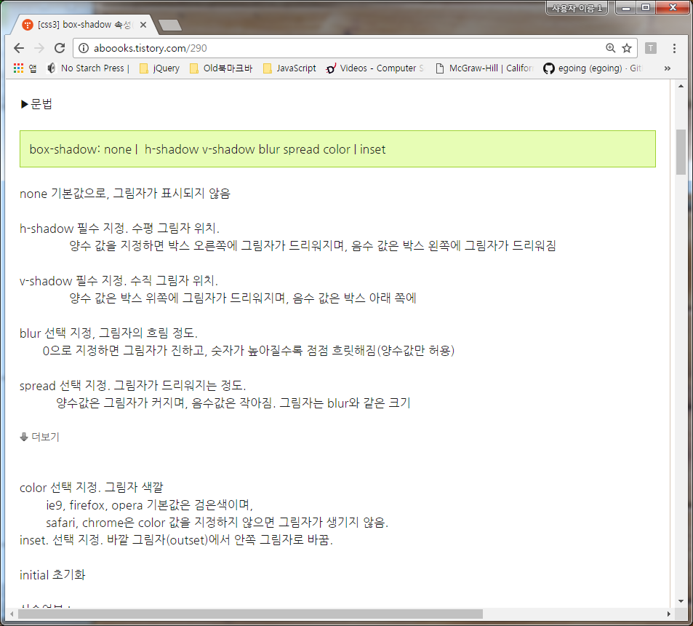

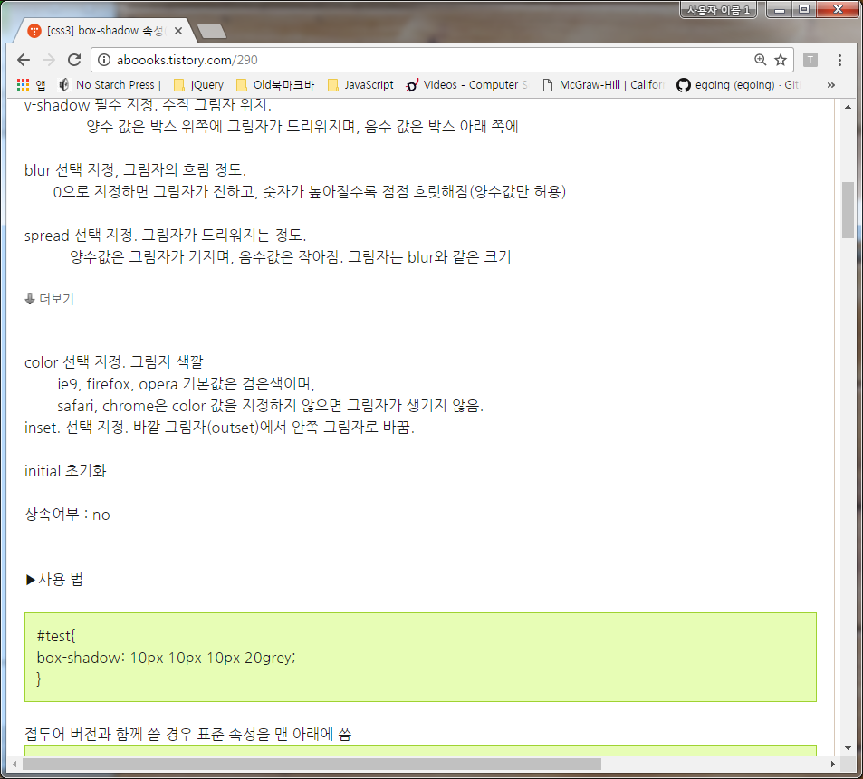

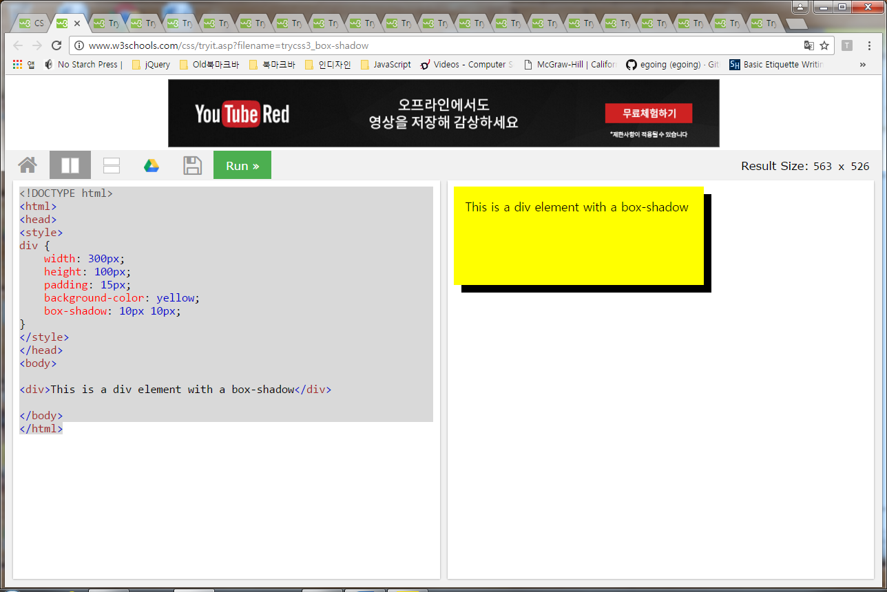

|  |
| --- |
| <!DOCTYPE html>  <html>  <head>  <style>  div {  width: 300px;  height: 100px;  padding: 15px;  background-color: yellow;  box-shadow: 10px 10px;  }  </style>  </head>  <body>  <div>This is a div element with a box-shadow</div>  </body>  </html> |

Css 수정

div {  
    box-shadow: 10px 10px grey;  
}

div {  
    box-shadow: 10px 10px 5px grey;  
}

# border-weight

|  |
| --- |
| <!DOCTYPE html>  <html>  <head>  <style>  p.one {  border-style: solid;  border-width: 5px;  }  p.two {  border-style: solid;  border-width: medium;  }  p.three {  border-style: dotted;  border-width: 2px;  }  p.four {  border-style: dotted;  border-width: thick;  }  p.five {  border-style: double;  border-width: 15px;  }  p.six {  border-style: double;  border-width: thick;  }  p.seven {  border-style: solid;  border-width: 2px 10px 4px 20px;  }  </style>  </head>  <body>  <h2>The border-width Property</h2>  <p>This property specifies the width of the four borders:</p>  <p class="one">Some text.</p>  <p class="two">Some text.</p>  <p class="three">Some text.</p>  <p class="four">Some text.</p>  <p class="five">Some text.</p>  <p class="six">Some text.</p>  <p class="seven">Some text.</p>  <p><b>Note:</b> The "border-width" property does not work if it is used alone.  Always specify the "border-style" property to set the borders first.</p>  </body>  </html> |

border 예제1

|  |
| --- |
| <!DOCTYPE html>  <!-- saved from url=(0071)http://www.htmlandcssbook.com/code-samples/chapter-13/border-color.html -->  <html><head><meta http-equiv="Content-Type" content="text/html; charset=UTF-8">  <title>Border Color</title>  <style type="text/css">  body {  font-family: Arial, Verdana, sans-serif;  color: #111111;}  p {  border-style: solid;  border-width: 3px;  width: 200px;}  p.one {  border-color: #0088dd;}  p.two {  border-color: #bbbbaa #111111 #ee3e80 #0088dd;}  </style>  </head>  <body>  <p class="one">The ARP Odyssey was introduced in 1972.</p>  <p class="two">The ARP Odyssey was introduced in 1972.</p>    </body></html> |

예제2

|  |
| --- |
| <!DOCTYPE html>  <!-- saved from url=(0071)http://www.htmlandcssbook.com/code-samples/chapter-13/border-color.html -->  <html><head><meta http-equiv="Content-Type" content="text/html; charset=UTF-8">  <title>Border Color</title>  <style type="text/css">  body {  font-family: Arial, Verdana, sans-serif;  color: #111111;}  p {  border-style: solid;  border-width: 70px;  width: 5px;  height: 5px;}  p.one {  border-color: #0088dd transparent;}  p.two {  border-color: #bbbbaa #111111 #ee3e80 #0088dd;}  </style>  </head>  <body>  <p class="one"></p>  <p class="two"></p>    </body></html> |

# text-shadow

|  |
| --- |
| <!DOCTYPE html>  <!-- saved from url=(0070)http://www.htmlandcssbook.com/code-samples/chapter-12/text-shadow.html -->  <html><head><meta http-equiv="Content-Type" content="text/html; charset=UTF-8">  <title>Text Shadow</title>  <style type="text/css">  p {  font-size: 200%;  padding: 20px;  text-align: center;}  p.one {  background-color: #eeeeee;  color: #666666;  text-shadow: 1px 1px 0px #000000;}  p.two {  background-color: #dddddd;  color: #666666;  text-shadow: 1px 1px 3px #666666;}  p.three {  background-color: #cccccc;  color: #ffffff;  text-shadow: 2px 2px 7px #111111;}  p.four {  background-color: #bbbbbb;  color: #cccccc;  text-shadow: -1px -2px #666666;}  p.five {  background-color: #aaaaaa;  color: #ffffff;  text-shadow: -1px -1px #666666;}  </style>  </head>  <body>  <p class="one">The briard is known as a heart wrapped in fur.</p>  <p class="two">The briard is known as a heart wrapped in fur.</p>  <p class="three">The briard is known as a heart wrapped in fur.</p>  <p class="four">The briard is known as a heart wrapped in fur.</p>  <p class="five">The briard is known as a heart wrapped in fur.</p>    </body></html> |

**Line-height**

The line-height property, when applied to block-level element, defines, as its name literally suggests, the **height of each line**.

The line-height property uses the following units:

* px
* em
* %
* unitless numbers, like 1.5

The unitless values basically act like percentages. So 150% is equal to 1.5. The latter is just more compact and readable.

* for body text, a line height of 1.5 times the size of the text is recommended.
* for headings, a line height of 1.2 is recommended

예를 들어

body{ font-size: 16px; line-height: 1.5;} 이면 The computed line height will thus be 16 * 1.5 = 24px.

그런데 body{ font-size: 16px; line-height: 1.5;}

blockquote{ font-size: 18px;} 라면 Line-height inheritance 에 의해 The blockquote element will have a line height of 27px 가 된다

|  |
| --- |
| <!DOCTYPE html>  <html>  <head>  <style>  p.small {  line-height: 0.7;  }  p.big {  line-height: 1.8;  }  </style>  </head>  <body>  <p>  This is a paragraph with a standard line-height.<br>  The default line height in most browsers is about 110% to 120%.<br>  </p>  <p class="small">  This is a paragraph with a smaller line-height.<br>  This is a paragraph with a smaller line-height.<br>  </p>  <p class="big">  This is a paragraph with a bigger line-height.<br>  This is a paragraph with a bigger line-height.<br>  </p>  </body>  </html> |

|  |
| --- |
| <!DOCTYPE html>  <html>  <head>  <title></title>  <style type="text/css">  body { line-height: 1; font-size: 20px;}  p { margin: 20px auto; max-width: 600px;}  .p1 { line-height: 150%;}  .p2 { line-height: 200%;}  .p3 { line-height: 250%;}  </style>  </head>  <body>  <p class="p1"><strong>Paragraph 1:</strong> Pellentesque habitant morbi tristique senectus et netus et malesuada fames ac turpis egestas.</p>  <p class="p2"><strong>Paragraph 2:</strong> Pellentesque habitant morbi tristique senectus et netus et malesuada fames ac turpis egestas.</p>  <p class="p3"><strong>Paragraph 3:</strong> Pellentesque habitant morbi tristique senectus et netus et malesuada fames ac turpis egestas.</p>  </body>  </html> |

In the demo above, the three paragraphs have their line heights set to 150%, 200%, and 250%, respectively. The body element has its font size defined at 20px. This means the computed line heights for the paragraphs are 30px, 40px, and 50px, respectively.

# **box-sizing**

|  |
| --- |
| <!doctype html>  <html>  <head>  <style>  /* *{  box-sizing:border-box;  }*/ div{  margin:10px;  width:150px;  }  #small{  border:10px solid black;  }  #large{  border:30px solid black;  }  </style>  </head>  <body>  <div id="small">Hello</div>  <div id="large">Hello</div>  </body>  </html> |

**마진 겹침 현상**

|  |
| --- |
| <!doctype html>  <html>  <head>  <style>  h1{  border:1px solid red;  margin:100px;  }  </style>  </head>  <body>  <h1>Hello world</h1>  <h1>Hello world</h1>  </body>  </html> |

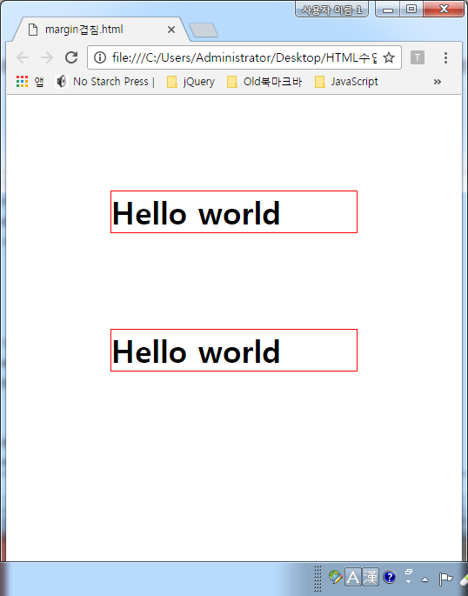

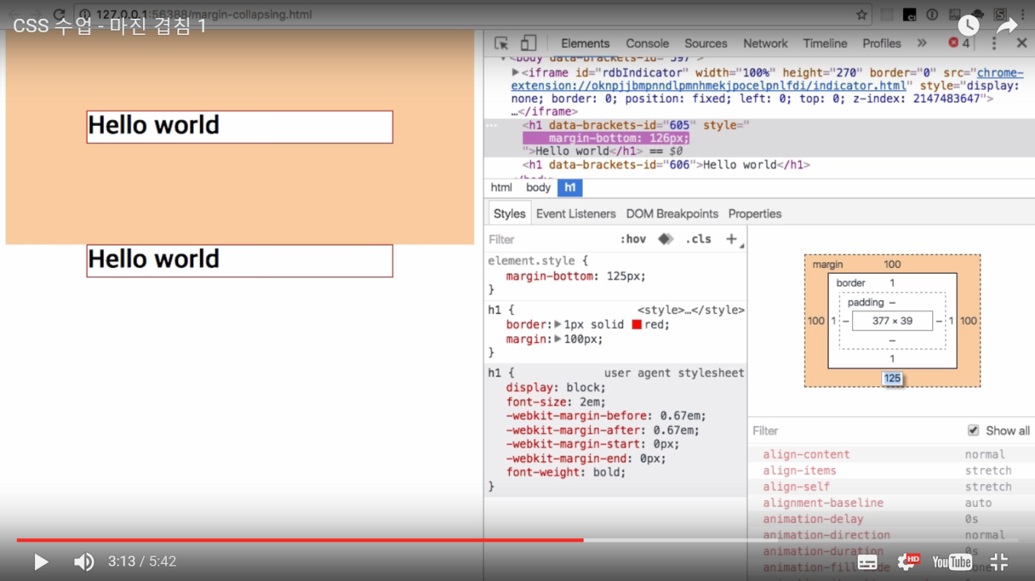

마진 값이 100보다 줄어들면 그때 사이의 간격이 벌어진다. 즉 2개의 마진 값 중 그쪽의 값이 두 태그 사이의 간격이 된다.

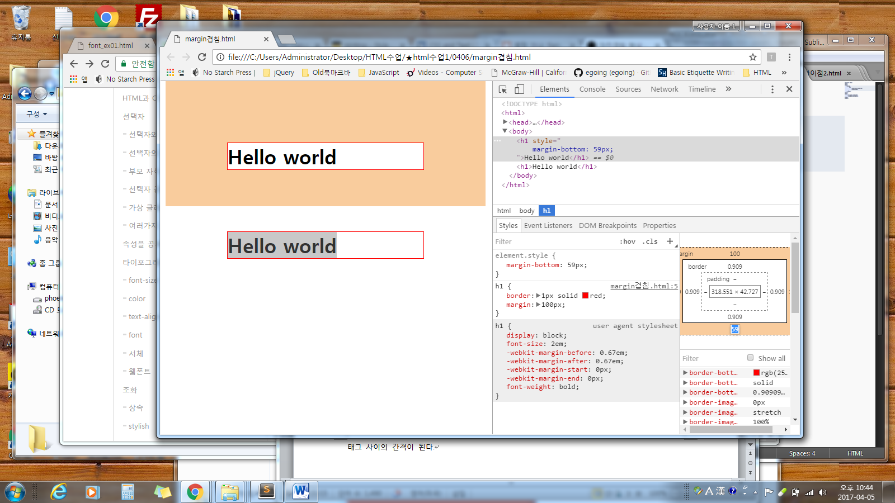

마진 겹침 현상 때문에 li 의 간격이 아래와 같이 된다.

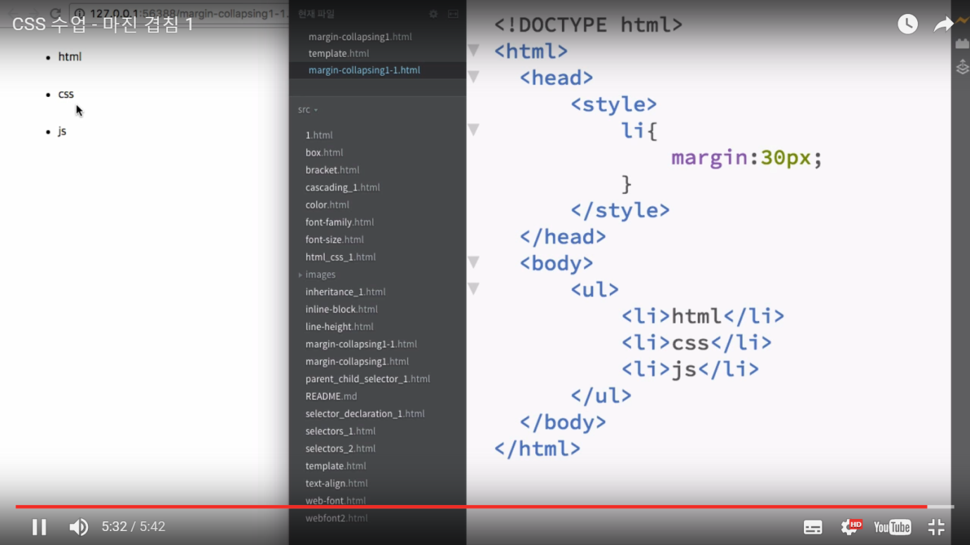

마진 겹침2

|  |
| --- |
| <html>  <head>  <style>  #parent{  /* border:1px solid tomato ; 부모의 태그가 주석될 때 마진 겹침 현상이 나타남 */  margin-top:100px;  }  /* 부모태그 화면에서 사라질 때 부모 태그의 마진과 자식 태그의 값이 합쳐지는 결과가 된다 */  #child{  background-color: powderblue;  margin-top:50px;  }  </style>  </head>  <body>  <div id="parent">  <div id="child">  Hello world  </div>  </div>  </body>  </html> |

**부모 엘리먼트의가 시각적으로 안 보일때 부모 엘리먼트의 마진 값과 자식 엘리먼트의 마진 값 중에서 큰 쪽의 마진 값이 자식 엘리먼트의 마진 값( 위치로 ) 으로 된다.**

# images 종합예제

|  |
| --- |
| <!DOCTYPE html>  <!-- saved from url=(0066)http://www.htmlandcssbook.com/code-samples/chapter-16/example.html -->  <html><head><meta http-equiv="Content-Type" content="text/html; charset=UTF-8">  <title>Images</title>  <style type="text/css">  body {  color: #665544;  background-color: #d4d0c6;  background-image: url("images/backdrop.gif");  font-family: Georgia, "Times New Roman", serif;  text-align: center;}  .wrapper {  width: 720px;  margin: 0px auto;}  .header {  margin: 40px 0px 20px 0px;}  .entry {  width: 220px;  float: left;  margin: 10px;  height: 198px;  background-image: url("images/shadow.png");  background-repeat: no-repeat;  background-position: bottom;}  figure {  display: block;  width: 202px;  height: 170px;  background-color: #e7e3d8;  margin: 0;  padding: 9px;  text-align: left;}  figure img {  width: 200px;  height: 150px;  border: 1px solid #d6d6d6;}  figcaption {  background-image: url("images/icon.png");  padding-left: 20px;  background-repeat: no-repeat;}  </style>  </head>  <body>  <div class="wrapper">  <div class="header">  <img src="./Images_files/title.gif" alt="Galerie Botanique" width="456" height="122">  <p>Here is a selection of antique botanical prints held in our collection.</p>  </div>  <div class="entry">  <figure><img src="./Images_files/print-01.jpg" alt="Helianthus">  <figcaption>Helianthus</figcaption>  </figure>  </div>  <div class="entry">  <figure><img src="./Images_files/print-02.jpg" alt="Passiflora">  <figcaption>Passiflora</figcaption>  </figure>  </div>  <div class="entry">  <figure><img src="./Images_files/print-03.jpg" alt="Nyctocalos">  <figcaption>Nyctocalos</figcaption>  </figure>  </div>  <div class="entry">  <figure><img src="./Images_files/print-04.jpg" alt="Polianthes">  <figcaption>Polianthes</figcaption>  </figure>  </div>  <div class="entry">  <figure><img src="./Images_files/print-05.jpg" alt="Ficus">  <figcaption>Ficus</figcaption>  </figure>  </div>  <div class="entry">  <figure><img src="./Images_files/print-06.jpg" alt="Dendrobium">  <figcaption>Dendrobium</figcaption>  </figure>  </div>  </div>    </body></html> |