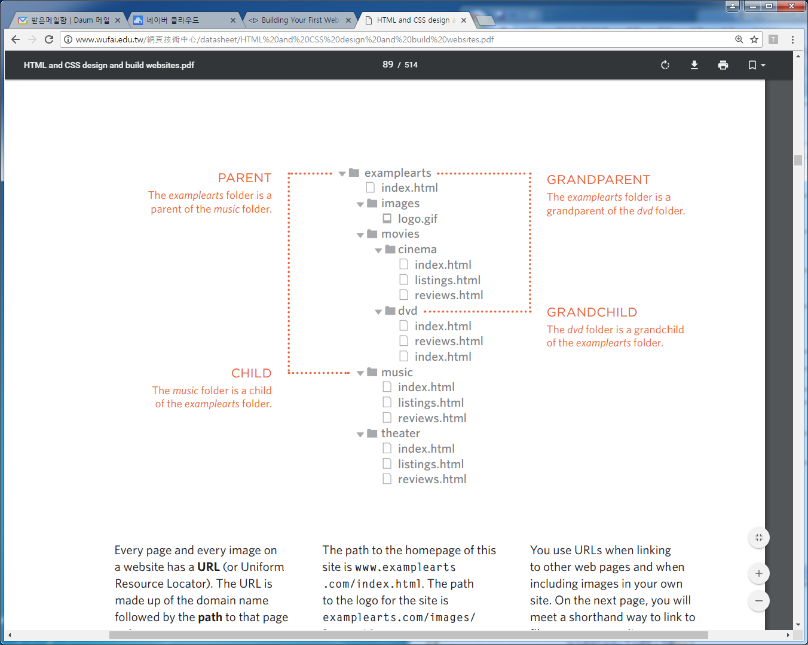

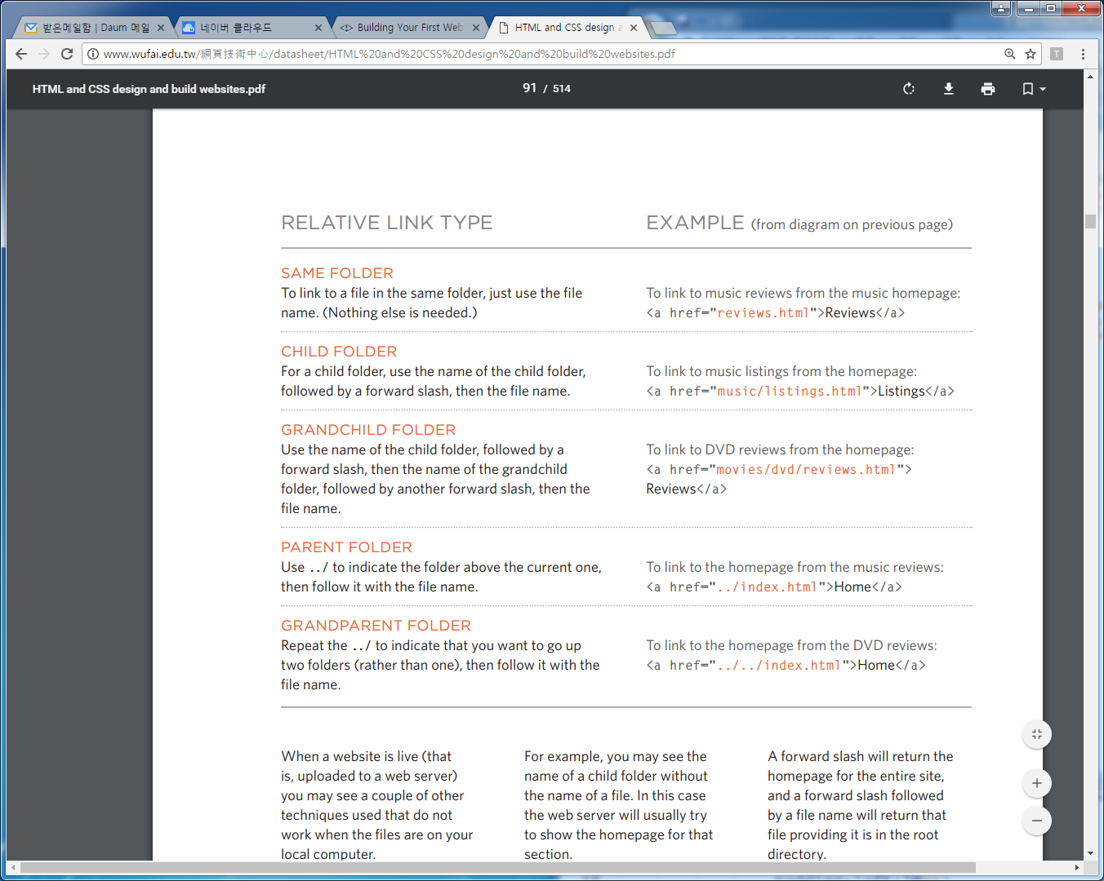

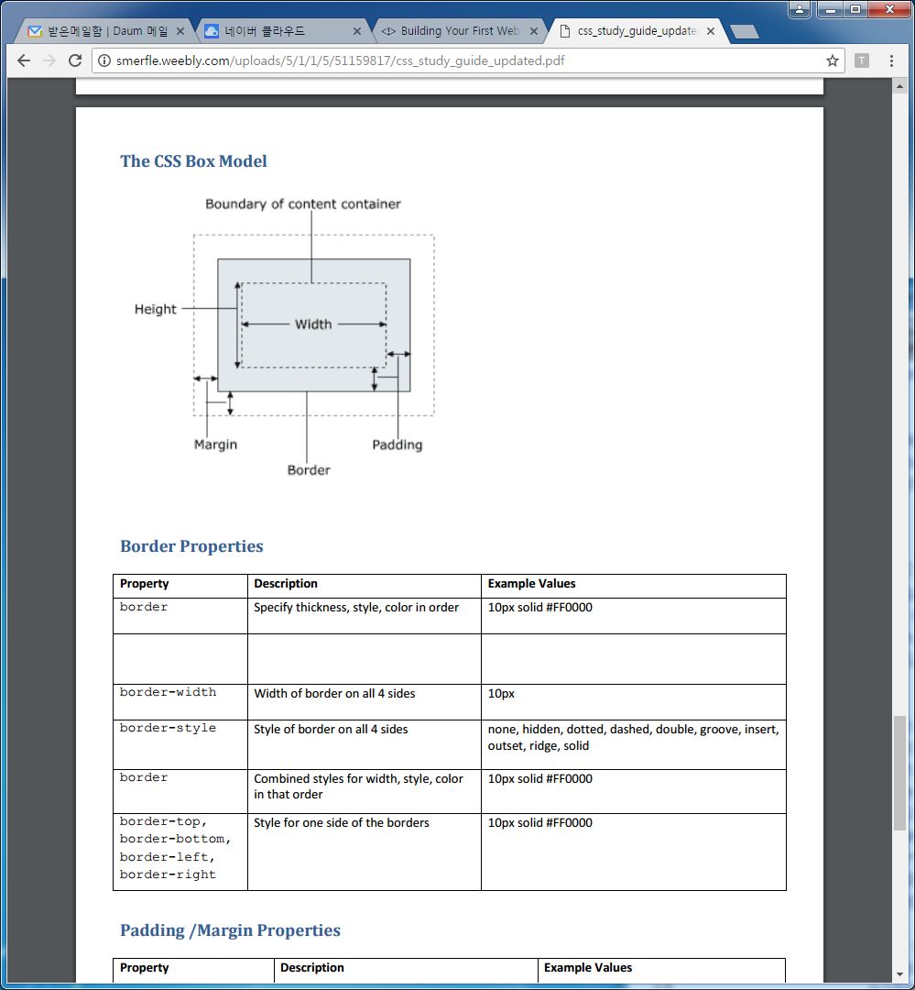

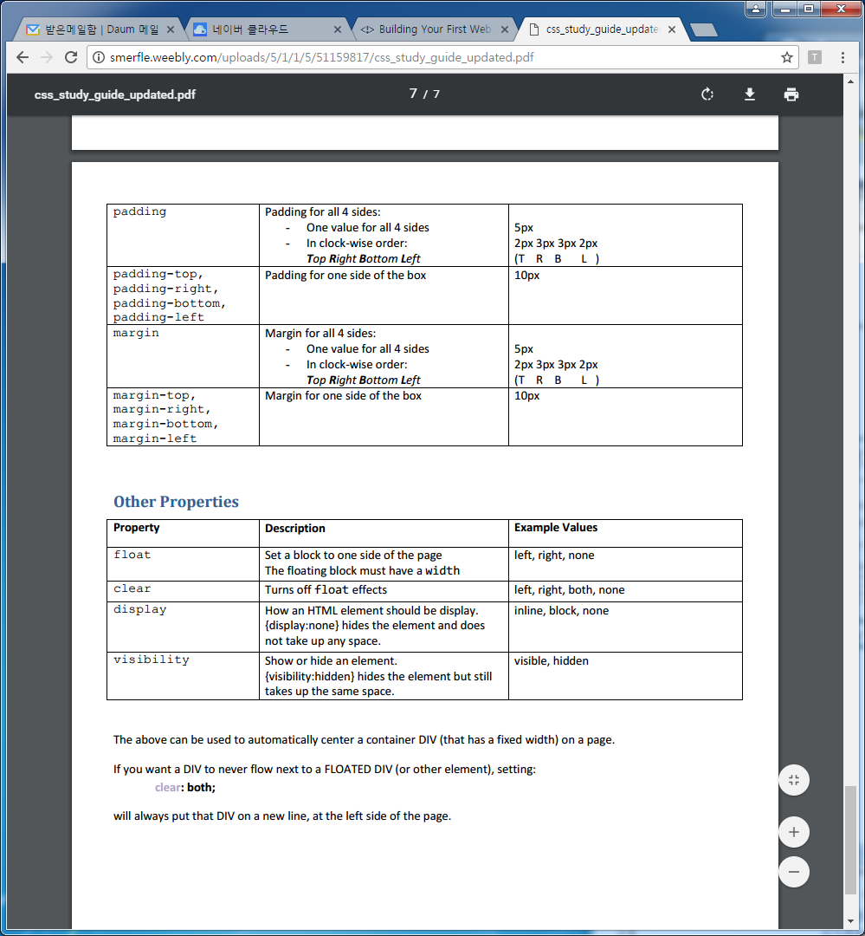

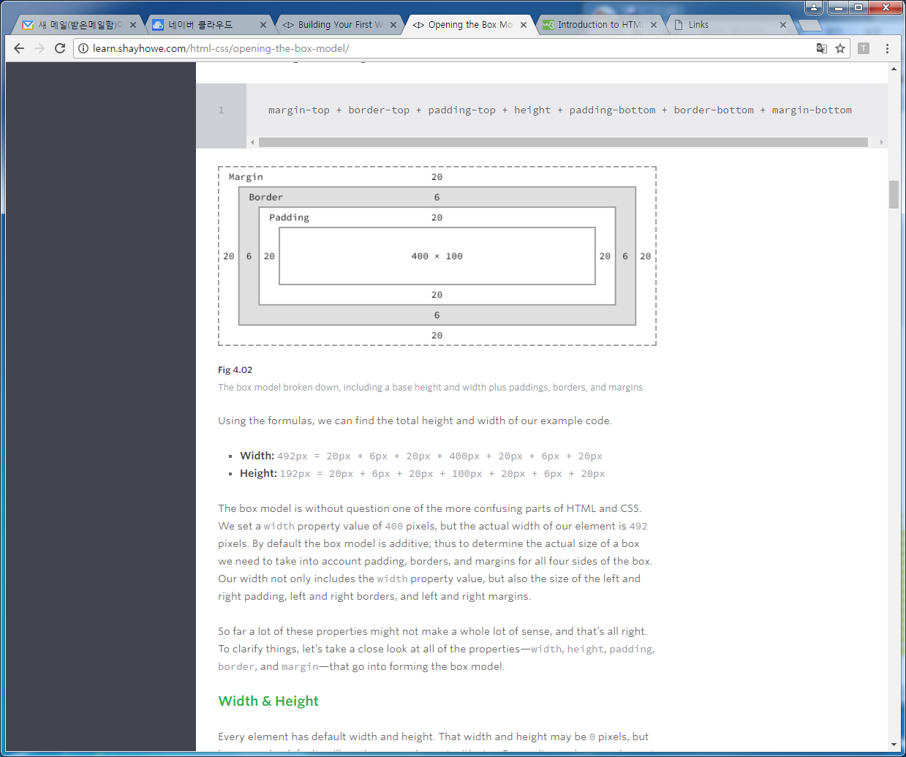

실습에제 1

|  |
| --- |
| <!DOCTYPE html>  <html>  <head>  <title></title>  <style type="text/css">    span {  background: #eaeaed;  color: #666;  font: 14px/24px "Source Code Pro", Inconsolata, "Lucida Console", Terminal, "Courier New", Courier;  display: inline-block;  height: 70px;  margin: 0 14px;  padding-top: 20px;  text-align: center;  width: 90px;  }  .border-solid {  border: 2px solid #9799a7;  }  .border-double {  border: 6px double #9799a7;  }  .border-dashed {  border: 8px dashed #9799a7;  }  .border-dotted {  border: 4px dotted #9799a7;  }  </style>  </head>  <body>  <span class="border-solid">2px <br> solid</span>  <span class="border-double">6px <br> double</span>  <span class="border-dashed">8px <br> dashed</span>  <span class="border-dotted">4px <br> dotted</span>  </body>  </html> |

**Links**

# Film Folk

## Festival Diary

Here are some of the film festivals we will be attending this year.  
Please [contact us](mailto:filmfolk@example.org) if you would like more information.

### January

[Sundance Film Festival](http://www.sundance.org)  
Park City, Utah, USA  
20 - 30 January 2011

### February

[Tropfest](http://www.tropfest.com)  
Sydney, Australia  
20 February 2011

[About Film Folk](about.html)

Top of page

인데스

Text

* [Headings](http://htmldog.com/examples/headings1/): [h1](http://htmldog.com/references/html/tags/h1h2h3h4h5h6/) to [h6](http://htmldog.com/references/html/tags/h1h2h3h4h5h6/) in their default style.
* [Size doesn’t matter](http://htmldog.com/examples/headings2/): Making headings any size you choose with CSS.
* [Bold, italics, case, and line height](http://htmldog.com/examples/case/): Using [font-weight](http://htmldog.com/references/css/properties/font-weight/), [font-style](http://htmldog.com/references/css/properties/font-style/), [font-variant](http://htmldog.com/references/css/properties/font-variant/), [text-transform](http://htmldog.com/references/css/properties/text-transform/), and [line-height](http://htmldog.com/references/css/properties/line-height/).
* [Font families](http://htmldog.com/examples/fontfamilies/): Font family lists and the generic fallback font families.
* [Font sizes](http://htmldog.com/examples/fontsizes/): Absolute and relative units.
* [Spacing out text](http://htmldog.com/examples/textalign/): [text-align](http://htmldog.com/references/css/properties/text-align/), [text-indent](http://htmldog.com/references/css/properties/text-indent/), [word-spacing](http://htmldog.com/references/css/properties/word-spacing/), and [letter-spacing](http://htmldog.com/references/css/properties/letter-spacing/) properties.
* [Vertical alignment](http://htmldog.com/examples/verticalalign/): The [vertical-align](http://htmldog.com/references/css/properties/vertical-align/) property.
* [Subscript and superscript](http://htmldog.com/examples/superscript/): Using positioning as an alternative to the [vertical-align](http://htmldog.com/references/css/properties/vertical-align/) property.
* [Text shadows](http://htmldog.com/examples/textshadows/): Shadows. On text.
* [Simple drop caps](http://htmldog.com/examples/dropcaps1/): A simple way to achieve a common effect.
* [Fancy drop caps](http://htmldog.com/examples/dropcapsFancy/): Jazzing up that first letter.
* [Graphical drop caps](http://htmldog.com/examples/dropcapsGraphical/): Using images.
* [First-paragraph drop caps](http://htmldog.com/examples/dropcaps3/): Targeting the first letter of the first paragraph.
* [Pull quotes 1](http://htmldog.com/examples/pullquotes1/): A simple pull quote structure.
* [Pull quotes 2](http://htmldog.com/examples/pullquotes2/): Adding a bit of style.
* [Pull quotes 3](http://htmldog.com/examples/pullquotes3/): A more elaborate style.

Links

* [Underlines](http://htmldog.com/examples/underlines/): Various ways of underlining (usually links), using [text-decoration](http://htmldog.com/references/css/properties/text-decoration/), [border-bottom](http://htmldog.com/references/css/properties/border-bottom/), and [background-image](http://htmldog.com/references/css/properties/background-image/).
* [Anchors and targets](http://htmldog.com/examples/target/): Linking to parts of a page, and styling them using the :target pseudo class.
* [Rollovers 1](http://htmldog.com/examples/rollovers1/): Graphical links that change when the cursor moves over them using :hover.
* [Rollovers 2](http://htmldog.com/examples/rollovers2/): Further interactive effects, utilizing the :activepseudo class.
* [Rollovers 3](http://htmldog.com/examples/rollovers3/): Fading in and out.
* [Rollovers 4](http://htmldog.com/examples/rollovers4/): Rotating, using [transform](http://htmldog.com/references/css/properties/transform/).
* [Simple CSS transitions](http://htmldog.com/examples/transitions1/): Subtle animations of text links when they are hovered over.
* [More CSS transitions](http://htmldog.com/examples/transitions2/): Using [border-radius](http://htmldog.com/references/css/properties/border-radius/) and RGBa colors.
* [CSS transition timing functions](http://htmldog.com/examples/transitions3/): Handling acceleration and deceleration of animated transitions.

Colors, Images, and Backgrounds

* [Colors](http://htmldog.com/examples/colors/): CSS colors, using [color](http://htmldog.com/references/css/properties/color/) and [background-color](http://htmldog.com/references/css/properties/background-color/)properties.
* [HTML images](http://htmldog.com/examples/images1/): The [img](http://htmldog.com/references/html/tags/img/) element.
* [Background images](http://htmldog.com/examples/images2/): The [background-image](http://htmldog.com/references/css/properties/background-image/) CSS property.
* [Positioning backgrounds](http://htmldog.com/examples/background-position/): Using the [background-position](http://htmldog.com/references/css/properties/background-position/)property.
* [Repeating background images](http://htmldog.com/examples/background-repeat/): Using the [background-repeat](http://htmldog.com/references/css/properties/background-repeat/)property.
* [Background attachment](http://htmldog.com/examples/background-attachment/): How a background behaves with scrolling content.
* [Background image size](http://htmldog.com/examples/background-size/): Using [background-size](http://htmldog.com/references/css/properties/background-size/).
* [Multiple backgrounds](http://htmldog.com/examples/multiplebackgrounds/): Layering backgrounds inside a single box.
* [Linear gradients](http://htmldog.com/examples/gradients1/): Creating gradient backgrounds with CSS.
* [Radial gradients](http://htmldog.com/examples/gradients2/): Circular and elliptical gradient backgrounds.
* [Opacity](http://htmldog.com/examples/opacity/): The transparency of a box.

Layout

* [Widths and heights](http://htmldog.com/examples/widthsheights/): [width](http://htmldog.com/references/css/properties/width/), [height](http://htmldog.com/references/css/properties/height/), [max-width](http://htmldog.com/references/css/properties/max-width/), [min-height](http://htmldog.com/references/css/properties/min-height/), and so on.
* [Borders](http://htmldog.com/examples/borders/): Thick, thin, this color, that color, solid, dotted, dashed…
* [Rounded corners](http://htmldog.com/examples/borderradius/): Using the [border-radius](http://htmldog.com/references/css/properties/border-radius/) property.
* [Box shadows](http://htmldog.com/examples/boxshadows/): Adding pop.
* [Margin collapsing](http://htmldog.com/examples/margincollapse/): How vertical margins merge, or “collapse”, into each other.
* [Outlines](http://htmldog.com/examples/outlines/): The “borders” that border borders.
* [Overflow](http://htmldog.com/examples/overflow/): Managing the portions of content that do not fit inside a box.
* [Block and inline 1](http://htmldog.com/examples/blockinline1/): Changing the behavior of boxes using the [display](http://htmldog.com/references/css/properties/display/) property.
* [Block and inline 2](http://htmldog.com/examples/blockinline2/): More differences between block and inline boxes.
* [Block and inline 3](http://htmldog.com/examples/blockinline3/): Applying display: inline-block.
* [Positioning: static](http://htmldog.com/examples/positioning1/): Following the normal flow.
* [Positioning: relative](http://htmldog.com/examples/positioning2/): Offsetting from the box’s initial position.
* [Positioning: absolute 1](http://htmldog.com/examples/positioning3/): Positioning in relation to a box’s container.
* [Positioning: absolute 2](http://htmldog.com/examples/positioning4/): Inside a positioned box.
* [Positioning: fixed](http://htmldog.com/examples/positioning5/): In relation to the viewport.
* [Z-index](http://htmldog.com/examples/z-index/): Stacking positioned boxes.
* [Floating 1](http://htmldog.com/examples/float1/): A simple floated box.
* [Floating 2](http://htmldog.com/examples/float2/): Two floated boxes.
* [Floating 3](http://htmldog.com/examples/float3/): Clearing floated boxes.
* [Page layout 1](http://htmldog.com/examples/pagelayout1/): Two columns step 1: positioning a navigation column.
* [Page layout 2](http://htmldog.com/examples/pagelayout2/): Two columns step 2: using [margin](http://htmldog.com/references/css/properties/margin/) to push the content out from under the navigation column.
* [Page layout 3](http://htmldog.com/examples/pagelayout3/): Using a border to provide the background for a column.
* [Page layout 4](http://htmldog.com/examples/pagelayout4/): Three columns.
* [Page layout 5](http://htmldog.com/examples/pagelayout5/): Adding a header.
* [Page layout 6](http://htmldog.com/examples/pagelayout6/): Footers won’t always work with absolute positioned columns…
* [Page layout 7](http://htmldog.com/examples/pagelayout7/): Adding a footer using floated columns.
* [Charles Darwin](http://htmldog.com/examples/darwin/): A styled up version of the basic principles of previous examples.
* [2D Transforms](http://htmldog.com/examples/transforms/): Manipulating the size, shape, and position of boxes with the [transform](http://htmldog.com/references/css/properties/transform/) property.
* [Transform origin](http://htmldog.com/examples/transform-origin/): Altering the point at which transformations are measured from.

Lists & Navigation

* [Basic lists](http://htmldog.com/examples/lists1/): [ul](http://htmldog.com/references/html/tags/ul/), [ol](http://htmldog.com/references/html/tags/ol/), and [li](http://htmldog.com/references/html/tags/li/) elements.
* [Nested lists](http://htmldog.com/examples/lists2/): Lists inside lists.
* [Description lists](http://htmldog.com/examples/lists3/): [dl](http://htmldog.com/references/html/tags/dl/), [dt](http://htmldog.com/references/html/tags/dt/), and [dd](http://htmldog.com/references/html/tags/dd/).
* [List markers](http://htmldog.com/examples/lists4/): Changing bullets and numbering using [list-style-type](http://htmldog.com/references/css/properties/list-style-type/).
* [Images as list item markers](http://htmldog.com/examples/list-style-image/): Using [list-style-image](http://htmldog.com/references/css/properties/list-style-image/).
* [Inside and outside list markers](http://htmldog.com/examples/lists5/): Using [list-style-position](http://htmldog.com/references/css/properties/list-style-position/).
* [Dropdowns 1](http://htmldog.com/examples/dropdowns1/): The basics of a dropdown menu.
* [Dropdowns 2](http://htmldog.com/examples/dropdowns2/): A simple multi-level dropdown menu.
* [Dropdowns 3](http://htmldog.com/examples/dropdowns3/): Multi-level dropdown with more detailed design.
* [Inline tabs](http://htmldog.com/examples/tabs1/): Basic tabbed navigation using the [display](http://htmldog.com/references/css/properties/display/) property.
* [Floated tabs](http://htmldog.com/examples/tabs2/): Basic tabs using the [float](http://htmldog.com/references/css/properties/float/) property.
* [More tabs](http://htmldog.com/examples/tabs3/): Making tabs more tab-like.
* [Yet more tabs](http://htmldog.com/examples/tabs4/): An alternative tab style.
* [Skinny tabs](http://htmldog.com/examples/tabs5/): Using simple underlines.
* [Fancy tabs](http://htmldog.com/examples/tabs7/): Going wild with CSS.
* [Show / hide navigation (JavaScript)](http://htmldog.com/examples/showhide1/): Toggling display using JavaScript.
* [Show / hide navigation (target)](http://htmldog.com/examples/showhide2/): Toggling display using the :targetpseudo class.

Tables

* [Basic table](http://htmldog.com/examples/basictable/): [table](http://htmldog.com/references/html/tags/table/), [tr](http://htmldog.com/references/html/tags/tr/), and [td](http://htmldog.com/references/html/tags/td/) elements.
* [Header cells](http://htmldog.com/examples/headercells/): [th](http://htmldog.com/references/html/tags/th/) elements.
* [Merging cells 1](http://htmldog.com/examples/rowspan/): The rowspan attribute.
* [Merging cells 2](http://htmldog.com/examples/colspan/): The colspan attribute.
* [Border collapsing 1](http://htmldog.com/examples/bordercollapse1/): Collapsing table cell borders.
* [Border collapsing 2](http://htmldog.com/examples/bordercollapse2/): Collapsing table cell borders and table borders.
* [Column groups](http://htmldog.com/examples/colgroup/): [col](http://htmldog.com/references/html/tags/col/) and [colgroup](http://htmldog.com/references/html/tags/colgroup/) elements.
* [Empty cells](http://htmldog.com/examples/emptycells/): Using the [empty-cells](http://htmldog.com/references/css/properties/empty-cells/) property to specify how empty cells should be displayed.
* [Automatic table layout](http://htmldog.com/examples/tablelayout1/): The default layout algorithm that tables use.
* [Fixed table layout](http://htmldog.com/examples/tablelayout2/): Set using the [table-layout](http://htmldog.com/references/css/properties/table-layout/) property.

Forms

* [Text boxes](http://htmldog.com/examples/inputtextboxes/): Text and password type [input](http://htmldog.com/references/html/tags/input/) elements.
* [Checkboxes and radio buttons](http://htmldog.com/examples/inputcheckboxes/): More [input](http://htmldog.com/references/html/tags/input/) element types.
* [File input](http://htmldog.com/examples/inputfile/): For uploading.
* [Text areas](http://htmldog.com/examples/textarea/): The [textarea](http://htmldog.com/references/html/tags/textarea/) element.
* [Select boxes](http://htmldog.com/examples/select1/): Basic use of [select](http://htmldog.com/references/html/tags/select/) and [option](http://htmldog.com/references/html/tags/option/) elements.
* [Select box option groups](http://htmldog.com/examples/select2/): Using the [optgroup](http://htmldog.com/references/html/tags/optgroup/) element.
* [Multiple selection select boxes](http://htmldog.com/examples/select3/): Using the multiple attribute.

Related pages

* [Tutorials](http://htmldog.com/guides/)
* [Techniques](http://htmldog.com/techniques/)

|  |  |
| --- | --- |
| **Special Characters** |  |
| &lt; | **<** - Less-Than Symbol |
| &gt; | **>** - Greater-Than Symbol |
| &amp; | **&** - Ampersand, or 'and' sign |
| &quot; | **"** - Quotation Mark |
| &copy; | **©** - Copyright Symbol |
| &trade; | **™** - Trademark Symbol |
| &nbsp; | - A space (non-breaking space) |
| &#??; |  |

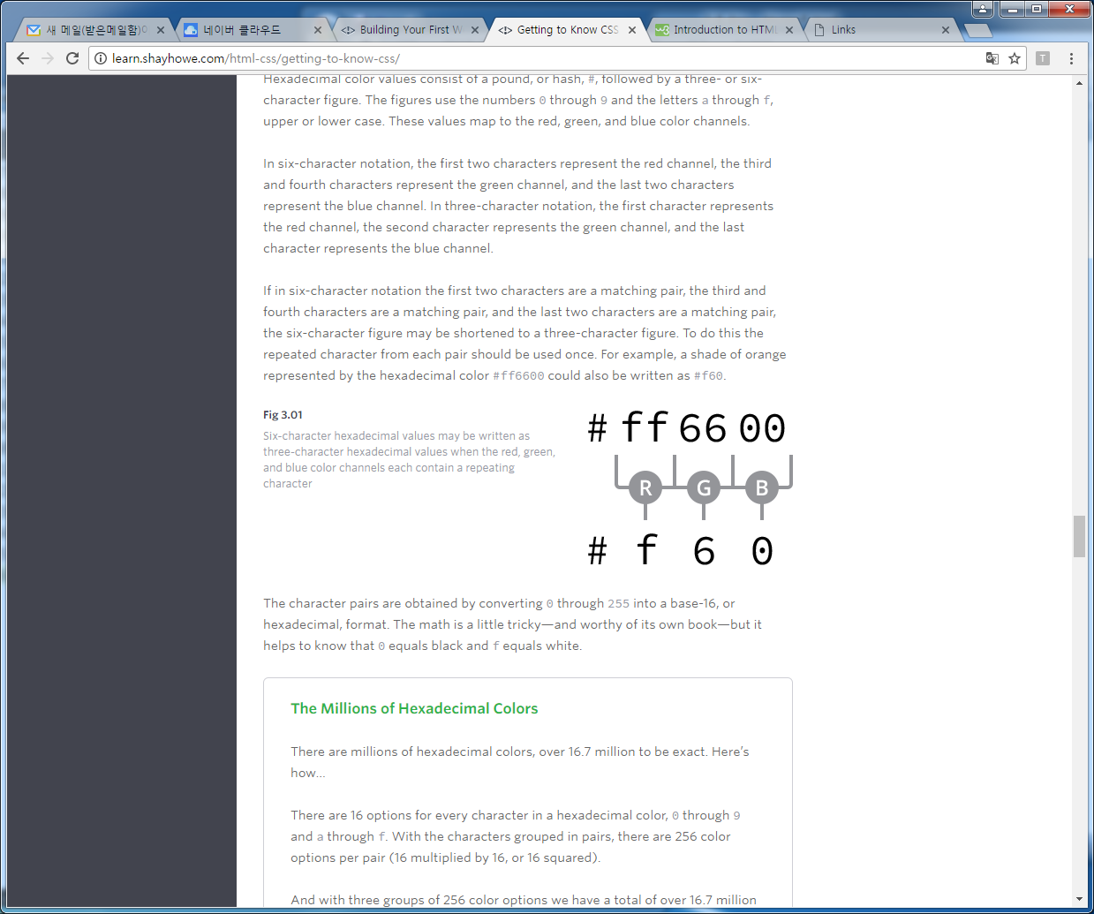

| **Color** | **Name** | **Hex Values** | **RGB Values** | **HSL Values** |
| --- | --- | --- | --- | --- |
|  | black | #000000 | rgb(0, 0, 0) | hsl(0, 0%, 0%) |
|  | silver | #c0c0c0 | rgb(192, 192, 192) | hsl(0, 0%, 75%) |
|  | gray | #808080 | rgb(128, 128, 128) | hsl(0, 0%, 50%) |
|  | white | #ffffff | rgb(255, 255, 255) | hsl(0, 100%, 100%) |
|  | maroon | #800000 | rgb(128, 0, 0) | hsl(0, 100%, 25%) |
|  | red | #ff0000 | rgb(255, 0, 0) | hsl(0, 100%, 50%) |
|  | purple | #800080 | rgb(128, 0, 128) | hsl(300, 100%, 25%) |
|  | fuchsia | #ff00ff | rgb(255, 0, 255) | hsl(300, 100%, 50%) |
|  | green | #008000 | rgb(0, 128, 0) | hsl(120, 100%, 25%) |
|  | olive | #808000 | rgb(0, 255, 0) | hsl(120, 100%, 50%) |
|  | lime | #00ff00 | rgb(128, 128, 0) | hsl(60, 100%, 25%) |
|  | yellow | #ffff00 | rgb(255, 255, 0) | hsl(60, 100%, 50%) |
|  | navy | #000080 | rgb(0, 0, 128) | hsl(240, 100%, 25%) |
|  | blue | #0000ff | rgb(0, 0, 255) | hsl(240, 100%, 50%) |
|  | teal | #008080 | rgb(0, 128, 128) | hsl(180, 100%, 25%) |
|  | aqua | #00ffff | rgb(0, 255, 255) | hsl(180, 100%, 50%) |