- Screenshot when you perform step#3
Test your cluster with nginx as followed:
a. Deploy an nginx on your cluster using the deployment file from https://k8s.io/examples/application/deployment.yaml
b. Use kubectl to describe the deployment
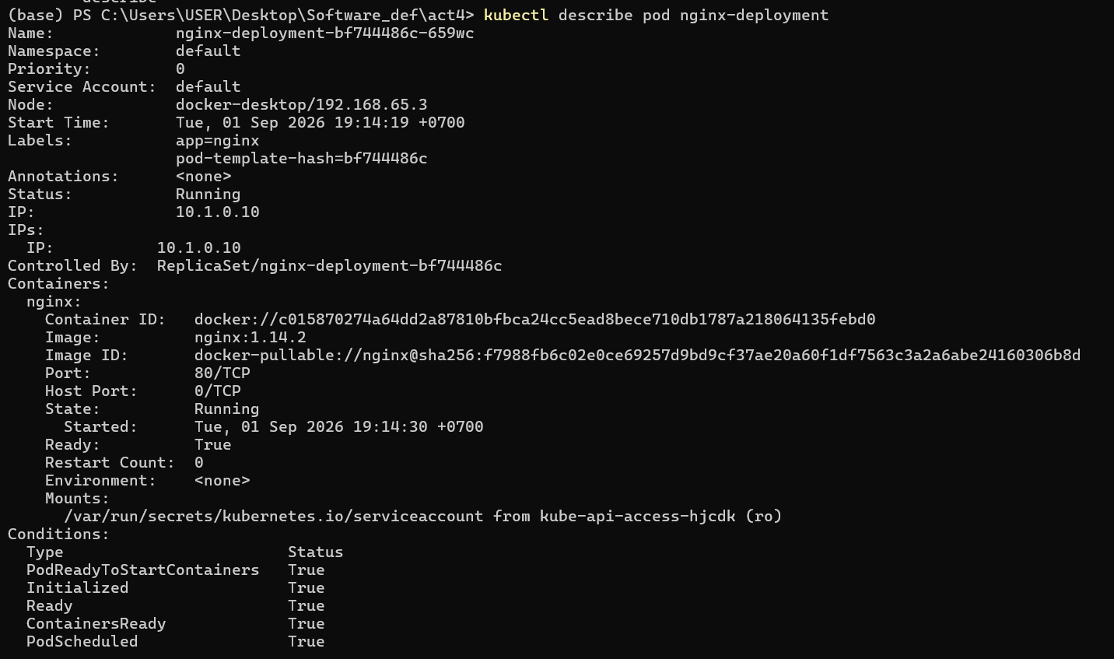

- The deployment file that you create in step#4b and ingress file in step#4d
b. Create a deployment file of a pod with service of the following containers:
i. todo (release-2.1)
ii. redis
Note: you can use a docker-hub image: natawut/todo-service:release-2.1 and you must ensure that environment for REDIS_HOST
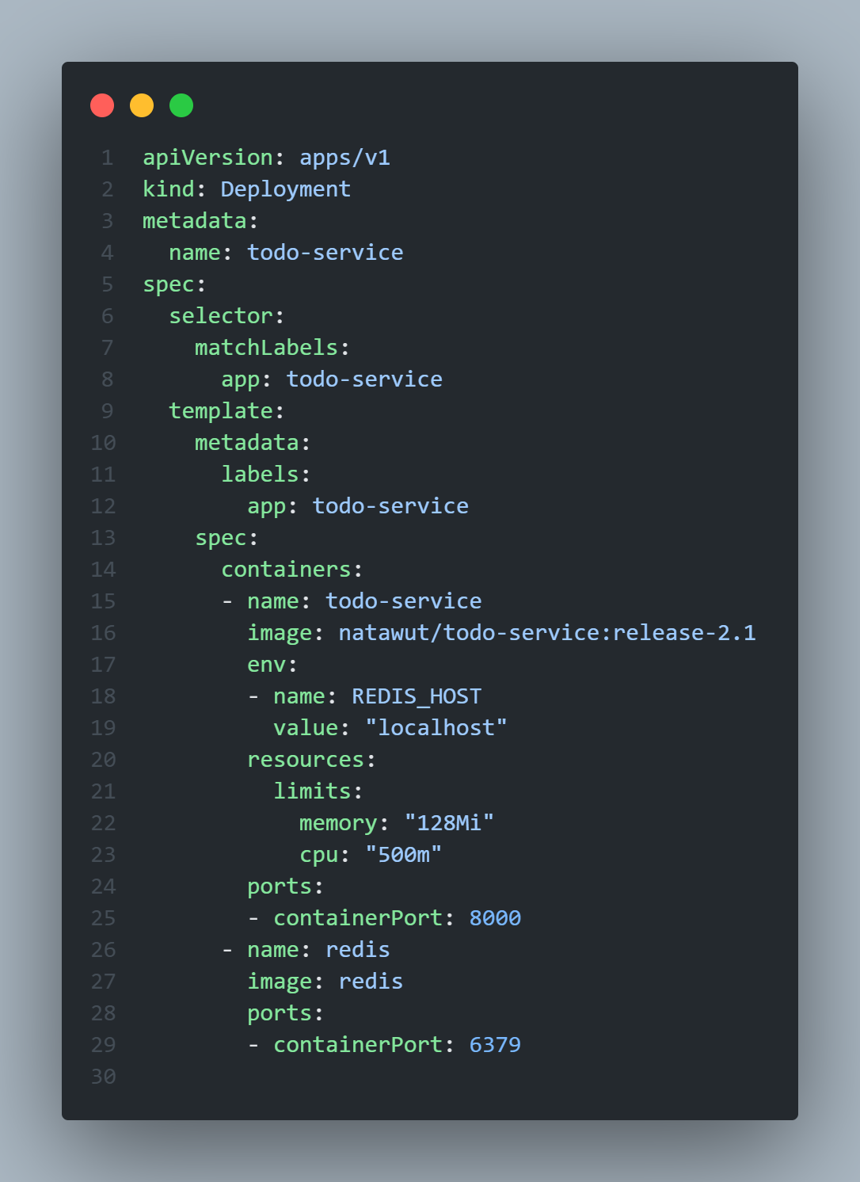
d. Create ingress configuration file, apply the file, and show the ingress information
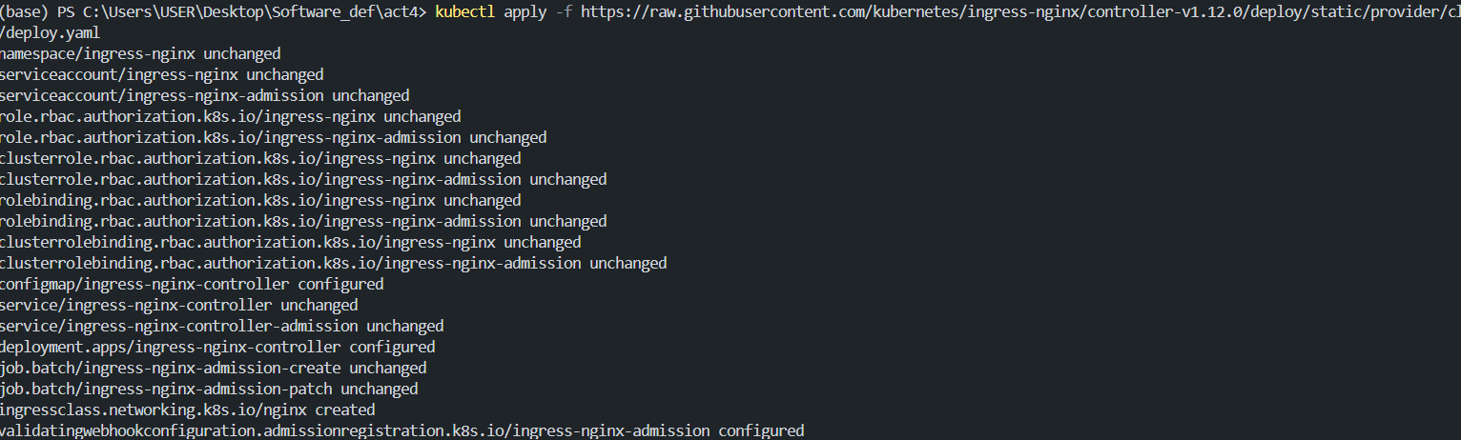
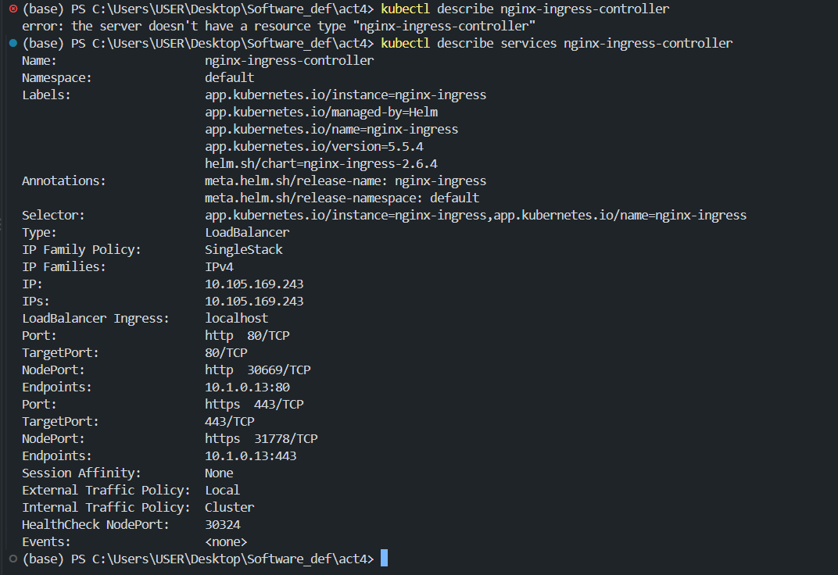

- 4-c
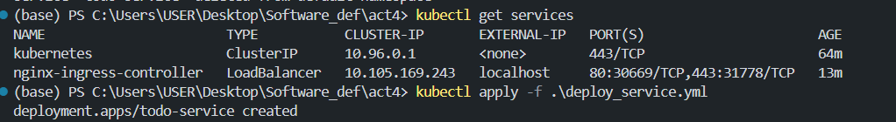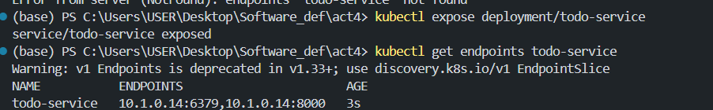
4-e
