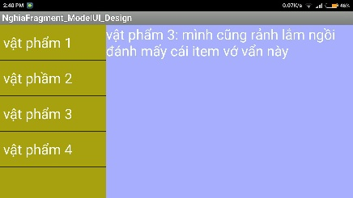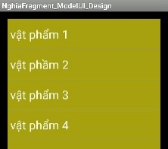MENU FRAGMENT – MODEL UI

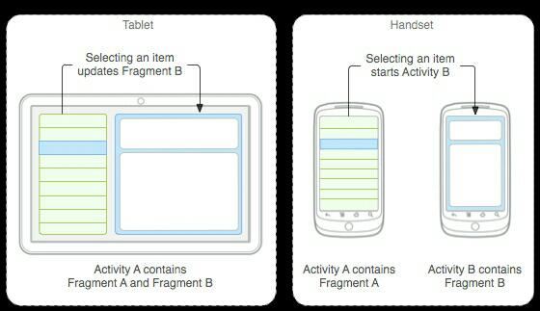

Màn hình thẳng sẽ chọn Menu item đến Activity Description.

Màn hình ngang hiện cả Menu lẫn Description.

**Bước 1: tạo fragmentA, hiển thị List**

**File: fragment_a.xml**

<LinearLayout…>

<ListView…

android:id="@+id/listView"/>

</LinearLayout>

**File: FragmentA.java**

public class FragmentA extends Fragment {

ICommunicate mCommunicate;

ListView listView;

ArrayAdapter mAdapterView;

@Override

public void onCreate(Bundle savedInstanceState) {

super.onCreate(savedInstanceState);

}

@Override

public View onCreateView(LayoutInflater inflater, ViewGroup container, Bundle savedInstanceState) {

// khởi tạo giao diện XML

View view = inflater.inflate(R.layout.fragment_a, container, false);

//find & init Views

listView = (ListView) view.findViewById(R.id.listView);

mAdapterView = ArrayAdapter.createFromResource(getActivity(), R.array.nghia_item, android.R.layout.simple_list_item_1);

listView.setAdapter(mAdapterView);

listView.setOnItemClickListener(new AdapterView.OnItemClickListener() {

@Override

public void onItemClick(AdapterView<?> parent, View view, int position, long id) {

listView_onItemClick(parent, view, position, id);

}

});

return view;

}

@Override

public void onActivityCreated(Bundle savedInstanceState) {

super.onActivityCreated(savedInstanceState);

}

@Override

public void onSaveInstanceState(Bundle outState) {

super.onSaveInstanceState(outState);

}

@Override

public void onDetach() {

super.onDetach();

}

private void listView_onItemClick(AdapterView<?> parent, View view, int position, long id) {

this.mCommunicate.fragmentRespone(position); // gởi postion qua MainActivity

}

/**

* khởi tạo Communicate cầu nối, liên hệ FRAGMENT_B

* @param communicate

*/

public void setCommunicate(ICommunicate communicate) {

this.mCommunicate = communicate;

}

/**

* giao tiếp chuyển đổi dữ liệu: FRAGMENT_A to MainActivity to FRAGMENT_B

*/

public interface ICommunicate{

/**

* phải hồi lại khi FRAGMENT_A GỞI DỮ LIỆU

* @param position vị trí trong list

*/

public void fragmentRespone(int position);

}

}

**Bước 2: tạo FragmentB, hiển thị Description**

**File: fragment_b.xml**

<LinearLayout…>

<TextView… android:id="@+id/textView"/>

</LinearLayout>

**File: FragmentB.java**

public class FragmentB extends Fragment {

TextView textView;

@Override

public void onCreate(Bundle savedInstanceState) {

super.onCreate(savedInstanceState);

}

@Override

public View onCreateView(LayoutInflater inflater, ViewGroup container, Bundle savedInstanceState) {

// khởi tạo giao diện XML

View view = inflater.inflate(R.layout.fragment_b, container, false);

// find & init views

textView = (TextView) view.findViewById(R.id.textView);

return view;

}

@Override

public void onActivityCreated(Bundle savedInstanceState) {

super.onActivityCreated(savedInstanceState);

}

@Override

public void onSaveInstanceState(Bundle outState) {

super.onSaveInstanceState(outState);

}

@Override

public void onDetach() {

super.onDetach();

}

public void changeData(int position){

// gởi position trong array qua để hiển thị lên TEXT VIEW

String[] arrDescription = getResources().getStringArray(R.array.nghia_item_description);

textView.setText(arrDescription[position]);

}

}

**Bước 3: tạo Main Activity**

**File: activity_main.xml**

<RelativeLayout... tools:context=".MainActivity">

<fragment…

android:id="@+id/fragA_List"

android:layout_width="match_parent"

android:layout_height="match_parent"

android:name="com.imark.nghia.nghiafragment_modelui_design.FragmentA"

tools:layout="@layout/fragment_a"/>

</RelativeLayout>

**File hiển thị khi xoay ngang: layout-land/activity_main.xml**

<LinearLayout... android:orientation="horizontal">

<fragment

android:id="@+id/fragA_List"

android:layout_width="0dp"

android:layout_height="match_parent"

android:layout_weight="0.3"

android:name="com.imark.nghia.nghiafragment_modelui_design.FragmentA"

tools:layout="@layout/fragment_a"/>

<fragment

android:id="@+id/fragB_Description"

android:layout_width="0dp"

android:layout_height="match_parent"

android:layout_weight="0.7"

android:name="com.imark.nghia.nghiafragment_modelui_design.FragmentB"

tools:layout="@layout/fragment_b"/>

</LinearLayout>

**File: MainActivity.java**

public class MainActivity extends Activity implements FragmentA.ICommunicate {

public static final String EXTRA_KEY_POSITION = "KEY POSITION";

FragmentA fragA_List;

FragmentB fragB_Description;

FragmentManager fragManager;

@Override

protected void onCreate(Bundle savedInstanceState) {

...

// find & init views

fragManager = getFragmentManager();

fragA_List = (FragmentA) fragManager.findFragmentById(R.id.fragA_List);

fragA_List.setCommunicate(this);

}

@Override

public void fragmentRespone(int position) {

// FRAGMENT_A gọi hàm này, hàm này chuyển qua FRAGMENT_B

fragB_Description = (FragmentB) fragManager.findFragmentById(R.id.fragB_Description);

if (fragB_Description != null && fragB_Description.isVisible()) {

// nếu fragment_b tồn tại => gởi dữ liệu đến

fragB_Description.changeData(position);

} else {

// fragment_b không tồn tại => chuyển đến activity khác

Intent intent = new Intent(this, DescriptionActivity.class);

intent.putExtra(EXTRA_KEY_POSITION, position);

startActivity(intent);

}

}

}

**File hiện description: activity_description.xml**

<RelativeLayout… tools:context="com.imark.nghia.nghiafragment_modelui_design.DescriptionActivity">

<fragment...

android:id="@+id/fragB_Description"

android:name="com.imark.nghia.nghiafragment_modelui_design.FragmentB"

tools:layout="@layout/fragment_b"/>

</RelativeLayout>

**File nhận description: DescriptionActivity**

public class DescriptionActivity extends Activity {

@Override

protected void onCreate(Bundle savedInstanceState) {

…

// find & init views

int postion = getIntent().getIntExtra(MainActivity.EXTRA_KEY_POSITION, 0);

FragmentManager fragmentManager = getFragmentManager();

FragmentB fragmentB = (FragmentB) fragmentManager.findFragmentById(R.id.fragB_Description);

fragmentB.changeData(postion); // đổi dữ liệu FRAGMENT_B

}

}